POOL POINTERS – Harbord Collegiate

ADDRESS: 286 Harbord St., Toronto, ON, M6G 1G5

MAJOR INTERSECTION: Bloor St. W. & Christie St. (Harbord St. & Euclid Ave.)

CLOSEST TTC STATION: Christie station

PARKING:
- Free underground school parking adjacent to pool entrance door, off of Euclid Ave.
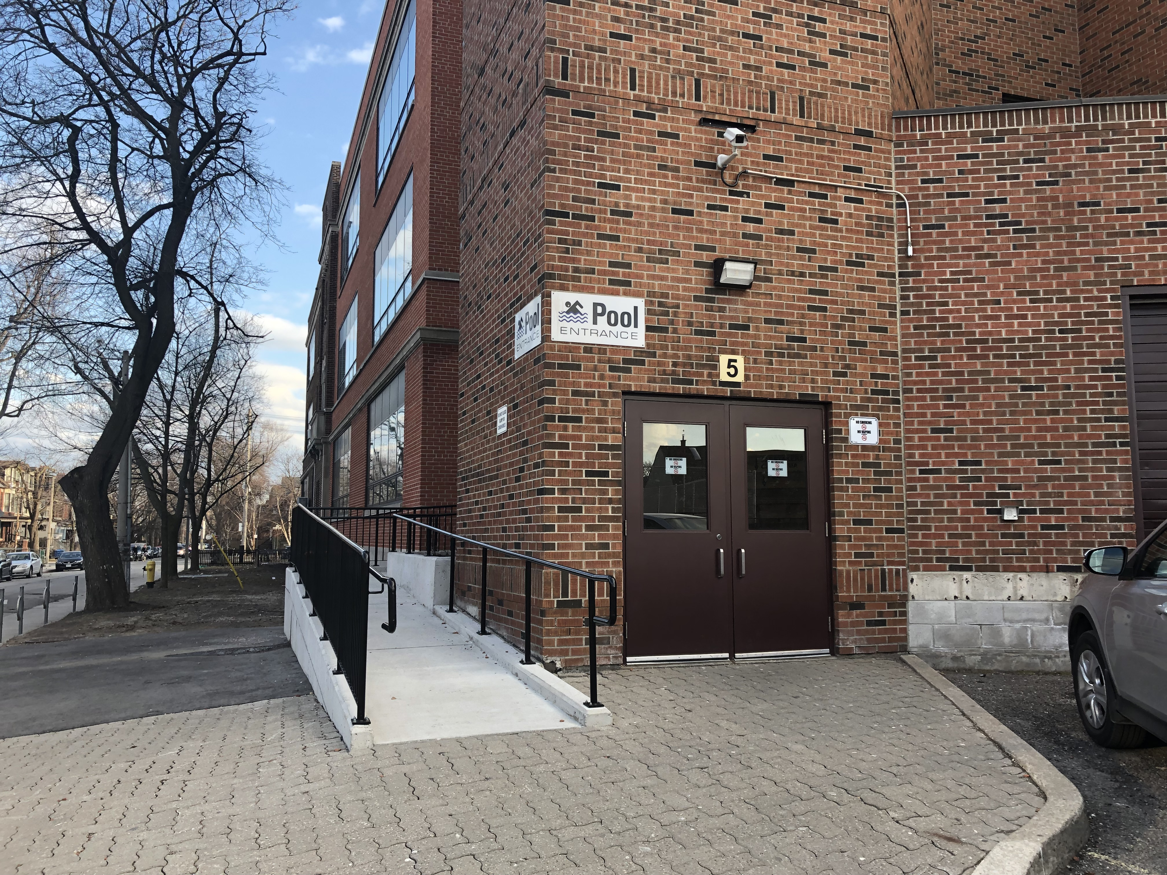
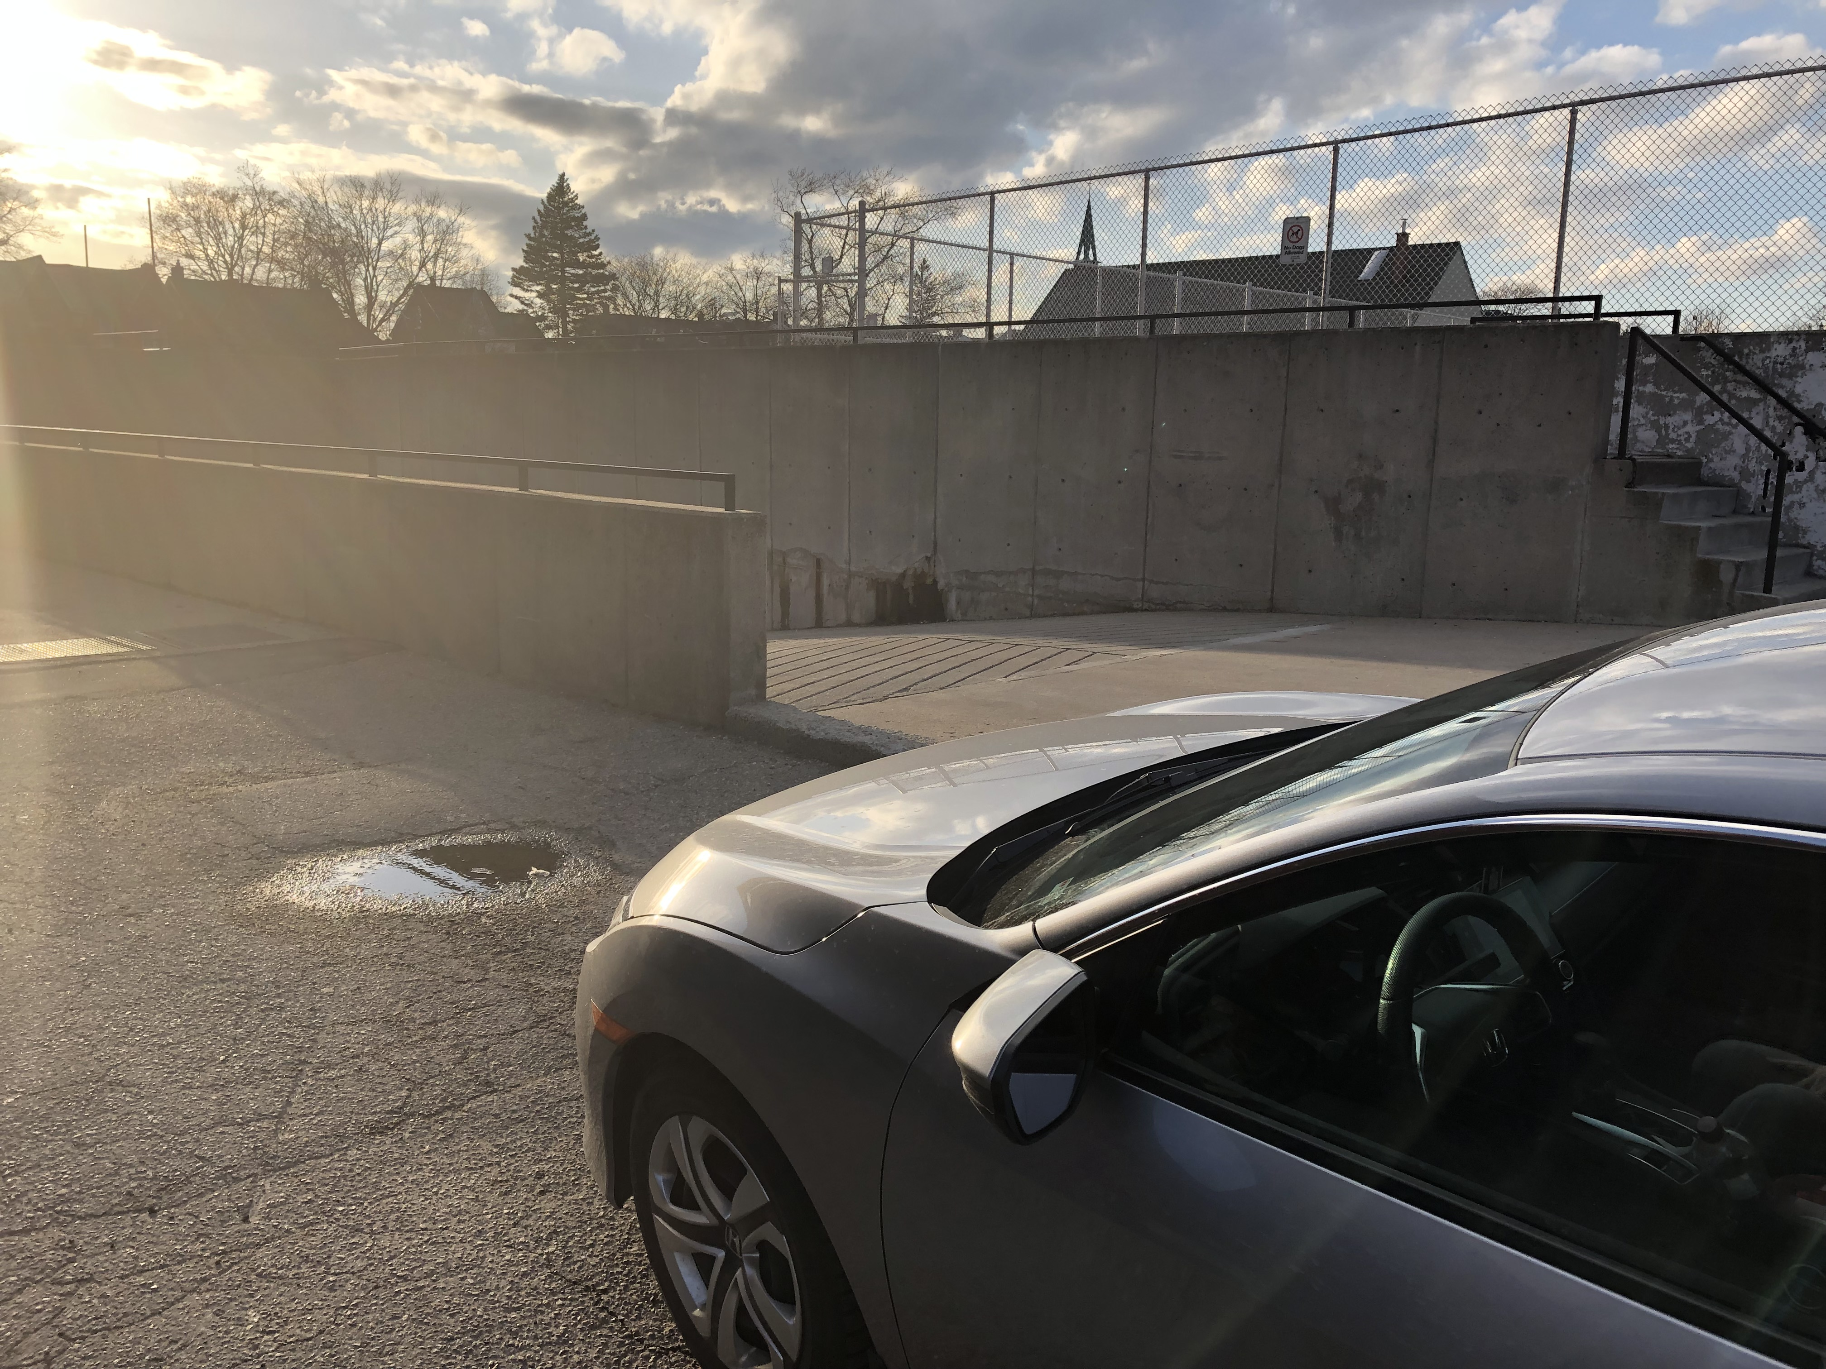
- 1 hour free street parking along Euclid Ave.

FACILITY ENTRANCE:
- Enter off of Euclid Ave. at the Northeast corner of the school – door marked #5.
- Sign for “Pool” is visible at entrance.

DECK/CHANGE ROOM ENTRANCE:
- Upon entering the building proceed immediately downstairs – see sign to Pool
- At the bottom of this set of stairs, turn left and walk down hallway; make first right and change room doors are on the right about halfway down the hall.

VIEWING GALLERY DIRECTIONS:
- Follow same directions as above – viewing gallery doors are adjacent to change room doors

VIEWING GALLERY CONDITIONS:
- Fairly humid.
- Virtually no cellular reception in viewing gallery. Only slightly better in hallway. Be prepared to work offline.
- This facility is often strict about prohibition of food and drink in the viewing gallery – especially no glass!
- Lots of seating and good view of practice

COFFEE & FOOD:
- Sam James Coffee Bar (297 Harbord St.).
- Bean & Baker Malt Shop (dessert spot; 326 Harbord St.).
- Krispy Kreme Donuts (215 Harbord St.).
- If you walk north to Bloor St., you will be in Korea Town where there are many food and drink options.

GROCERY STORES:
- Fiesta Farms is located north of the facility, on Christie St., south of Dupont (it is a drive, not a walk).
- PAT Central – Korean supermarket – 675 Bloor St. W at Manning Ave.

MISC.:
- Just north of Harbord Collegiate is Christie Pits Park – great for a walk, run or reading on a bench.
- Bickford Park is located just west of the facility, at Harbord St. at Grace St.

