POOL POINTERS – Havergal College

ADDRESS: 1451 Avenue Rd., North York, ON, M5N 2H9

MAJOR INTERSECTION: Avenue Rd. & Lawrence Ave. W.
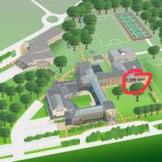
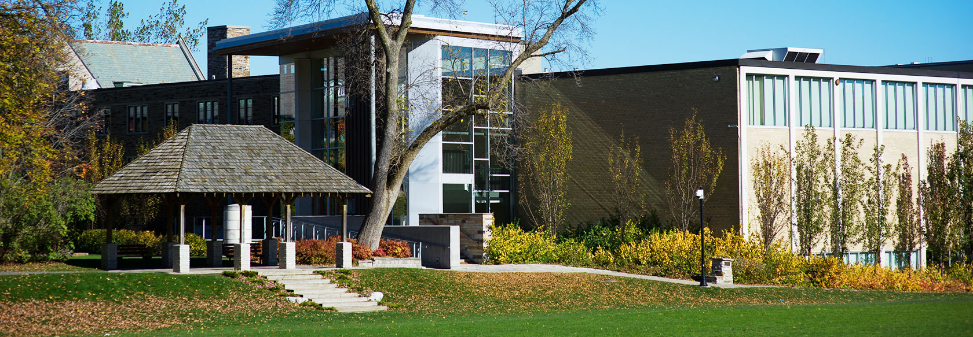
CLOSEST TTC STATION: Lawrence station

PARKING:
- Free onsite parking – the lot is the first section of school property upon which you may drive; just as you turn into the school off of Avenue Rd.
- Be mindful of the one-way directions entering and leaving the lot.
- Be prepared for a longer than usual walk from school parking to facility entrance. Bring an umbrella if raining. Pathway can be icy in the winter.

FACILITY ENTRANCE:
- Do not enter the main, historic looking building. The facility entrance is to the south/right of the main building by walking along pathway from southernmost parking lot – take pathway adjacent to open field (it will take you through a gazebo).
- Enter the glass front building which will be the first building you find along the pathway.

DECK/CHANGE ROOM ENTRANCE:
- Upon entering the building, proceed downstairs – change rooms and deck are two levels downstairs.

VIEWING GALLERY DIRECTIONS:
- Follow same directions as above – viewing gallery is just one level down – then proceed through glass doors on right, walk past washrooms on right and study desks in hall – then further down the hall you can overlook a workout room – viewing gallery is at very end of hall.

VIEWING GALLERY CONDITIONS:
- Normal temperature.
- About a dozen chairs that you may pull up to the glass to overlook the pool.

COFFEE & FOOD:
- South St. Burger (1542 Avenue Rd. – about one block north of Lawrence on the west side).
- A&W (1638 Avenue Rd., just north of Woburn Ave.).
- Starbucks at corner of Lawrence and Yonge St. (Southwest corner).

GROCERY STORES:
- Pusateri’s Fine Foods (1539 Avenue Rd.)

MISC.:
- A Shopper’s Drugmart is located at the northwest corner of Avenue Rd. & Lawrence Ave. W.
- Corner of Lawrence Ave. W. & Bathurst St. has much more in terms of shopping – Lawrence Plaza: LCBO, Winners, Shoppers Drugmart; across the street is an Esso and Pet Valu

