POOL POINTERS – Jarvis Collegiate

ADDRESS: 495 Jarvis Street, Toronto, ON, M4Y 2G8

MAJOR INTERSECTION: Jarvis Street & Wellesley Street East

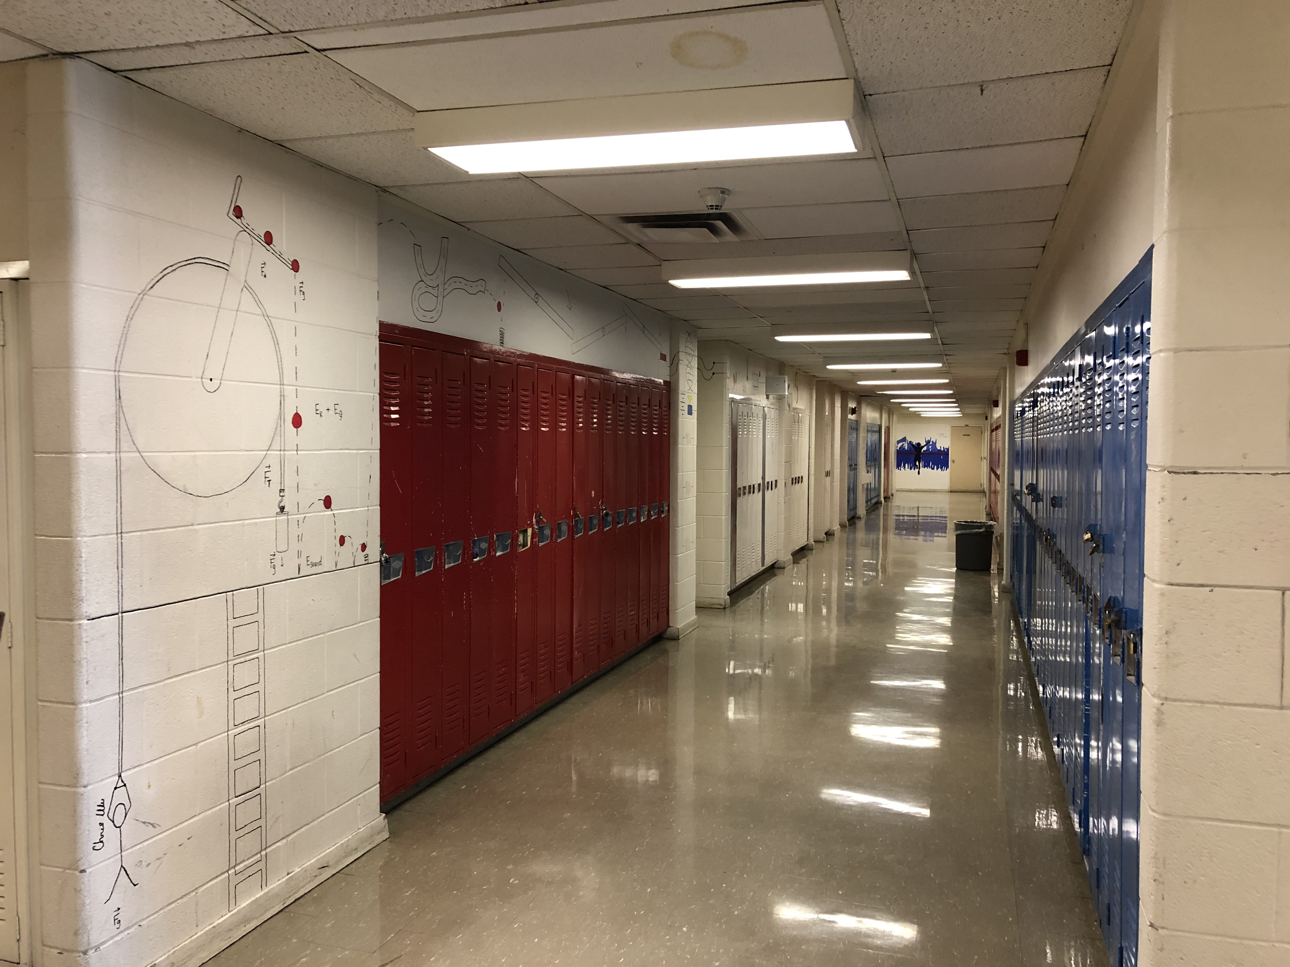
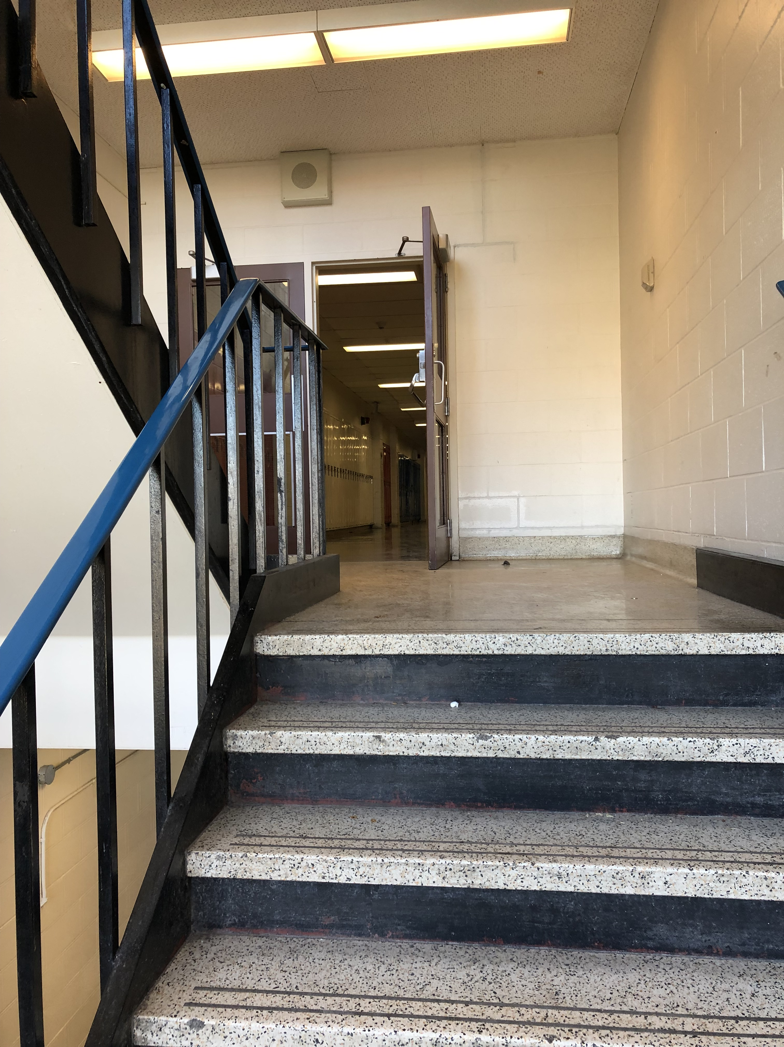
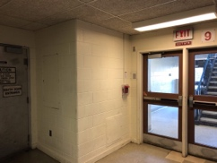
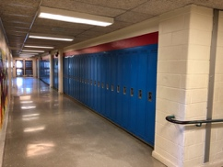
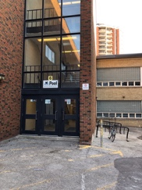
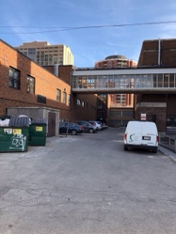
CLOSEST TTC STATION: Wellesley station or Sherbourne station
Hall to access door to pool deck. Stairs at end of hall to reach viewing gallery

PARKING:
- Free school parking (no guarantee that it won’t be chained, but typically open):
- Long lot off of Wellesley St E, across from Petro Canada gas station (most convenient as it is directly in line with entrance to the school on pool side).
- Smaller lot off of Maitland (also accessible off of Jarvis) but on opposite side of school from pool.
- Metered parking very limited on Jarvis but most plentiful on Maitland (be aware of time frames and limitations).

FACILITY ENTRANCE:
- Exterior access is on Wellesley St E side at the bottom of the long parking lot (look for pool sign and door #6).

DECK/CHANGE ROOM ENTRANCE:
- Upon entry from outside, proceed straight ahead through doors and then make immediate left to walk down hall with blue lockers.
- Please enter change rooms via pool deck; find steel door to pool deck marked “south door entrance” on the left side of the hallway just past the first hallway on your left but before the set of doors at the end of the hall, marked 9. While the actual change room doors are down the hallway on the left, just before the door to the deck, the change room doors are always locked for security. You will, however, meet your child in this hallway upon their exit from the change rooms.

VIEWING GALLERY DIRECTIONS:
- Proceed through the doors at the end of the hallway with blue lockers – door marked 9; go up stairs to next floor and make your first right down a hall where you will find double doors on your right halfway down the hall to viewing gallery.

VIEWING GALLERY CONDITIONS:
- Temperate. Beware of very open railing if you have little ones.

COFFEE & FOOD:
- Closest coffee is across the street on the corner of Wellesley and Jarvis – the Petro Canada is paired with a convenience store and A&W burger take-away.
- There’s a small independent café – Red Rocket Coffee – at the corner of Wellesley St. E. and Homewood Ave.
- Church St is not far – just westward if you walk along Wellesley or Maitland. Various coffee shop options in the Village and quick dinner options such as Pho and other noodle houses.

GROCERY STORES:
- Across from the North East corner of the back field of Jarvis Collegiate is a Rabba Fine Foods (148 Wellesley St. E).
- Major grocery shop option is the Loblaws in the old Maple Leaf Gardens at Church & Carlton.

MISC.:
- RBC is found at Wellesley and Church intersection (on Church St).
- There is no easy exit from the back field if you decide to exit back doors; you will have to walk around to find open gate. Also be aware that dog walkers often use this back field so pay attention to possible doo-doo on the ground and avoid the area if you do not like dogs off leash.
- Washrooms for non-swimmers may be found by walking straight upon entry to the building, and then turn left onto ramp. Be aware that this single washroom (next to basketball court) is often locked. Turn right down that hall and you may find the larger washrooms open. Custodial staff are friendly on this lower level and may open a washroom upon request.

