POOL POINTERS – University of Toronto Athletic Centre / Benson
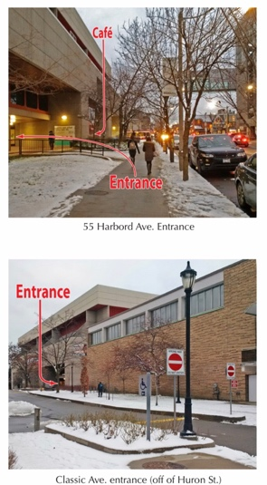
ADDRESS: 55 Harbord St., Toronto, ON, M5S 2W6

MAJOR INTERSECTION: Spadina Ave. & Harbord St.

CLOSEST TTC STATION: Spadina station

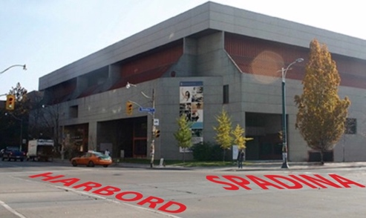

PARKING:
- Metered street parking on Harbord St., Huron St., and Spadina Ave. (3hr limits)
- Parking lot at 17 Glen Morris St. (Adjacent to the U of T Graduate House)

FACILITY ENTRANCE:
- Enter off of Harbord St. – door next to the café or even enter via the café.
OR
- Enter off of Classic Ave., which runs off of Huron St.
OR
For all practices set to occur outside of the regular Athletic Centre building hours, please enter via the Spadina St. side doors. Some exceptions made for swim meets.

DECK/CHANGE ROOM ENTRANCE:
- Change rooms (Spadina Change Rooms) are accessed by crossing the viewing gallery to the other side of pool where you will find a door that will take you to a hall – walk down hall, past offices and follow signs to Spadina Change Rooms. At end of hall, take stairwell down to change rooms.
- Space is very limited and therefore parents/guests should not join swimmers in change rooms.
- External pool user groups do not have access to the main change rooms, ever. No one is allowed through the turnstiles either. Some exceptions made for swim meets.

VIEWING GALLERY DIRECTIONS:
- Viewing gallery is accessed by at least three doors along the central hall on the main level.
- One small area in the main hall across from the athletic shop allows viewers to overlook the pool through a large window rather than sitting in the viewing gallery stands.

GALLERY CONDITIONS:
- Normal, unless very crowded.

COFFEE & FOOD:
- There is a café inside the facility on the main level on Harbord St. side.
- Second Cup Coffee is located across the street at northeast corner of Harbord & Spadina.
- At the northwest corner of Harbord & Spadina there is a Papa Ceo pizza parlour and Cora Pizza.
- Many great restaurants westward along Harbord St.

GROCERY STORES:
- Metro (425 Bloor St. W).

MISC.:
- If you or your swimmer have accessibility issues, it is advisable to request for the Spadina Ave. entrance to be opened upon your arrival since traversing the viewing gallery when populated can be difficult.

Building & Pool Entry
External Rental Groups:
External rental groups, who are approved to be using either of our pools, do not have access to enter into the Athletic Centre via the turnstiles. All participants associated with an external rental group must enter into the building and proceed to the 50m pool following a different path compared to all other members of the Athletic Centre.
Out of Building Hours
Out of building hours is when the Athletic Centre is closed to all members but we have internal and/or external bookings occurring in the pool(s). This is often before 7am on weekdays and before 9am or after 5pm on weekends. Generally, we never have OBH bookings after 11pm during the week.
Building hours do change in May, June, July & August.
Access
- All participants are to enter into the building via the external doors on the Spadina side of the building (west side).
- Once in the building, all participants must head down the southwest staircase and enter directly into the men’s or women’s Spadina change room. During these hours, participants are not walking on to the deck to access the Spadina change rooms.
- Once changed, participants may exit on to the deck through the gated entrances beside the Teach Pool.
- No external rental groups are to be using the Main changing rooms.
- The 50m viewing gallery is locked and remains off limits to everyone. Spectators may sit on the bleachers on the 50m pool deck.
- IF USING BENSON
  - Once changed and on the 50m pool deck, all participants are to exit the 50m pool deck via the double silver doors beside the 50m Varsity pool office, proceed down the hallway to the staircase leading to the Benson pool, walk up the staircase and enter directly onto the Benson pool deck.
During Building Hours
During building hours is when the Athletic Centre is open to all members. During these hours, internal and external bookings may also occur. Hours are generally Monday – Friday 7am – 11pm and Saturday & Sunday 9am – 5pm.
Building hours do change in May, June, July & August.
Access – External Rental Groups
- External rental participants are to enter into the building via the main doors on the Harbord St. or Classic Ave. sides of the building (north side = Harbord, south side = Classic).
- Once in the building, all participants must enter into the 50m viewing gallery, proceed around the viewing gallery to the Spadina side, enter into the hallway on the Spadina side, walk down the hallway to the southwest staircase, go down the stairs, open and walk through the door leading to the pool deck in the southwest corner, and then walk along the deck on the west side to the Teach Pool where participants may enter into the Spadina change rooms from the deck.
- Once changed, participants may exit on to the deck through the gate entrances beside the Teach Pool.
- No groups are to be using the Main changing rooms.
- IF USING BENSON
  - Once changed and on the 50m pool deck, all participants are to exit the 50m pool deck via the double silver doors beside the 50m Varsity pool office, proceed down the hallway to the staircase leading to the Benson pool, walk up the staircase and enter directly onto the Benson pool deck.

