POOL POINTERS – University of Toronto Athletic Centre / Benson
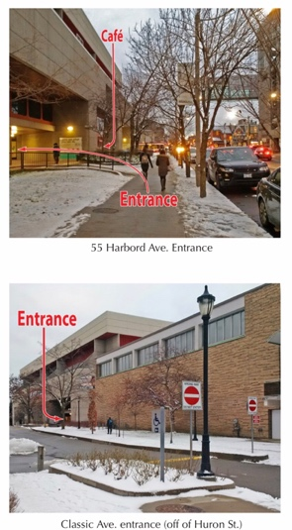
ADDRESS: 55 Harbord St., Toronto, ON, M5S 2W6

MAJOR INTERSECTION: Spadina Ave. & Harbord St.

CLOSEST TTC STATION: Spadina station

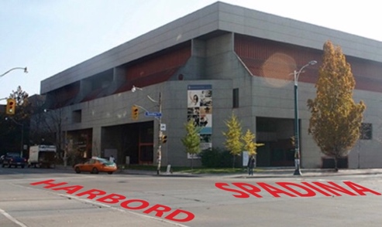

PARKING:
- Metered street parking on Harbord St., Huron St., and Spadina Ave. (3hr limits)
- Parking lot at 17 Glen Morris St. (Adjacent to the U of T Graduate House)

FACILITY ENTRANCE:
- Enter off of Harbord St. – door next to the café or even enter via the café.
OR
- Enter off of Classic Ave., which runs off of Huron St.
OR
- For early morning training, the Spadina St. side entrance may be open, although it is typically closed.

DECK/CHANGE ROOM ENTRANCE:
- Change rooms (Spadina Change Rooms) are accessed by crossing the viewing gallery to the other side of pool where you will find a door that will take you to a hall – walk down hall, past offices and follow signs to Spadina Change Rooms. At end of hall, take stairwell down to change rooms.
- Space is very limited and therefore parents/guests should not join swimmers in change rooms.
- On occasion the main level change rooms are in use. These change rooms are accessed through the turnstiles past the main reception desk.

VIEWING GALLERY DIRECTIONS:
- Viewing gallery is accessed by at least three doors along the central hall on the main level.
- One small area in the main hall across from the athletic shop allows viewers to overlook the pool through a large window rather than sitting in the viewing gallery stands.

GALLERY CONDITIONS:
- Normal, unless very crowded.

COFFEE & FOOD:
- There is a café inside the facility on the main level on Harbord St. side.
- Second Cup Coffee is located across the street at northeast corner of Harbord & Spadina.
- At the northwest corner of Harbord & Spadina there is a Papa Ceo pizza parlour and Cora Pizza.
- Many great restaurants westward along Harbord St.

GROCERY STORES:
- Metro (425 Bloor St. W).

MISC.:
- If you or your swimmer have accessibility issues, it is advisable to request for the Spadina Ave. entrance to be opened upon your arrival since traversing the viewing gallery when populated can be difficult.

