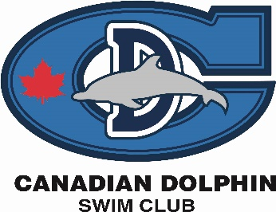

West Coast Open highlights:

3 Club Records broken!

Ridley breaks the 50 fly (Chelsea’s) and smashes the 200 fly club records (Caitlin Quon) for 10 & u girls at the WCO.
Noah breaks the record recently set by Jordan in the 50 fly!

Great swims over the weekend by these two and many more!! CONGRATS!

Hannah – 4/6 best times
Austin – 3/6 best times
Teo – 4/5 best times – new Tier I times
Lauren – 2/6 best times
Ruby – 5/6 best times
Zach – 4/5 best times
Charles – 3/7 best times
Nathalie – 7/8 best times
Sahara – 6/7 best times
Lily – 1/5 best times
Tia – 3/6 best times
Julian H. – 2/6 best times
Luke – 6/8 best times
Alex J. – 1/3 best times
Ridley – 6/7 best times – 2 new club records – 50 and 200 fly (10 & u girls)
Alexis – 4/6 best times
Andrew K. – 4/8 best times
Andrew Kwo – 3/7 best times
Derek – 2/6 best times
James L. – ¼ best times
Noah – 8/8 best times – New club record in 50 fly (11-12 boys)
Erin – 3/3 best times
Negin – 1/5 best times
Andjela – 4/8 best times
Chihana – 3/3 best times
Maria – 6/7 best times
Trevor – 1/3 best times
Julia – 4/6 best times
Julian S. – 6/7 best times
Sofia – 5/7 best times
Nathaniel – 6/8 best times
Kris – 4/7 best times
Kenza – 1/3 best time

123 BEST times swum over the weekend

Congratulations to all swimmers and anyone who made new Tier I or II cuts this past weekend!

Great job.

