December
2020
Christmas schedule 2020
Title  December training schedule | 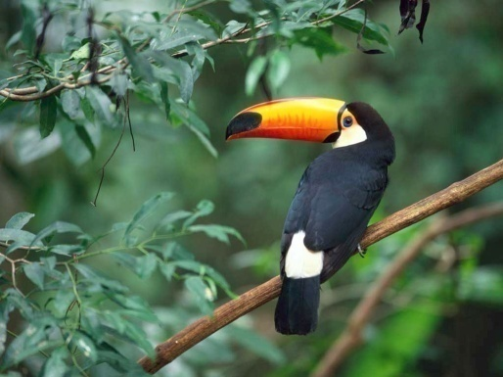
Sunday | Monday | Tuesday | Wednesday | Thursday | Friday | Saturday
 |  | 1 | 2 | 3 | 4 | 5
 |  | Normal training | Normal training | Normal training | Normal Training | Normal training
6 | 7 | 8 | 9 | 10 | 11 | 12
Normal training | Normal training | Normal training | Normal training | Normal training | Normal training | Normal training
13 | 14 | 15 | 16 | 17 | 18 | 19
Normal training | Normal training | Normal training | Normal training | Normal training | Normal training | Normal training
20 | 21 | 22 | 23 | 24 | 25 | 26
Normal training | Normal training | Normal Training | Normal Training | NO SWIM | NO SWIM | NO SWIM
27 | 28 | 29 | 30 | 31 | Jan. 1 | Jan. 2
NO SWIM | Normal training | Normal training | Normal training | Normal training | NO SWIM | NO SWIM
Jan. 3

Return to normal training for groups

