CARLETON PLACE WATER DRAGONS
SPONSORSHIP PACKAGE 2018-19 SEASON

Carleton Place Water Dragons (CPWD) swim club is a non-profit, volunteer-run, organization that has been an integral part of the Carleton Place sports community, in which swimming has been a part of this for over 25 years. Drawing our swimming membership from Carleton Place and surrounding communities, including Smiths Falls, Almonte, Clayton, Carp, Pakenham, Richmond and Stittsville, we are very proud of the strong and inclusive culture of our team.
- CPWD club fosters and teaches the sport of swimming, while promoting individual growth and development of life-skills among our swimmers and its membership.
- We maintain a healthy relationship within our community, especially with the Township of Carleton Place and the CP Pool
- Many of our athletes actively support and excel in other community and school sports, such as paddling, hockey, athletics and basketball.

PHYSICAL ACTIVITY
- Children and youth aged 5–17 require at least 60 minutes of moderate to vigorous physical activity daily.
- Physical activity contributes to physical and mental health, social development, building self-confidence and reducing the risk of becoming involved in unsafe activities, such as drugs and alcohol.
- CPWD swimmers are in the water anywhere between 3 and 18 hours per week and are arguably some of the fittest kids in our community!
- Our club is committed to building strong, healthy and happy swimmers and providing the opportunity to achieve the highest level of performance based on their inherent desire and ability.

______________________________________________________________________________

“Our goal is to successfully support each generation of young athletes reach their full potential
by ensuring a thriving, healthy swim club remains available in our community.”
______________________________________________________________________________

WHY SPONSOR CPWD

Swimming programs are expensive and swim fees only cover a portion of our costs. We appeal to our community to help us in our efforts.

Benefits
- Satisfaction in knowing you or your business supports a community club that promotes personal growth, friendships, sporting behaviour and a healthy lifestyle.
- Grow your business and brand in our community by backing youth activity!
- Promote your products and services within our membership and community.
- Increase your business reach with new audiences and reconnect with existing customers.
- Help our swimmer’s turn goals turn into reality as they compete at local, provincial, national and international levels.

SPONSORSHIP INFORMATION
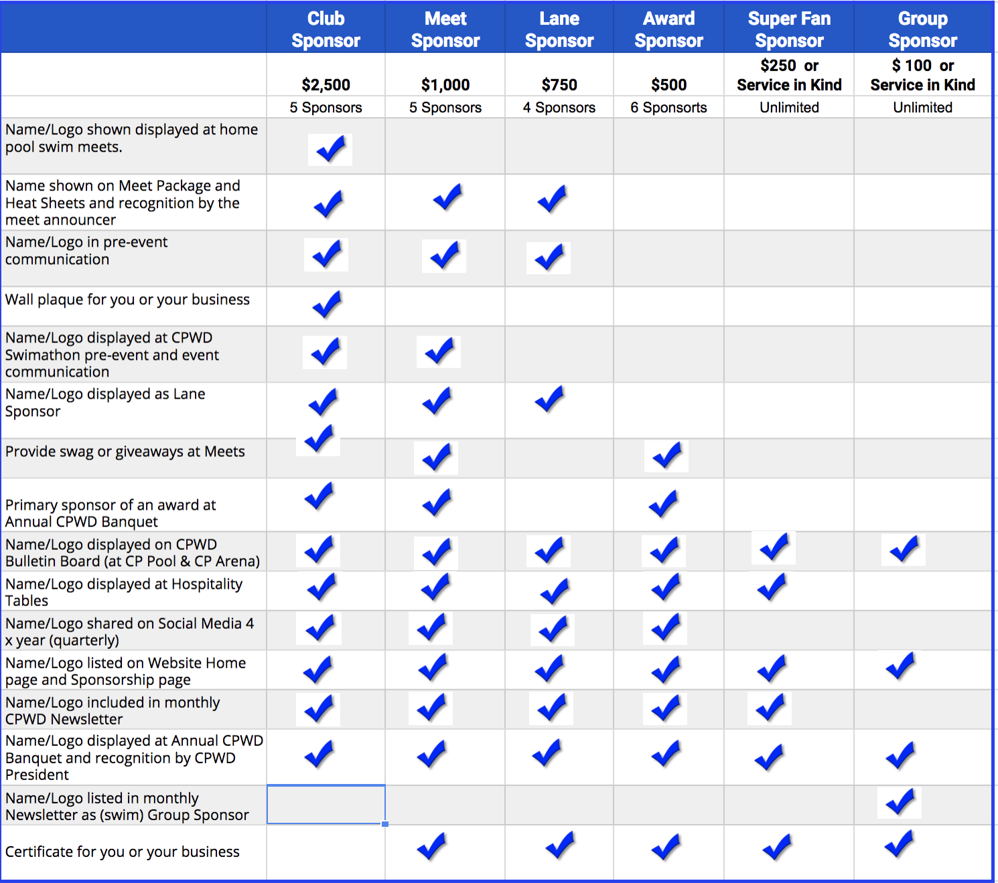

We thank you for your sponsorship consideration or decision to sponsor CPWD
in our 2018-19 season!

Questions or help can be directed to our Club President
Monica-Lynn Terpstra @ cpwd.pres@gmail.com
SPONSORSHIP FORM
Business Name: _______________________________________
Contact Name: __________________________________________
Business Address:_________________________________________________________
________________________________________________________________________
Business Phone: _______________________ Mobile: ________________________
Email: _______________________________
SELECT SPONSOR LEVEL (Indicate with Tick)
Club $2,500.00

Meet $1,000.00
Lane $ 750.00

Award $ 500.00

Superfan $ 250.00. Donation in kind offer: ___________________________

Group $ 100.00 Donation in kind offer: ___________________________
Group you would like to sponsor: __________________
We appreciate any Donations in kind. CPWD Board of Directors will respond with approval if yours is accepted.
Donation Total Amount $______________ Method of Payment (circle): CASH CHQ E-TRANSFER
Please make cheques payable to Carleton Place Water Dragons.

Logo Artwork Supplied: YES ________ NO ________

Please email file(s) to Sharyl-Anne Andrews cpwd.comms@gmail.com

Swimmer Name associated with sponsorship? _______________________________

.
Our Sincerest Thanks.
CPWD Board, Swimmers and Membership

For further information please contact our Club President,
Monica-Lynn Terpstra @ cpwd.pres@gmail.com

