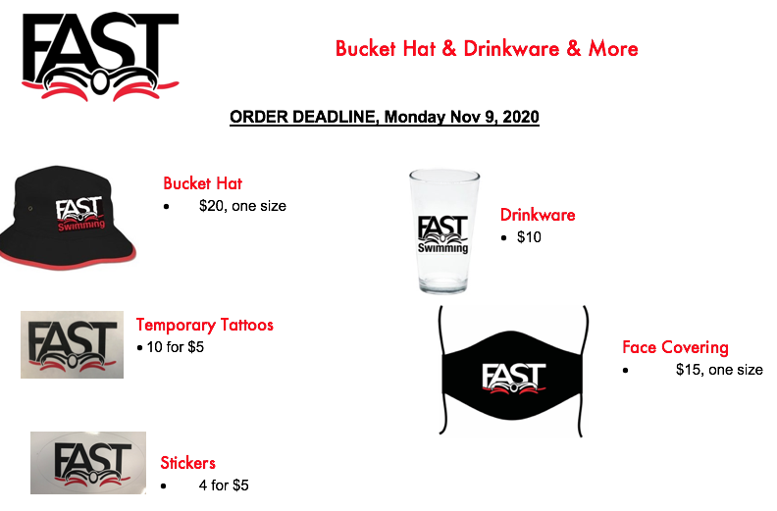

Order Form
Swimmer Name:
Swimmer Group:
Parent Name:

Item | Qty | Item Cost per | Total Cost
Bucket Hat |  | 20
Drinkware |  | 10
Temporary Tattoos |  | 5
Stickers |  | 5
Face Covering |  | 15
Total Due Dec 1, 2020

We will contact parents - not swimmers - when the order arrives.

Please email orders to Michelle Barclay fastswimmingclothing@gmail.com

Payment due by Dec 1, 2020

