Financial Policies
Inconnu Financial Statements: See Appendix B
The Fort St. John Inconnu Swim Club (the Club) is a non-profit organization and the Board of Directors (the Board) operates the Club as such. With the assistance of other Board members and the Head Coach, the Treasurer prepares a budget for the upcoming swim year and presents to the Board each spring for their review and input. The budget is finalized and approved at a regular meeting of the Board.
Club members should be aware that they are responsible for
- registration fees for each of their swimmers
- Swim BC insurance fees
- Two fundraising events (if the swimmers are registered for the year); one fundraising event is held in the fall and the other is held in the spring.
- Swim Meet Entry Fees (if swimmers wish to compete)
- Volunteer Points Commitment
Additional fundraising events are held on an ad hoc basis and are voluntary.
It is assumed that once a swimmer has participated in Club activities (for example; dryland) or the first day of in-water training, that the swimmer is considered registered and must be compliant with the following financial policies; unless participating in the one-week trial.

Registration Fees
Registration Fees are intended to cover the delivery of the training program among other things. See below for an explanatory diagram.

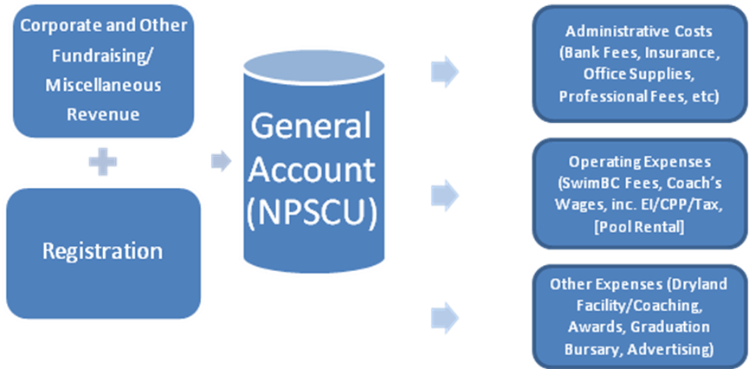

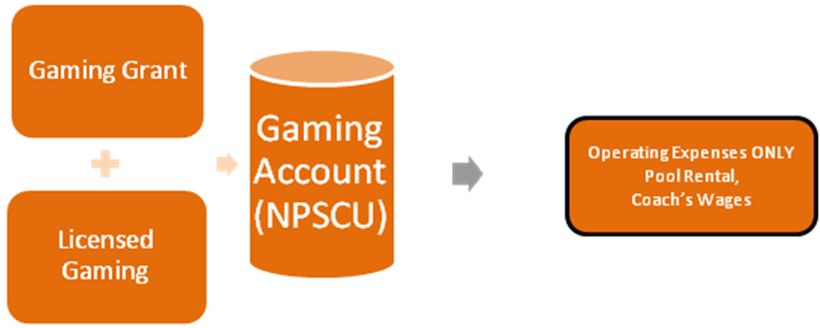

Payment Schedules

Novice/Junior A & B
Novice and Junior groups swim two sessions per year: September to December (Session 1) and January to April (Session 2). Novice and Junior groups may opt to swim in Session 1only, Session 2 only or commit to both at the beginning of the year. If registered for each session individually, the fees will be charged at the beginning of the session. Should a swimmer wish to discontinue swimming with the Club prior to the conclusion of the swim session, it is your responsibility to notify the Club Administrator in writing.
For those that commit to register for the year, fees can be paid in a lump sum, or as equal payments over 7 months from October to April. Should a swimmer wish to discontinue swimming with the Club prior to the conclusion of the swim season, it is your responsibility to notify the Club Administrator in writing.
You will be responsible for all financial commitments accrued to the month of notification and one month’s penalty. No refunds will be issued after April 15 of the swim season.
Intermediate/Senior /Nationals
For Intermediate/Senior/National Swimmers, registration fees are charged as a lump sum at the beginning of the season, or as equal payments over 9 months from October to June.
Should a swimmer wish to discontinue swimming with the Club prior to the conclusion of the swim season, it is your responsibility to notify the Club Administrator in writing. You will be responsible for all financial commitments accrued to the month of notification and one month’s penalty. No refunds will be issued after May 15 of the swim season.
Swim 4 Fit
The Swim 4 Fit group is a drop-in program with registration fees charged per usage and a monthly calculation is charged to your Team Unify account on the first of the following month.
Should a swimmer wish to discontinue swimming with the Club prior to the conclusion of the swim season, it is your responsibility to notify the Club Administrator in writing. You will be responsible for all volunteer commitments accrued to the month of notification and one month’s penalty. You are also responsible for fundraising commitments for that session.

Swim BC Insurance Fees
Swim BC insurance fees are due in September or at the time of registration. There are no refunds for Swim BC insurance fees.

Fundraising Events

Novice/Junior A & B/Swim 4 Fit
Fundraising commitments are required on a per session basis for swimmers in the Novice/Junior group. In the event that a swimmer discontinues swimming prior to the completion of the session, the fundraising commitment is not refundable for that session.

Intermediate/Senior/Nationals
No refunds will be issued for the fall fundraiser after October 31 of the swim season. No refunds will be issued for the spring fundraiser after February 28 of the swim season.

Swim Meets (including Team Travel) & Swim Training Camps
Charges for swim meets and swim camps will consist of entries fees. There are no refunds for swim meets once our Club’s registration deadline has passed. Swim meets will be charged on the day following the registration deadline.
Swim BC charges athletes to attend swim camps. This will be charged to the athlete’s family. No refunds will be issued once our Club’s registration deadline has passed.
The Chaperone(s) assisting with Team Travel is entitled to accommodation reimbursement and per diem ($50 or Breakfast=$10, Lunch=$15, Dinner=$25) for the travel to and from meets and for each day of a meet. Transportation will be reimbursed at cost or mileage paid at the Canada Revenue Rate.

Dryland Training
Dryland training is an elective option for the swimmers. Charges will be borne by attending athletes and the amounts will be determined by the third party provider and may be subject to change. Other rules of commitment and cancellation will also be determined by the provider and will be disclosed at time of sign up.

Age Qualifier Training
Age Qualifier athletes swim for the month of July after the season is officially over, in order to be prepared for Age Qualifying meets. The pool lane rental cost for July will be divided equally between the athletes attending and will be charged to their Team Unify accounts.

Multi-Swimmer Discount
Families with more than two youth swimmers are eligible for a 20% discount for the 3rd swimmer and 20% for the 4th swimmer on registration fees for the LOWEST COST swimmer. The discount will be applied as a credit to member’s accounts at the end of the youngest swimmer’s season.

Swimmer Group Movement
Every effort will be made to limit group movements within a calendar month in order to facilitate an organized transition. Intake will occur at the end of December, February and April or within the first two weeks of the season. Charges will be calculated on a per month basis and charged the first of each month. Coach or Head Coach will notify the Club Administrator to keep the accounts current.

Temporary Movement or Transition
A temporary group movement or transition is defined as the movement of a swimmer from one group to another on a trial, non-permanent basis of no more than two weeks. After two weeks, the move will be considered permanent.
During the process of a temporary group movement or transition, no additional registration or fundraising fees will be charged.

Permanent Movement of Move Up/Down
A permanent group movement or Move Up/Down is defined as the permanent movement of a swimmer from one group to another.
At the conclusion of a temporary group movement or a permanent group movement, there may be an increase in registration fees and fundraising commitment. If so, the family will be notified and the fees will be charged accordingly at the beginning of the subsequent month and the fundraising commitment will be adjusted.

One Week Trial Period
The one week trial period is intended for swimmers wishing to try competitive swimming. After the tone week period, you may choose to continue swimming with the Club at which point all fees will apply. If you choose to not continue, no further charges will be incurred.

Suspension or Expulsion from the Club
In the event a swimmer is suspended from the Club as a result of disciplinary action, all fees will continue to apply for the duration of the suspension.
In the event a swimmer is removed from the Club as a result of disciplinary action, all financial commitments, such as registration, fundraising commitments, dryland charges, remain in effect. Registration fees will be charged to the month of re-instatement and one month’s penalty. No refunds will be issued after April 15 (Novice/Junior) and May 15 (Intermediate/Senior/National) of the swim season.

For example, should a swimmer wish to discontinue swimming in February, the member is responsible for registration charges for February and March.
For example, should a swimmer wish to discontinue swimming in February, the member is responsible for registration charges for February and March.
For example, should a swimmer wish to discontinue swimming in February, the member is responsible for registration charges for February and March.
For example, should a swimmer wish to discontinue swimming in February, the member is responsible for registration charges for February and March.

