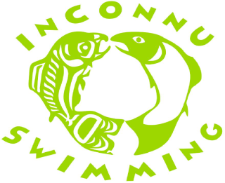 2017/18 Inconnu Swim Meet Schedule
(August 9, 2017)

Event Date

Pre-season Dry land September TBD
FSJ Time Trial Novice & Jnr October 28th
Grande Prairie ALL November 3rd–5th
Prince George Fall Invitational ALL November 17th-19th
FSJ Swim Meet ALL December 1st-3rd
J.P Fiset Edmonton (QT) December 14th-17th

Christmas Break No Swimming (Dec 23rd – Jan 2nd : National, Senior, Intermediate)
(Dec 23rd - Jan 7th: Jnr A/B, Novice, Swim for Life and Fit)

Peace River ALL January 20th & 21st
Grande Prairie Winterfest Snr-Nat January 27th & 28th
FSJ Swim Meet ALL February 16th-18th
Tier 2 Provincials – Kamloops TBD (QT) March 2nd-4th
Tier 1 Provincials - Penticton (QT) March 9th-11th
Alberta Spring Championships (Edmonton) TBD (QT) March 16th-18th

Spring Break No Swimming (March 17th- 25th: National, Senior, Intermediate)
(March 17th- April 2nd: Junior A/B, Novice, Swim for Life and Fit)

Swim Challenge ALL April 3rd-6th
Senior Nationals - Montreal (QT) April 5th-8th
Western Championships - Victoria (QT) April 12th-15th
Grande Prairie ALL May 5th&6th
FSJ Time Trial Int-Nat/ May 19th
Wolf Pack Invitational - Kamloops Int-Nat June 1st-3rd

Championship Competition phase of season swim meets:

2018 ManSask LC Prov. Championships - Saskatoon (QT) July 5th-8th
Swim BC Open Water Championships- (QT) July 9th
Canadian Trials - Edmonton (QT) July 19th-22nd
Canadian Junior Championships – Winnipeg (QT) July 25th-30th
Far Westerns – Moraga CA (QT) July 26th-29th

*(ALL) - All athletes that want to participate are encouraged to attend the swim meet.
** (QT) - Athletes attending the meet must have met the required qualifying standard.

