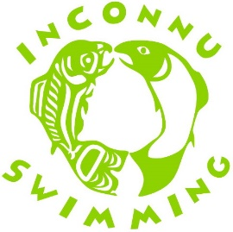
How to Support the
FSJ Inconnu Swim Club with

Here are the steps:
- Go to https://www.fundscrip.com and click on in the top right hand corner.
- Enter the Group Invitation Code FWUA3B and click search. This will take you to the Fort St John Inconnu Swim Club group.
- Enter your personal information, agree to the terms & conditions and click on
- You will receive an email asking you to confirm your email address and complete the registration.
- Now you can buy cards, manage your e-cards, manage your profile, etc.
- Click on to see the different cards available and the % earned by Inconnu.

- Add some cards to your cart – thank you!
- Choose a shipping method and address by clicking on Edit. Direct shipping is the option available to Inconnu supporters. Your card(s) will be shipped to you by Canada Post at a cost of approximately $0.95.
- Choose a payment method by clicking on Edit. is quick and easy. Simply add Fundstream/Fundscrip as a payee on your online banking website. Place your Fundscrip order, receive an Online Bill Payment Number from Fundscrip and then login to your banking website and pay Fundstream/Fundscrip your amount owing. It will take a couple of days to process your order and then your cards will be mailed to your selected shipping address.

Thank You for your support!

