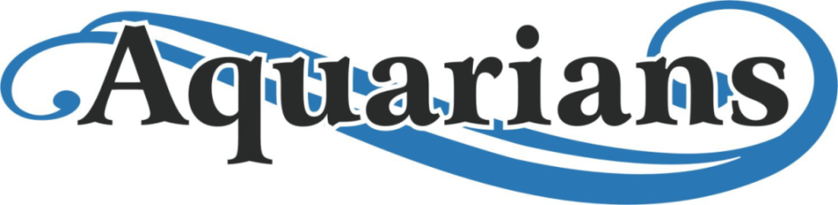
Ideas for Raffle table June 22nd
Tablet
Smart watch
Hillberg and Berk earrings
Hover board
Wireless Headphones – received!
Cooler with wheels - received!
Ernies gift cards so we can put them together to purchase bigger items
Goggles
Quick dry towels-received
Gift cards from various places in Grande Prairie(starbucks)
Movie passes – received!
Speedo Swim bag
Yoga matt’s
Water bottles
Coffee mugs
Eastlink youth 10 punch pass
Outdoor activities (bean bag toss, ladder ball, bocce ball, etc. )
BUSINESSES THAT HAVE BEEN ASKED FOR DONTATIONS:
- Mastermind toys
- Stickey’s candy
- Chatters hair salon
- Clay and cupcakes
- Wapiti Bean and co.
- Starbucks Mission heights
- Menchies
- Brogan Safety
- Semcams
- Riley Transfer
- Northern Metallic
- Kindred Creations
- North point (GPR)
- Radium
- Greggs Distributers

PRIZES WE HAVE COLLECTED SO FAR:
- $80 in Cineplex gift cards
- Hand painted framed picture
- Cooler on wheels
- Handmade wooden picture of mountains from Kindred Creations
- Handmade wood stuffed animal holder
- 3 jump yard passes
- “Big joe” floaty from Costco
- 2 sets of waterproof wireless headphones
- Gift basket with various summer things including Frisbee golf
- 2 family drop in swim passes for the eastlink
- 1hr message gift card
- Nintendo Switch with Mario kart 8 delux

