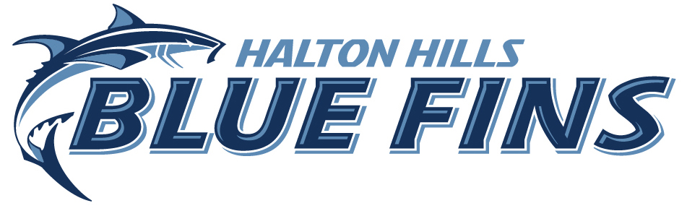

Swim it Fast
In-House Competition

Saturday Jan. 27, 2018

Georgetown Indoor Pool

70 Guelph Street
Georgetown, Ontario
L7G 3Z5

HHBF In House Competition

DATE: January 27, 2018 Region: Central
HOSTED BY: Halton Hills Blue Fins

LOCATION: Georgetown Indoor Pool
70 Guelph Street
Georgetown, ON L7G 3Z5
FACILITY: 6 Lanes, 25 meters, Kiefer Lane Ropes, Manual CTS Dolphin Timing System (Only 4 lanes will be used)
PURPOSE: The purpose of this In-House Competition is for HHBF intro-competitive swimmers to swim competitive times and allowing select competitive swimmers to achieve qualification times
MEET PACKAGE: The only meet package which will be considered as valid must be the most current version found on www.swimming.ca
COMPETITION: Sanctioned as an In House competition by Swim Ontario.
All current Swimming/Natation Canada (SNC) rules will be followed.
Seeding for all swims will be optimized by distance and stroke, but otherwise random.
Please note that Swimming Canada Competition Warm-Up Safety Procedures will be in effect. 2017 SNC Swimwear interpretation in effect. Details HERE.
Events are Timed Finals.

ELIGIBILITY: All athletes must be registered as Competitive swimmers with SNC.

AGE UP DATE: Ages submitted are to be as January 27, 2018

ENTRY: There are no entry restrictions. A 3 hour time limit on session length will be adhered to. All entries must be submitted via www.swimming.ca. There are no entry fees or awards allowed. HHBF allowed to restrict entries to meet time limitation. Entry Close Date: Jan 24, 2018
COMPETITION
COORDINATOR: Guenther Schweigl , Level 4

MEET MANAGER: Jamie Wellings, meetmanager@haltonhillsbluefins.com

SESSION: Warm Up: 9:15am Start: 9:45am Finish: Noon

SCHEDULE OF EVENTS:

Session | Event # | Open Event (maximum distance to swim) | Stroke | Gender
1 | 1 | 4x50m | Free Relay | Mixed Gender
1 | 2 | 4X50m | IM Relay | Mixed Gender
1 | 3 | 200m | Free | Mixed Gender
1 | 4 | 25m | Fly | Mixed Gender
1 | 5 | 25m | Back | Mixed Gender
1 | 6 | 25m | Breast | Mixed Gender
1 | 7 | 25m | Free | Mixed Gender
1 | 8 | 100m | IM | Mixed Gender
1 | 9 | 50m | Fly | Mixed Gender
1 | 10 | 50m | Back | Mixed Gender
1 | 11 | 50m | Breast | Mixed Gender
1 | 12 | 50m | Free | Mixed Gender

