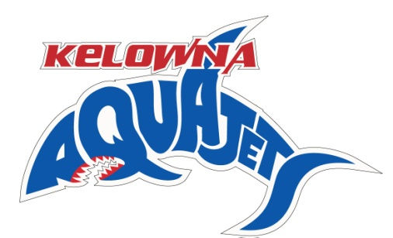

KELOWNA AQUAJETS SWIM CLUB IS LOOKING FOR A TEAM MANAGER
Kelowna Aquajets Swim Club - Job Posting – Team Manager

Kelowna Aquajets swim club is seeking a motivated, passionate and experienced individual for its team manager position. This person needs to be personable and be able to interact with a multitude of people on a daily basis.

KAJ is rapidly growing swim club with approximately 360 swimmers with Provincial and National level swimmers. Currently training out of three Kelowna facilities, including our 50m pool at H2O.
The team manager will be a year-round, part-time salaried position based on qualifications and experience.

EXPERIENCE/EDUCATION EXPECTATIONS
- Preferred minimum 3 years of extensive swimming experience
- Preferred swim coach certification
- Experience in organization and booking all team travel
- Computer skills, Team Unify management system, Meet Manager
- Preferred finance / accounting experience
RESPONSIBILTIES
- Work with head coach and President to implement the vision of the club with membership (staff,swimmers,parents)
- Prepare monthly/quarterly reports for board meetings
- Oversee set-up and running of team hosted swim meets
- Oversee and co-ordinate all team travel (hotels,meals,transportation)
- Effectively communicate with staff,parents,facility,municipality staff, etc
- Abide by policies established by the board of directors
Desired start date is August / September of 2019
Interested applicants should send resume, cover letter by July 22, 2019 to the attention of President – Gary Desrosier: desrosier@cofi.org 250-212-4344

