Kamloops Classic Swimming
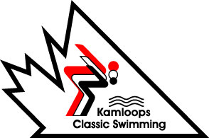
is HIRING!!

SUMMER CAMP COACHES & COUNSELLORS

Kamloops Classic Swimming will be hiring Coaches and Junior Counsellors for our half-day Swim & Play Summer Camp programs running throughout July-August. Camp dates are as follows:

- Session 1: July 5th – 9th Mon-Fri
- Session 2: July 12th -16th Mon-Fri
- Session 3: July19th -23rd Mon-Fri
- Session 4: July 26th -30th Mon-Fri
- Session 5: Aug 3rd -6th Tues-Fri
- Session 6: Aug 9th – 13th Mon-Fri
(no camp on Mon, Aug 2nd, BC Day)

All camps are Half Day [8:30am-12:00pm | 1-4:30pm].
Jr. Counsellor Minimum Qualifications:
- 14 years of age
- Bronze Medallion
- Swim Club experience preferred
Coach Minimum Qualifications:
- 15 years of age
- Bronze Medallion
- Water Safety Instructor cert.
- Swim Club experience preferred.

Please complete the application form and attach your resume if you have one. Proof of certifications will also be included by applicant.
Application deadline: May 28th, 2021

** Applications can be submitted:

- BY EMAIL: admin@swimkamloops.com with a subject line “Summer Camp Job Application” (must be received by May 28th, 6pm).

*** No phone calls please

