Meet Information Package

40th Annual
LAC – Dr. Paul Hauch Invitational
July 14 - 16, 2017
London, Ontario

40th Annual
LAC – Dr. Paul Hauch Invitational
DATE(S): | Friday, July 14 through Sunday, July 16, 2017
HOSTED BY: | London Aquatic Club  In co-operation with the London Parks and Recreation Department.
LOCATION: | Thames Pool - Southwest corner of Ridout and Horton Streets.  Enter from Ridout, just south of the bridge.
FACILITY: | Eight lane, 50 meter outdoor tank with “Keifer” type lane markers.  Dolphin Timing System.
PURPOSE: | Long Course Invitational
MEET PACKAGE: | The only meet package which will be considered as valid must be the most current version found on www.swimming.ca
MEET MANAGER: | Geoff Moskalyk | glmoskalyk@gmail.com  (519) 609-6080
ENTRIES COORDINATOR: | Michael Mohammed | michaelmlacmm@gmail.com
COMPETITION COORDINATOR: | Mark Lukings | mark.lukings@gmail.com  519-854-6765
MINOR OFFICIALS: | Mike Joudrey | mikejoudrey@lrah.ca
DESCRIPTION: | All events are Timed Finals.  All events will be swum slowest to fastest by submitted entry times.  Individual events will be senior seeded by gender and awards given by age classification.
COMPETITION RULES: | Sanctioned by Swim Ontario  All current Swimming/Natation Canada (SNC) rules will be followed.  Please note that Swimming Canada Competition Warm-Up Safety Procedures will be in effect. Swimmers witnessed by a Safety Marshal diving or entering the water in a dangerous fashion may be removed without warning from their first individual event following the warm-up period in which the violation occurred. The full details can be viewed HERE.  Only FINA approved swimwear is allowed in competition as per GR 5. The full details can be viewed HERE.
AGE UP DATE: | Age determined as of the first day of meet, Friday, July 14, 2017.
ELIGIBILITY: | All athletes must be registered as Competitive Swimmers with SNC, or any other amateur swimming organization recognized by FINA. A valid SNC registration number is required for all Canadian swimmers, and entries without a SNC registration number will be declined entry.
QUALIFYING/  DE-QUALIFYING TIMES: | There are no qualifying time standards to swim in this competition.

ENTRY FEES: | $10.00 per swimmer per individual event for all events.  $14.00 per team per relay event.  (includes HST – London Aquatic Club GST # R103378279)  No refunds after entry deadline.
PAYMENT: | Please submit one cheque for all club swimmers with your entries.  Payable to: London Aquatic Club
ENTRIES: | Entries will be at the discretion of the Meet Manager.  All entries must be in Hy-tek format and be submitted through the SNC online entries system  at: www.swimming.ca.  Meet Management will not accept entries directly via any other means.  Please include appropriate Long Course (in meters) entry times. “NT” entries WILL NOT be accepted.  Except for relays, each swimmer must swim in the proper age group, no swimming up is permitted. Swimming “up” is only permitted on relays as per SNC rules. A maximum of 2 swimmers may swim up for a relay team.  Each swimmer's entries are limited as follows:  - Friday PM - maximum of 4 individual events.  - Saturday and Sunday AM/PM - maximum 3 individual events per day.  - Saturday morning's 200 metre butterfly is restricted to ages 11 & over.
ENTRY DEADLINE: | Monday, July 3, 2017  You will be sent confirmation of receipt of your entries.  Please ensure that you check these entries and immediately contact the Meet Manager with any problems.
DECK ENTRIES: | Deck entries may be accepted (as Exhibition Swims) to fill empty lanes or scratched lanes, but will not be eligible for awards or prizes in those events, except at the discretion of the Meet Manager.
DECK ENTRY FEES: | $12.00 per swimmer per individual event for all events.  $15.00 per team per relay team.  Payable at the time of the request.  (includes HST – London Aquatic Club GST # R103378279)
SCRATCH RULES: | Scratch deadline is 30 minutes prior to the start of the affected session. There will be no penalties (or refunds) for scratches or no shows.
CONVERSION: | Any Short Course times submitted will be converted into Long Course times using MM6 default conversion factor.
AGE CLASSIFICATIONS: | Male and female:  Individual: 8 & Under; 9; 10; 11; 12; 13; 14; 15; 16 & Over.  Relays: 10 & Under; 11-12; 13-14; 15 & Over.
PARA: | PARA swimmers will be officiated under IPC Swimming Rules.

MANAGEMENT ITEMS: |  | Meet Management reserves the right limit entries to any event, session, or the meet. Meet Management reserves the right to modify session times and event limits or times as necessary to accommodate meet requirements and will notify coaches whenever possible.  Sprint lanes will be available for the last 20 minutes of warm-ups. Lanes 1 and 8 will be used for Sprinting and are designated as diving lanes with one way traffic only. PARA and Backstroke start lanes may also be designated, will be announced, and then will be controlled by the Safety Marshalls.  There are capacity restrictions and limited spectator seating at this facility. People not directly involved in the current session may be asked to leave the fenced-in area.  This is an outdoor swim meet. In the event of lightning or severe weather there may be delays or interruptions to the meet and possibly cancellation of some or all events.  Meet officials will provide a safe environment and an organized competition. We are not responsible for the supervision of the athletes during the competition or during session breaks.
CANCELLATIONS: |  | In the event of unforeseen circumstances beyond the control of the City of London or London Aquatic Club, (for example but not limited to; weather interruptions or facility malfunctions) that force the cancellation of all or part of the meet, a partial refund may be granted at the discretion of the Meet Manager.
COACH'S REGISTRATION: | Meet Management will cross-reference the list of coaches in attendance at this competition with the Swim Ontario Compliancy lists. If a coach is not on this list, Meet Management is obligated to enforce the SNC policy and not permit that coach on the deck. Meet management will forward to Swim Ontario a list of coaches who been found to be in non-compliance.
TIME SPLITS: | The procedure for obtaining an 'Official Split' now requires that coaches make the request to the session Referee or Meet Management on a time card (provided by the Meet Office) prior to the race. The split for the lead-off leg in relays will still be regarded as an official split and therefore no request by coaches is needed for relays. However, in the new 'mixed gender' relays, lead-off times/splits are not considered “official splits' as per international practice.  Official Splits: Meet Management requires that any coach wishing to rely on a time achieved by the swimmer for an interval shorter than the total distance of the event shall so advise the Referee prior to the commencement of the session (or event) in question. Please note that the coach must provide 3 timers to complete this official split.
AWARDS: | Individual: “Medals” for 1st, 2nd, and 3rd by gender and listed individual age classifications.  Relays: “Medals” for 1st, 2nd, and 3rd by gender and listed relay age classifications.
MEET RESULTS: | The meet will run on Hy-Tek Meet Manager. Results will be posted on the LAC website www.londonaquaticclub.ca at the end of the meet and uploaded to www.swimming.ca within 48 hours of the completion of the meet.  Connectivity Permitting, Unofficial results will also be posted to Meet Mobile following each event.
RECORDING OF THE MEET: | Only individuals who have made application and received authorization, in advance, to record the event, in any manner, in any medium or context now known or hereafter developed, shall be granted access and permission to do so. Please contact Meet Manager for application and authorization.  Photographers must obtain authorization from Meet Management before the start of the meet to obtain access to the deck.
SAFETY AND LIABILITY: |  | Only participating swimmers, officials, certified registered coaches, and authorized people are allowed on deck.

FOREIGN COMPETITORS: | All swimmers and coaches must be duly registered and residents of the governing body for which they are competing. All swimmers and coaches must be in good standing with their respective governing swim body.  All swimmers and coaches must have primary residence within the province /state or country for which they claim registration. Proof of residency may be green card, student ID, driver’s license, college residence or other document as deemed acceptable by Swim Ontario and shall be submitted with the Proof of Residence and Registration Status form to Swim Ontario no later than 7 days prior to start of competition.
MIXED GENDER SWIMMING: | Notwithstanding Rule SW 10.1 adopted by the Technical Swimming Committee of Swimming/Natation Canada, Swim Ontario will consider requests for sanction for meets that provide for mixed gender swimming in the following circumstances:  The host seeks an exemption from the requirement to swim events in gender separated events, on the following basis:  - Due to facility or time limitations, swimming separated by gender would not permit all swims to be completed while offering reasonable opportunities to swim for all participants, and in particular on an equitable basis for swimmers of each gender.  Mixed gender swims may also be permitted when, due to a missed swim, it is necessary for a referee to seed a swimmer in a heat of the same or shorter distance, for competitors of the opposite gender, on an exception basis.  In spite of this rule, any swimmer who achieves a record time at any level (regional, provincial, national etc, whether age group or open) will not be recognized for that record unless the coach has advised the referee prior to the start of the session that there is a possibility of the record being broken, and the referee ensures that the swimmer competes with competitors of the same gender for his/her heat.  In the event that mixed gender swims are permitted pursuant to this policy, the results must still be posted separately by the gender of swimmers.
DURING THE MEET: | Parking & Accommodations:  - Parking (see Appendix C on Page 9)  - Accommodation options will be posted on the LAC website – LAC Hosted Meets – LAC Dr. Paul Hauch Invitational ( http://www.londona quaticclub.ca )  Swim Supplies:  - Team Aquatic Supplies will have a booth at the pool for all of your equipment needs.  Concession:  - Food will be available for purchase from various vendors who will be at the park during the meet.  Sun Shelters:  - Teams are welcome to bring and set up sun shelters on the deck and grassy area on the north side of the pool. One exception: There is a large umbrella on the deck. No shelters are allowed under this as this is reserved for those without shelters of their own. See Appendix B on page 8 for a facility layout.

SCHEDULE OF SESSIONS:
 | Session # | Date |  | Timed Finals | Warm Up | Start | Finish | Estimated Duration
 | 1 | Fri, July 14th |  | 12 & Under (Max 4) | 1:00 pm | 1:45 pm | 3:15 pm | 1:30 hrs.
 | 2 | Fri, July 14th |  | 13 & Over (Max 4) | 3:30 pm | 4:15 pm | 6:30 pm | 2:15 hrs.
 | 3 | Sat, July 15th |  | 12 & Under (Max 3) | 8:00 am | 9:00 am | 1:00 pm | 4 hrs.
 | 4 | Sat, July 15th |  | 13 & Over (Max 3) | 1:00 pm | 2:00 pm | 6:00 pm | 4 hrs.
 | 5 | Sun, July 16th |  | 12 & Under (Max 3) | 8:00 am | 9:00 am | 1:00 pm | 4 hrs.
 | 6 | Sun, July 16th |  | 13 & Over (Max 3) | 1:00 pm | 2:00 pm | 6:00 pm | 4 hrs.

*** The above schedule is tentative. No session will be longer than 4.5 hours in length

SCHEDULE OF EVENTS: | See Event List - Appendix D on Page 11.

Appendix A

City Of London By-Law

Single Use Disposable Water Bottles

According to the City of London by-laws, single use disposable standard water bottles can no longer be sold at events hosted at city-owned facilities.

We will continue with our Maximize Waste Diversion. Water coolers / city water taps will be available for water needs for our Athletes, Coaches, Officials, and Volunteers.

Please make sure that you bring a refillable water bottle with you to our meet.

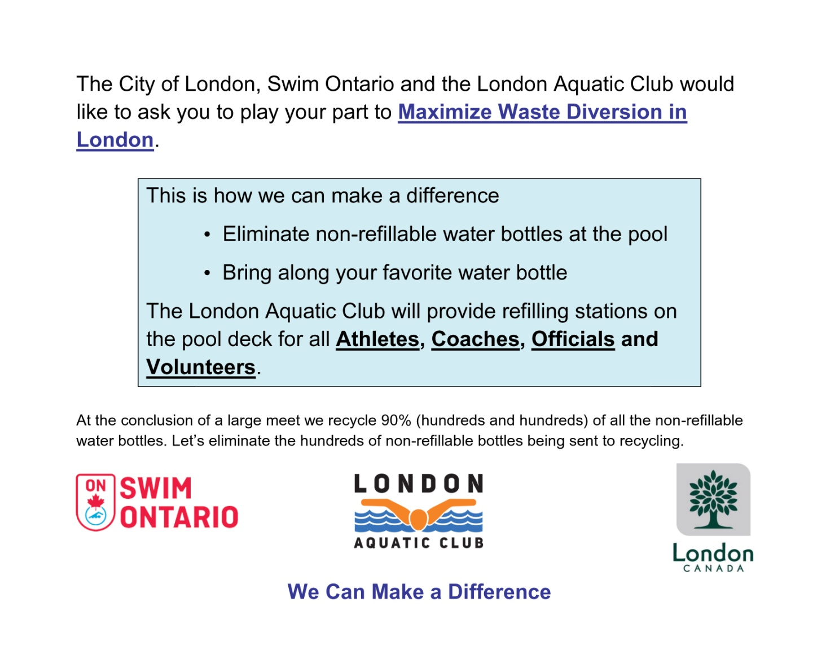

Appendix B

Thames Pool-Thames Park, London, Ontario
Layout for 2017 Dr. Paul Hauch Invitational
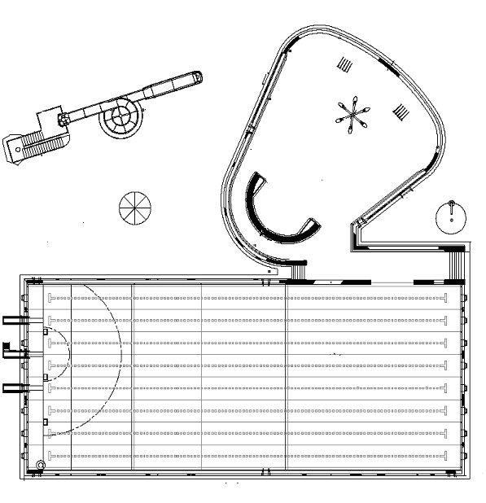
Officials Room
Marshalling Area
Starting Blocks
Starter
Change Rooms/ Pool Deck Entrances
Water Slide – open select times Fri., Sat. & Sun.
Spectator Seating
Coaches’ Area
Team Area
Wading Pool/Splash Pad – open during entire meet

Appendix C

Map of the City of London, Ontario
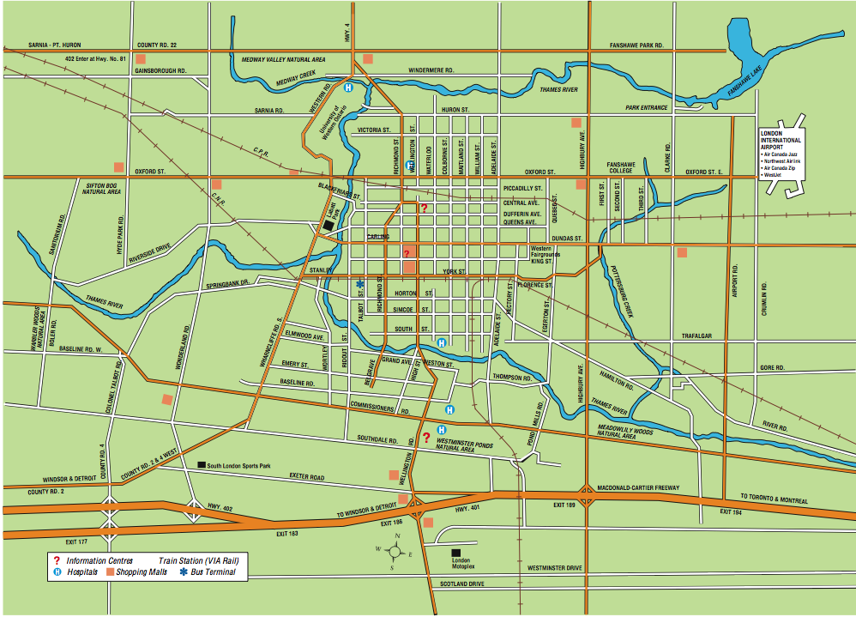

Thames Pool Public Parking

Thames Pool – Southwest Corner of Ridout and Horton Streets (Enter from Ridout, south of the Bridge) London, Ontario.

Limited parking is available on the lawn surrounding the pool but priority will be given to meet management, coaches, and officials for this space. Please be considerate of others and provide ample room to get people and cars in and out. There is a large city owned parking lot with reasonable daily rates at the Northwest Corner of Ridout and Horton Streets and free on-street parking can be found in the area.

There are no lockers at Thames Pool. There is a children’s splash pool area that will be open for the use of family members throughout the meet and there is a water slide that will be open at certain times during the meet.

Aerial Map:

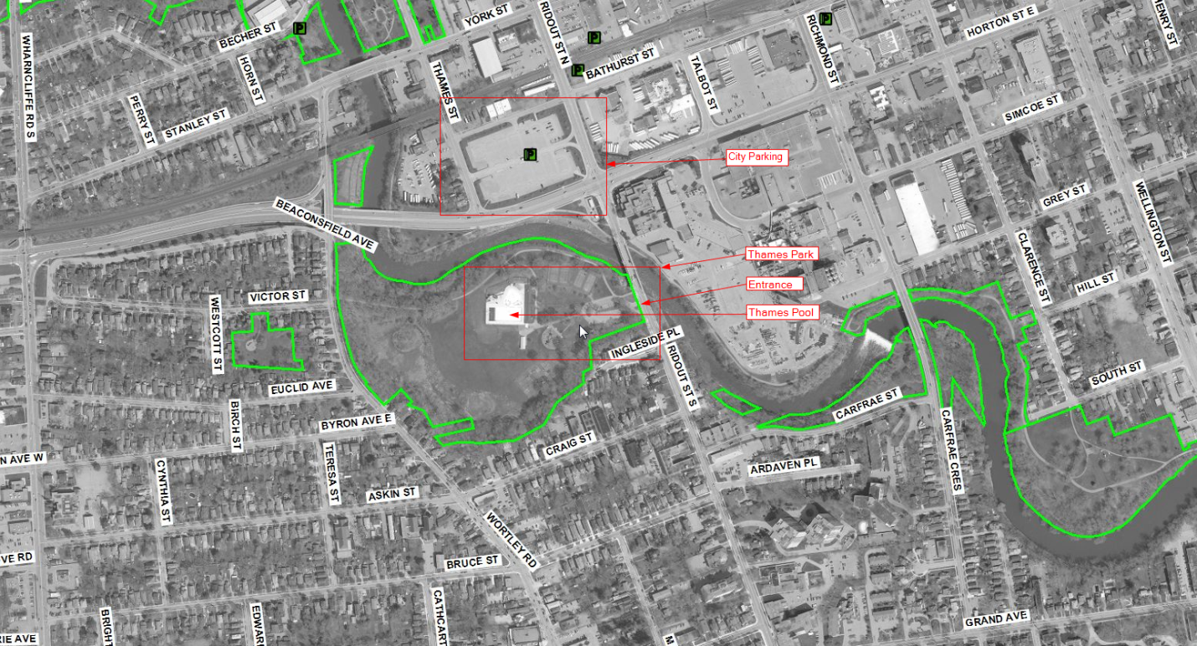

Appendix D

Event List

Session 1 - 12 & Under
Maximum 4 individual events
Friday Afternoon, July 14th, 2017
Timed Final
Warm-up ⇒ 1:00 p.m. Start ⇒ 1:45 p.m. Finish ⇒ 3:15 p.m.
Event # |  | Event |  | Event #
Girls |  |  |  | Boys
1 |  | 50 Butterfly |  | 2
3 |  | 50 Backstroke |  | 4
5 |  | 50 Breaststroke |  | 6
7 |  | 50 Freestyle |  | 8

Session 2 - 13 & Over
Maximum 4 individual events
Friday Late Afternoon, July 14th, 2017
Timed Final
Warm-up ⇒ 3:30 p.m. Start ⇒ 4:15 p.m. Finish ⇒ 6:30 p.m.
Event # |  | Event |  | Event #
Women |  |  |  | Men
9 |  | 50 Butterfly |  | 10
11 |  | 50 Backstroke |  | 12
13 |  | 50 Breaststroke |  | 14
15 |  | 50 Freestyle |  | 16

Session 3 – 12 & Under
Maximum 3 individual events
Saturday Morning, July 15th, 2017
Timed Final
Warm-up ⇒ 8:00 a.m. Start ⇒ 9:00 a.m. Finish ⇒ 1:00 p.m.
Event # | Age | Event | Age | Event #
Girls | Exceptions |  | Exceptions | Boys
17 | 11 & Over | 200 Butterfly | 11 & Over | 18
19 |  | 100 Backstroke |  | 20
21 |  | 200 Breaststroke |  | 22
23 |  | 100 Freestyle |  | 24
25 |  | 200 I.M. |  | 26
201 | 10 & Under | 4 x 50 Medley Relay | 10 & Under | 202
203 | 11-12 | 4 x 50 Medley Relay | 11-12 | 204

Session 4 – 13 & Over
Maximum 3 individual events
Saturday Afternoon, July 15th, 2017
Timed Final
Warm-up ⇒ 1:00 p.m. Start ⇒ 2:00 p.m. Finish ⇒ 6:00 p.m.
Event # | Age | Event | Age | Event #
Women | Exceptions |  | Exceptions | Men
27 |  | 200 Butterfly |  | 28
29 |  | 100 Backstroke |  | 30
31 |  | 200 Breaststroke |  | 32
33 |  | 100 Freestyle |  | 34
35 |  | 200 I.M. |  | 36
205 | 13-14 | 4 x 50 Medley Relay | 13-14 | 206
207 | 15 & Over | 4 x 50 Medley Relay | 15 & Over | 208

Session 5 – 12 & Under
Maximum 3 individual events
Sunday Morning, July 16th, 2017
Timed Final
Warm-up ⇒ 8:00 a.m. Start ⇒ 9:00 a.m. Finish ⇒ 1:00 p.m.
Event # | Age | Event | Age | Event #
Girls | Exceptions |  | Exceptions | Boys
37 |  | 200 Freestyle |  | 38
39 |  | 100 Breaststroke |  | 40
41 |  | 200 Backstroke |  | 42
43 |  | 100 Butterfly |  | 44
209 | 10 & Under | 4 x 50 Freestyle Relay | 10 & Under | 210
211 | 11-12 | 4 x 50 Freestyle Relay | 11-12 | 212

Session 6 – 13 & Over
Maximum 3 individual events
Sunday Afternoon, July 16th, 2017
Timed Final
Warm-up ⇒ 1:00 p.m. Start ⇒ 2:00 p.m. Finish ⇒ 6:00 p.m.
Event # | Age | Event | Age | Event #
Women | Exceptions |  | Exceptions | Men
45 |  | 200 Freestyle |  | 46
47 |  | 100 Breaststroke |  | 48
49 |  | 200 Backstroke |  | 50
51 |  | 100 Butterfly |  | 52
213 | 13-14 | 4 x 50 Freestyle Relay | 13-14 | 214
215 | 15 & Over | 4 x 50 Freestyle Relay | 15 & Over | 216

