Notification of Changes to 34th Annual Dr. Paul Hauch Invitational

Thank you for your support of our annual outdoor fun meet! We are pleased to have received more entries than expected and to allow everyone to participate; we have had to make some changes to the schedule. Please note the following:

Friday session will start at 2:30 p.m.
Warm-up will be 2-30 minute warm-ups with 12 & under swimmers warming up from 1:30 p.m. - 2:00 p.m. and 13 and over swimmers warming up from 2:00 p.m. - 2:30 p.m. Team will be assigned lanes for warm-ups.
Our fun relays will be held at the end of this session around 5:15 p.m. If any of the parents/coaches/swimmers wish to submit a team, please obtain a relay card from the office and have it returned by 4:00 p.m.

Saturday morning session will start at 8:30 a.m., as scheduled.
Saturday afternoon session will start at 1:00 p.m. with a warm-up at 12:15 p.m. Estimated finish time is 4:30 p.m.

Sunday session will start at 9:00 a.m.
Warm-up will be 2-30 minute warm-ups with 12 & under swimmers warming up from 8:00 a.m. - 8:30 a.m. and 13 and over swimmers warming up from 8:30 a.m. - 9:00 a.m. Team will be assigned lanes for warm-ups.
A 15-minute break may be introduced after Event 34 – 200 Backstroke. Estimated finish time is 2:30 p.m.

Here are some extras to make our meet FUN!

All swimmers and coaches will receive a ticket for a BBQ to be held following each session on Saturday (approximately 11:00 a.m. to 1:30 p.m. for morning session swimmers and approximately 3:30 p.m. to 5:00 p.m. for afternoon session swimmers.) Spectators may purchase tickets for $5.00.

Marble Slab Creamery will be selling Ice Cream on Friday from 3:00 p.m. and Saturday from 10:30 a.m. Watch for their ad in the Meet Program for details.

Domino’s Pizza will be on site on Sunday from 10:30 a.m. Watch for their ad in the Meet Program for details.

Team Aquatic Supply will be on site on Friday and Saturday of the meet.

The “big red slide” will be open each day at select times during the meet. The “beach” area will be open at all times during the meet.

Please be advised that thunder and/or lightning may cause delays to the meet. It is at the lifeguard’s discretion to clear the pool and advise when a restart may occur.

Map of the City of London, Ontario – not to scale, for reference only
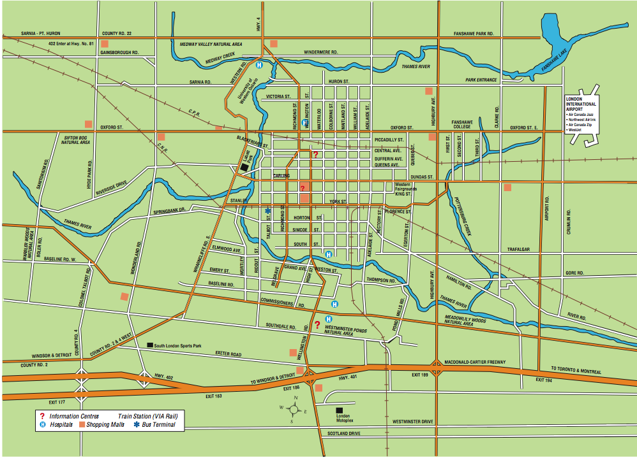

Thames Pool – entrance is just south of the intersection of Ridout and Horton Streets

Limited parking is available on the lawn surrounding the pool. Please be considerate of others and provide ample ingress and egress.

There are no lockers at Thames Pool. There is a children’s splash pool area that will be open for the use of family members.

Please note that Horton Street from Richmond Street (just east of Thames Pool) to Wellington Road is under construction. Travelers going to and from hotels located on Wellington Road might consider using Commissioners Road East and Ridout Streets or York Street, just north of Horton Street.

