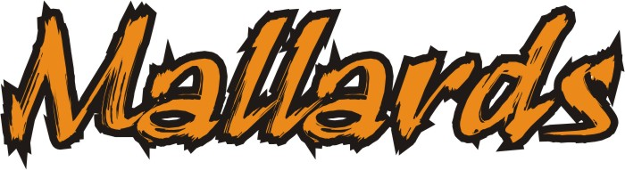

OFFICIALS SHIRT ORDER FROM
Deadline: October 21, 2016 to Receive at ABI meet

Parent’s Name: ________________________________________________
(Last Name) (First Name)
Name of Swimmer(s): ___________________________________________
Group(s): Starlet Avalanche Waterspout
Typhoon Tsunami Tornado Hurricane

MENS ($20.00) | QTY | LADIES ($20.00) | QTY
S |  | XS
M |  | S
L |  | M
XL |  | L

Price include all taxes and Team logo embroidery
Please indicate color White or Red next to QTY

Total Qty: ______ x $20.00
Total Qty: ______ x $20.00
Total Due: $_____________
Payment Received by: _________________

