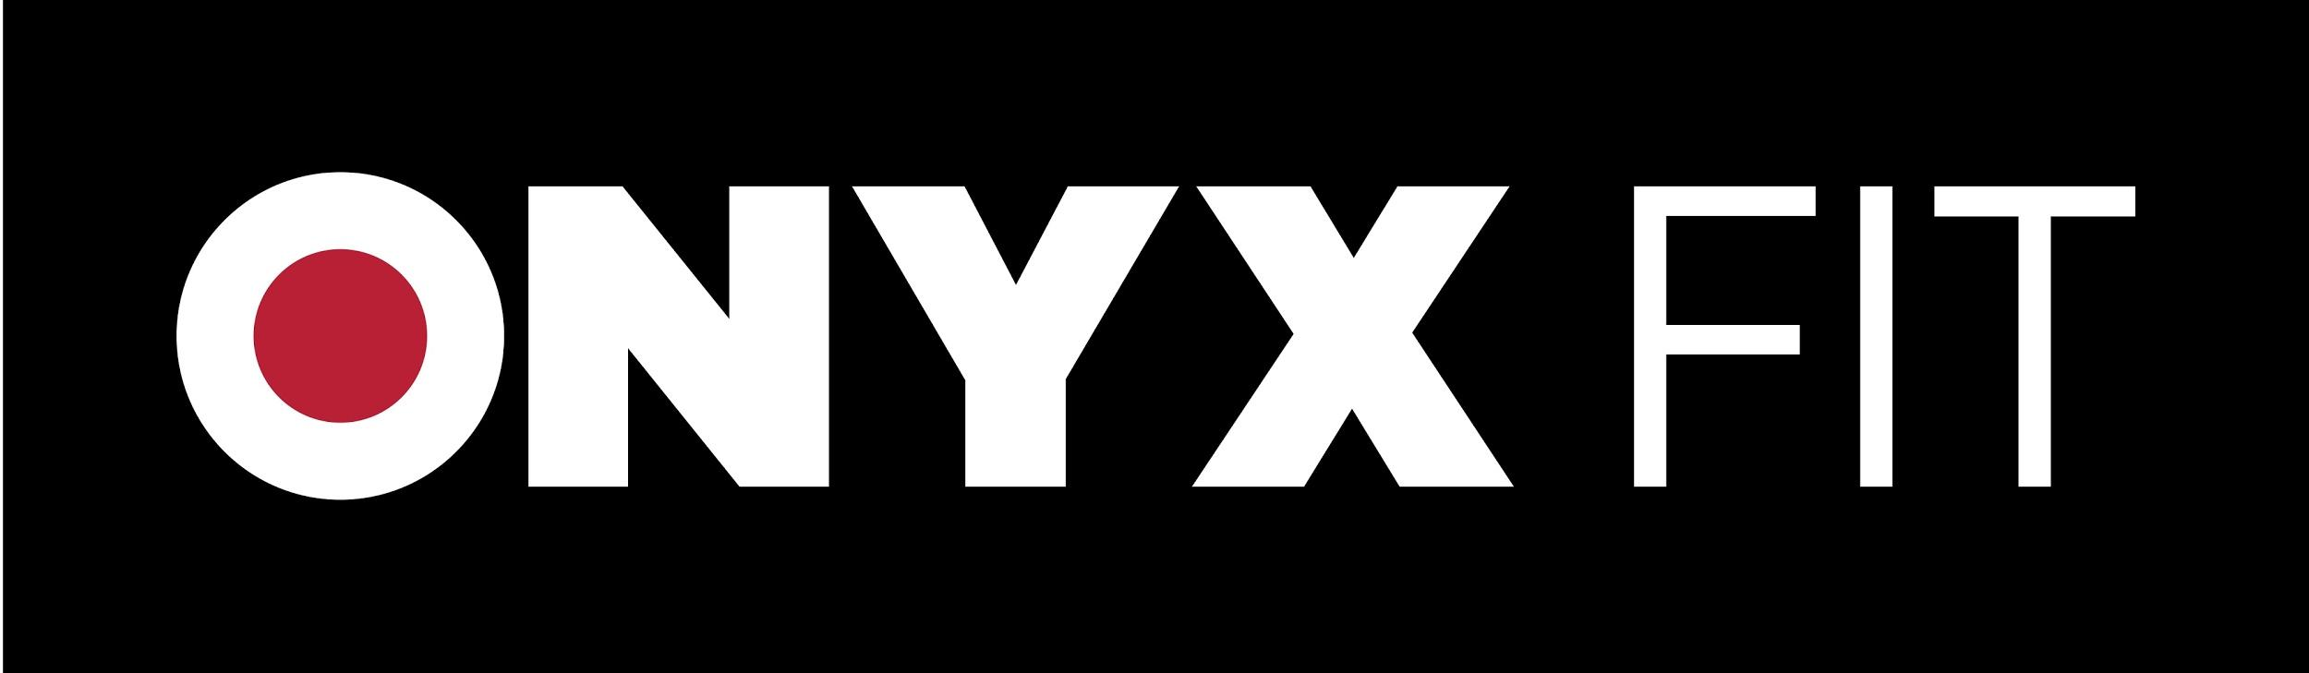
WAIVER & RELEASE OF LIABILITY (For Minors)

I, ______________________________, have volunteered to participate in a program of
(Child’s Name) physical exercise under the direction of ONYX Fit
which will include, but may not be limited to, weight (resistance) training, movement, flexibility and other assorted exercise skills and drills. In consideration of ONYX Fit’s agreement to instruct, assist, and train _________________________ I agree not to hold ONYX Fit
(Child’s Name)
liable, and do here and forever release and discharge and hereby hold harmless ONYX Fit’s respective contractors, and employees from any and all claims, demands, damages, rights of action or causes of action, present or future, arising out of or connected with my participation in this or any exercise program including any injuries resulting there from.
________ (Parent or Guardian Initials)

ASSUMPTION OF RISK
I, ______________________________, recognize that exercise might be difficult and strenuous
(Child’s Name) and that there could be dangers inherent in exercise for
some individuals. I acknowledge that the possibility of certain unusual physical changes during exercise does exist. These changes include, but are not limited to, abnormal blood pressure, fainting, disorders in heartbeat, heart attack, and in extremely rare instances, death. __________ (Parent or Guardian Initials)
Although, the trainer will take precautions to ensure safety, I expressly assume and accept sole responsibility for my safety. ___________ (Parent or Guardian Initials)
I recognize that an examination by a physician should be obtained by all participants prior to involvement in any exercise program. If I have chosen not to obtain a physician's permission prior to beginning this exercise program with ONYX Fit, I hereby agree that I am doing so at my own risk. __________ (Parent or Guardian Initials)
In all cases, circumstances, situations, events and locations, I acknowledge and agree that I assume the risks associated with any and all activities and/or exercises in which my child participates.__________ (Parent or Guardian Initials)

I acknowledge and agree that no warranties or representations have been made to me or my child regarding the results I will achieve from this program. I understand that results are individual and may vary.

Parent or Guardian’s Signature __________________________________________
Print Name (Parent or Guardian)__________________________________________
Email Address __________________________________________
Today’s Date (Month/Day/Year)__________________________________________
Emergency Phone________________________________
Participant’s Age_____________

