Mount Pearl Marlins
Little Caesars - Future League Series 1 Invitational

November 23- 24th 2019
Mount Pearl Summit Center
126 Smallwood Drive, Mount Pearl, NL

GENERAL INFORMATION
Dates: 23nd -24th November 2019
Location: Mount Pearl Summit Center
126 Smallwood Drive, Mount Pearl, NL

Spectator Admission: No charge.
Pool: 8 lanes 25 meters plus two 25 meter lanes for additional warm up and cool down throughout the meet.
Coordinating Referee: Eric Rose
Sanction: Swimming Newfoundland and Labrador
Meet Management: marlinsmeetmanagement@gmail.com

Mark Pelley (Meet Manager)
mark.thomas.pelley@gmail.com
(709) 769-1576

Officials Coordinator: Lisa Sheppard
chairofofficialsmarlins@gmail.com

Important Dates: Oct 15th 2019 0001 NST Entry acceptance
Oct TBD 2019 2100 NST Clothing order deadline
Nov 8th 2019 2100 NST Entry deadline
Nov 12th 2019 2100 NST Coaches Entry review notification
(72 hours to respond)
Nov 17th 2019 2100 NST Psych Sheet posted
Nov 21st, 2019 2359 NST Age-up date
Nov 22nd, 2019 1700 NST Coaches meeting
Nov 23nd 2019 1330 NST Meet start

MEET INFORMATION

Rules:

- Swim Canada rules will govern the meet. Swim Canada Warm-Up safety procedures will be in effect. FINA One-Start Rule (False Start DQ) in effect.

Description:

- Swim Newfoundland and Labrador sanctions the meet as an open invitational;
- This meet includes 2 sessions: timed distance finals on Saturday and Sunday;
- All events will be timed finals, mixed gender, ages 12 years old & under, and seeded fastest to slowest;
- Backstroke starting wedges will be in use;

Warmups:

- SWIMMING CANADA WARM-UP COMPETITION SAFETY PROCEDURES WILL BE IN EFFECT AT THIS MEET;
- Sprint lanes will be available for the last 20 minutes of warm-ups. Lanes 1, 2 and 8 will be used for Sprinting and are designated as diving lanes with one way traffic only. Lane 7 will be designated pace;
- Backstroke starting wedge(s) will available in Lanes 1 and 8;
- The two lanes of the leisure pool may be used by the swimmers 11 & younger or swimmers who are not comfortable in the main pool. The Leisure pool will also be used for open warmup and cool down during competition;
- Swim Canada Warm-up procedures will be posted during the meet; and
- A failure of a swimmer to promptly leave the pool when directed or when the end-of-warmup is announced will result in the swimmer being scratched from the meet including relays (relay substitutions will not be permitted).
Officials:
- Official Signup sheets can be found in the official room (multiple purpose room) on the second floor of the Summit Centre at the beginning of each session;
- Teams are encouraged to support each session. With an 8-lane pool, there is an increased demand for on-deck officials and the Marlins kindly thank all volunteers in advance;
- There will be an officials meeting held 30 minutes prior to the start of each session;
- Officials are to be in position 5 minutes prior to the start of the session; and
- Food and refreshments will be provided to coaches and officials prior to and during each session. This food is uncontrolled with respect to allergies and dietary needs.

Coaches:

- There will a coaches meeting held at 1700 NST, 22nd November 2019, on the second floor of The Summit Centre. Each team shall send a representative;
- All Coaches must be in good standing with their respective provincial bodies;
- Coaches must submit contact information plus email address where they can receive messages from meet management. Please email this information when submitting entries; and
- Coaches requesting information on a DQ must speak to the Referee.

On Deck Access:

- Only participating swimmers and registered coaches plus officials are permitted on deck; and
- Meet Management and Referees reserve the right to request a coach to produce coaching credentials. Failure to produce credentials may result in the coach being asked to leave the pool deck.
Photography and video:
- With the exception of coaching video, only meet management sanctioned photography and video recordings are permitted on deck.

ENTRIES & SCRATCHES

Meet Management Conditions:

- Meet Management reserves the right to limit, or exclude entries, in any event or session to maintain facility session times;
- Meet Management reserves the right to modify session times and event order as necessary to accommodate meet requirements and will notify coaches whenever possible; and
- Meet Management reserves the right to combine heats and events when numbers warrant.

Qualifying Standard:

- All Swimmers ages 12 & under who meet both of the Swim NL AA Standards cannot enter this meet.

Eligibility:

- All athletes must be registered as Competitive Swimmers with Swim Canada, or any other amateur swimming organization recognized by FINA; and
- A valid SNC registration number is required for all Canadian swimmers, and entries without a Swim Canada registration number will be declined entry.

Entries:

- Swimmers may enter up to six individual events plus relays;
- Swimmers are restricted to entering no more than three individual events per session;
- Teams are encouraged to submit entries early due to anticipated numbers.;
- Online entries will be accepted via SNC online system only. Limited email entries may be accepted at the discretion of meet management;
- Entry acceptance begins 0001, 15th October 2019;
- Entry deadline is 2100 NST, 8th November 2019. Swimmers entered in less than 6 events will be may not permitted to add events past this deadline;
- All entry times must be provable (time auditing will occur). Invalid times will result in the entry rejection without substitution;
- The entry fee and late entry fee may be applied to any swimmer wishing to swim after entry deadline. All swims will be exhibition;
- All entries will be processed after the entry deadline; and
- Teams will have the opportunity review club entries.

Para-Swimmers
- Para-swimmers must be classified as per Swim Canada with theirs names reflecting their classification.
- Para-swimmers will swim in able-body events.
Out-of-Province Entries:
- Mount Pearl Marlins encourages out-of-province entries.
- Out of province teams will be served on a first come first serve basis.
- Swim NL swimmers will be given priority. Meet Management will make every reasonable effort to accommodate out-of-province swimmers.
Foreign Entries:
- Foreign Swimmers are permitted; and
- Swim NL swimmers will be given priority. Meet Management will make every reasonable effort to accommodate foreign swimmers.

Charges and fees:
- $40.00 flat fee per swimmer. Cheques or e-transfer only please; (No cash accepted);
- Please make cheques payable to: Mount Pearl Marlins Swim Team; e-transfer: marlinstreasurer2016@gmail.com (use password ‘MPMswimming’);
- The amount of fees due are based on the entries confirmed on 2359 17th November 2019. Fees are due at the start coaches meeting before the start of the first (Thursday) session;
- Meet management reserves the right to charge a $100.00 for all late entries or to refuse late entries;
- **Meet management reserves the right to charge $5.00 per occurrence for each of the following:
  - A prohibited entry;
  - An invalid entry time, or
  - A swimmer with greater than six individual events;

Psych Sheet:
- The psych sheet will be emailed to coaches no later than 2100, 17th November 2019.

Deck Entries (C.S.W 3.6.5):

- There will be no deck entries.

Scratches (C.S.W 3.6.1):
- There are no penalties for late scratches or no-shows;
- Meet management may not accommodate swimmers who no-show;
- Meet Management may not accommodate requests to move a swimmer to another open lane, and
- An accommodation is at the sole desertion of meet management and are not tied to precedents.

RESULTS/SCORING & AWARDS
Results:
- Results will be posted on the deck and outside the multi-purpose room throughout the session.
- Results will be uploaded to Meet Mobile after the conclusion of the session.
- If the results fail to upload, a copy will be posted on the Mount Pearl Marlins website.
Scoring:
- There will be no scoring.

Individual Events Ribbons
- Certificates

Prizes and certificates:
- There will be a personal best (PB) time draw box on deck at the meet manager desk for all sessions. Each PB allows one entry for the draw. A prize draw will be done during each AM session; and
- There will prizes for winning a heat in which music is played. The prize can be claimed at the scorer’s table.
Award Presentation:
- There will be no awards ceremony. Coaches will receive certificates at end of meet or via mail.

SESSION INFORMATION

Session | Saturday | Sunday
PM | 1300 – warm-up | 1300 – warm-up
 | 1330 – Start | 1330 – Start
 | 1530 – session End | 1530 – session End
- Warm-up ends 5 minutes before start of session. Swimmers are expected to have vacated the pool by this time. Session lengths are approximate.

SESSION | Saturday | Sunday
PM | Session #1  - 100 Back  - 50 Free  - 50 Breast  - 100 IM  - 200 Free  - 200 Free Relay Boys | Session #2  - 50 Back  - 100 Free  - 50 Fly  - 100 Breast  - 200 IM  - 200 Free Relay Girls

VISITOR INFORMATION

The Summit Centre:
To check out our fabulous facility, follow the link and select “Summit Centre (Fitness and Swimming pools)”.
http://www.mountpearl.ca/recreation/rec-facilities/
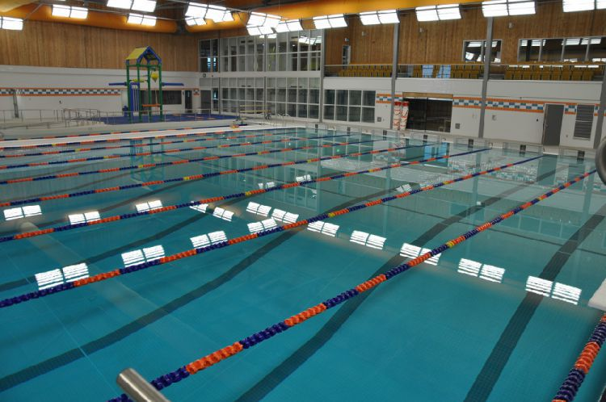
Viewing Balcony
- All spectators must watch from the pool viewing balcony

Parking, vehicles and Accommodations:
- Parking is available on site.
Hotel
TBD
Swim Supplies:
- A swim supply vender will be onsite throughout the meet.
Merchandise:

Meet Programs
- Meet programs will be for sale for $2.00 each on the second floor. There will be no online heat sheets.
Meet clothing

Photographs:
TBD
Concessions:
TBD

ACKNOWLEDEGEMENTS

We would like to extend our gratitude in advance to all the volunteers and officials who will assist in making this meet an awesome experience!!!

See You Soon!!
