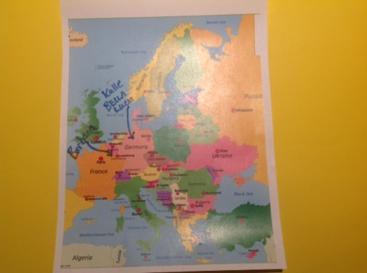 Tour de NCA FAQ’s
Q: Why do the Tour?
A: To bring an awareness to how active we can be on a daily basis even if it is in just small increments.
Q: Who can join the Tour?
A: Any swimmer can join.
Q: What if I didn’t start at the beginning of the Tour?
A: Any swimmer can join any time.
Q: If I started late, can I still win a jersey?
A: Yes. If you accumulate the most fitness points in any given week, you win the yellow jersey.
Q: How do I log my points?
A: Just keep a day to day record. It doesn’t need to be on the spread sheet.
Q: What if I just do an exercise for 15 min? Does it still count?
A: Yes. Points are accumulated by ½ hour but if you do 2 half hour walks, then you add these together.
Q: Does everyone who completes the Tour win a Tour tee shirt?
A: Yes
Q: How do I win a hoodie?
A: A swimmer has to accumulate the most overall points in their group to win a Tour hoodie.
Q: When do I send in my points?
A: Send your points in every Sunday evening to:
nickelcityaquatics@gmail.com
Q: What if I do an activity that is not on the list?
A: Just email Coach Linda with your activity to have it added.

