Activation Exercises

There are many reasons to complete activation exercises before you hop in the pool. Activation exercises train your body and brain - the exercises serve as a warm up for the muscles you use most, and get your mind ready to focus on the workout to come. Additionally, activation exercises are shown to prevent injury, build strength, increase range of motion and address muscular imbalances.

Quality activation practice doesn’t have to be complex, can have huge benefits to swimmers and is reasonably simple to introduce once you look beyond the perceived barriers. All that is required is a little open mindedness, combined with a willingness to adapt.

Three main phases – RAISE & MOBILIZE, ACTIVATE and PRIME. Within the ACTIVATE phase, we have three main areas which independently address the essential key components required within swimming – shoulder stability (incorporating push-pull integrity), trunk alignment & control and lower body muscle engagement (particularly backline muscle tissue).

Activation practice is about preparing the body’s systems for optimum task completion, by stimulating and initiating key physical responses in the body. Good activation practice will also often have the huge added value of promoting mental readiness & mental focus.

Activation exercises should be done before every practice, and take between 10-15 minutes to complete. They should include exercises that engage the whole body and are specific to swimming. Below are some sample exercises you can include in your activation program.

If you need help developing an activation program please contact Amber Baird our Sport Physiotherapist at amberjbaird5@gmail.com.

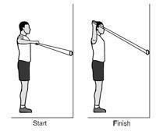
Shoulder External Rotation
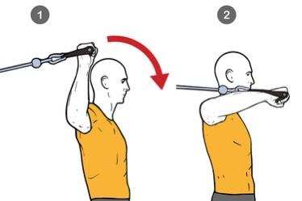

Shoulder Internal Rotation
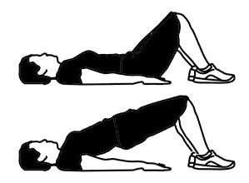

Glute Bridge
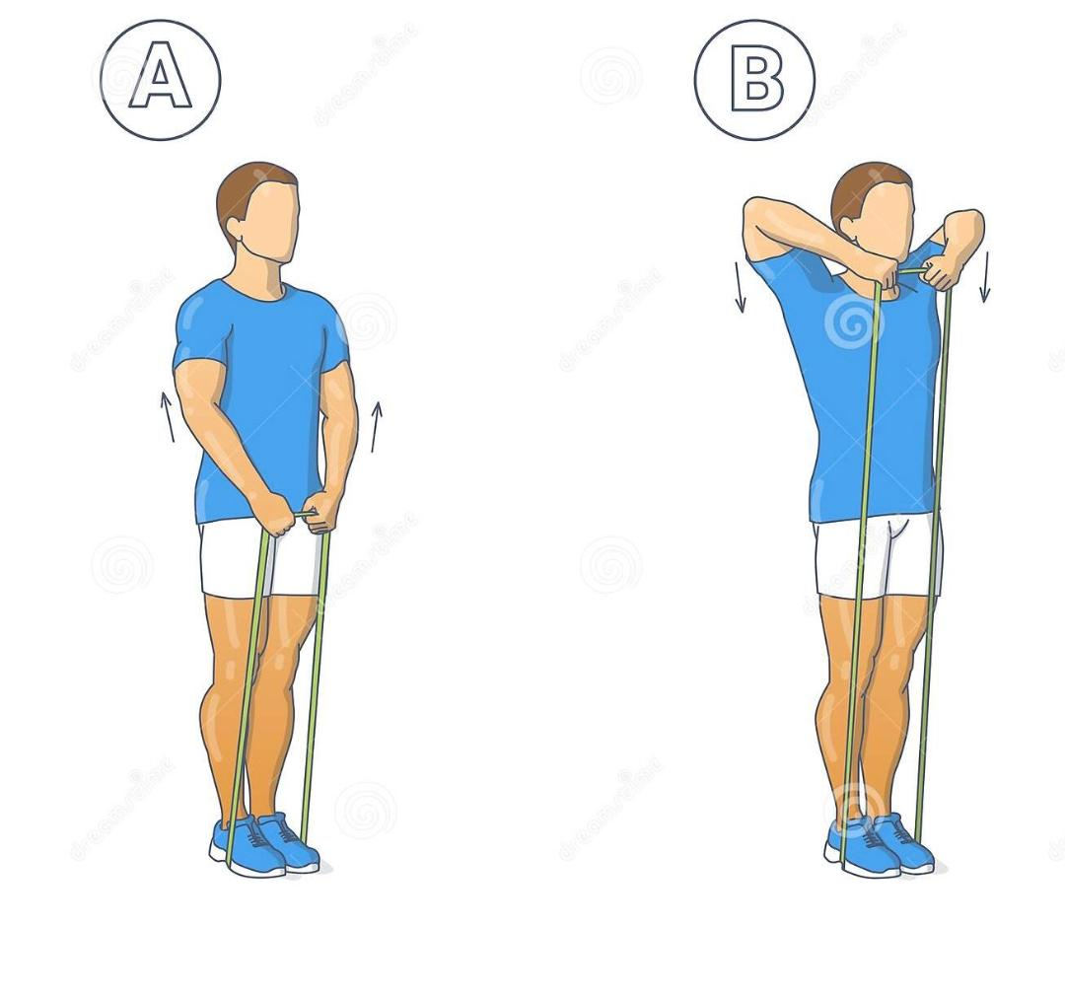

Upright Row
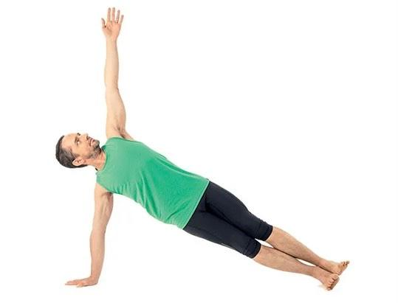

Side Plank

