THE SWIMMER'S HANDBOOK

2022

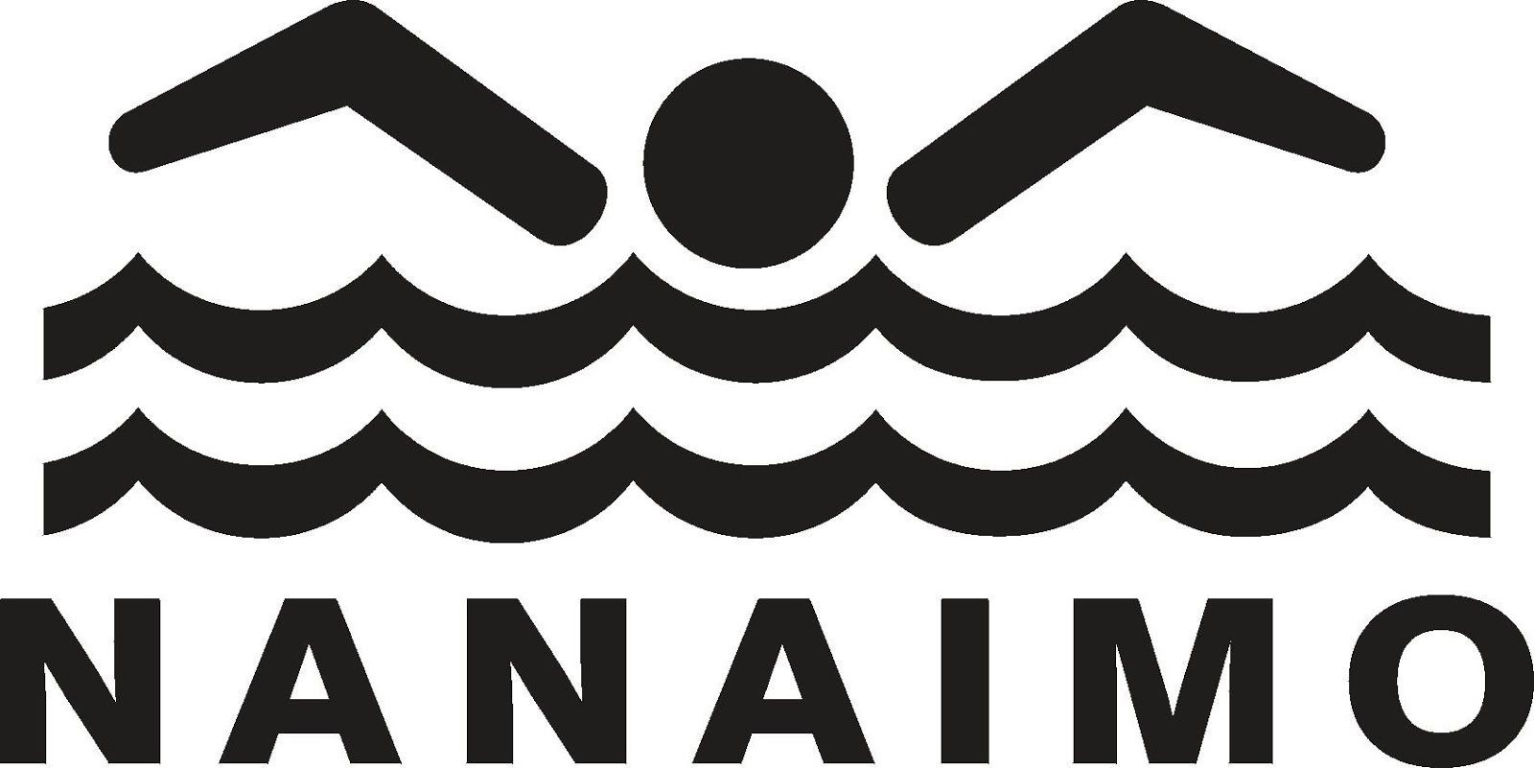

Nanaimo White Rapids Swim Club
Established 1966

This book belongs to:

The Nanaimo White Rapids Swim Club gratefully acknowledges the support and financial assistance of the Province of British Columbia.

2021 Best Times

 | 2021 Best: | 2022 Goal:
I.M.
50 Free
50 Fly
100 Fly
Back
Breast
100 Free

2021 Mile Swim time:

Goals for the 2022 season:

2022 Swim Meet Schedule

May 28 | Blue & White Meet | Kin Pool
June 4-5 | Cowichan Icebreaker | Cowichan Aquatic Center
June 11-12 | Oak Bay Invitational | Commonwealth
June 18-19 | Courtenay | Memorial Pool
July 1-3 | Nanaimo | Kin Pool
July 9-10 | Campbell River | Centennial Pool
July 11-15 | Hell Week | Various
July 16-17 | Sidney | Commonwealth
July 23-24 | Salt Spring | Rainbow Rd. Pool
Aug 5-7 | Regionals - Victoria | Commonwealth
Aug 16-19 | Provincials - Kamloops | Canada Games Aquatic

Vancouver Island Region Summer Swim Clubs

Campbell River Salmon Kings (CAM) Courtenay Blue Devils (COU) Cowichan Valley Breakers (CVB) Gordon Head Gee Gees (GHG)
Juan de Fuca Royals (JUA) Nanaimo White Rapids (NAN) Oak Bay Orcas (OAK)
Pender Island Otters (PIO) Powell River Aquatic Club (POW) Salt Spring Stingrays (SSS) Sidney Piranhas (SID)

Mission Statement
The Nanaimo White Rapids Swim Club provides coaching and organizational support for both recreational and competitive swimming and water polo. This family-centered youth swim club fosters social and skill development focusing on each athlete's personal best, in a safe and fun community-based program.

History
The White Rapids have been in existence since 1966, swimming out of the Kin Pool in beautiful Bowen Park. Swimming in the British Columbia Summer Swimming Association (BCSSA), the White Rapids have a rich tradition dating back decades and a culture that is unparalleled. The club prides itself on its family feeling and focus on each swimmer’s personal improvement. This is the club’s 56th summer of operation and it is shaping up to be an exciting one. The Nanaimo White Rapids Swim Club operates Kin Pool in a co-management arrangement with the City of Nanaimo.

2022 White Rapids Board of Directors
Kate Palmer – President
Laurel Laturnus – Past President
Chris Boulding – Vice President
Gabrielle Kosmider - Secretary
Mark Duffell– Registrar
Mary Blackburn– Parent Liaison
Vacant– Treasurer
Carly Williams – Volunteer Coordinator
Renay Deschambault – Director
Mike Goerzen – Director
Sarah Segal – Director
Nadia Elzinga - Director

2022 White Rapids Coaches

Finn Bodnar – Head Coach
Ava Johnson – Assistant Head Coach
Sophie Peer – Senior Coach
Nyah DePol – Senior Coach
Emily Metituk – Senior Coach
Cam Laturnus – Intermediate Coach
Isabelle Parsons – Intermediate Coach
Jack Mace – Junior Coach
Aia Segal – Junior Coach

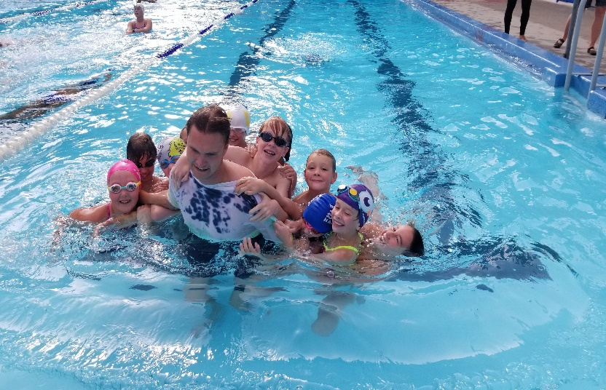

Follow us on Twitter @NWRSC Follow us on Instagram @NWRSC Like us on Facebook @NWRSC

#WhiteRapidsFast #SummerClubMagic

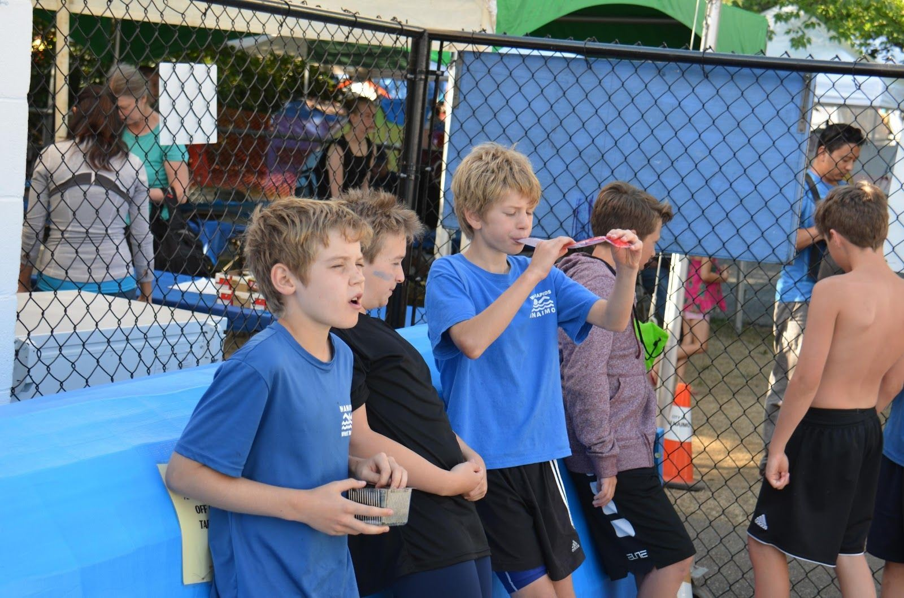

White Rapids Water Polo

The Olympic sport of water polo gives athletes a chance to experience the aquatic environment in a very different way than competitive swimming. It is a team-based sport that combines one’s physical toughness, hand-eye coordination, and ability to move through the water in unique ways.
Some describe it as a mix between sports like lacrosse, basketball, and hockey but played in the water. It is an opportunity to build characteristics you wouldn’t generally receive through swimming lengths such as teamwork, fair play, motor coordination, mental concentration, and the desire for peer-to-peer competition. For the White Rapids, it offers a great addition to regular scheduled practice times with huge benefits in terms of cross training for other team sports.

Drop-in water polo will be offered on both the May/June schedule as well as the July/August schedule. There is no fee to participate and no need to register in advance.

White Rapids Artistic Swimming

Artistic Swimming is another opportunity for swimmers to experience a different aquatic sport. Artistic Swimming is both an individual and a team sport. Athletes will learn basic figures and will create short routines but combining different figures together and coordinate those moves to music. Artistic Swimming is often described as dancing in the water. This sport is one of the most fun to learn and most challenging to master! Athlete participants will develop a whole new set of skills in the water and although the skills are different from speed swimming, they are very complimentary.
Drop-in sessions of artistic swimming we will be offered in the second July/August schedule.

Meet Tip 1
Know Your Times & Set Goals

A goal without a plan is just a dream…

This handbook provides a way of tracking your goals and your accomplishments throughout the summer swim season. It's hard to improve unless you know what you want to achieve. Set goals and record your results.
- Be realistic and then challenge yourself a step beyond. Set specific goals. They do not have to be race times. They can also focus on turns, dives or improved stroke techniques, team spirit or more.
- Identify ways to achieve the goals and then record your goals and what you accomplished in your swimmer's handbook.

Blue and White Days

Blue and White Days bring the whole club together for team building and skills practice. Mixing swimmers of different ages and from different groups, athletes get to both mentor and learn from one another, while being exposed to coaching from the entire staff. Getting to know swimmers in the club, meeting new friends, learning from each other, and getting to work with different coaches are all benefits of Blue and White Days.

Blue and White Day #1: Wednesday, May 18th Blue and White Day #2: Wednesday, June 22nd
Blue and White Day #3: Wednesday, July 27th
(Specific practice times will be posted closer to the date. On these days, regular afternoon practices will be cancelled.)

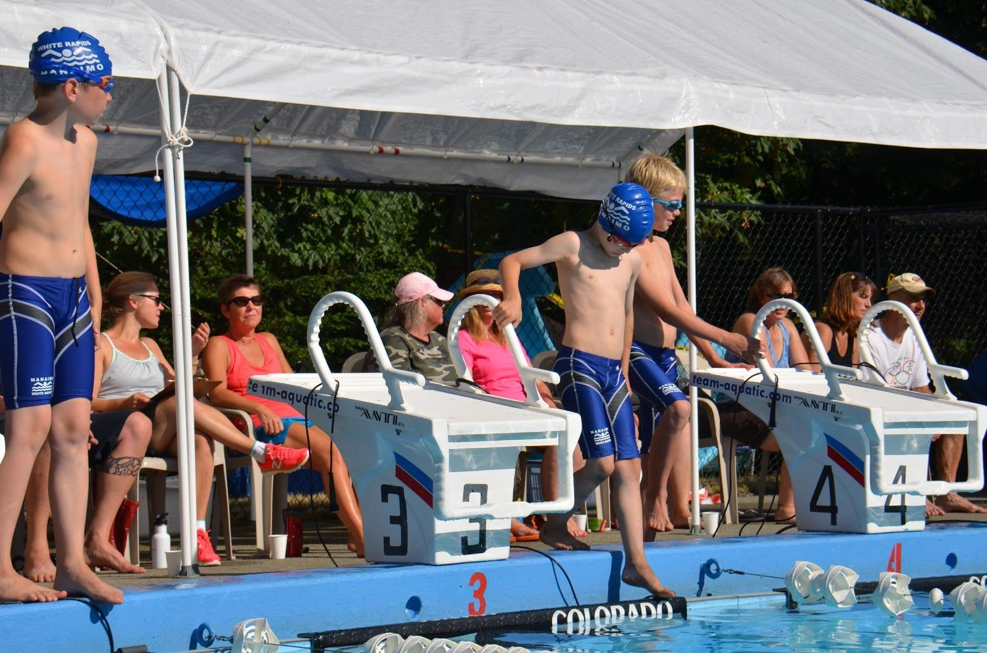

Meet Tip 2 Be Prepared

Swim meets are great fun, but you need to be organized and prepared for these all day events – indoors or outdoors
– rainy or sunny & hot!
- Know when to arrive for the morning warm-ups. Check the meet book on the bulletin board.
- Bring plenty of fluids to drink. Pack healthy food for a long day.
- Bring hot weather gear- sunscreen, hat, T-shirts. Bring cold weather or rainy day gear- warm clothes, sleeping bags, changes of warm clothing and extra towels.

Pack your goggles, team suit, and team shirt.

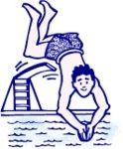

Blue & White Fun Meet May 28th
Bowen Park Kin Pool, Nanaimo

Sign Up Deadline: May 25th

 | Best: | Goal: | Finals:
50 Fly
50 Back
50 Breast
50 Free
100 IM
(Div 4+)
The Blue and White Meet is a chance for new swimmers to see how a swim meet works at a smaller scale before the meet season gets rolling.
IM Order: "Butter my back, my breast is free!" But … the Team Relay has to start in the water with back:
"Back, Breast, Fly, Free"
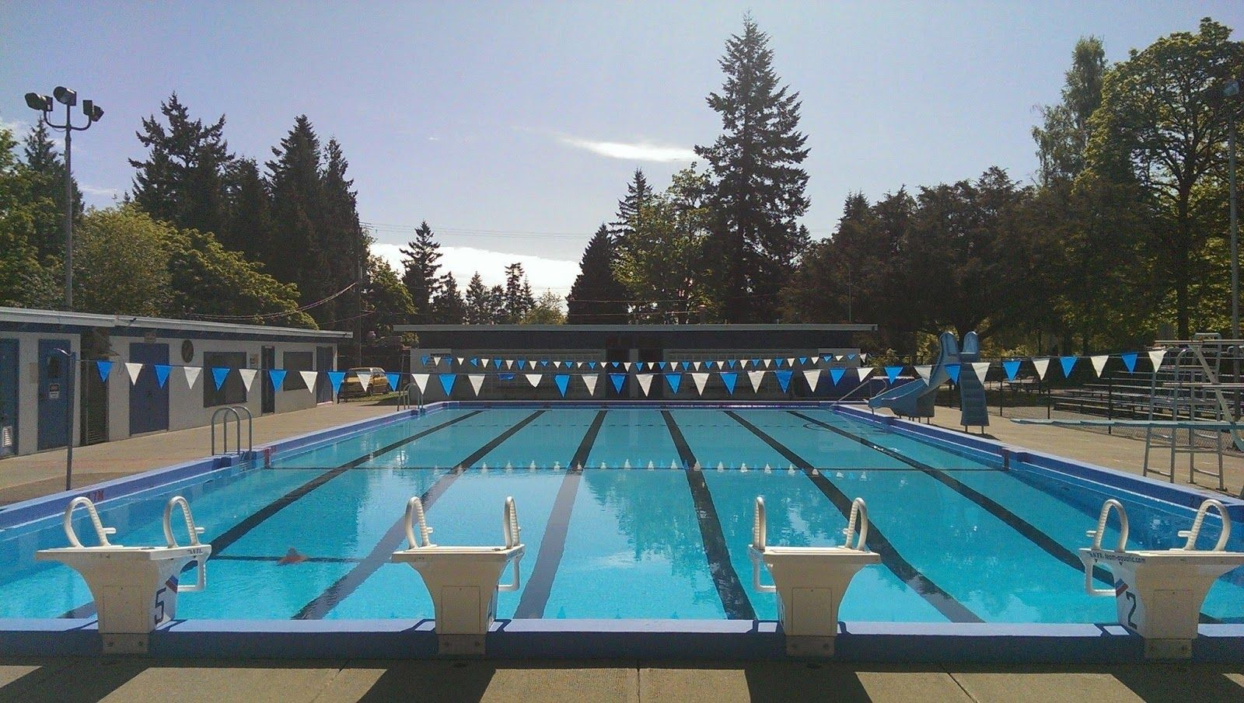

Meet Tip 3 Fuel your Body

Diet is very important to your performance. Here are some recommendations to get the most out of your meals.
- Make dinner the night before a meet a
high carbohydrate/low fat meal of rice or pasta. Fats and oils seriously impede the speed of digestion, slowing you down, so aim for lower fat foods.
- Have breakfast containing high-carb foods like bread, cereal and fruit to top up blood sugar levels. Eat breakfast before you get to the pool to ensure time for the fuel to work its way to your muscles.
- Large meals make you sluggish and lethargic. Small spaced out snacks work! Avoid 'fast-food' stops on your way home; the high-fat food will delay recovery and affect your ability to swim the following day.

Hydrate, Hydrate, Hydrate

- Pre-hydrate your body for three days before the competition. Drink extra water. Since muscle contains so much water, a slight degree of dehydration can greatly diminish muscle performance. Dried-up muscles become weak.

- Drink water, juice regularly throughout meet to replace fluids used during warm-up and races.
- Stick to fluid replacement when there is less than 45 minutes between your races.

Mile Swim
Bowen Park Kin Pool, Nanaimo Mile Swim # 1: June 2nd 3:30pm - 7:00pm Mile Swim #2: June 10th 6:00am - 8:00am Mile Swim #3: June 15th 3:30pm – 7:00pm

2021 Mile Swim Time:

2022 Mile Swim Goal:

2022 | Mile Swim #1 | Mile Swim #2 | Mile Swim #3
Time:

One mile:
1.6 kilometers … 1600 meters … 25 meter pool = 64 lengths … 32 x ‘50s’ … 16 x ‘100s’ … 4 x ‘400’s … No matter how you like to look at it … Just do it!

Triple Crown Award:
Any swimmer who completes the mile swim, within the allotted time, at each of the three mile swim sessions will be awarded the prestigious Triple Crown Award.

Meet Tip 4 Stay Focused

Once you get to the meet, here are some good suggestions to follow:
- Be on time! Find where the team is sitting and warming up. Locate the marshalling area and where the event numbers are posted.
- Find out where the team swim event grid and relay sheets are located. Note your swim event numbers and whether you are on a relay.
- Listen and watch for your event number and go to marshalling in plenty of time. If you're too late, you could lose the right to swim! While you are in marshalling "Imagine Your Race!"
- Talk to your coach before and after every race. Ask questions about your race. Coaches are there to help you swim your best. Please inform your coach if you must leave the meet early, especially if you are in a relay.

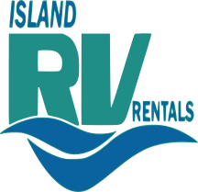

Cowichan Valley Icebreaker Meet June 2nd and 3rd
Cowichan Aquatic Center, Duncan

Sign Up Deadline: May 27th

 | Best: | Goal: | Finals:
I.M.
50 Free
50 Fly
100 Fly
Back
Breast
100 Free
Additional Meet Goals

Meet Tip 5 Success is in the details
Huge improvements are the results of small steps!
- Warm-up the body by stretching, and the mind by thinking before every swim.
- Remind yourself of what you are going to do well as you stand behind the blocks.
- Perform legal strokes and turns.
- Speed up into every turn; nail the finish.
- Streamline tightly off every dive and turn.
- Follow regular breathing patterns.
- Keep strokes long and smooth.
- Listen carefully to your coach and mentally rehearse the agreed upon strategy.
- Swim your own race and stick to your own strategy.

Oak Bay Invitational Meet June 11th and 12th Commonwealth Pool, Saanich

Sign Up Deadline: June 3rd

 | Best: | Goal: | Finals:
I.M.
50 Free
50 Fly
100 Fly
Back
Breast
100 Free
Additional Meet Goals

Meet Tip 6 Visualization & Self Talk

Mental preparation for each event is an essential key towards achieving your goals. Visualization of the event will help you channel all your energy, strength and skills into executing your best race. Visualization requires practice and perseverance. Although it does not replace practicing, imagining your race will certainly improve your swimming performance.
- Find a quiet place where others won't disturb you.
- Take a few slow breaths to calm yourself.
- Imagine yourself standing behind the blocks.
- See the pool, hear the cheers, feel the humid air, see the other swimmers.
- Hear the call to the blocks.
- You listen for the start. You hear the buzzer and dive.
- Imagine your swim, fast and clean. Feel the turn and the finish. See the board display your goal time.
- Visualize the entire race. Keep imagining the race until it is part of you. You are ready to race!

Courtenay Blue Devils Invitational Meet June 18th and 19th
Memorial Outdoor Pool, Courtenay

Sign Up Deadline: June 10th

 | Best | Goal | Heats | Finals
50 Free
100 Free
Back
Breast
50 Fly
100 Fly
I.M.

Additional Meet Goals

Meet Tip 7
Eat the Right Snacks

What you put into your body affects how you swim!!!

Here are some recommended snacks when you are between events with breaks of 1 to 2 hours.
- Fruits, bananas, energy bars
- Plain rolls, pitas, raisin bread
- Homemade low-fat muffins, jam or honey sandwiches
- Rice-cakes or plain crackers with honey, jam, or banana
- Rice pudding, low-fat yogurts
- Plain boiled pasta (a little tomato sauce)
- Your own fruit smoothie (with low-fat milk)

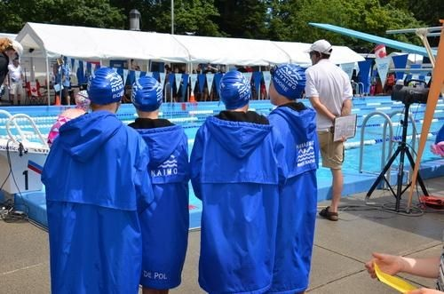

2018 BCSSA Provincial Qualifying Times
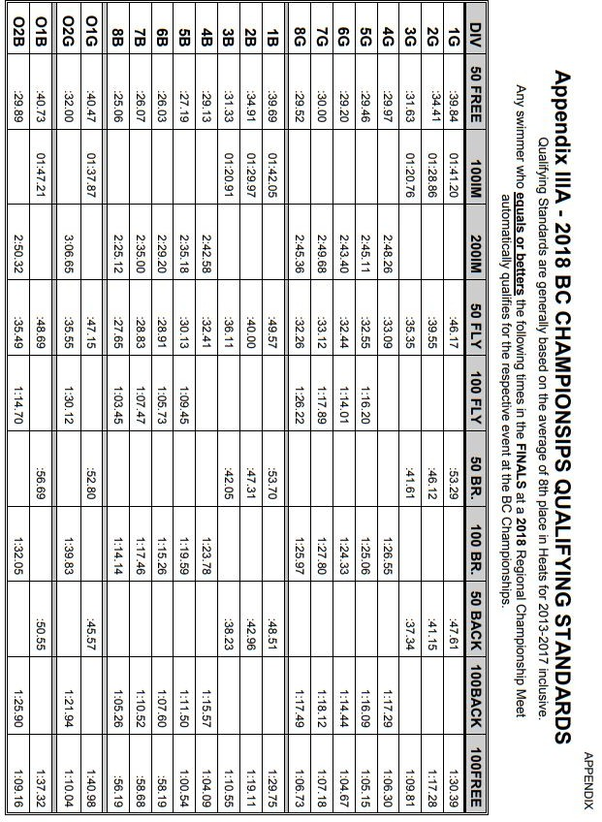

Nanaimo White Rapids 52nd Annual Invitational Meet

Kin Pool, Nanaimo
July 1st to 3rd

Sign up deadline: June 24th

 | Best: | Goal: | Finals:
I.M.
50 Free
50 Fly
100 Fly
Back
Breast
100 Free

Additional Meet Goals

NWRSC Awards

The following awards are offered at the end of the swim season to swim club members. Refer to the Policies manual from the website under Members Page, NWRSC Policies for a full description of these awards.

- Marge Dudley Award
Policy Number 521
Major club award to recognize commitment to the sport of swimming, sportsmanship and club involvement.

- Outstanding Swimmer Award
Policy Number 522
Junior and Senior girl and boy based on A, B and C times qualifications based on points earned, competitiveness and dedication.

- Novice Swimmer Award
Policy Number 523
New boy and girl swimmers who show potential for competitive swimming and sportsmanship as new swimmers.

- Most Improved Swimmer Award
Policy Number 524
Girl and Boy for each division showing improvement in strokes, personal best times and sportsmanship.

- Good Sportsmanship Award
Policy Number 525
Junior and Senior Boy/Girl who meet the policy criteria.

Campbell River Salmon Kings Swim Meet
July 9th to 10th Centennial Pool, Campbell River

Sign Up Deadline: July 1st

 | Best: | Goal: | Finals:
I.M.
50 Free
50 Fly
100 Fly
Back
Breast
100 Free
Additional Meet Goals

NWRSC Scholarship

$500.00

Eligibility: These scholarships are available to graduating students attending any secondary school in the Nanaimo / Ladysmith District.
The applicant must have participated in swimming (as a coach or competitor) with the Nanaimo White Rapids for a minimum of three years. In addition, the student should be registering to participate with the White Rapids Swim Club in the summer of their graduating year.

Method of Application: The procedure involved with applying for these scholarships is clearly outlined in the SD #68 Scholarships and Bursaries Booklet, which can be obtained from the Career Centre at each secondary school. Applications should be submitted to your school counsellor and they will be forwarded to the NWRSC President through the Nanaimo Ladysmith School Foundation’s website.

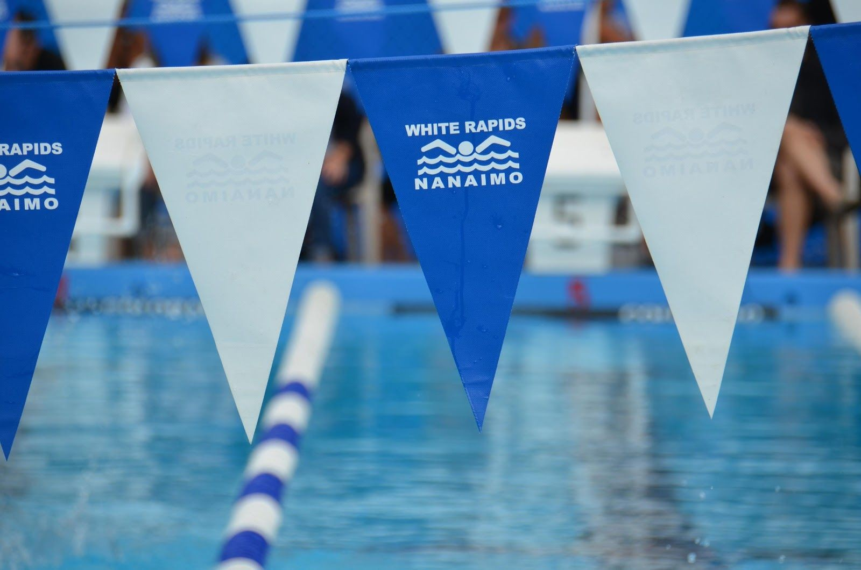

Sidney Piranhas Swim Meet

July 16th and 17th
Commonwealth, Victoria

Sign Up Deadline: July 8th
 | Best | Goal | Heats | Finals
I.M.
50 Free
50 Fly
100 Fly
Back
Breast
100 Free

Additional Meet Goals

NWRSC Code of Conduct and Ethics

The NWRSC Code of Conduct and Ethics is posted on the NWRSC website as well as included in the season plan document. Agreeing to the NWRSC Code of Conduct and Ethics is a mandatory part of the registration process. It is parents' responsibility to ensure that they are familiar with the expectations that are laid out in that document as well as reviewing the relevant parts with their swimmers.

Coaches will also review the expected behaviors outlined in the NWRSC Code of Conduct and Ethics with each of their swim groups and answer any questions to ensure that all participants are familiar with this code.

Warm-up Policy
Warm-ups are important for a number of reasons:
- Swimmers become familiar with the host pool and get a chance to practice details such as dives and turns. These details can be sensitive to changes in the facility, such as a block slanted at a different angle, a wall textured differently, a higher or lower pool edge, or a ceiling or lack of one for navigating in backstroke.
- Swimmers warm up and wake up their bodies.
- Important information is given out to swimmers at this time regarding specifics of the meet, such as changes in the event numbers and the time and location of the team meeting.
- Coaches take attendance to see who has made it to the meet. They will use this information to make deck entries, scratches and to write up the relay teams.

Our policy regarding warm-ups and swim meets is as follows: All swimmers are expected to be behind the blocks and prepared to get into the pool at the scheduled warm-up time. Any swimmer who is not present at the start of warm-ups will have the following actions taken:

  - First Offense: the swimmer will be given a verbal warning from his or her coach
  - Second Offense: the swimmer will be scratched from any relays they have been placed on for that given day

Swimmers are responsible for knowing their warm-up times. These times are provided in three different places:
Posted in the meet packages in the binder hanging from the blue bulletin board on the fence

  - Posted on line on Club website prior to the meet
  - Written on each registered swimmer’s individual information sheets -- in the family folders during the week prior to the meet
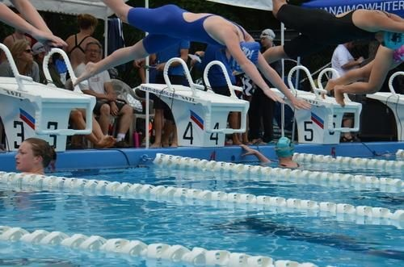

POLICY NUMBER 620 RELAY TEAM FORMATION

- Coaches are responsible for making up relay teams, not parents or swimmers.

- Coaches will follow these general guidelines in the formation of relay teams for all swim meets prior to the Regional Championships:

  - Members of a relay team will be chosen within their age category.
  - There will be consideration taken by the coaching staff as to the fastest stroke combination within that age category as to determine the composition of each relay team.
  - A maximum participation of swimmers available for relays at each swim meet will be achieved by the coaching staff in their relay team selections.
  - Where there are insufficient swimmers of an age group to form a relay, additional swimmers can be chosen to move up from lower divisions. This selection will be chosen from the remaining swimmers not on relays of their own division.
  - The best time a swimmer has achieved during the current season prior to the immediate swim meet will be considered in determining placement on or removal from a relay team.
  - Disciplinary action taken by a Coach may override these guidelines.

- Relay teams for the Regional Championships and the Provincials Championships will be selected using the following guidelines:

  - Every effort will be made by the coaching staff to ensure that all swimmers participating at Regionals, and are available to swim on a relay, will be considered in the selection of teams.
  - The best time a swimmer has achieved during the current season prior to Regionals will be considered in determining placement on or removal from a relay team.
  - It is the goal of the Nanaimo White Rapids to qualify as many swimmers as possible to Provincials. The coaching staff can move a swimmer up into a higher division if they feel it is necessary to qualifying a relay team in that division. This will only take place if: The swimmer moving up is not impeding the qualification of a relay team in their own division. In this event the Head Coach will communicate to the swimmers and parents involved to notify and give reason of this change.
  - A relay team that qualifies for Provincials will swim with the same team members as swam at Regionals unless there is a change due to extenuating circumstances. These circumstances include injury, illness or an inability to attend. Changes will be posted as soon as possible and the Head Coach will notify the swimmers directly involved.
  - A Coach who wishes to digress from these guidelines must present justification for a change to the Board of Directors or to the Coach Liaison committee, who will confer with the Board of Directors for approval. A coach must also explain the reasoning for the swimmers affected.
  - A deadline to post the Regional relay teams will be 4 days prior to the Regional Championship.

Salt Spring Island Swim Meet

July 23rd and 24th
Rainbow Pool, Salt Spring

Sign Up Deadline: July 15th

 | Best | Goal | Heats | Finals
I.M.
50 Free
50 Fly
100 Fly
Back
Breast
100 Free

Additional Meet Goals

Championship Checklist

Take some time to:
- Review the meet tips.
- Reconsider how you have swum.
- Think of what worked and what didn't.
- Rest! Relax! Rejuvenate!
- Listen carefully to your coach.

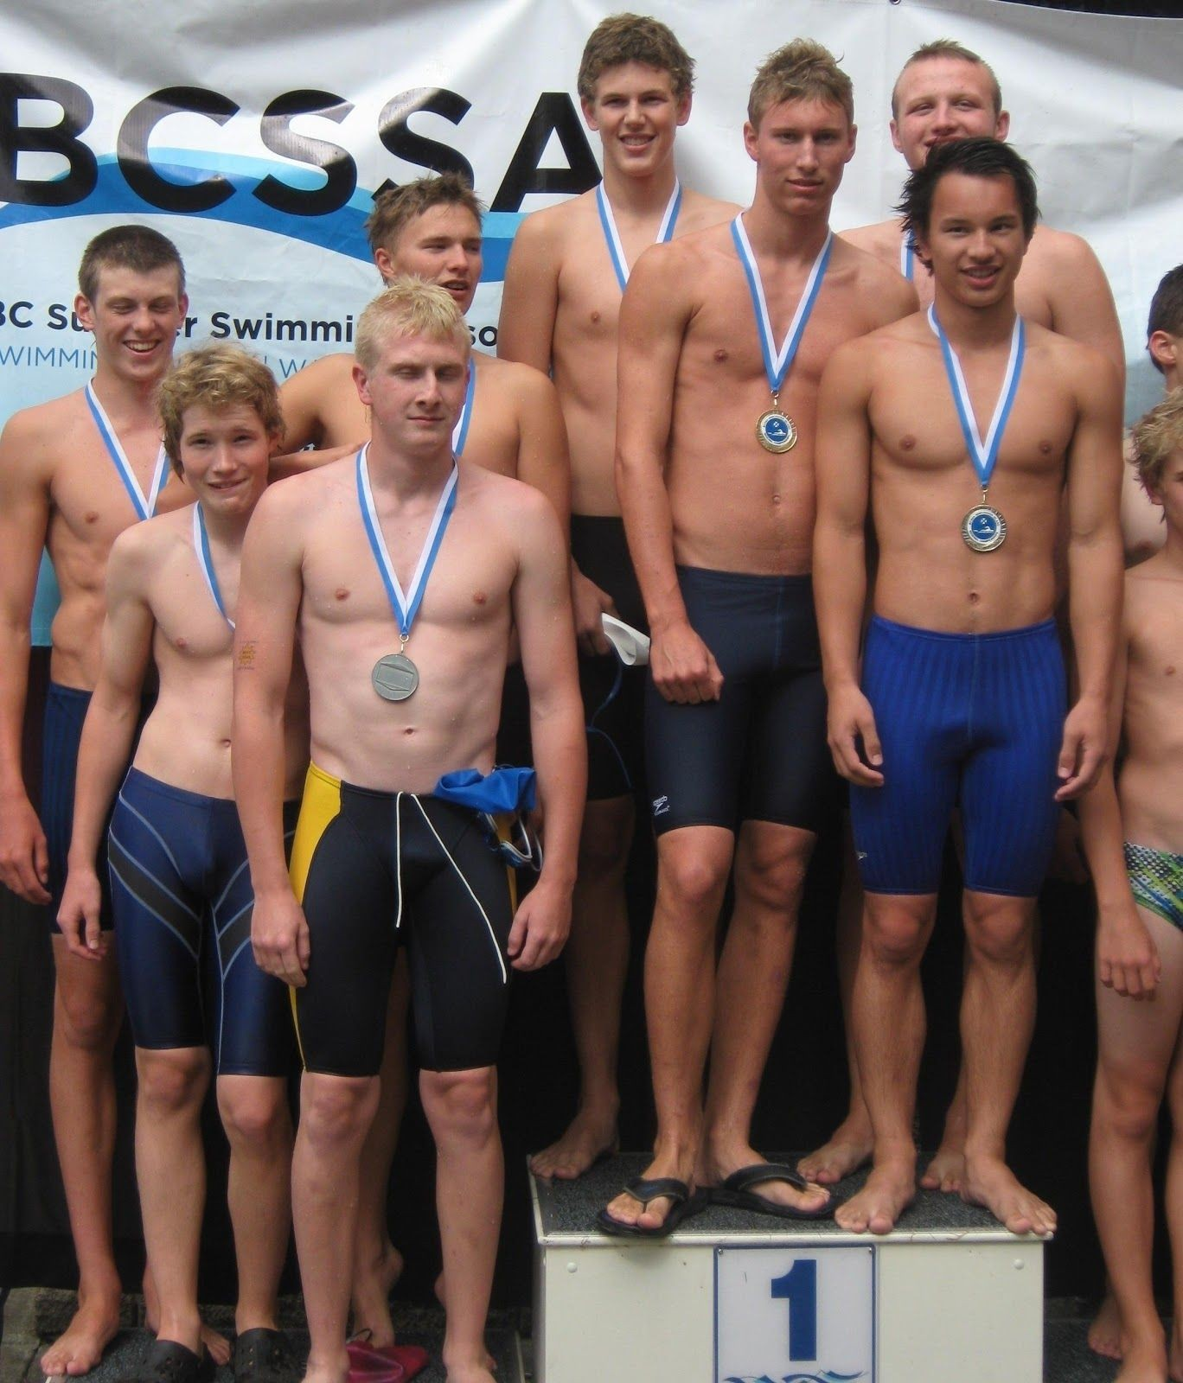

At championship meets I will:
- Eat well, drink wisely, and rest.
- Know my times; know my goals.
- Support my teammates.
- Imagine my race.

Vancouver Island Regionals
Aug 5th to 7th
Saanich Commonwealth, Victoria

 | Best | Goal | Heats | Finals
I.M.
50 Free
50 Fly
100 Fly
Back
Breast
100 Free

Additional Meet Goals

BCSSA Provincial Championships August 18th to 21st

Canada Games Aquatic Centre, Kamloops

 | Best: | Goal: | Finals:
I.M.
50 Free
50 Fly
100 Fly
Back
Breast
100 Free

Additional Meet Goals

White Rapids Club Records
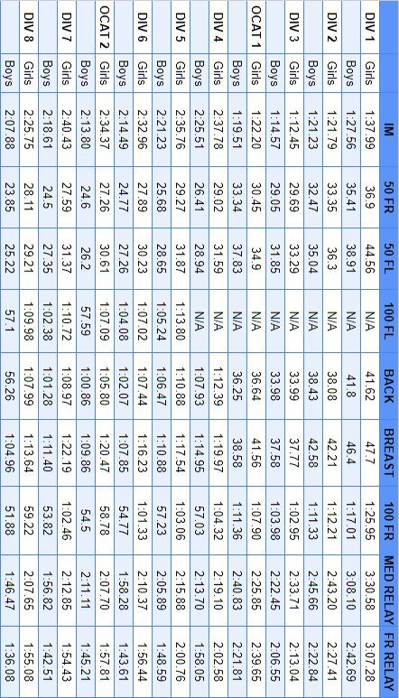

AGE LOCATOR
Use this table to determine your division as a summer swimmer.
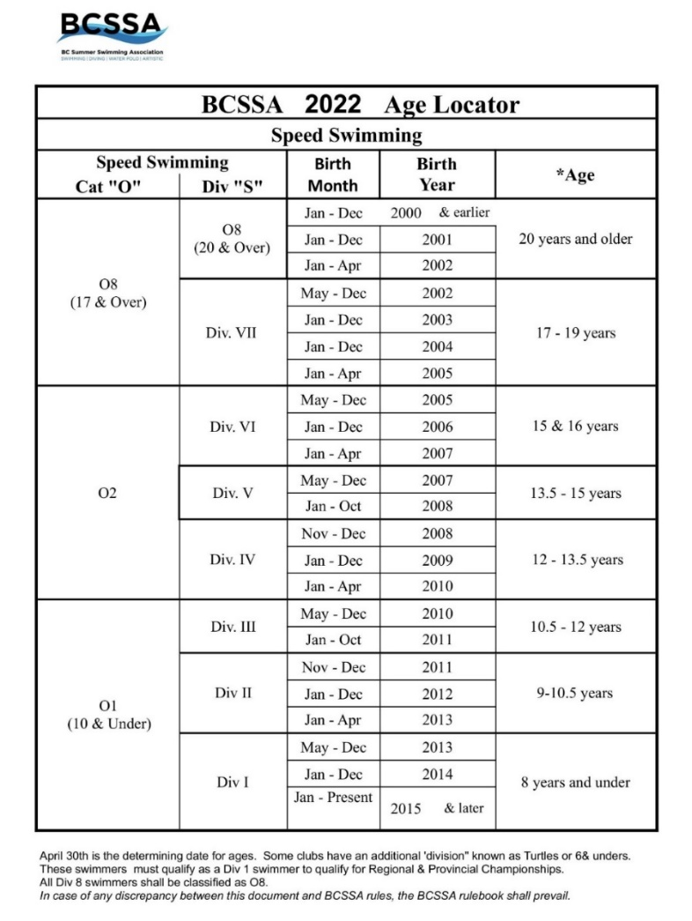

The Nanaimo White Rapids would like to acknowledge the continued support of the City of Nanaimo in the co-management agreement of operating the
Bowen Park Kin Pool.

