Welcome to NYAC’s What’s Happening Newsletter. Newsletters will be sent out bi-weekly on Fridays. Please look for it in your inbox and be sure to read it! It will make you a more informed swim parent! Missed a previous newsletter? Find it posted on the NYAC home page HERE.
GO NYAC!
NYAC continues to climb up the rankings of Ontario Swimmers! Congratulations to everyone who raced at Winter Ontario Provincials and Central Region C, you all made NYAC proud!
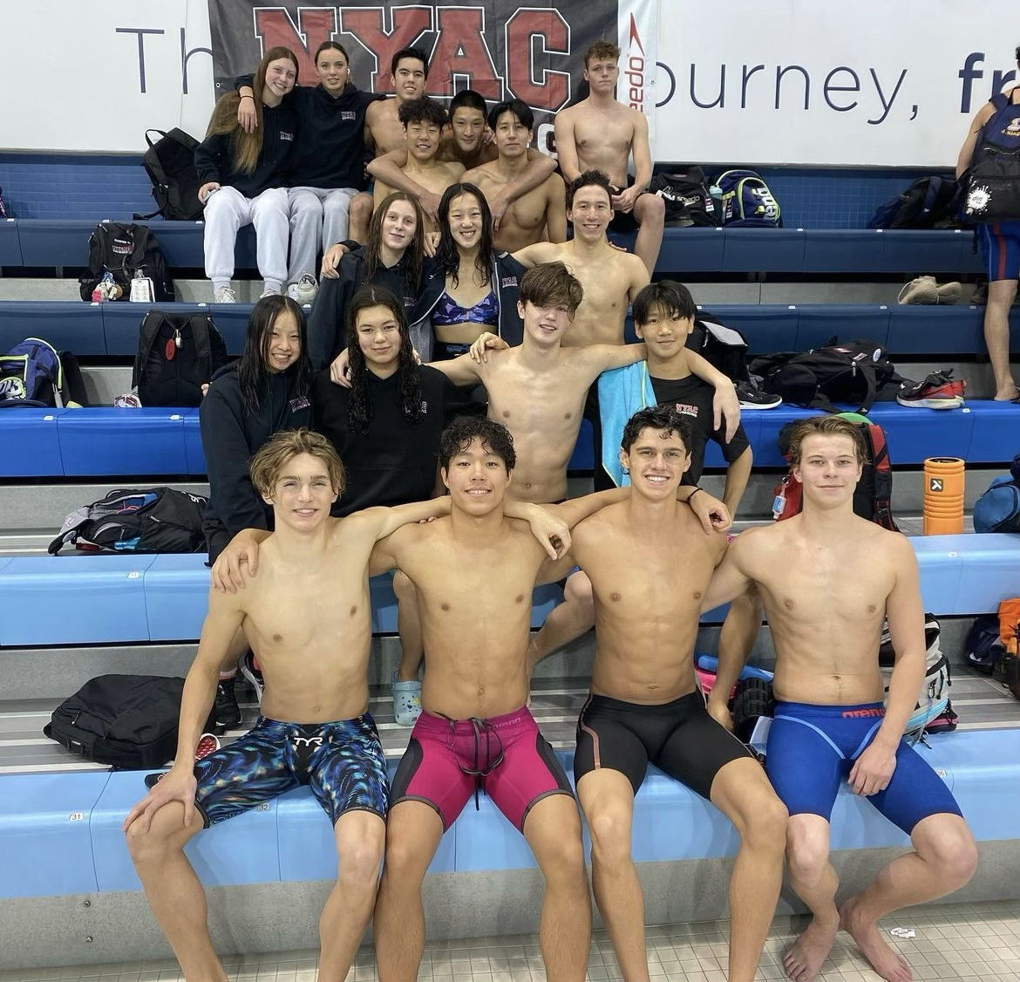
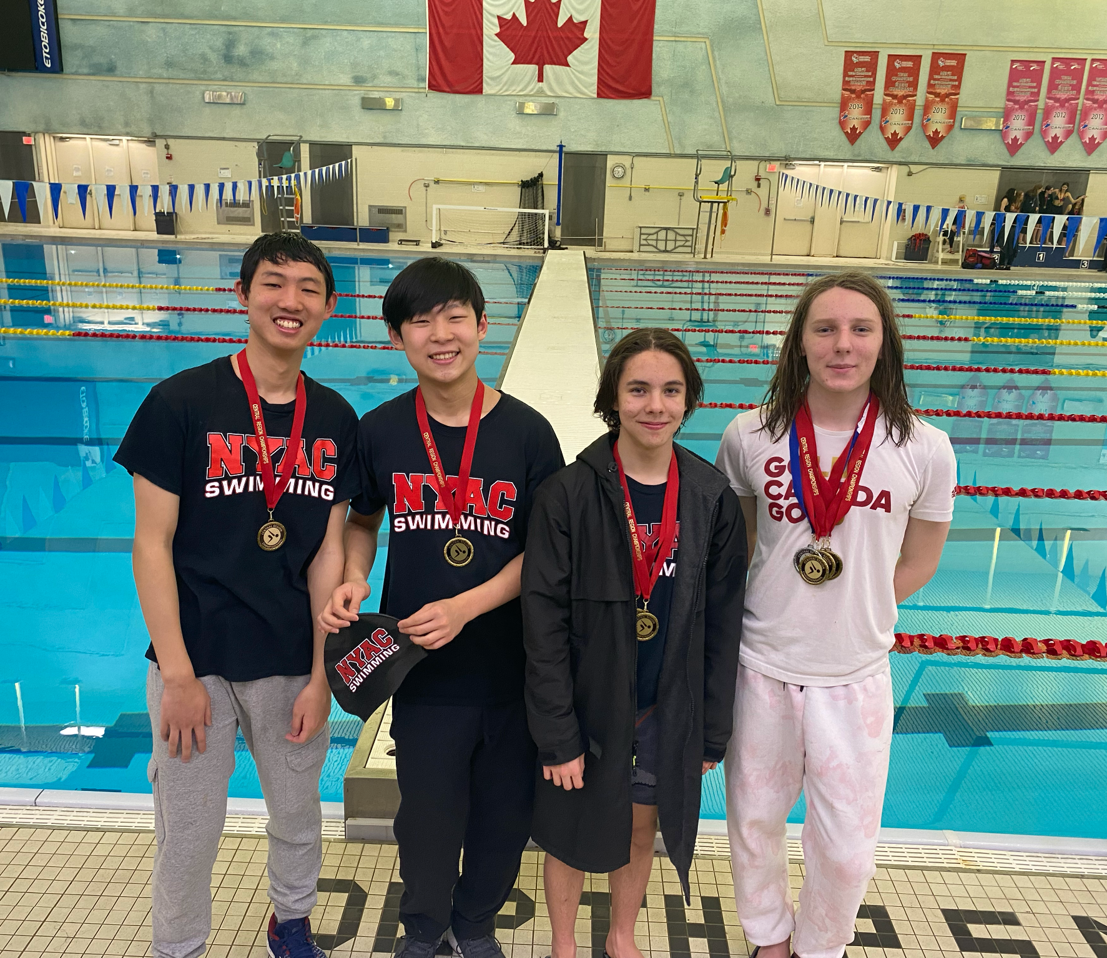

NYAC UPCOMING EVENTS
2023 Speedo Eastern Canadian Championships
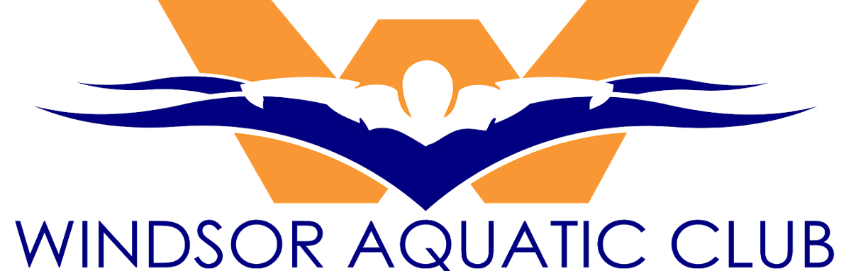
March 16 - 19, 2023.
Click here for more information
Good luck to all NYAC swimmers attending!
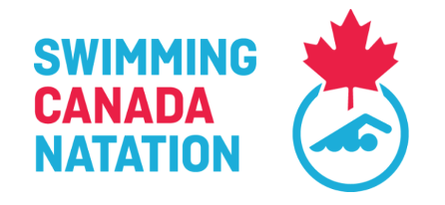
Ava Arhontoudis  Evelyn Baetz  Nicole Bertelink | Adele Miksa  Analise Ryan  Maggie Shackell  Abigail Yuen | Damien Bailey  Holden Brock  Toby Gort  Shaye Gross | Jordan Kong  Luke Lee  Dominic Lee  Jack Mills | Harper Lipton  Rowen Uy  Colin Smith  Daniel Kim | Yuen  Anna Yu  Paul Yang  Ethan Killam

Judge of Stroke and Inspector of turn Clinic - Zoom
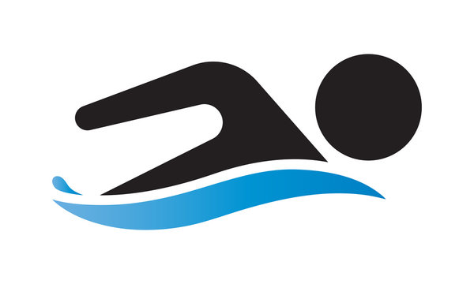
Date: Sunday, April 16, 2023 7:00pm - 9:00pm
Location: Zoom Meeting
Sign up here!

OFFICIALS INFORMATION & CLINICS

Did you know that if you take an officiating course, you can register for volunteer official sessions at NYAC meets, which are considered contributions to the eight (8) required sessions you are to complete in the 2022-2023 season?
To refresh your memory, session commitments for 2022/23:
- At least three (3) sessions completed by January 31, 2023.

- All of the eight (8) sessions will be completed by June 15, 2023.

Please note: you can volunteer in other positions which contribute the same way for completed sessions. Failure to complete session commitments has financial consequences of $125/per missed session.
If you still don’t have an officials account set up for the 2022-2023 season, please reach out to officials@nyacswimming.ca immediately, as you cannot sign up on the job board until you have an Officials Account with Swim Canada.

Let us know which clinic you are interested in by filling in the following form here.
NYAC will be offering several courses to help you become familiar with swim meets and qualify you to work as an official on deck. A schedule of upcoming sessions is located on our website.
If you are new to swimming, the first course to take is:
- Intro to Swimming, and then
- Strokes and Turns
Questions about officiating? Contact nyacofficials@nyacswimming.ca

IMPORTANT DATES TO KEEP IN MIND
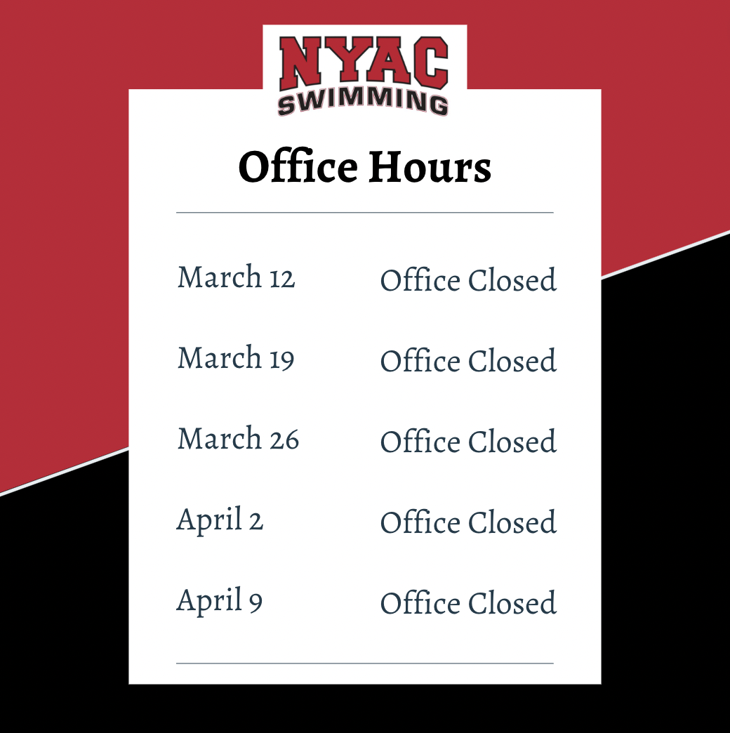
March Break - No practice: Monday, March 13 - Sunday, March 19, 2023

2023 BELL CANADIAN SWIMMING TRIALS

Come support NYAC’s top swimmers compete at the 2023 Bell Canadian Swimming Trials!

Date: Tuesday, March 28 - Sunday, April 2
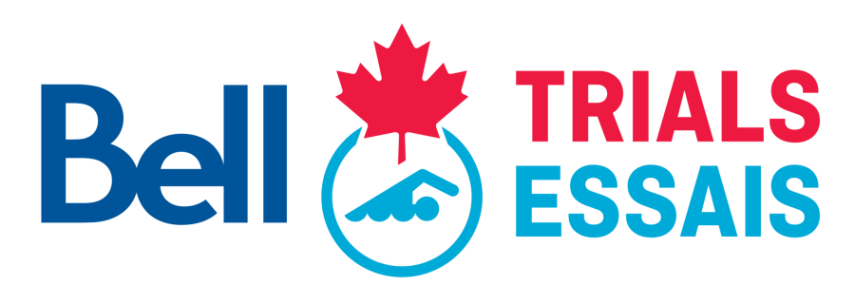
Location: Toronto Pan Am Sports Centre
Purchase your ticket here!

COACHES CORNER

Sports Psychologist Susannah Muller Part 1 is uploaded in our YouTube account.
WATCH HERE!

NYAC - AGM and Board of Directors for 2023-2024
Thank you to all the membership who attended our successful AGM held last week. Congratulations the the re-elected President Evan Lipton and welcome to all the board of directors who will do their best to lead and govern NYAC:
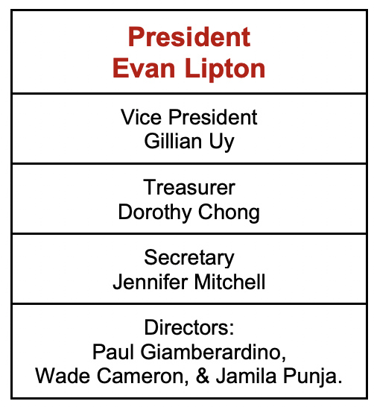

A special thank you to Soma Choudhury for serving on the Board previously and a warm welcome to the newly elected, Jamila Punja!

SWIMMING CANADA NOTICE
Due to the Swimming Canada site being down over the past 5 weeks, some registration information has been lost. You may receive an email asking you to re-sign your Swimmer Acknowledgement Forms. If required, please sign and submit these forms at your earliest convenience. Thank you for your understanding.

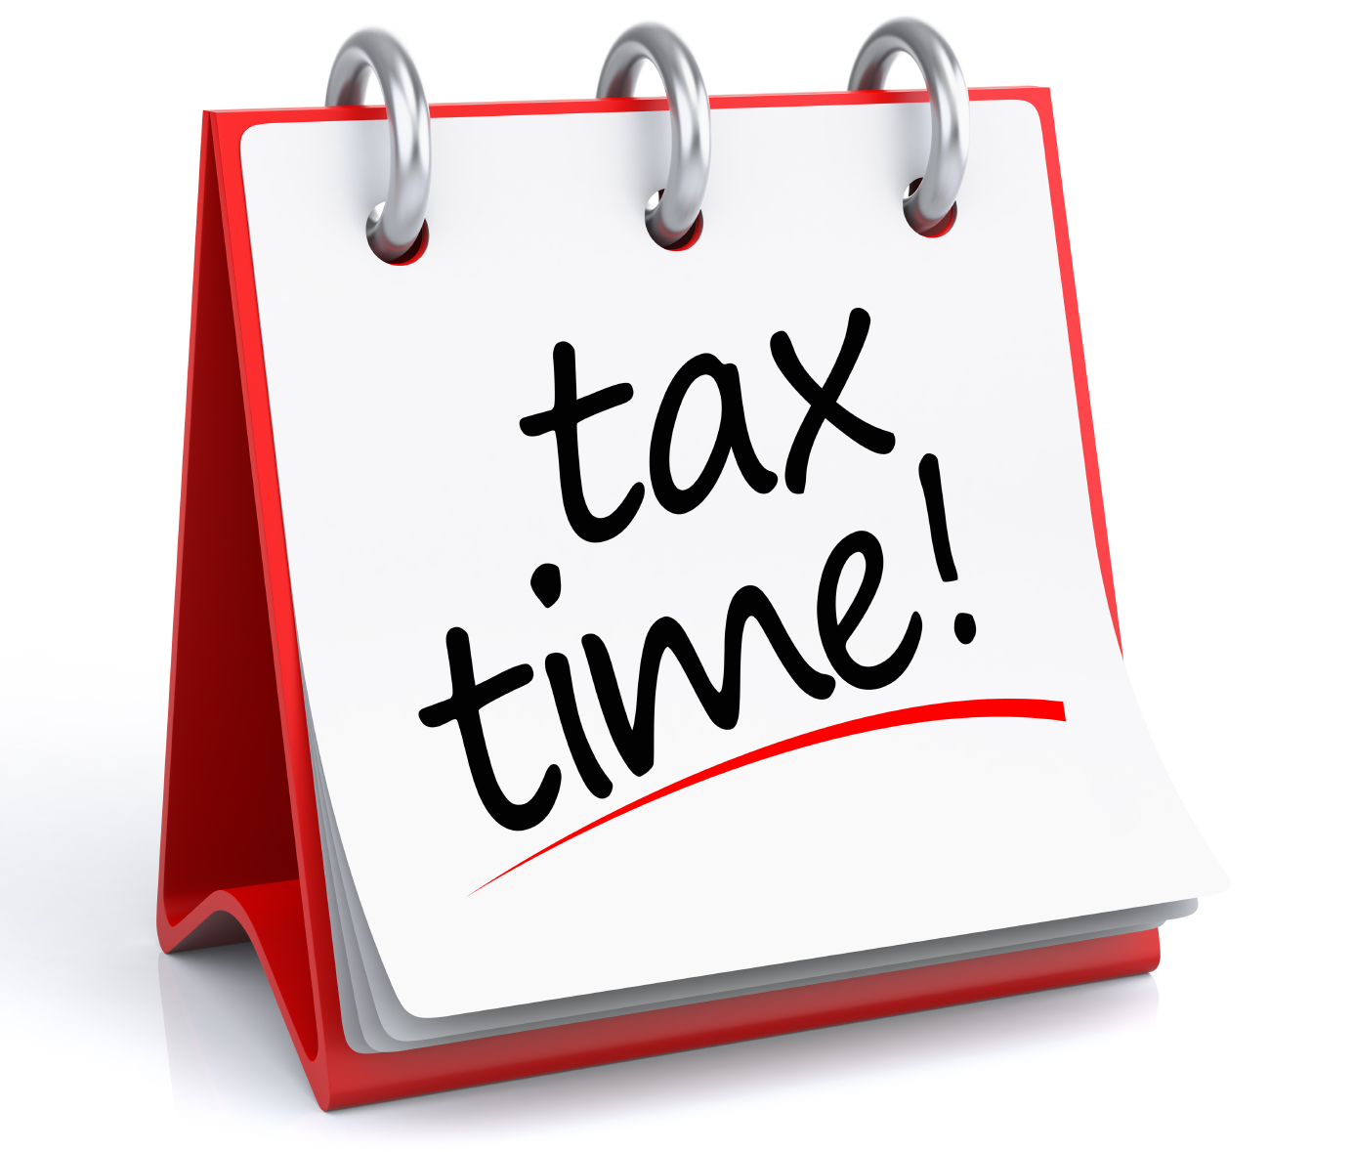
NYAC’s QUESTION OF THE WEEK
Question: How can I find a copy of my receipts for the 2022 swim year?
Answer: To find copies of your receipts for the 2022 swim year please follow the steps below.
For Competitive Receipts:

Log into your NYAC account > My Account> Invoices & Payments > Billing History > Search Billing / Payment History > Select the dates needed for your records. (example: Jan 1, 2022 - Dec 31 -2022) > Print receipt.

For Waves/Swimtec Summer Camp Receipts:

Log into your NYAC account > My Account > Account Info > Swim Lessons > look for blue (Invoice) button for any Waves / Swimtec Summer Camp receipts needed

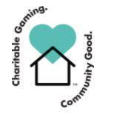

GO NYAC GO! Connect with NYAC on social media!
Thank you to Delta Bingo, who has supported NYAC for many years, helping us to keep swimmers swimming with proceeds going to pay pool rent.

