PSW RETURN TO SPORT POLICY AND PROCEDURES
(COVID-19)

As of June 2020

TABLE OF CONTENTS

INTRODUCTION 3
Disclaimer 3
GENERAL INFORMATION FOR ALL MEMBERS 4
How Coronavirus Spreads 4
Symptoms of Covid-19 4
PSW Covid-19 Officer 4
SWIMMERS 5
Health Questionnaire 5
Best Practices for Athletes 5
Arrival Protocol 6
Equipment (Swim only sessions) 6
Equipment (Dryland only sessions) 6
Activation and Dryland Protocols 7
Lane Assignments & Density 7
Post Workout Protocol 7
PARENTS 8
Health Questionnaire 8
Best Practices for Parents 8
Drop off and Pick up 9
Communication 9
Protocols for Maintaining a Safe Training Environment 9
COACHES 10
General Notes 10
Health Screening 10
Best Practices for Coaches 10
Worksafe Requirements 11
Facility requirements 11
Monitoring and Attendance 11
Outbreak response procedure for Coaches 11
First Aid Expectations 12
Program flow 12

Appendix A 13
PSW ILLNESS AND POSITIVE TEST PROTOCOLS 13
Appendix B 14
ACKNOWLEDGEMENT AND ASSUMPTION OF RISKS FORM 14
Appendix C 17
PSW Participation Agreement 17
Appendix D 18
Bear Creek Park Specific Procedures 18

INTRODUCTION

In an effort to facilitate the safe return to the pool and the sport of competitive swimming, PSW has implemented the following guidelines, operational procedures and policies that all members must adhere to in order to ensure best practices during this time of “new normal”. These policies are built from the resources from the following groups and the “5 principles”

- Swim BC Return to Swimming- Swim BC
- Swimming Canada Return to Swimming -SNC
- BCPRA Restarting Operations
- Via Sport Return to Sport
- Worksafe BC Return to Safe Operations

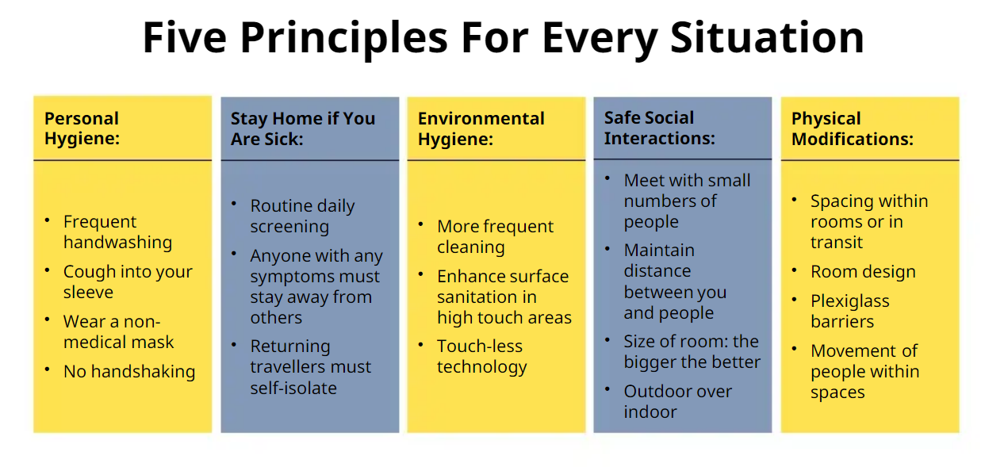
DISCLAIMER
- While the Provincial Government has limited the liability risk to teams during the COVID-19 (BC Liability protection announcement), safety for everyone is still first and foremost
  - It is up to each and every person to reduce the infection, or spread of COVID-19
  - It is the responsibility of each and every person to assess the risk, and decide their own personal risk of participation within the team
- While all efforts are made to provide the best possible information available, members should understand that this is a live document and updates or changes may happen
  - Currently this document is based off BC Restart Plan Phase 2
- PSW will do its best to keep you up to date with the ever-changing environment, however it is the responsibility of the membership to stay informed

GENERAL INFORMATION FOR ALL MEMBERS

HOW CORONAVIRUS SPREADS
- Human coronaviruses cause infections of the nose, throat and lungs. They are most commonly spread from an infected person through:
  - Respiratory droplets generated when you cough or sneeze
  - Close, prolonged personal contact, such as touching or shaking hands
  - Touching something with the virus on it, then touching your mouth, nose or eyes before washing your hands
- Current evidence suggests person-to-person spread is efficient when there is close contact
(Source used - Government of Canada public health )
SYMPTOMS OF COVID-19
- The symptoms of COVID-19 are similar to other respiratory illnesses, including the flu and common cold. These symptoms include:
  - Fever
  - chills
  - cough
  - shortness of breath
  - sore throat and painful swallowing
  - stuffy or runny nose
  - loss of sense of smell
  - headache
  - muscle aches
  - fatigue and loss of appetite
- People infected with COVID-19 may experience little or no symptoms, with illness ranging from mild to severe. Some people are more vulnerable to developing severe illness or complications from COVID-19, including older people, those with compromised immune systems or chronic health conditions. ( Sourced used - Swim BC - Return to Swimming)
- For a complete understanding about Covid-19, please refer to one of the many credible sources including:
  - Fraser Health
  - BC Centre for Disease Control

PSW COVID-19 OFFICER
- PSW has created a PSW COVID-19 Officer position. This person is responsible for:
  - Monitoring the overall health of the team
  - Keeping apprised of COVID-19 updates within the province
  - Assist in the development of PSW’s plan, education and enforcement

SWIMMERS

HEALTH QUESTIONNAIRE:
- Swimmers will be required to complete the PSW COVID-19 Self-Assessment each day before attending workouts
  - Legal guardians need to complete for 11 and under swimmers
  - Swimmers that do not have the questionnaire completed prior to attending workout will not be able to participate in dryland or water sessions that day
- If swimmers answer YES to any question on the Self-Assessment they must:
  - Not attend workout under any circumstance
  - Inform PSW COVID-19 Officer and Head Coach
  - Follow PSW ILLNESS AND POSITIVE TEST PROTOCOLS (Appendix A)
- Coaches will review questionnaire results daily to confirm all questions have been answered and that any negative or unusual responses are noted to the COVID-19 Officer and Head Coach

BEST PRACTICES FOR ATHLETES
- Prior to participating in any session, athletes and parents must participate in a zoom orientation meeting to address guidelines and protocols
- Keep minimum of 2 meters from anyone outside your household at all times
  - Swimmers are not to assist other swimmers outside their household with equipment such as goggles, caps, suits, etc.
  - Coaches will not be performing physical manipulations/corrections on athletes
  - In a medical emergency, the coach will wear gloves and a mask
  - Swimmers will maintain appropriate distance from facility staff members throughout the duration of the time spent at the facility
- Do not greet with handshakes, hugging, high fives, etc. that involve physical contact
- Do not share food, drink or equipment with team mates
- Avoid touching your eyes, nose and mouth
- Frequently wash hands with soap and water, or if not accessible, use hand sanitizer
  - Hand sanitizer is part of athletes required equipment
- Cough or sneeze into a sleeve
- Athletes must follow the entry and exit policies for the particular facility or location that they are training in (Appendix D)
- Athletes must follow the directions of facility staff with regards to physical distancing procedures in place
- Failure to follow staff direction, facility procedures and PSW procedures may result in the removal of the athlete from the group training environment
- Athletes must follow physical markers (cones, lines, stickers, etc.) that indicate appropriate spacing while on deck or in dryland areas
- Athletes are to act responsibly and promote appropriate behavior on social media with their peers
- Athletes are encouraged to remain in local community through Phase 2

ARRIVAL PROTOCOL
- Swimmers should arrive no earlier than 10mins before their scheduled dryland or pool time
  - Swimmers that arrive earlier are asked to remain in vehicle until the appropriate time away from drop off area
  - Swimmers who are driving or being dropped off will do so at the noted drop off location and proceed to the meeting area (Appendix D)
  - 11 and under swimmers must have parents escort to meeting area
- Upon arrival, swimmers will proceed to a well-marked designated area outside of the facility and be met by a coach as indicated in Appendix D
  - Coaches will verify that the PSW COVID-19 Self-Assessment has been filled out for that day
  - If not completed that swimmer will be unable to participate that day
- Physical distance rules are in effect
- Swimmers are asked to show up with suits already on or in dryland gear

EQUIPMENT (SWIM ONLY SESSIONS)
- Swimmers must ensure they are dressed appropriately for activation and swimming activities. This includes all weather conditions. Required equipment includes:

  - Goggles
  - Pull buoy only
  - Pool workout attire
  - Water Bottle (Swimmers must have a water bottle prefilled at home before arrival)
  - Carabiner (To hang swim bag on the fence)
  - Garbage Bag (for those rainy days)
  - Sun screen (should be applied before arrival to workout)
  - Hand Sanitizer

NOTE: The use of Snorkels will not be permitted at anytime
Only equipment accepted at this time is a pullbuoy – no mesh bags
- Swimmers should use washroom facilities at home before arriving at the pool location
- Swimmers are asked to place swim bag in designated spots as noted in the workout procedure (Appendix D) then move to assigned lanes and slot allocation
- Swimmers will not be permitted to share equipment at this time

EQUIPMENT (DRYLAND ONLY SESSIONS)
- Swimmers must ensure they are dressed appropriately for dryland activities. This includes all weather conditions
- Required equipment includes:

  - Yoga mat
  - Running shoes
  - Dryland workout attire
  - Rain gear
  - Skipping Rope
  - Hand Sanitizer
  - Water Bottle (Swimmers must have a water bottle prefilled at home before arrival)
  - Garbage Bag (for those rainy days)
  - Sun screen (should be applied before arrival to workout)

- Swimmers should use washroom facilities at home before arriving to the dryland location
- Swimmers are asked to place equipment and set up in designated spots as noted in Appendix D
- Swimmers will not be permitted to share equipment at this time
ACTIVATION AND DRYLAND PROTOCOLS
- Markers will be placed at least 2 meters apart in designated activation and dryland zones
- Athletes and their bags will be placed at these markers, starting at markers furthest from entry point and will remain there for the duration of activation/dryland session
- At the end of session, athletes will leave starting with the markers closest to:
  - Pool entry point for activation
  - Pick up entry point for dryland
- Athletes will be placed in the same groups for pool sessions, when applicable

LANE ASSIGNMENT & DENSITY:
- Lane Density (number of swimmers in the pool) has been determined by a number of factors, including physical distance requirements, city policy and other regulatory bodies
  - At this time PSW will operate at 6 per lane swimming double lanes (see chart below)
- Swimmers lane assignment and lane placement (within the lane) has been determined by the coaches, creating the best “training lane” available
  - Swimmers must stay in their respective allocated spots as noted in Appendix D
  - Swimmers will not be able to pass each other during workouts

- Size of the group has been determined by maintaining physical distance requirements, creating a safe training environment, and the ability and maturity of the swimmer. All dryland and water workouts have a maximum capacity of 30 swimmers (based on an 8-lane pool with 6 swimmers per double lane) with 1-2 coaches present
POST WORKOUT PROTOCOL
- Swimmers are not allowed to access the changing rooms or showers
- Swimmers must leave workout areas immediately and follow exit procedures
  - Swimmers are not allowed to linger on the pool deck or in dryland workout areas to socialize
- As per Safe Sport guidelines and club policy NO DECK CHANGING is permitted
- Swimmers must take all swim equipment home with them after each session to be sanitized
PARENTS
HEALTH QUESTIONNAIRE
- Swimmers will be required to complete the PSW COVID-19 Self-Assessment each day before attending workouts
  - Legal Guardians need to complete for 11&Under swimmers
  - Swimmers that do not have the questionnaire completed prior to attending workout will not be able to participate in dryland or water sessions that day
- If swimmers answer YES to any question on the Self-Assessment they must:
  - Not attend workout under any circumstance
  - Inform PSW COVID-19 Officer and Head Coach
  - Follow PSW ILLNESS AND POSITIVE TEST PROTOCOLS (Appendix A)
- Swimmers that do not have the questionnaire completed prior to attending workout will not be able to participate in dryland or water sessions that day
- Coaches will review questionnaire results daily to confirm all questions have been answered and that any negative or unusual responses are noted to the COVID-19 Officer and Head Coach
BEST PRACTICES FOR PARENTS
- Keep a minimum of 2 meters from anyone outside their household at all times
  - This includes coaches and facility staff members
  - Parents are not to assist other swimmers outside their household with equipment such as goggles, caps, suits, etc.
- Do not greet others with handshakes, hugging, high fives, etc. that involve physical contact
- Do not share food, drink or equipment with others
- Avoid touching eyes, nose and mouth
- Frequently wash hands with soap and water or if not accessible, use hand sanitizer
  - Hand sanitizer is part of the athlete’s necessary equipment
- Cough or sneeze into sleeve
- Follow the entry and exit policies for the particular facility or location that practices take place at (Appendix D)
- Follow the directions of the PSW coaches and facility staff with regards to physical distancing
  - Failure to follow staff direction, facility procedures and PSW procedures may result in the removal of their athlete from the group training environment
- Parents are unable to watch workouts, both in and around facility, or remain in dryland and activation areas, in order to keep numbers down and mitigate risk
  - BC is in Phase 2 and gatherings of people are still restricted
  - This will allow PSW to maximize the number of athletes participating

DROP OFF AND PICK UP
- Prior to drop off, parents must have completed or ensured that their swimmer the PSW COVID-19 Self-Assessment for their swimmers for that day
  - Swimmers that have not completed this daily questionnaire will not be able to participate in workouts
- Parents are asked to drop off and pick up swimmers from the parking lot in designated areas
- Keep the window of drop off and pick up to 10 minutes before and after workouts each day
- If parents and swimmers arrive early, please stay in the vehicle until the appropriate time
- Keep a minimum of 2 meters of anyone outside their household at all time

COMMUNICATION
- There will be no in person meetings set until further notice
  - Any required parent/athlete meetings will be conducted via zoom with a third party present
- Email will be the primary method of communication
  - Ensure primary account email is an email that you check on a regular basis
  - Ensure that you have verified your email and you are receiving club emails beyond billing emails
  - It will be the responsibility of families to ensure that they keep their primary contact email up to date

PROTOCOLS FOR MAINTAINING A SAFE TRAINING ENVIRONMENT
- While all efforts are being made to mitigate the risks of a COVID-19 infection, parents are asked to help monitor the health of their swimmers on a daily basis to help keep the risk to a minimum
- If we all continue to follow the “5 Principles”, the chance of a COVID-19 outbreak is low at this time, however if an outbreak should occur with any member of the PSW team (Swimmers, Parents, Coaches) they are to follow the protocols for illness and/or a positive test (Appendix A)
  - If an athlete answers YES to any question on the PSW COVID-19 Self-Assessment they are not to attend workout under any circumstances
- Before in-person participation all PSW Members will be required to update their registration agreement by signing the following documentation
  - ACKNOWLEDGEMENT AND ASSUMPTION OF RISKS FORM (Appendix B)
  - SWIMMER PARTICIPATION AGREEMENT (Appendix C)

COACHES
GENERAL NOTES

During this time of “new normal”, it is more important than ever that coaches take a leadership role with the daily operations of the team, including health screening, attendance and the general well-being of the team.

HEALTH SCREENING
- Coaches must complete the PSW COVID-19 Self-Assessment on a day of a session, before they can participate
- If a coach answer YES to any question on the Self-Assessment they must:
  - Not attend workout under any circumstance
  - Inform PSW COVID-19 Officer and Head Coach
  - Follow PSW ILLNESS AND POSTITIVE TEST PROTOCOLS (Appendix A)

BEST PRACTICES FOR COACHES
- Prior to participating in any session, coaches must participate in a zoom orientation meeting to address guidelines and protocols
- Coaches should arrive 15mins before dryland/ pool session to set up markers
  - This will include directional flow signs/markers, activation markers, placement of bag markers, lane ropes, flags etc.
- Keep a minimum of 2 meters from anyone outside your household at all times
  - Coaches are to refrain from assisting other swimmers outside their household with equipment such as goggles, caps, suits, etc.
  - Coaches will not be performing physical manipulations/corrections on athletes
  - In a medical emergency, the coach will wear gloves and a mask
  - Coaches will maintain appropriate distance from facility staff members throughout the entire duration of the time spent at the facility
    - This includes pool storage areas when accessing equipment
- Avoid greetings with handshakes, hugging, high fives, etc. that involve physical contact
- Avoid touching eyes, nose and mouth
- Frequently wash hands with soap and water or if not accessible, use hand sanitizer
  - Hand sanitizer is available for coaches’ use
- Cough or sneeze into sleeve
- Coaches must follow the entry and exit policies for the particular facility or location that they are training in
- Coaches must follow the directions of facility staff with regards to physical distancing procedures in place
  - Failure to follow staff direction, facility procedures and PSW procedures may result in the removal of the coach from the group training environment
- Coaches will ensure all athletes have left the dryland location or pool facility before leaving themselves
- Coaches are to act responsibly and promote appropriate behavior on social media with their peers
WORKSAFE REQUIREMENTS
- Mitigating of risk:
  - PSW has taken all efforts to reduce risk and encourages all staff to forward any potential issues that have been missed or not address to the COVID-19 Officer and President to be address immediately
  - When applicable, coaches should perform any administrative tasks from home
- Equipment provided:
  - Hand sanitizer for staff (Swimmers are required to bring their own)
  - PPE (cloth mask and gloves)
    - Coaches have the option of using PPE while coaching, however are required to use if:
      - Their own safety is at risk
      - Have to break physical distance of 2 meters
      - Attending a first aid incident
- Equipment not provided:
  - Stopwatch
  - Monitoring tools for attendance/workouts
  - Whistle
    - working outdoors may be required for first-aid situations
  - Rain gear
- Sick Days:
  - Salary staff will be paid as normal to their contracts
  - Hourly employees will not be paid if required to take a sick leave

FACILITY REQUIREMENTS
- Coaches are required to ensure that swimmers follow any protocols, procedures or policies that the facility has set out. These may include:
  - Ensure swimmers do not have any dirt or grass on them before entering pool deck and pool
  - Coaches are responsible for setting up and taking down pool equipment
    - Lane ropes
    - Flags
    - Physical distancing markers
MONITORING ATTENDANCE
- Coaches are to make sure that all swimmers attending a workout have completed the PSW COVID-19 Self-Assessment before participating in a workout
  - This can be done by checking the responses through google drive on a mobile device
  - Any unusual responses by either a coach or swimmer must be reported to the PSW COVID-19 Officer and Head Coach immediately
- Coaches are responsible for recording attendance using the On Deck App
  - Attendance must be taken by the conclusion of each practice
OUTBREAK RESPONSE PROCEDURE FOR COACHES
- The PSW ILLNESS AND POSITIVE TEST PROTOCOLS that apply to membership applies to coaches as well
- All coaches are required to read through these protocols before participation in training sessions
FIRST AID EXPECTATIONS
- In the event of a first aid incident, it is the responsibility of the coaching staff present to assist the Lifeguards (under their direction)
- In the event of a first aid incident during dryland, coaches must follow WorkSafe BC protocols and wear PPE. In the event of a major emergency, contact the lifeguards
- Any incident must be recorded electronically using THIS FORM
- Head Coach and the president must be notified immediately
- Gloves and mask must be worn while attending any incident that involves a coach to be closer than 2 meters

PROGRAM FLOW
- Group changeovers would look like
  - In water group ends, 5 minutes to clear pool and deck
  - Arrival window for activation 5 minutes before water group ends
  - Activation starts 5 minutes before water group ends
  - Activation group moves on deck when water group leaving deck and 5mins to get ready and into position
  - EXAMPLE
    - Group 1 Water 6:40 arrival, 6:45-6:55 activation, 6:55-7:00 on deck, 7:00-8:20 water, 8:20-8:25 exit period
    - Group 2 arrival 8:10, activation 8:15-8:25, on deck 8:25-8:30, water 8:30-9:25
- Pool down time of 10 mins between “workouts”
- There will be a 15-minute period between end of water workout to start of dryland for applicable workouts for swimmers to dry off and prepare for dryland workout

Appendix A
PSW ILLNESS AND POSITIVE TEST PROTOCOLS

Inform an individual in a position of authority (Coach or COVID-19 Officer) immediately if, your swimmers feel any symptoms of COVID-19 such as fever, chills, cough, shortness of breath, sore throat and painful swallowing, stuffy or runny nose, loss of sense of smell, headache, muscle aches, fatigue and loss of appetite.

Assessment:
- Swimmers will be required to respond to a pre-training questionnaire recorded electronically before their practice/ activity to attest that they are not feeling any of the COVID-19 symptoms
- Coaches will visually monitor team members to assess any early warning signs as to the status of their health and to touch base on how they are regarding their personal safety throughout the practice/ activity
- If members are unsure, please have them use the BC COVID-19 Self-Assessment Tool
If a member is feeling sick with COVID-19 symptoms:
- They should remain at home and contact Health Link BC at 8-1-1
- If they feel sick and/or are showing symptoms while at practice they should be sent home immediately and have them contact 8-1-1 or a doctor for further guidance
- NO member may participate in a practice/activity if they are symptomatic
If a member tests positive for COVID-19:
- The member will not be permitted to return to practice until they are free of the COVID-19 virus
- Any member who worked / practiced closely with the infected member will also be removed from club activity for at least 14 days
- Ensure work / practice area is closed off, cleaned and disinfected immediately and any surfaces that could have potentially been infected/ touched
If a member has been tested and is waiting for the results of a COVID-19 test:
- As with the confirmed case, the member must be removed from the work / practice area
- The BCCDC advises any person who has even mild symptoms to stay home and call 8-1-1
- Other members who may have been exposed will be informed and removed from the work / practice for at least 14 days or until the diagnosis of COVID-19 is ruled out by health authorities
- The works / practice space will be closed off, cleaned, and disinfected immediately and any other surfaces that could have been potentially infected/ touched
If a member has come in to contact with someone who is confirmed to have COVID-19:
- Members must advise their employer/ coach if they reasonably believe they have been exposed to COVID-19
- Once the contact is confirmed, the member will be removed from the workplace/ practice for at least 14 days or as otherwise directed by public health authorities. Members who may have come into close contact with the member will also be removed from the workplace for at least 14 days
- The workspace/ activity area will be closed off, cleaned, and disinfected immediately and any other surfaces that could have potentially been infected/touched
Quarantine or Self-Isolate conditions:
- Any member has travelled outside of Canada or the province within the last 14 days is not permitted to enter any part of the facility and must quarantine and self-isolate
- Any member with any symptoms of COVID-19 is not permitted to enter any part of the facility and must quarantine and self-isolate
- Any member from a household with someone showing symptoms of COVID-19 is not permitted to enter any part of the facility and must quarantine and self-isolate
- Any member who is quarantined or self-isolating as a result of contact with an infected person or in families who are self-isolating, is not permitted to enter any part of the facility
Appendix B
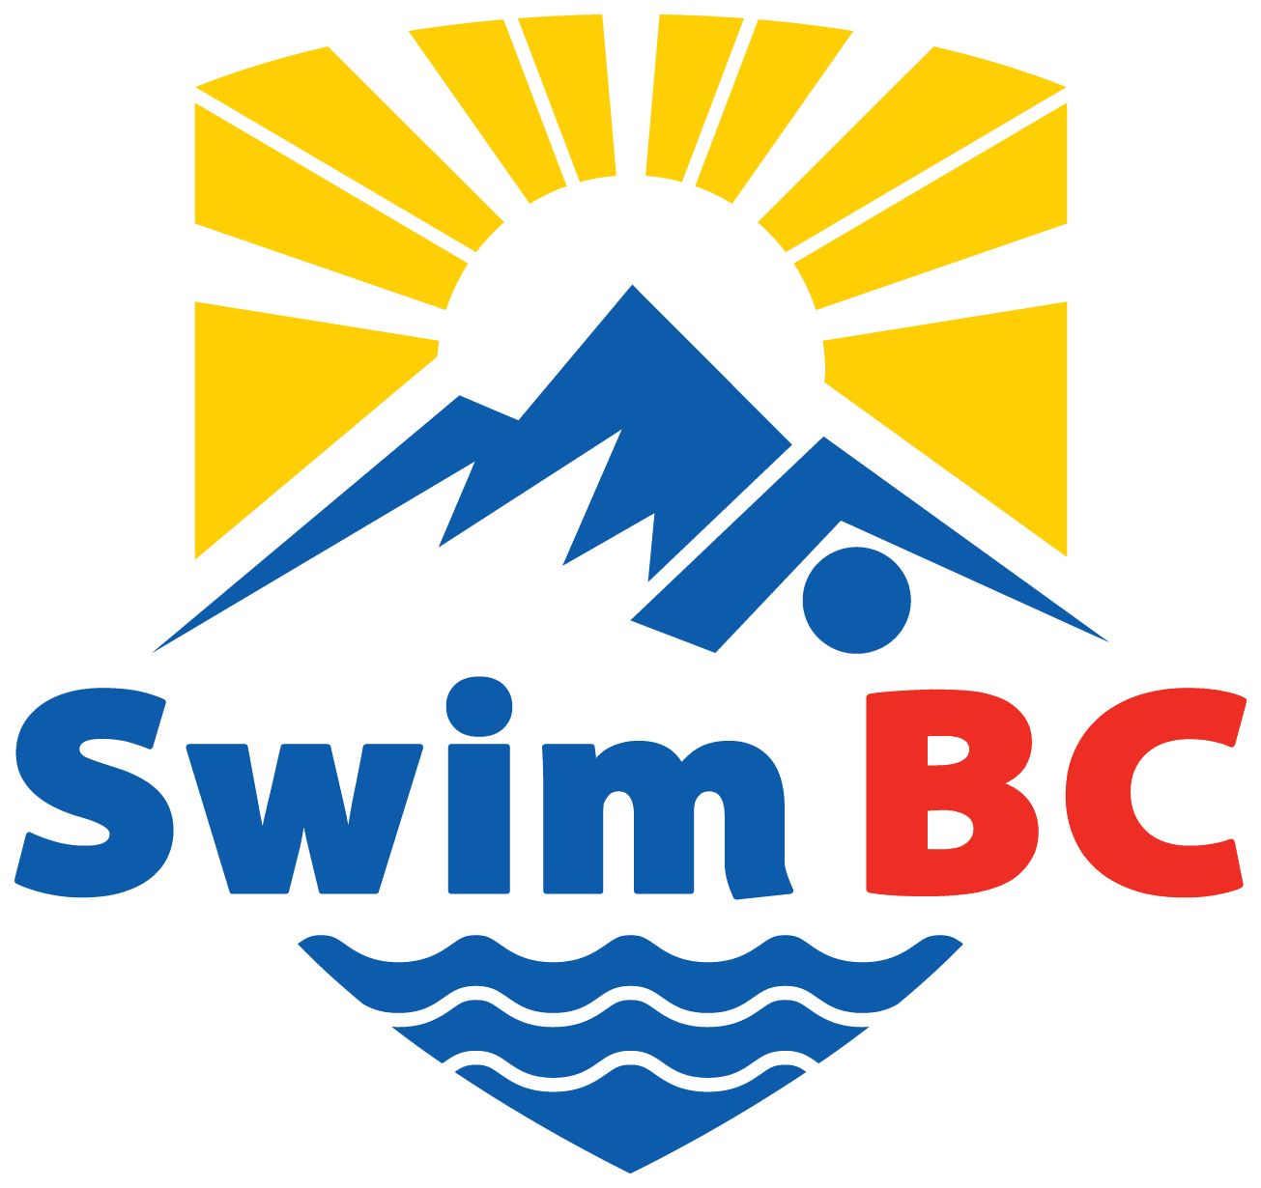
ACKNOWLEDGEMENT AND ASSUMPTION OF RISKS FORM
(FOR ADULT PARTICIPANT AND MINOR PARTICIPANT)
Please read this document carefully
This acknowledgment and assumption of risks form must be signed before participating in any Activity sanctioned or organized by Swimming Natation Canada, Swim BC, or Swim BC Member Clubs
As a participant, or on behalf of a minor participant, in the Activities organized, recognized or sanctioned by Swimming Natation Canada (“SNC”), Swim BC or a Swim BC Member Club (“Club”) I hereby acknowledge and agree to the following terms and conditions respecting my/their participation in any Activity.
Introduction As a participant, or on behalf of a minor participant, in the Activities organized, recognized or sanctioned by SNC, Swim BC or Swim BC Member Clubs, I, the undersigned
______________________________________ (name of adult participant)
OR ____________________________________ (name of a parent or legal guardian of a minor participant),
acting as ____________________________ (parent or legal guardian)
of_________________________________________ (name of minor participant),
hereby acknowledge and agree to the following terms and conditions respecting my/their participation in any Activity.
Definitions
- “Activity” or “Activities” means any in-person or virtual activities such as events, training camps, programs, competitions, physical training performed or conducted in water or outside water, recognized, organized or sanctioned by SNC or Swim BC or Swim BC Member Clubs.
- “Agreement” means this Acknowledgement and Assumption of Risk.
- “Injury or Health-related problem” means any injury, health-related issue or illness including mental health issues diagnosed by a medical practitioner.
- “Members” means the members listed in Section 3.01 of Swim BC bylaws dated October 10, 2019 or Section 2.1 of SNC’s bylaws dated July 29, 2019, as revised.
- “Minor” means the minor participant named in the Introduction.
- “Organization” means collectively, SNC, Swim BC, Swim BC Member club and their respective coaches, directors, officers, committee members, members, employees, volunteers, participants, agents and representatives.
- “Registrant” means a participant and all individuals or entities of SNC including those individuals and associations, incorporated or unincorporated, as described in SNC’s national registration policy, procedures and rules manual who have met the requirements of registration and the registration has been completely processed and registrants or registered participants of Swim BC or a Member Club.
- “Club” means a Member club that is registered with Swim BC.
- “Water” means any outdoor or indoor pools, artificial or natural water basins used for swimming.

Description of Risks
- As a participant, or parent or legal guardian of a Minor participant in the sport of swimming and the Activities of the Organization, the undersigned agrees to the following terms and conditions.
- I am, or the Minor is participating voluntarily in the sport of swimming and the Activities of the Organization. In consideration of my participation or the Minor’s participation in the sport of swimming and the Activities of the Organization, I hereby acknowledge that I am aware of and hereby accept the risks, dangers and hazards inherent and associated with or related to the sport of swimming and any Activities of the Organization, including any Injury or Health-related Problem, which can be severe and even fatal. These risks, dangers and hazards may include, but are not limited to, an Injury or Health-related Problem resulting from:
a. Exertion and stretching of various muscle groups or strenuous cardiovascular activity in or out of water;
b. Vigorous physical exertion or physical contact in or out of water;
c. Slips or falls due to uneven, slippery or irregular surfaces, including on the pool deck, in dressing rooms or other facilities or rooms at an aquatic venue and at any physical facilities in and around open water venues;
d. Failure to properly use any piece of swimming related equipment or the mechanical failure of any piece of equipment;
e. Concussions or aggravated related symptoms;
f. Spinal cord injuries which may result in permanent paralysis;
g. Travel to and from training or competitive events and associated non-competitive events which are an
integral part of the Organization’s Activities;
h. Infectious sources such as COVID-19, as defined by the relevant municipal, provincial or federal health Authorities;
i. Extreme weather conditions which may result in heatstroke, sunstroke or lightning strikes;
j. Unforeseen events.
12. Furthermore, I am aware:
a. That an Injury or Health-related Problem sustained can be severe and even fatal;
b. That I or the Minor may experience anxiety during an Activity of the Organization;
c. That the risk of Injury or Heath-related Problem is reduced if the rules established for participation are
followed; and
d. That the risk of Injury or Health-related Problem increases with fatigue.
13. In consideration of the Organization allowing me, or the Minor to participate in Activities, I confirm that I have not been advised by a medical doctor that my or my child’s physical condition prevents me or my child from participating in the Organization’s Activities.
Medical Assistance In case of an Injury or Health-related Problem, I authorize the Organization, for myself or the Minor, to obtain all necessary on-site medical assistance for the medical situation, including transportation by ambulance or by other means to a hospital.

Acknowledgement and signature
I have read this Agreement, and by signing it, I understand that it is binding upon myself, my heirs, executors, administrators and representatives. If this Agreement is signed electronically, I acknowledge and recognize that the electronic signature constitutes my official signature and that I am the person who completed this Agreement.

For a Minor participant or registrant
Name of the Minor: ______________________________________Date of birth:______________________
Name of parent or legal guardian (Print): _____________________________________________________
Signature of parent or legal guardian: _______________________________________________________
Signed in (City): Date: ____________________________________________________________________

For Adult participant or registrant
Name: ________________________________________________________________________________
Signature: _____________________________________________________________________________
Signed in (City): Date: ____________________________________________________________________

Appendix C

PSW PARTICIPANT AGREEMENT

Application- all athletes, coaches, members, volunteers, participants and family members of participants while in attendance at Club activities.

All Participants of Pacific Sea Wolves Swim Club agree to abide by the following points when entering club facilities and/or participating in club activities under the COVID-19 Response plan and RTP protocol.

- I agree to symptom screening checks and will let my club know if I have experienced any of the symptoms in the last 14 days.

- I agree to stay home if feeling sick and remain home for 14 days if experiencing COVID-19 symptoms.

- I agree to sanitize my hands upon entering and exiting the facility, with soap or sanitizer.

- I agree to sanitize the equipment I use throughout my practice with approved cleaning products provided by the club (shared and personal equipment).

- I agree to continue to follow social distancing protocols of staying at least 2 meters away from others.

- I agree to not share any equipment during practice times

- I agree to abide by all of my clubs COVID-19 Policies and Guidelines

- I understand that if I do not abide by the aforementioned policies/ guidelines, that I may be asked to leave the club for up to 14 days to help protect myself and others around me.

- I acknowledge that continued abuse of the policies and/or guidelines may result in suspension of my club membership temporarily.

- I acknowledge that there are risks associated with entering club facilities and/or participating in club activities, and that the measures taken by the club and participants, including those set out above and under the COVID-19 Response Plan and Return to Sport Protocols, will not entirely eliminate those risks.

Name: ______________________________ Parent or Guardian Name: ____________________________

Date: _______________________________

Signature of Participant (over 18 years of age): _____________________________________

Signature of Parent / Guardian (if participant is a minor): _____________________________________

Appendix D
BEAR CREEK PARK SPECIFIC PROCEDURES

 | Bear Creek Park Pool – Figure A
Facility Bathing Load | Phase 2: 30 people, including athletes and coaches
Drop Off Location | Bear Creek Main Parking Lot (off 88th Ave), southern portion
Activation Location | 5:50am Group  - Proceed directly onto deck via procedures below and do activation by bag markers  All other groups  - Markers along fence between washrooms and main pool deck, west side of pool (shown with blue arrows on Figure A)  - Proceed to marker 1, furthest from entrance
Entry procedure building (black arrow on Figure A) | - Upon instruction, with bags enter through main entrance while maintaining physical distancing  - Turn left and stay behind fence, along wall with bathrooms  - Remove shoes at this time if dirty  - If athlete is covered in grass notify coach
Entry procedure on deck (orange arrows Figure A) | - Upon instruction, enter the deck area through the showers  - Showers will not be available  - If covered in dirt or grass notify coach before entering showers  - From showers turn left and proceed around pool deck (furthest from main entrance)  - Place bags on marked locations along east and south fence proceeding to furthest marker from shower that is available
Handwashing Location | - Swimmers are required to bring their own hand sanitizer  - Sinks with soap available for restroom use only
Swimmer Bag Placement | - Marked positions along eastern and southern deck fence  - Odd lanes bags placed along south fence  - Even lanes bags placed along east fence  - Once ready, swimmers are to remain at bag until instructed
Entry Procedure Water (Positioning in Figure B) | - Once instructed, swimmers will move into their assigned lane and position according to the following:  - Odd lanes enter from dive tank end  - Even lanes enter from shower end  - Position C swimmers  - Position B swimmers  - Position A swimmers
Washroom Procedure | - Washrooms are locked and access is extremely limited  - Swimmers should use washroom at home before leaving their house  - Swimmers must give notice to the coaches before using the washroom to notify the lifeguard to open the washroom  - Swimmers shall leave and enter at the shallow end of the lane  - 1 swimmer at a time in the washroom  - must wash hands with soap before returning to workout
Lightning/Clear Pool Procedure | - swimmers will clear pool, proceed to bag marker and follow lifeguard instructions  - maintain physical distancing at all times while clearing the pool and moving out of facility
Exit Procedure Water (green arrows on Figure A) | - Lane 1 heads to their bags first, with lane 8 last in the following order:  - Position A swimmer  - Position B swimmer  - Position C swimmer  - Upon instruction, swimmers will grab their gear, then head towards dive tank west fence  - Swimmers will then wait by the gate and dry off while maintaining physical distancing
Exit Procedure from Deck (green arrows in Figure A) | - Once the next group has passed through the showers, upon instruction, swimmers will be escorted off the deck through the gate by the guard office
Exit Procedure from building | - Exit via main entrance
Dryland Location (blue arrows on Figure A) | - Dryland will be preformed prior to swimming in the activation area before the fence to the main deck on designated markers
Pick Up Location | - Bear Creek Park Main Parking Lot off 88th Ave  - Closest to pool entrance

FIGURE A: BEAR CREEK PARK POOL SATELLITE IMAGE

FIGURE B: BEAR CREEK PARK SWIMMER PLACEMENT IN WATER
SWIMMER A: START AT WALL
SWIMMER B: APPROX. 10M AWAY FROM START WALL
SWIMMER C: APPROX. 17M AWAY FROM START WALL

