Appendix - Open Water Summer Training

Question |  | YES | NOTES
1 | Coach Experience – attendance at OW provincial and/or Canadian Juniors or above | YES | Head Coach Konstantin Danailov attended 2 Open Water Junior National Competitions in Victoria, BC.  All assistant coaches are a Provincial level Open Water coaches.
2 | Swimmer Experience – min 11 years old, participation in OW event at provincial level and/or Canadian Juniors or above | YES | All athletes will be 11 years and older.
3 | Safety Person – NLS certified and experienced kayaker on water or on shoreline, ration 1:10 to  # of swimmers | YES | A NLS certified Safety Person will be on water kayaking alongside swimmers or accompanying on the shoreline line.  RHAC will maintain the 1:10 Safety Person to Swimmer ratio
4 | Site Review – completed with all specifics documented | YES | See images attached
5 | Route – viewable with safety person | YES | YES- the route being swam by swimmers is visible at all times by Coach and Safety Person
6 | Emergency Action Plan – completed and documented | YES | RHAC EAP is provided.  See file attached.
7 | Acknowledgement and  Assumption of Risks form – for all participants completed and on file | YES | All Swimmers and Coaches are registered Swim Ontario Swimmers and Coaches, Acknowledgement and Assumption of Risk forms were completed during Swim Canada RTR Registration. Being a Swim Ontario approved and sanctioned activity additional forms are not required.

Location
- C3 James Dick Quarry - Caledon Village, ON
- 18075 Hurontario St (Hwy 10), Caledon Village, ON L7K 1X2
  - 800m south of Caledon Village on the east side of Hwy 10
- https://c3online.ca/

RHAC Summer Program Details
- The program would be open to Junior, Provincial and National Groups
  - All swimmers will need Coach approval and RHAC registration before participation in the program
- 12 week program: RHAC will have month by month registration.
  - July 1 – August 31, 2021
- A certified/registered coach will be supervising each group with each group remaining separate at all times so as not to be perceived as one large group.
- Days and Times
Coach | Group | Monday | Tuesday | Wednesday | Thursday | Friday | Saturday | Sunday
Konstantin  Danailov | National |  |  |  |  |  | 4:00 – 5:30 pm | 4:00 – 5:30 pm
Nemanja Colic | Provincial | 9:00 – 10:30 am |  | 9:00 – 10:30 am |  | 9:00 – 10:30 am | 10-11:30am | 11:30-12pm
Roxana  Danilov | Youth |  |  |  |  |  | 10:00 -  12:00 pm | 11:30 –  1:30 pm

Groups
- All 3 separate groups will follow Provincial and Municipal Guidelines
- If and when larger groups are allowed based on Provincial Guidelines, RHAC will fallow Public Health guidelines
- Swimmers will be kept together based on size and abilities
Coaches & Other Staff
- Konstantin Danailov, Nemajna Colic and Roxana Danailov (RHAC Registered Coach), 1 NLS Safety Person per 10 participants will be made aware they are not covered by Swim Ontario Insurance).
  - Coach in the front of training group and/or at rear of training group
  - Coach on kayak will be ready to instruct and whistle when necessary
  - Coach will walk athletes through procedures BEFORE first day of training
  - Coach will enforce rules and procedures each practice
COVID Screening Protocol
- Before arriving at the C3 James Dick Quarry
- Screening and Attendance
  - Daily Self-Screening Protocol is in place to try and prevent sick or symptomatic athletes, coaches and/or parents from leaving their homes and decrease the likelihood of spreading infection. Screening will need to be completed by Coaches and Swimmers, as per Swim Ontario Screening and Positive Test Protocols.
  - Daily swimmers’ attendance will be taken at each practice by Coach and stored on Google Drive for a period of 10 years.

- All Provincial, Municipal and local Public Health Unit Guidelines will be adhered to.
- Coaches will ensure that all participants maintain physical distancing of at least 3m at all times during ALL training activities.
- Mask Usage
  - Masks must be worn in all outdoor settings until the training begins. Swimmers shall remove their mask just prior to entering the water or their training area to begin their session and put them on immediately following the conclusion of their sessions.
  - Coaches must wear their masks at all times in the training environment.

Before In-Person Training Session
Participants (athlete or staff) shall not attend practice if they:
  - have been diagnosed with COVID-19, or are waiting to hear the results of a lab test for COVID-19
  - have symptoms of COVID-19, even if mild
  - have been in contact with a suspected, probable, or confirmed case of COVID-19 in the last 14 days
  - have been told by public health that you may have been exposed to COVID-19
  - have returned from travel outside Canada with symptoms of COVID-19
The following questions are to be ascertained before any in-person training:
Do you have any of the following symptoms:
  - Cough
  - Shortness of breath
  - Chest pain
  - Difficulty breathing
  - Fever
  - Chills
  - Repeated shaking with chills
  - Abnormal muscle pain
  - Headache
  - Sore throat
  - Painful swallowing
  - Runny nose
  - New loss of taste or smell
  - Gastrointestinal illness
- Have you been in contact with or cared for someone with COVID-19 in the last 14 days?
- Have you returned from a trip outside the country within the last 2 weeks?
- Clean/wash your hands frequently with soap and water for at least 20 sec., or use a hand sanitizer (≥ 60% alcohol). Coaches and swimmers are encouraged to carry a personal supply of hand sanitizer for use as
needed before, during and after training.
Electronic Self assessment forms to be filled by each athlete and each coach before each practice and to be stored by the club on Google drive. RHAC uses Google sheets files with all Self-Screening protocols. After athletes and coaches fill in the file it gets stored for future reference. RHAC IT person keeps a copy of it.
An athlete/coach/staff member must answer ‘No’ to all the above questions before participating in any in-person training session.
If an athlete/coach/staff member answers ‘Yes’ to any of the above, the person cannot participate in the in-person training and they must contact their medical provider (doctor/nurse practitioner) and follow medical directions and cannot return to in-person training until cleared by public health in accordance with Provincial regulations. This includes a negative test.

- The questions will be administered at the C3 Quarry before entering the lake for training.
- If athlete/coach/staff member answers ‘Yes’ to any of the above will not be allowed to come into the group
If athlete/coach/staff member has any symptoms will have to self isolate at home and notify the staff/ Club via established form of communication (Whatsapp group chat).
- If a coach answers ‘Yes’ to any of the above (practice will be cancelled). This will be communicated via group chat and email sent to the pool supervisors.

Training Group Protocol for a Positive COVID-19 Test
If any athlete or staff test positive for COVID-19, the following steps will be taken:
  - The athlete/staff member is removed from the training group immediately.
  - Group Training will be suspended, and all group members are placed in self-isolation.
  - The local public health authority will provide further management recommendations which may include further testing and arrange for contact tracing.
  - Any further team members who develop symptoms will be referred to the appropriate public health authority or helpline for guidance on testing and appropriate management.
  - Group training could resume if:
    - All group members undergo self-isolation for 14 days and no other member has developed symptoms.
  - All group members can return to group training after being cleared by Public health in accordance with Provincial Health regulations.
  - Swim Ontario will be notified of any COVID-19 positive test of any participant (athlete, coach, volunteer, staff…..) by completing the Incident/Injury Report Online Form. Requested information will include:
    - Gender
    - Age
    - Recent Training Activity (14 days)
  - The C3 Quarry should also be notified if a participant tests positive for COVID-19 and has attended the facility within the last 14 days.

Weather and Water
- Coach will arrive before swimmers to gauge weather and water temperature
- C3 staff will communicate concerns for unsafe weather (tornado, lightning, etc.)

Arrival
- Upon arrival swimmers will be required to wait in one of the swim team holding areas while maintaining required 3M physical distancing until coaches arrive. Once coaches have arrived swimmers will head into the swim area through the Paddle Board Entrance

Swimmers
- Swimmers will not be sharing equipment, water bottles and sunscreens
- Swimmers are to arrive swim ready with swimsuit already on as change rooms will be closed

C3 James Dick Quarry
- Portable bathrooms will be on site, there is no running water. Hand sanitizer will be provided for usage throughout the facility.
- C3 James Dick beach has life guards.
- Site Review and layout
  - Images below
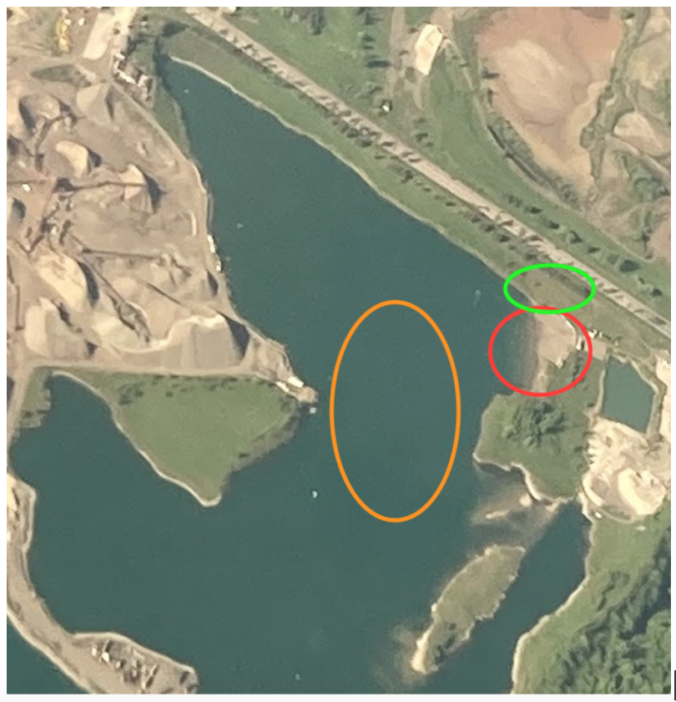
AN AERIAL SHOT OF C3 QUARRY-
ORANGE- OPEN WATER SWIMMING AREA
RED- BEACH, ENTRANCE AND EXIT OF WATER
GREEN- MEETING AREA, ENTRANCE TO BEACH, HOLDING AREA FOR GEAR, DRYLAND

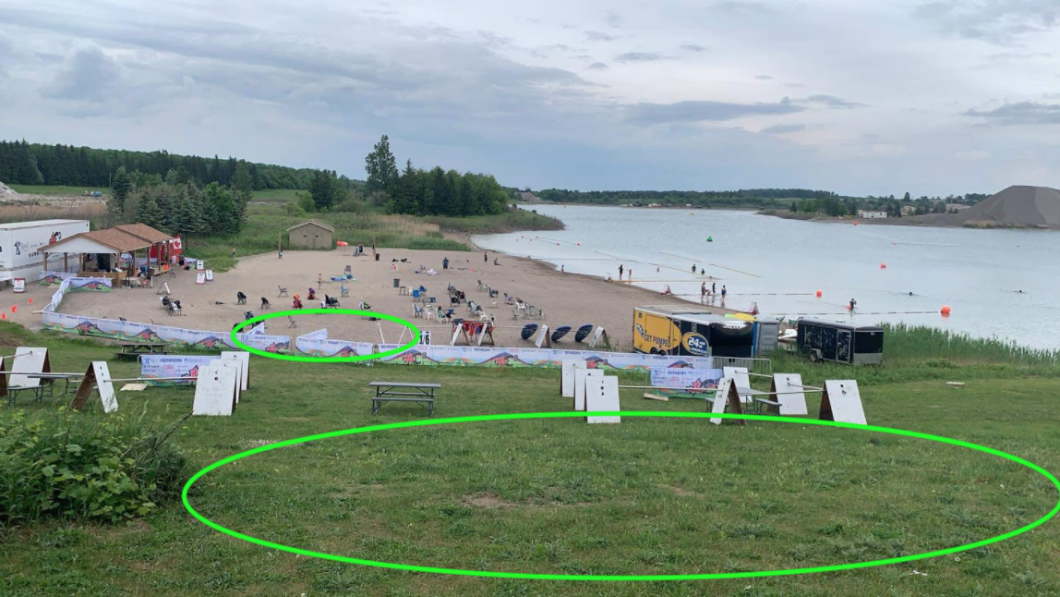
- PADDLE BOARD ENTRANCE FOR SWIM TEAMS ONLY
- ALL GREEN GRASS AREA SURROUNDING THE TEAM WAITING AREA

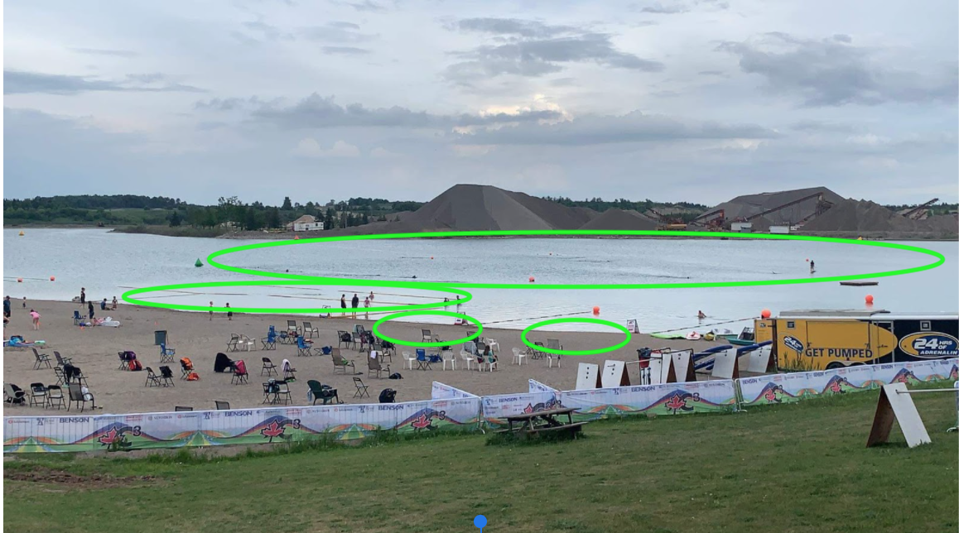
- OPEN WATER TRAINING AREA (400M AND 1000M LOOPS)
- 50M LANE AREA
- WATER EXIT AND ENTRANCE AREA

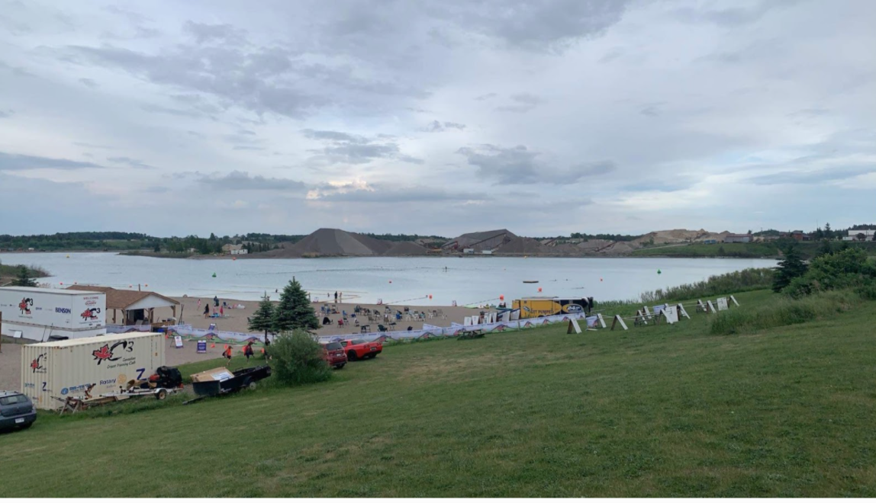
GRASSED AREA USED FOR MEETING AREA, ENTRANCE TO BEACH, HOLDING AREA FOR GEAR, DRYLAND

