Facilities
WLU Athletic Complex

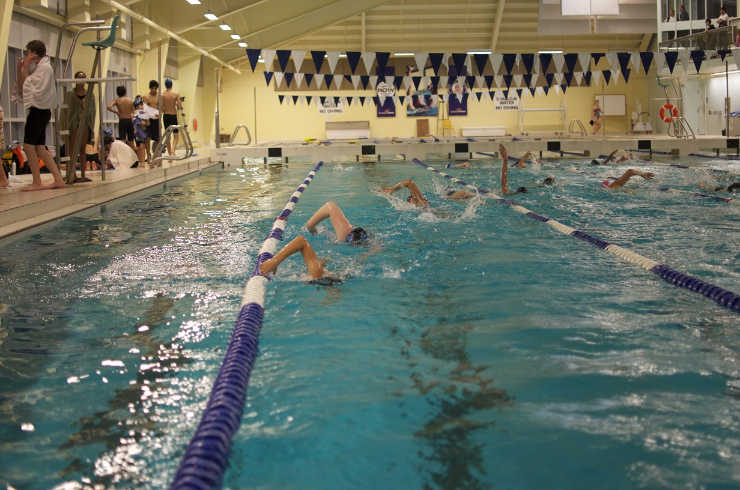

This Olympic length (50 m) pool features six lanes, however it is two lanes short of meeting National and Olympic standards. It is home to the Region of Waterloo (ROW) Swim Club, the Laurier Golden Hawk swimming team, the Laurier competitive lifeguarding team, prospective National Team members and many previous Olympic swimmers, as well as intramural water polo and recreation swim programs (both Laurier and Waterloo Region-related).

A gallery is located on the second floor of the Athletic Complex to view the pool activity below.

This facility does not have a nut-free policy.
Map to WLU Athletic Complex pool

Swimplex

The Waterloo Memorial Recreation Complex is home to the Waterloo Swimplex, a world class indoor facility, open year round.

This facility does not have a nut-free policy.

Map to Waterloo Recreation Centre

Breithaupt

Breithaupt's Centre has a 25 yard pool.

This facility does not have a nut-free policy.

Official Web site:
https://www.kitchener.ca/en/things-to-do/breithaupt-centre-pool.aspx

Address: 350 Margaret Ave., Kitchener, ON, CANADA, N2H 4J8 Telephone: 519-741-2502

Map to Breithaupt pool

Harry Class

Address: 45 Woodside Ave., Kitchener, ON, CANADA Telephone: 519-741-2481
The Harry Class outdoor pool is open during the summer season.

This facility does not have a nut-free policy.

Map to Harry Class pool

Cameron Heights

Address: 301 Charles St. E., Kitchener, ON, CANADA Telephone: 519-741-2482 Located in Cameron Heights Collegiate Institute. Not wheelchair accessible.

This facility does not have a nut-free policy.

Map to Cameron Heights pool

Forest Heights

Address: 253 Fischer Hallman Rd., Kitchener, ON, CANADA Telephone: 519-741-2493. Located next to Forest Heights Collegiate Institute

This facility does not have a nut-free policy.

Map to Forest Heights pool

