REgina Marlins Swim Club

2400 13th Ave Regina

REgina Marlins Return to swimming Plan

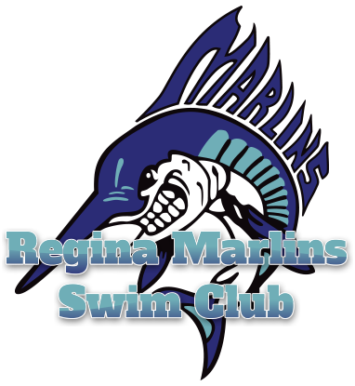

Regina Marlins

Return to Swimming Plan

The Regina Marlins are committed to providing a safe and challenging competitive swimming opportunity to Regina and surrounding communities.

## **RETURN TO COMMITTEE and CONTACT INFORMATION**

Melina Jenkins 306-789-7732   
Jessica George 306-536-2208   
Jeralyne Manweiler 306-581-7150  
Jennifer Bean, RN 306-530-2704

## **FACILITIES**

* Down Town YMCA   
  50.445730, -104.616093
* Lawson Aquatic Centre  
  50.451552, -104.630106

## **ACKNOWLEDGMENT and ASSUMPTION of RISK FORM**

* **All** Regina Marlins **swimmers and coaches will electronically complete an “Acknowledgement and Assumption of Risk Form” prior to participating in any club activities. This form will be completed within the Swimming Canada National Registration system for the 2020-2021 season and MUST be completed within 14 days of commencing participation. There are no exceptions.**

## **RISK ASSESSMENT**

* **Will the training be held in a community that has documented active local transmission of COVID-19 in the last 14 days?** *YES*
* **Will the training be held in a venue/facility with access by multiple groups?** YES
* **Will the groups include team members relocating from areas outside the training location that have documented active local transmission of COVID-19?** *NO*
* **Will the groups include participants (athletes and coaches) at higher risk of severe COVID-19?** *YES*
* **Is the training considered at higher risk of spread of COVID-19 (where physical distancing cannot be maintained, indirect contact through training equipment, etc.)?** *NO*
* **Will the training be held indoors?** *YES*
* **Has the club established stricter protocols?** *YES*

**PPE Plans:**

**Use of PPE**

* Coaches will be required to wear a non-medical face covering while on deck. One (1) plastic face shield will be provided, but it is recommended that they wear a cloth face mask as well.
* Athletes will be asked to wear a non-medical face mask upon arrival for instruction, which will be removed only when entering the pool. Athletes will be asked to re-apply the face mask after exiting the pool until safely outside of the facility or in their mode of transportation home.
* Any parents that need to walk athletes onto deck prior to training sessions (aged 7 and under only) will also be required to wear a face mask.

**Principles of Safe Sport and the** **Responsible Coaching Movement:**

* The Marlins will ensure that all club activities will be done in an open and observable environment. Open and Observable environments mean making meaningful and concerted efforts to avoid situations where a coach, official or other presentative might be alone with an athlete of any age.
* All interactions between an athlete and an individual who is in a position of trust should be in an environment or space that is both ‘open’ and ‘observable’ to others.
* Open and Observable environments also apply to all online (i.e. Zoom) and electronic communication (i.e. email, text), and should never be in the form of a one-on-one interaction; should always be done in a group setting.
* All training sessions must include a minimum of 3 people.
* Athletes are reminded not to ‘deck change’

**OVERARCHING HEALTH MEASURES**

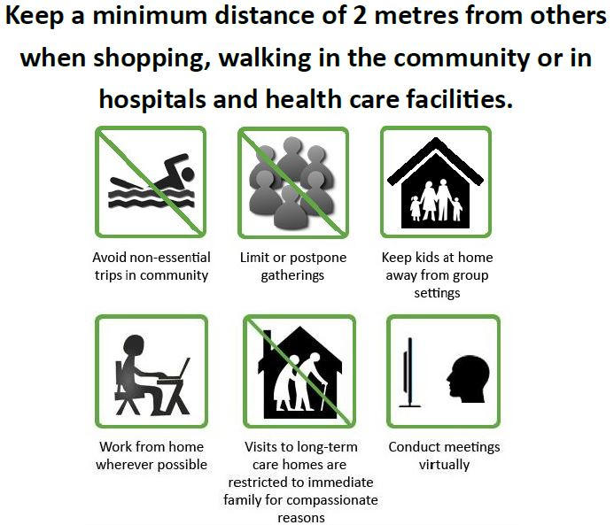**Our clubs plan adheres to the health measures provided by: Sask Health Authority and Swimming Canada’s overarching health, medical and safety information, and considerations.**

## **PROGRESSIVE, CONTROLLED PROGRAMMING**

1. **Phases of return**

Groups will be brought back to the pool using the top down method on an alternate schedule for the first 4 weeks (September 8- October 6). Groups of higher age and skill level will be brought in first, and each subsequent group will follow in two week increments. Groups in order of “top down” will be as follows:

Competitive (Senior, Red, Blue, White) - September 8

Non-Competitive - September 22

Mini Marlins (Mini 3 – October 6, Mini 2 – October 6, Mini 1 – November 4)

Group size and implementation of the next level will depend on the following:

* Continued health of athletes in current groups that are training
* Pool availability and scheduling to ensure groups and coaches are spaced to have minimal contact between groups
* Group size based on requirements of Swim Sask and Swim Canada
* Group Size based on space of facility

**Training Format and Pool Layout**

* Down Town YMCA
* Entrance will be through the front doors (South), on 13th Ave.
* Entry into the pool will be through gender specific change rooms.
* It is expected that athletes arrive in their training suits.
* Athletes will go directly to pool deck and will put bag and coat on a chair at their appointed area and stand in front of their chair to wait for direction prior to pool entry.
* When instructed to do so from the coach, athletes will circle back into the shower in the gender specific change rooms to rinse prior to pool entry.
* Upon completion of training, athletes will be guided to exit the pool following the coach’s commands.
* Once the athlete has collected their belongings, they will be instructed to leave the pool area via the gender specific change room.
* Coaches will exit through the Plus or family change room. There should be no athletes in these areas.
* When in the changing area, the athletes will maintain physical distancing by selecting benches at a minimum of 2 m in distance apart.
* Parents will pick athletes up at the end of practice. If an athlete needs to be met by the parent inside the building, wait in the hall at the front of the building, maintaining appropriate social distancing, to receive their swimmer. Or in the gender specific change room. Please ensure that your swimmer knows where to meet you post practice.
* Parents of Mini 1’s will be asked to stay on deck during practice times.
* Lawson Aquatic Centre
* Entrance and exit will be through the West doors on Elphinstone.
* Entrance and exit into the pool cell will be done through the change rooms.
* Athletes must follow guides on floor.
* Once on deck the athletes will be asked to put their bags in the designated areas for the duration of training.
* It is expected that athletes arrive in their training suits with clothing over top.
* The athletes will follow the coach into the change room, and any changing done in the facility MUST be done after the coach has left the change room.
* Athletes will wait inside, maintaining social distancing, until they see their means of transportation pull up in front of the West or East doors.

As per SHA physical distancing guidelines must be followed therefore, double lanes will need to be used; or if a single lane then only one swimmer per lane, except that swimmers from the same household may swim in a single lane together.

Training will be done in both Short Course Meters and Short Course Yards for competitive and non-competitive groups.

Training groups are small enough to start with appropriate pool spacing as shown below. Groups will be implemented to follow spacing guidelines.

Training for our Mini Marlins will be done in the ‘Small pool following the diagrams below. Swimmers in Mini 1 will each have a single lane to themselves.

* *Lane ropes will be installed every 2 lanes, to adhere to the physical distancing guidelines. Where a single lane is used only one swimmer will be allowed except for swimmers living in the same household may train together in the same single lane.*

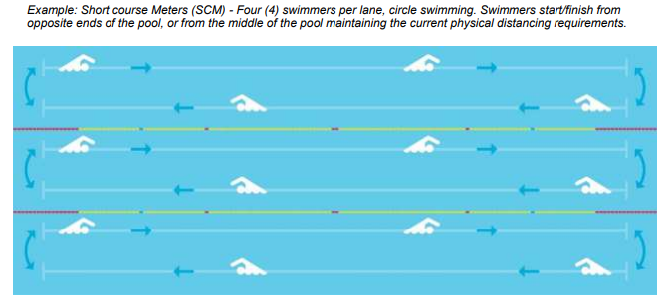



**Schedule**

* Competitive (Senior, Red, Blue, White) - September 8
* Non-Competitive - September 22
* Mini Marlins (Mini 3 and Mini 2 – October 6, Mini 1 – November 4)

*Please refer to pool schedule document for implementation of groups

**Exclusion Plans:**

* **All members must adhere to the rules, regulations, and protocols.**
* **If any swimmer or coach is sick, they MUST stay home.**
* **If any swimmer or coach should show any COVID-19 symptoms, they must not attend training.**
* **If a swimmer arrives at practice showing any symptoms, they must return home, stay home and self-isolate.**
* **They should call the Healthline at 8-1-1 to see if a COVID-19 test is required.**
* **Swimmers and coaches must see a physician and be cleared for training/coaching after being diagnosed or suspected to have COVID-19.**

**Refund Information**

Groups that are to be phased in as listed above, will be notified two weeks in advance of their potential start.

Families will not be billed regular monthly fees until their group is able to start. Half monthly fees will apply if groups are scheduled to start after the 15th of the month

Refunds of Marlins registration fees will only be available if a group is unable to return.

Refunds, due to a positive case within the club, of monthly fees will be determined by the COVID committee and the BOD.

There will be no refund of Swim Sask fees

## **DAILY TRAINING ENVIRONMENT**

Please refer to Daily Checklist, facility requirements, and [Marlins training questionnaire](https://docs.google.com/forms/d/e/1FAIpQLSckS1XC1dZ1EpvCvqt1HZca3WD81-N1Y9G-y4ubVQeOgZhZpg/viewform?usp=sf_link). Training schedules and group implementation will be based on access to facilities. Updated information will be communicated via email to Marlins membership.

**Below you will find our clubs daily training environment processes as they relate to COVID-19:**

**Arrival/Departure:**

* *Coaches should arrive at practice 15 minutes prior to the beginning of the practice.*
* *Swimmers should arrive no more than 10 minutes prior to the beginning of the practice.*
* *Please refer to the Marlins Daily Checklist provided on our website home page to ensure all steps have been followed*
* *Please refer to facility information for direction on what to do upon arrival at each facility*
* *All athletes and coaches must leave the facility immediately upon finishing the practice.*

**Athlete Intervention/Interaction:**

* *Online platforms will be used as needed to communicate with swimmers. Safe Sport and Rule of Two will also be adhered to online.*

**Attendance and Daily Screening**:

* Athletes, coaches, and staff must answer ‘NO’ to all the following questions prior to attending any training session (before arrival at the training session) digitally via the [Marlins Daily Questionnaire](https://docs.google.com/forms/d/e/1FAIpQLSckS1XC1dZ1EpvCvqt1HZca3WD81-N1Y9G-y4ubVQeOgZhZpg/viewform?usp=sf_link):
* Do I have any of the symptoms: cough, shortness of breath, chest pain, difficult breathing, fever, chills, repeated shaking with chills, abnormal muscle pain, headache, sore throat, painful swallowing, runny nose, new loss of taste or smell, gastrointestinal illness?
* Have I been in contact with or cared for someone with COVID-19 within the last 2 weeks?
* Coaches, Athletes or Volunteers will not be permitted to training if they are unable to answer NO to any of the above questions.
* Further investigation by the COVID committee will determine any individual with ‘YES’ answers prior to being permitted to continue with training.
* Stay home when sick, even with mild symptoms
* Any athlete or staff member that is required to leave a training session because of experiencing signs or symptoms consistent with COVID-19 is required to contact 811 to consider the appropriateness of further investigations. Further investigations may include a test for COVID-19, which then may lead to the notification of appropriate Public Health Officials regarding a positive test result. Public Health Officials will determine any requirements related to facility and/or group operations, as well as any requirements around contact tracing as it relates to managing the spread of the virus. The athlete or staff member may not return until receiving clearance from the physician, and if a test for COVID-19 was completed, a negative test result will be required before further training is permitted. If home isolation is required, guidelines have been provided in a subsequent section below.
* Staff or athletes at risk for severe illness from COVID-19 are recommended to review their specific health concerns with their primary care provider prior to attending training sessions.
* Common underlying health conditions which may place an individual at higher risk would include hypertension, heart disease, diabetes, obesity, chronic respiratory diseases such as asthma and those who are otherwise immunocompromised

**PROTOCOL FOR POSITIVE TEST**

If an athlete or staff member tests positive for COVID-19, the following steps must be taken:

• The athlete is removed from the training group immediately   
• Team training for that training group will be suspended and all team members are placed in self-isolation for 14 days

When an athlete, coach or staff is notified by SHA that they have tested positive for COVID-19 they will:

1. Provide SHA with the Club’s COVID-19 representative’s name and number Melina Jenkins, 306-789-7732, to assist with club related contact tracing.
2. Continue to self-isolate and follow all Sask Health Authority (SHA) instructions.
3. Only return to club activities as per club and SHA instructions.

 The club’s COVID-19 representative will:

1. Follow all instructions provided by SHA
2. Notify Swim Saskatchewan
3. Advise, at minimum those training in the same lane and may want to consider advising the rest of the training group/club about this positive test result to ensure that these team-mates are self-monitoring more closely. Any other athletes, coaches or staff, experiencing symptoms will be required to stay home and contact 811 for further guidance.

• Team training could resume if:

* All team members undergo self-isolation for 14 days and no other member has developed symptoms
* All team members are cleared to return to group training by their physician in accordance with Provincial guidelines

**HOME ISOLATION RECOMMENDATIONS**

If you find yourself ill with symptoms suggestive of COVID-19:

• Remain at home except to get urgent medical care

• Do not go to work, school, pool or other public places

• Cancel non-urgent appointments

• Do not use public transport

• Notify your doctor or local health department by phone, as testing may be required

• Monitor your symptoms and seek medical attention if you are having difficulty breathing, are unable to drink fluids, or if your illness is significantly worsening

• Wear a face mask when around others, particularly when physical distancing cannot be maintained

• Separate from household members, at least 2 meters always

• Do not have visitors

• Stay in a well-ventilated room (open windows) and use your own bathroom if possible

• Sanitize common use surfaces frequently

• If close contacts are vulnerable in terms of their health, consider alternative accommodations

• Avoid sharing household items

• Maintain excellent hand hygiene

• Follow any other local health regulations

**Equipment:**

• Clean equipment thoroughly with a disinfectant pre-and post-training session. Remember that COVID-19 can last between two hours and nine days on surfaces depending on many factors. Simple cleaning measures can inactivate the virus

• Athletes are not to leave equipment or mesh bags at the facility/site. All equipment needs to be brought home and thoroughly cleaned after each training session

• Personal items and clothing (backpacks, jackets, shoes, etc.) brought in by athletes, coaches, and staff should be kept to a minimum. Where bags must be brought in, they should be stored separately, with adequate space between each member’s items (re: backpacks left 2 meters apart on pool deck)

• Limit the amount of equipment to be brought into the pool throughout the return to sport process. The coach is required to communicate necessary swim training equipment prior to each session

• Athletes are not permitted to share any training equipment

• There is no permitted sharing of water bottles. Athletes, coaches, and staff are required to fill their personal water bottles at home, prior to leaving for the facility

• Coaches are not permitted to use whiteboards so that swimmers do not congregate around them, and to limit the spread through equipment. Use other means of communicating the training sessions to the swimmers such as bringing individual printed copies of the workouts

• Coaches are not permitted to share hand-held equipment such as stopwatches, clipboards or pens, with colleagues or others. Reminder to clean this equipment with disinfecting wipes pre-and post-training session

• In general, pool set-up such as putting in lane lines and backstroke flags will be left to the facility to complete.

**Mental Health**

* The Marlins will do verbal checks and follow up with families on mental health as we have in the past.

**Parents/Spectators**

* *There will be no spectators/additional people allowed on the pool deck during practice outside, other than coaches and athletes.*

**Emergency Action Plan (EAP)**

* The Marlins team will follow the facilities EAP when needing to vacate the facility for a power outage or emergency etc.

**Physical Distancing and Hygiene:**

* *Indoor pool training will consist of 4 swimmers per double lane-spaced accordingly and will use an evaluation period of at least 2 weeks before additional swimmers are added.*
* *Swimmers with hearing issues will not be placed in the middle of the pool, unless on the deck side.*
* *There will be no dryland training, to limit contact surfaces to be sanitized.*
* *Athletes and coaches will respect physical distancing during all aspects of training.*
* *There will be no passing allowed.*
* *Swimmers will adhere to the protocols established by the facility.*
* *Please follow facility guides for showering prior to entering the pool.*

**Training**

* *Instructions will be sent out via group electronic message in advance of the session (no one on one communication at less than 2 meters)*
* *In-person instruction will be given while maintaining physical distancing.*
* *The facility has stated it will provide visual markers to indicate appropriate spacing.*

**Travel**

* Travel for meets will be dependent on meets running. Travel to any meet outside of the city, as it has in the past, will be up to each individual family.
* **No inter-provincial or international travel.**

1. **COMMUNICATION**

.

* **All important information regarding swimming and COVID-19 will be accessible on the Regina Marlins Web Page. www.reginamarlins.com**
* **Any important information regarding any changes to swimming and COVID-19, and our training plan, will be communicated to our swimmers and coaches by email via TeamUnify**
* Any positive case within the club will be communicated through email, with a request of read-receipt

## **RE-EVALUATION PLANS**

* The Marlins COVID planning team will work to stay up to date with the newest information and re-evaluate and/or make necessary adjustments as new information emerges from Swim Canada, Swim Sask, our training facilities, and the Saskatchewan Health Authority.
* This Return to Swimming Plan will be re-visited and re-formatted when our mini marlins who need assistance are allowed back in the water. Diagrams and information directly related to the structure of teaching will be added at that time.

## **RESOURCES/REFERENCE LINKS**

* [**Swim Sask Covid-19 Resource**](http://www.swimsask.ca/news/covid-19.html) **link**
* [**Swimming Canada Covid-19 Resource Hub link**](https://www.swimming.ca/en/resource-hub/)
* [**Government of Sask - COVID-19**](https://www.saskatchewan.ca/government/health-care-administration-and-provider-resources/treatment-procedures-and-guidelines/emerging-public-health-issues/2019-novel-coronavirus/re-open-saskatchewan-plan/re-open-saskatchewan) **link**
* [**Government of Canada – COVID-19**](https://www.canada.ca/en/public-health/services/diseases/coronavirus-disease-covid-19.html) **link**