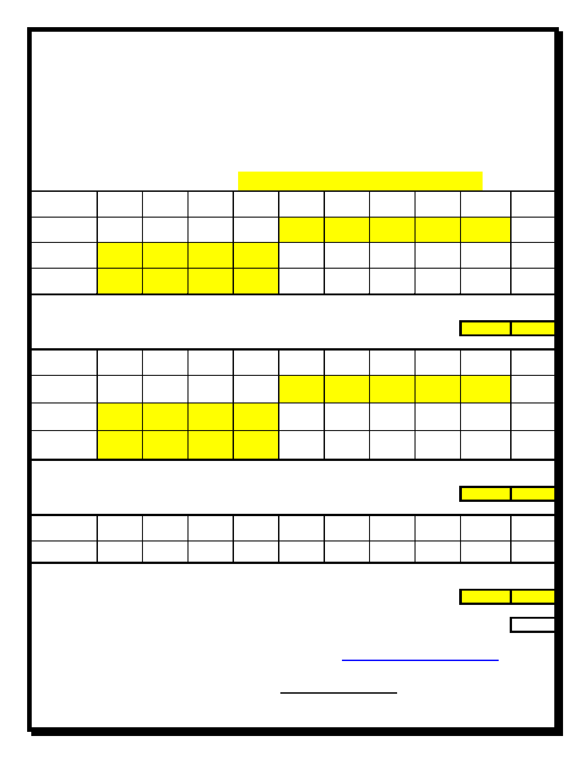

|  |  |  |  |  |  |  |  |  |  |  |  |  |  |  |
| --- | --- | --- | --- | --- | --- | --- | --- | --- | --- | --- | --- | --- | --- | --- |
| **ORDER FORM**  **2020 New Brunswick**  **Long Course Spring Championships  Saint John, NB**  **March 2022, 2020** | | | | | | | | | | | | | | |
| **Swim TEAM NAME:** | | | | |  | | | | | | |  | | |
| Item | Youth  Small | Youth Medium | Youth  Large | Youth  X-Large | | Adult  X-Small | Adult  Small | Adult Medium | Adult  Large | Adult  X-Large | | | | Total |
| Youth  T-Shirt |  |  |  |  | |  |  |  |  |  | | | | 0 |
| Ladies  T-Shirt |  |  |  |  | |  |  |  |  |  | | | | 0 |
| Mens  T-Shirt |  |  |  |  | |  |  |  |  |  | | | | 0 |
| Quantity | | | | | | | | | | | | | Amount | |
| (@ $30.00) 0 | | | | | | | | | | | | | 0 | |
|  | | | | | | | | | | | | |  | |
| Item | Youth  Small | Youth Medium | Youth  Large | Youth X-Large | | Adult  X-Small | Adult  Small | Adult Medium | Adult  Large | Adult  X-Large | | | | Total |
| Youth  Sweatshirt |  |  |  |  | |  |  |  |  |  | | | | 0 |
| Ladies Sweatshirt |  |  |  |  | |  |  |  |  |  | | | | 0 |
| Mens  Sweatshirt |  |  |  |  | |  |  |  |  |  | | | | 0 |
| Quantity | | | | | | | | | | | | | Amount | |
| (@ $50.00) 0 | | | | | | | | | | | | | 0 | |
|  | | | | | | | | | | | | |  | |
| Item | Youth  Small | Youth Medium | Youth  Large | Youth  X-Large | | Adult  Small | Adult Medium | Adult  Large | Adult  X-Large | Adult XX-Large | | | | Total |
| Sweatpants |  |  |  |  | |  |  |  |  |  | | | | 0 |
| Quantity | | | | | | | | | | | | | Amount | |
| (@ $40.00) | | | | | | | | | | | 0 | | 0 | |

**GRAND TOTAL**

$ 0

Please complete this page and forward your order to [alexander.keith@gmail.com](mailto:alexander.keith@gmail.com) before

**midnight** on **February 27, 2020**.

Please make cheques payable to: **SJFAC** (one cheque per team)

Orders must be paid in full at time of pick up.