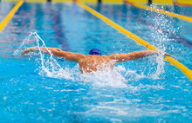
A LIST OF THINGS A NEW SWIM PARENT NEEDS TO KNOW

#1 EQUIPMENT
Thankfully swimming requires less equipment than most sports…and its small stuff!! Swimming Matters on Grant Ave is a great place to get all of this stuff. You will also receive a discount if you tell them, you are with the Seals. Here is a list of what your swimmer will need (depending on team/coach)
- Swim Suit: your swimmer will need at least one practice suit, 2 is even better. The chlorine is hard on them. One piece suit for girls and for boys they have a few options; Jammers that are tight and similar to bike shorts (most common), Square legs that go a few inches below their butt, and the Briefs that you would see on Olympic swimmers…some high school swimmers may choose these but most shy away from these. Once your swimmer starts competing, they will need a racing suit that is tighter and cost significantly more. Swimming Matters is a great place to try the suits as the brands differ in size

- Goggles: Invest in a good pair of quality googles and have a few pairs is best as they tend to get lost and/or broken

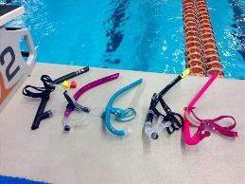
- Snorkel: The snorkel they will need is different than the one you see in summer at the beach. These ones have a front snorkel not one to the side

- Flippers/fins: you will want to get real swim flippers not scuba or the little toy ones. You buy them according to shoe size and they are meant to fit pretty snug. Ask around the team as there are probably hand me downs waiting to be taken off of someone’s hands

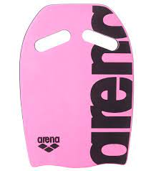
- Kickboard: you will need to have a kick board and just a suggestion…get an off color so it doesn’t look like everyone else’s

- Swim cap: your swimmer will need a swim cap…you can pick up a team one from your coach. They are available in silicone or latex. Latex is thin and super stretchy but it can pull the hair, and the silicon one is thicker and fits snug. The chlorine is so hard on their hair. Clarifying shampoo is also a good idea to use as their hair will be super dry.

- Back Pack and Mesh Bag: They will need a good bag for all their stuff. The Back packs are great! They have loads of pockets and they come with a wet bag to hang outside the backpack to keep the inside dry. A mesh bag is great to have so they can bring all their equipment on deck and it’s good to put all wet equipment back in so it can dry easily

** Don’t forget to label everything with a sharpie. The label stickers just fall off in the pool, please don’t use those**
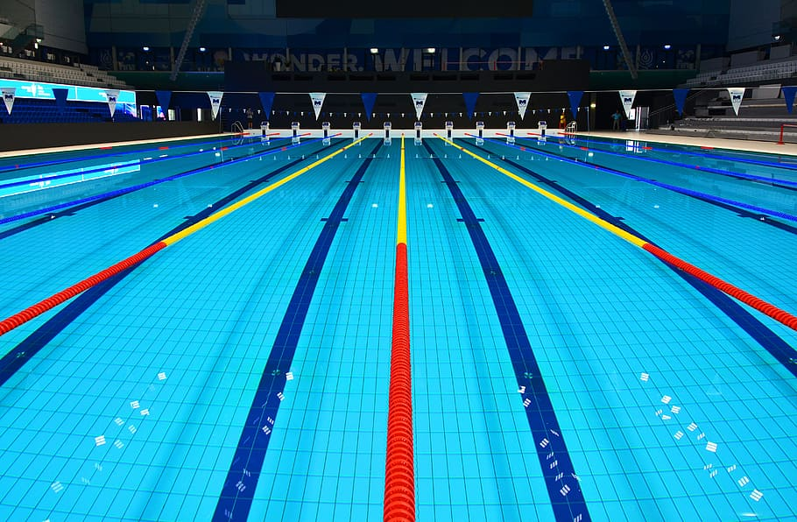
#2 TERMS TO KNOW
There are a lot of terms in swimming that you will need to know. Here is a rundown of the biggies
- Strokes: There are four main strokes your child will learn as a swimmer. The freestyle, backstroke, breast stroke, and butterfly. These are often shortened to free, back, breast and fly.
- Flip Turn: If you child is swimming freestyle or back stroke, they’ll learn to perform a flip turn at the end of each lap. Rather than coming up they’ll flip forward and kick off the wall
- Disqualified or DQ’d: There are stroke and turn judges that follow the swimmers alongside the pool making sure they follow the rules. They can be disqualified for a variety of things- touching the bottom or sides of the pool, adjusting their goggles during a race, doing a different stroke then they’re supposed to be doing, or going too early in a relay. You can get a complete list from your coach, or if your child is disqualified, they can tell you why
- Fly Over Starts: During a meet to make things go quickly they’ll often do fly over starts. What that means is that the swimmers who have just finished their race will stay in the water, while the swimmers getting ready to race step up on the block, and start their race “flying over” the swimmers still in the water. This helps keep the meet moving along and the swimmers have less time waiting for their events.
- The Block: Just another name for the platform the swimmers dive from.
- Seed Time: This is the record time your swimmer has for the event they’re swimming in. For instance, if they’re swimming the 5o freestyle for the second time, the time they had the first time they swam it will be their seed time. This is their best time ever and what they’ll be trying to beat! Often heats are organized by seed time putting the fastest swimmers against each other.
- Seeding Area: For the longest time I thought they were saying seating area… that seemed to make perfect sense. But it’s seeding. This is where the swimmers get organized the pre-lineup before their races. They’ll usually call events in batches, “Now seeding events 1-5” and the swimmers in those events go and get lined up.
- Heat Sheet: When you go to a meet you can usually buy a heat sheet for a couple of dollars however most clubs are going paperless so you can print it off at home before hand off the website or emailed from coach. This is a listing of all of the events, who is swimming and their seed time. It’s not necessary to purchase them but they can be nice to have to keep track of what your child is swimming, and see what their current record time is.
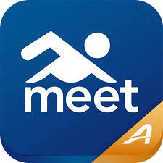
- Meet mobile: This is a very handy App to have available to both android and apple. There is a yearly fee under $10 and its so worth it. On here you can access all the meet info and heat sheets. You can track your swimmers’ times and races and follow the team success as well. It’s a great too!!
- “A” times and “AA” times: Once your swimmer starts competing you will hear these terms being used and it will be confusing at first. “A” times are the provincial times and the “AA”times are Man/Sask times…these are the most common at first. Once they make these then you will hear Western times and Olympic trials. There are charts for these times and I recommend pulling them up on your phone and taking a screenshot
- Long course and Short course: these are the length of the lanes in competitions and its either or. 25meter lanes are Short and 50meter lanes are long. The times are also different depending on length of course

#3 Races
In each race your child will swim one of the four basic strokes. The only exception is an IM (individual medley) where they’ll swim all four strokes in one race. Most races at the recreational level are 5o or 100 meters. There is usually a 200-meter freestyle and even a 500! There are also relay races, freestyle where everyone swims the free, and medley where each swimmer swims a different stroke when it’s their turn. The races are numbered with event numbers, and often there are multiple heats, or smaller races, within an event. The more popular races like the 50 free often have several heats

#4 Meets
I’m going to break this down into two parts; what to take and what to expect because there is a lot

What to take:
- Your team suit & an extra suit: it’s best to be prepared with an extra suit just in case of wardrobe malfunction!
- 2 Pairs of goggles: Once again it’s always best to have a spare, just in case!
- 2-3 Towels: When one gets soggy your swimmer will want another one! Another great idea is a robe or sweats and hoodie (even better…order a team one!!) to wrap up in after events!
- Snacks and/or concession stand money: Your swimmer will get HUNGRY, and most likely so will you. Take “real food” like sandwiches or salads, and a variety of snacks. Lots of drinks too!! There is a canteen available for food as well provided at most meets.
- Seating: Most meets are at PanAm Pool. If they are in the main tank seating is not a problem as they have lots. If the meet is in the Training Tank it’s a bit of a gong show. I would suggest bringing a lawn chair or a blanket to sit on. They do have some bleachers but not enough. Usually, we sit along the wall and wait for our swimmer to be up and then go close to the rail so you can watch. Be gracious to others who want to watch and take photos and then move out of the way after your swimmers finishes. Most other pools have adequate seating I have noticed

- Entertainment: There can be a lot of downtime between events so you should bring something along to keep entertained…especially if siblings tag along. Books, tablets (don’t forget chargers), magazines, coloring books… whatever your favorite boredom buster is!
- A Sharpie: As crazy as it sounds this is a must have. When your child is told their events they can use it to write them on their hand so they can remember what they’re swimming. You obviously don’t want it to wash off so it has to be permanent. Black works best, the colored ones seem to come off easier. A highlighter is great too for marking on the heat sheet when your swimmer is up (if you printed one)
- Meet Program: You can print out your meet program by going to the seals website and clicking on the meet program and printing it out. This comes in handy when you want to see when your swimmer is swimming. If you don’t want to print it or if you forget you can just pull it up on your phone https://www.teamunify.com/team/cansjssc/page/events/club-meets

What to Expect:
- Arrival time: You usually have to arrive at the pool about an hour before start time, your child will be told what events they are in and they’ll have a team warm up time.
- Volunteer positions: It takes a lot to run a meet so teams often need volunteers. If your able you can volunteer to help with the concession stand, timing the races, or organizing swimmers in the seeding area. There are online clinics on the Swim Canada website https://www.swimming.ca/en/registration/ where you can take online clinics that allow you to do most positions. Contact your team manager and they can help set you up to access these clinics. You can also volunteer without training as well in some areas however, it is best to complete at least the Intro to Swimming. This will set you up for some positions AND help you to know a bit of what’s going on and how YOU can help. Being on deck is a great way to watch your swimmer and to know what is going on.
- Keep in mind that Seals Swim Club and all the meets are volunteer run. All the officials, time keepers, computer people, organizers, hospitality, marshallers (cat herders lol) set up and cleanup crew, everyone involved to make the meets happen are not PAID positions which means we will only survive if we have volunteers.

- Meet Procedures: Once all teams have had a chance to warm up seeding will begin for the first several races. Meets begin with the National Anthem and then the races will start. The official will announce the first race, tell the swimmers to step up, take their mark, then signal the start of the race. The next race will step up and begin the same way. There is usually a break about half way through the meet so the swimmers can eat and rest a little.

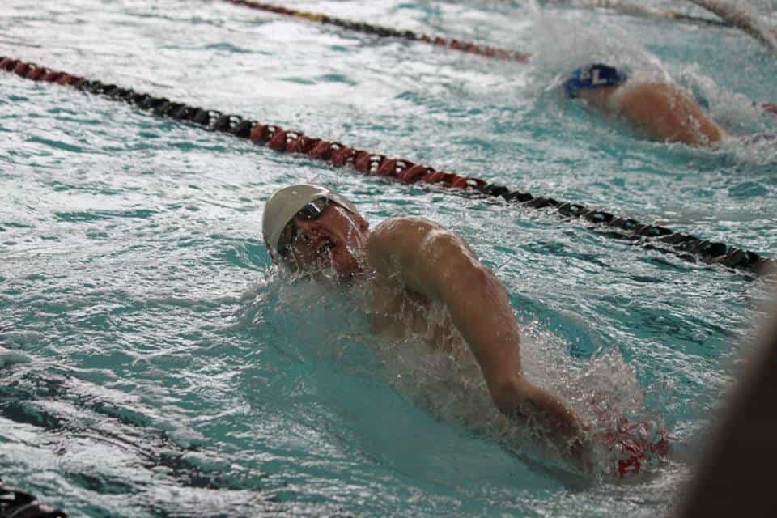

I have two kids with the St. James Seals at the competitive level and I have been inspired from my many years of confusion and feeling lost that I have decided to make this list for you. Please feel free to reach out to your coach, team manager, Pups Liason or even ME…I know how it feels to be at a practice or meet and be completely lost and my goal is to help you out!!
Swimming with the Seals has been so fun for both my kids and I have seen them both grow and develop confidence, friendship, physical and mental strength through swimming. They have a great time and have learned to push themselves! Being a swim mom is a bit tiring especially having two at this level it can be exhausting, early swim times, keeping towels clean, having snacks at all times…but it is well worth the journey.
I hope this helps as you and your child set out on the journey to becoming a swimmer and new swim mom (or parent)!
Just keep swimming!
~Melissa Grenkow
Meet Manager and Mom to Swimmers Hayden and Jilly!
melissagrenkow@gmail.com
meetmanagement@gmail.com

