Meet Information Package

Long Course
May 9th – 12th, 2019
London, Ontario

DATE(S): | Thursday, May 9th through Sunday, May 12th, 2019
HOSTED BY: | London Aquatic Club
LOCATION: | Canada Games Aquatic Centre  1045 Wonderland Road North  London, Ontario N6G 2Y9  (Between Gainsborough and Lawson Road. Map/Parking will be posted on the LAC Website.)
FACILITY: | Eight lane, 50 meter indoor tank with “Keifer” type lane markers; Daktronics 64101-H8 8 lane swimming scoreboard at both ends of pool with Swiss Timing Quantum Aquatic Timing System.
PURPOSE: | Long Course Invitational.
MEET PACKAGE: | The only meet package which will be considered as valid must be the most current version found on www.swimming.ca.
MEET MANAGER: | Christie Thomas  Mark Lukings | thomasdce@hotmail.com  mark.lukings@gmail.com
COMPETITION COORDINATOR: | Greg Lewis, Level 5 | britshay@sympatico.ca
MINOR OFFICIALS: | Rebecca Shearer  Stephanie Quigley  Sonya Beckett | lacminorofficials@hotmail.com
DESCRIPTION: | All Preliminary and Timed Final events on Thursday, Friday, Saturday and Sunday will be senior seeded and will run single-ended format.  12 and Under:  - All events will be Timed Finals and will swim in the afternoons plus Thursday evening.  13 and Over:  - The top 8 in each age group going to finals.  - 50m Fly, 50m Back, 50m Breast, 400m IM, 400m Free, 800m Free, and 1500m Free are Timed Finals.
COMPETITION RULES: | Sanctioned by Swim Ontario.  All current Swimming Canada (SC) rules will be followed.  All swimmers participating in a provincially sanctioned meet shall be required to comply with swimwear rule GR 5. Click HERE to view full details. For advance notification for exemptions or for clarification of the rule please see the Competition Coordinator.  Swimming Canada Competition Warm-Up Safety Procedures will be in effect. The full document can be viewed HERE.
AGE UP DATE: | Age determined as of first day of meet, Thursday, May 9th, 2019.

DIVE STARTS: |  | As per the Facility Rules for Dive Starts, this competition will be conducted as follows:  Starts will be conducted from Starting Platforms (blocks) as per FINA FR 2.3 and SW 4.1  - from deep end only.
RECORDS: |  | Swim Ontario has a completed certified pool length survey (25m and 50m pool only) for the aforementioned swimming pool and swim times achieved at this competition will be eligible for provincial or national records.
ELIGIBILITY: |  | All athletes must be registered as Competitive Swimmers with SC, or any other amateur swimming organization recognized by FINA. A valid SC registration number is required for all Canadian swimmers, and entries without a SC registration number will be declined entry.
QUALIFYING/  DE-QUALIFYING TIMES: |  | There are no qualifying times for events less than 200 m.  Standards for remaining events are as stated in the attached schedule.
 | ENTRY FEES: |  | $10.00 per swimmer per individual event for all events except 800 m and 1500 m.  $15.00 per swimmer 800 m and 1500 m individual events.  (includes HST – London Aquatic Club GST # R103378279)
 | PAYMENT: |  | Please submit one cheque for all club swimmers with your entries.  Payable to: London Aquatic Club
 | ENTRIES: |  | Entries will be at the discretion of the Meet Manager.  All entries must be in a Hy-Tek accepted format and be submitted through the SC online entries system at: www.swimming.ca.  Meet Management will not accept entries directly via any other means.  Please include appropriate Long Course (in meters) entry times. “NT” entries WILL NOT be accepted.  Each swimmer must swim in the proper age group, no swimming up is permitted.  Maximum number of individual events:  - 800 m (11 & Over) OR 1500 m (13 & Over) but not both events.  - Distance events may be limited to the top 40 total swimmers entered with equal gender representation.  - 13 and Over – 3 events Friday and Saturday mornings.  - 12 and Under – 3 events Friday and Saturday afternoons.  - Maximum of 3 entries in Sunday’s sessions.  - Swimmers MAY be limited to one of the two 400m events.  - 10 total events for the meet.  Coaches are asked to consider entering Athletes who will NOT be available for evening finals as exhibition in the morning preliminary events on Thursday and Friday.

ENTRY DEADLINE: | Entry Deadline: Monday, April 29th, 2019  You will be sent confirmation of receipt of your entries.  Please ensure that you check these entries and immediately contact the Meet Manager with any problems.
DECK ENTRIES: | Deck entries may be accepted (as Exhibition Swims) to fill empty lanes or scratched lanes, but will not be eligible for awards or prizes in those events.
DECK ENTRY FEES: | $12.00 per swimmer per individual event for all events except for 800 m and 1500 m.  $17.00 per swimmer for 800 m and 1500 m individual events.  Payable at the time of the request.  (includes HST – London Aquatic Club GST # R103378279)
SCRATCH RULES: | The scratch deadline for Finals sessions will be 30 minutes after the conclusion of the preliminary session. If a swimmer is a late scratch or is a no show or steps down for a Final swim that swimmer will not be allowed to swim any of their other events during that Final session. While there is no monetary penalty for Final scratches, to be fair to alternates, please inform us of all scratches. There will be marshaling for Finals and positive check-in for distance events.
AGE CLASSIFICATIONS: | Male and female:  Individual: 10 and Under; 11; 12; 13; 14; 15; 16 and Over.
AWARDS: | Individual events: age categories 10 and Under; 11; 12; 13; 14; 15; 16 and Over:  - Medals for 1st, 2nd, and 3rd; ribbons for 4th -8th.  - Awards for all events will be distributed by age and gender within the classifications listed above, even though some events may have had multiple ages and/or genders swimming together.
CONVERSION: | Any Short Course times submitted will be converted into Long Course times using MM7 default conversion factor. Coaches will be contacted if, after Short Course to Long Course conversion, a swimmer no longer qualifies for an event with a qualifying time.
PARA: | PARA swimmers will be officiated under WPS Swimming Rules.
TIME SPLITS: | The procedure for obtaining an 'Official Split' now requires that coaches make the request to the session Referee or Meet Management on a time card (provided by the Meet Office) prior to the race. The split for the lead-off leg in relays will still be regarded as an official split and therefore no request by coaches is needed for relays. However, in the new 'mixed gender' relays, lead-off times/splits are not considered “official splits' as per international practice.  Official Splits: Meet Management requires that any coach wishing to rely on a time achieved by the swimmer for an interval shorter than the total distance of the event shall so advise the Referee prior to the commencement of the session (or event) in question. Please note that the coach must provide 3 timers to complete this official split if requested by Meet Management.  Events finals (sessions 4 and 7) are NOT eligible for official splits.

MANAGEMENT ITEMS: | Meet Management reserves the right to split Preliminary or Timed Final sessions or age categories to ensure proper session lengths. Meet Management reserves the right to limit the number of entries and the number of swimmers in any event. Meet Management will notify clubs in the event of entry restrictions. Meet Management reserves the right to adjust the start times of sessions once the entry deadline passes and session durations are known.  Preliminary events with less than 9 swimmers will still swim – will not go straight to finals.  800 m and 1500 m Freestyle Events:  - Senior seeded and mixed gender.  - Will swim fastest to slowest.  - Will swim 1 heat of 800 m, 1 heat of 1500 m, alternating until there are only heats of one distance left. We will then continue with heats of the one distance.  - The 8 fastest seeded swimmers for each of the 800 m and the 1500 m Freestyle will swim one per lane, slower heats MAY swim 2 per lane. In this situation we will alternate by swimming two heats per distance at a time.  400 m Free and 400 IM Events:  - Will swim slowest to fastest.  - Will start with heats of whichever sex has the most heats and when the number of heats remaining for both sexes are equal we . . .  - Will alternate heats, 1 heat of women, 1 heat of men, 1 heat of women . . . and so on until all of the heats of the 400 m event are complete.  Sprint lanes for the last 20 minutes of warm-ups. Lanes 1 and 8 in the deep end only will be used for Sprinting and are designated as diving lanes with one way traffic only. PARA, Backstroke start lanes, and additional sprint lanes may also be designated, will be announced, and then will be controlled by the Safety Marshalls.  Meet officials will provide a safe environment and an organized competition. We are not responsible for the supervision of the athletes during the competition or during session breaks.  Backstroke ledges will be available and their use is optional. Swimmers and coaches are expected to know, understand, and follow rule SW6.1 regarding the backstroke start. Warnings will NOT be given.
CANCELLATIONS: | In the event of unforeseen circumstances beyond the control of the City of London or London Aquatic Club, (for example but not limited to; weather interruptions or facility malfunctions) that force the cancellation of all or part of the meet, a partial refund may be granted at the discretion of the Meet Manager.
COACH'S REGISTRATION: | Meet Management will cross-reference the list of coaches in attendance at this competition with the Swim Ontario Compliancy lists. If a coach is not on this list, Meet Management is obligated to enforce the SC policy and not permit that coach to attend the meet. Meet Management will forward to Swim Ontario a list of coaches who they have found to be in non-compliance.
MEET RESULTS: | The meet will run on Hy-Tek Meet Manager. Results will be posted on the LAC website www.londonaquaticclub.ca as quickly as possible and uploaded to www.swimming.ca within 48 hours of the completion of the meet. Unofficial results will also be posted to Meet Mobile following each event.

RECORDING OF THE MEET: | Only individuals who have made application and received authorization, in advance, to record the event, in any manner, in any medium or context now known or hereafter developed, shall be granted access and permission to do so. Please contact the Meet Manager for application and authorization.  Photographers must obtain authorization from Meet Management before the start of the meet to obtain access to the deck.
SAFETY AND LIABILITY: |  | Only participating swimmers, officials, certified registered coaches, and authorized people are allowed on deck.
FOREIGN COMPETITORS: |  | All swimmers and coaches must be duly registered and residents of the governing body for which they are competing. All swimmers and coaches must be in good standing with their respective governing swim body.  All swimmers and coaches must have primary residence within the province /state or country for which they claim registration. Proof of residency may be green card, student ID, driver’s license, college residence or other document as deemed acceptable by Swim Ontario and shall be submitted with the Proof of Residence and Registration Status form to Swim Ontario no later than 7 days prior to start of competition.
MIXED GENDER SWIMMING: |  | The host seeks an exemption from the requirement to swim events in gender separated events, on the following basis:  - Due to facility or time limitations, swimming separated by gender would not permit all swims to be completed while offering reasonable opportunities to swim for all participants, and in particular on an equitable basis for swimmers of each gender.  Mixed gender swims may also be permitted when, due to a missed swim, it is necessary for a Referee to seed a swimmer in a heat of the same or shorter distance, for competitors of the opposite gender, on an exception basis.  In spite of this rule, any swimmer who achieves a record time at any level (regional, provincial, national etc, whether age group or open) will not be recognized for that record unless the coach has advised the Referee prior to the start of the session that there is a possibility of the record being broken, and the Referee ensures that the swimmer competes with competitors of the same gender for his/her heat.  In the event that mixed gender swims are permitted pursuant to this policy, the results must still be posted separately by the gender of swimmers.
DURING THE MEET: |  | Parking & Accommodations:  - Parking and accommodation options will be posted on the LAC website – LAC Hosted Meets – LAC Hollandia Spring Invitational (http://www.londonaquaticclub.ca).  Concession:  - A snack bar will be open throughout the meet.  - Vendors will be on site.

SCHEDULE OF SESSIONS:
 | Session # | Date |  | Prelim/Final | Warm Up | Start | Finish | Estimated Duration
 | 1 | May 9th |  | Timed Final  11 & O – 800/13 & O - 1500 | 4:00 pm | 5:00 pm | 9:30 pm | 4:30
 | 2 | May 10th |  | Prelim/Timed Final  13 & O | 7:00 am | 7:45 am | 12:15 pm | 4:30
 | 3 | May 10th |  | Timed Finals  12 & U | 12:15 pm | 1:00 pm | 5:30 pm | 4:30
 | 4 | May 10th |  | Finals  13 & O | 5:30 pm | 6:30 pm | 8:30 pm | 2:00
 | 5 | May 11th |  | Prelim/Timed Final  13 & O | 7:00 am | 7:45 am | 12:15 pm | 4:30
 | 6 | May 11th |  | Timed Finals  12 & U | 12:15 pm | 1:00 pm | 5:30 pm | 4:30
 | 7 | May 11th |  | Finals  13 & O | 5:30 pm | 6:30 pm | 8:30 pm | 2:00
 | 8 | May 12th |  | Timed Finals  13 & O | 7:00 am | 7:45 am | 12:15 pm | 4:30
 | 9 | May 12th |  | Timed Finals  12 & U | 12:15 pm | 1:00 pm | 5:30 pm | 4:30

*** The above schedule is tentative. No session will be longer than 4.5 hours in length

SCHEDULE OF EVENTS: | See Event List - Appendix C on Page 10.
Appendix A

Canada Games Aquatic Centre

Event Procedure Policy For:
Meet Managers, Officials, Coaches, Athletes & Spectators
- The City Of London Aquatic Staff (and specifically the CGAC Deck Supervisor) will remain in control of the facility at all times during the event. Their decisions and instructions are to be complied with without argument by all participants, coaches and officials. In the event of an emergency, City staff will only transfer care of an individual to EMS personnel.
- No coach or official may permit a swimmer to enter the pool prior to the lifeguards being in place. No swimmer is to enter the pool without lifeguards in place.
- All participants must obey all pool rules as posted.
- No outside footwear may be worn on the pool deck by any participant, coach, official or any other person.
- No food of any kind is permitted on the pool deck, except for refreshments provided directly to officials.
- Coaches are responsible for the conduct of their team at all times in all areas of the facility.
- Participants / coaches are responsible for picking up their garbage and depositing it in waste containers; excessive garbage left on the pool deck will be billed as an additional staffing charge.
- Participants must be dry and wearing footwear on the upper level.
- Participants / coaches / officials must not leave belongings in front of access points, including but not limited to emergency exits, staff offices, first aid rooms, change rooms, etc.
- Parking is permitted in designated areas only; parking is not permitted on curbs or on grass areas surrounding the building. Signs will be posted indicating parking locations.
RZONE
Rzone is a program requiring all persons wishing to visit or use any City of London recreation facility, park, or program, to respect others and take responsibility in helping the City maintain a positive environment. The "R" in Rzone stands for Respect and Responsibility. Respect for yourself, Respect for others, and Responsibility for your actions. The Rzone program applies to all community organizations and individuals using City of London recreational facilities, parks, and programs.

Please review the information online at http://london.ca/rzone before attending this event.
Appendix B

City Of London By-Law

Single Use Disposable Water Bottles

According to the City of London by-laws, single use disposable standard water bottles can no longer be sold at events hosted at city-owned facilities.

We will continue with our Maximize Waste Diversion. Water coolers / city water taps will be available for water needs for our Athletes, Coaches, Officials, and Volunteers.

Please make sure that you bring a refillable water bottle with you to our meet.

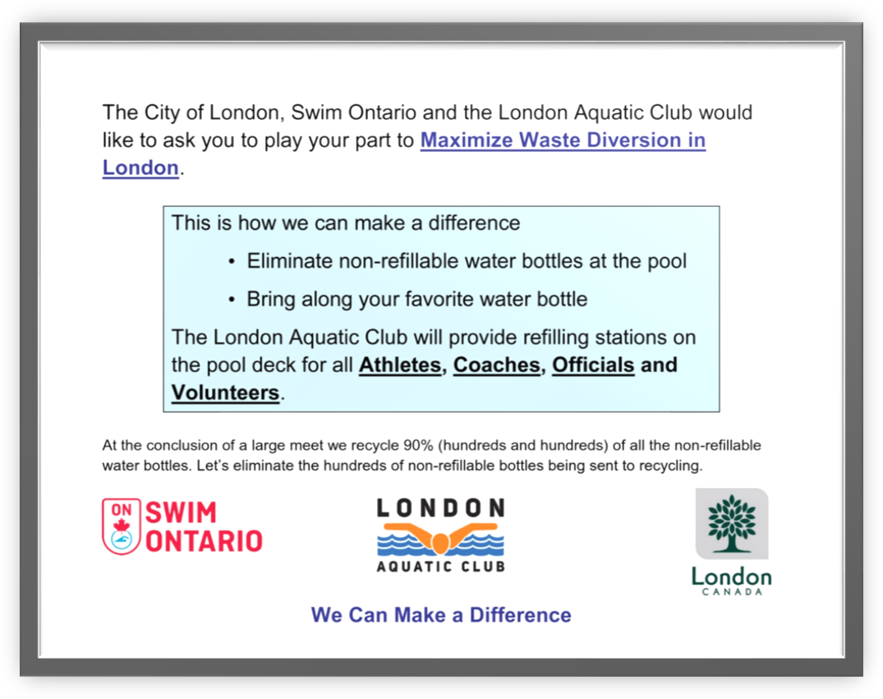
Appendix C

Event List

Session 1

Thursday Evening, May 9th, 2019

Distance - Timed Final
Warm Up ⇒ 4:00 pm Start ⇒ 5:00 pm Finish ⇒ 9:30 pm
Event # |  | Qualifying Time | Event  Mixed Senior Seeded  Fast to Slow | Qualifying Time | Event #
Women |  |  |  |  | Men
1 |  | 10:46.14 | Timed Final - 800 Free - 15 & O | 10:46.14 | 1
 |  | 11:41.79 | Timed Final - 800 Free - 13 & 14 | 11:41.79
 |  | 13:36.25 | Timed Final - 800 Free - 11 & 12 | 13:36.25
2 |  | 20:15.31 | Timed Final - 1500 Free - 15 & O | 20:15.31 | 2
 |  | 21:30.83 | Timed Final - 1500 Free - 13 & 14 | 21:30.83

Session 2

Friday Morning, May 10th, 2019

Preliminaries
Warm Up ⇒ 7:00 am Start ⇒ 7:45 am Finish ⇒ 12:15 pm
Event # |  | Qualifying Time | Event  Senior Seeded  Slow to Fast | Qualifying Time | Event #
Women |  |  |  |  | Men
3 |  | 2:47.70 | Prelim - 200 IM - 15 & O | 2:41.69 | 4
 |  | 3:04.33 | Prelim - 200 IM - 13 & 14 | 2:59.36
5 |  |  | Prelim - 100 Back - 13 & O |  | 6
7 |  | 2:51.02 | Prelim - 200 Fly - 15 & O | 2:45.52 | 8
 |  | 3:08.79 | Prelim - 200 Fly - 13 & 14 | 3:06.84
9 |  | 3:08.47 | Prelim - 200 Breast - 15 & O | 3:05.98 | 10
 |  | 3:26.75 | Prelim - 200 Breast - 13 & 14 | 3:22.57
11 |  |  | Prelim - 100 Free - 13 & O |  | 12

Session 3

Friday Afternoon, May 10th, 2019

Timed Finals
Warm Up ⇒ 12:15 pm Start ⇒ 1:00 pm Finish ⇒ 5:30 pm
Event # |  | Qualifying Time | Event  Senior Seeded  Slow to Fast | Qualifying Time | Event #
Women |  |  |  |  | Men
13 |  |  | Timed Final – 50 Free – 12 & U |  | 14
15 |  |  | Timed Final - 100 Fly – 12 & U |  | 16
17 |  | 3:28.74 | Timed Final – 200 Back - 11 & 12 | 3:30.59 | 18
 |  | 3:58.21 | Timed Final – 200 Back - 10 & U | 3:58.21
19 |  |  | Timed Final - 100 Breast - 12 & U |  | 20
21 |  | 3:07.12 | Timed Final – 200 Free 11 & 12 | 3:07.81 | 22
 |  | 3:30.34 | Timed Final – 200 Free 10 & U | 3:30.34

Session 4

Friday Evening, May 10th, 2019

Finals
Warm Up ⇒ 5:30 pm Start ⇒ 6:30 pm Finish ⇒ 8:30 pm
Event # |  | Qualifying Time | Event  Finals - 13; 14; 15; 16 & O | Qualifying Time | Event #
Women |  |  | Top 8 in each age group |  | Men
3 |  |  | Final - 200 IM |  | 4
5 |  |  | Final - 100 Back |  | 6
7 |  |  | Final - 200 Fly |  | 8
9 |  |  | Final - 200 Breast |  | 10
11 |  |  | Final - 100 Free |  | 12

Session 5

Saturday Morning, May 11th, 2019

Preliminaries
Warm Up ⇒ 7:00 am Start ⇒ 7:45 am Finish ⇒ 12:15 pm
Event # |  | Qualifying Time | Event  Senior Seeded  Slow to Fast | Qualifying Time | Event #
Women |  |  |  |  | Men
23 |  |  | Prelim – 50 Free – 13 & O |  | 24
25 |  |  | Prelim – 100 Fly – 13& O |  | 26
27 |  | 2:45.43 | Prelim – 200 Back - 15 & O | 2:40.38 | 28
 |  | 3:00.40 | Prelim – 200 Back - 13 & 14 | 2:58.39
29 |  |  | Prelim – 100 Breast - 13 & O |  | 30
31 |  | 2:27.13 | Prelim – 200 Free - 15 & O | 2:21.32 | 32
 |  | 2:41.91 | Prelim – 200 Free - 13 &14 | 2:37.95

Session 6

Saturday Afternoon, May 11th, 2019

Timed Finals
Warm Up ⇒ 12:15 pm Start ⇒ 1:00 pm Finish ⇒ 5:30 pm
Event # |  | Qualifying Time | Event  Senior Seeded  Slow to Fast | Qualifying Time | Event #
Women |  |  |  |  | Men
33 |  | 3:31.15 | Timed Final – 200 IM – 11 & 12 | 3:35.48 | 34
 |  | 3:55.20 | Timed Final – 200 IM - 10 & U | 3:55.20
35 |  |  | Timed Final – 100 Back - 12 & U |  | 36
37 |  | 4:08.25 | Timed Final – 200 Fly - 11 & 12 | 4:08.25 | 38
39 |  | 3:57.94 | Timed Final - 200 Breast - 11 & 12 | 3:57.94 | 40
 |  | 4:38.00 | Timed Final - 200 Breast - 10 & U | 4:38.00
41 |  |  | Timed Final - 100 Free – 12 & U |  | 42

Session 7

Saturday Evening, May 11th, 2019

Finals
Warm Up ⇒ 5:30 pm Start ⇒ 6:30 pm Finish ⇒ 8:30 pm
Event # |  | Qualifying Time | Event  Finals - 13; 14; 15; 16 & O | Qualifying Time | Event #
Women |  |  | Top 8 in each age group |  | Men
23 |  |  | Final – 50 Free |  | 24
25 |  |  | Final – 100 Fly |  | 26
27 |  |  | Final – 200 Back |  | 28
29 |  |  | Final – 100 Breast |  | 30
31 |  |  | Final – 200 Free |  | 32

Session 8

Sunday Morning, May 12th, 2019

Timed Finals
Warm Up ⇒ 7:00 am Start ⇒ 7:45 am Finish ⇒ 12:15 pm
Event # |  | Qualifying Time | Event  Senior Seeded  Slow to Fast | Qualifying Time | Event #
Women |  |  |  |  | Men
43 |  | 5:55.94 | Timed Final - 400 IM - 15 & O | 5:43.00 | 44
 |  | 6:29.95 | Timed Final - 400 IM - 13 & 14 | 6:18.12
45 |  |  | Timed Final – 50 Fly - 13 & O |  | 46
47 |  |  | Timed Final – 50 Back - 13 & O |  | 48
49 |  |  | Timed Final – 50 Breast - 13 & O |  | 50
51 |  | 5:11.15 | Timed Final - 400 Free - 15 & O | 5:03.83 | 52
 |  | 5:39.03 | Timed Final - 400 Free - 13 & 14 | 5:36.11

Session 9

Sunday Afternoon, May 12th, 2019

Timed Finals
Warm Up ⇒ 12:15 pm Start ⇒ 1:00 pm Finish ⇒ 5:30 pm
Event # |  | Qualifying Time | Event  Senior Seeded  Slow to Fast | Qualifying Time | Event #
Women |  |  |  |  | Men
53 |  | 7:40.02 | Timed Final - 11 & 12 - 400 IM | 7:40.02 | 54
55 |  |  | Timed Final – 50 Fly - 12 & U |  | 56
57 |  |  | Timed Final – 50 Back - 12 & U |  | 58
59 |  |  | Timed Final – 50 Breast - 12 & U |  | 60
61 |  | 6:34.33 | Timed Final - 400 Free - 11 & 12 | 6:39.47 | 62
 |  | 7:47.44 | Timed Final - 400 Free – 10 & U | 7:47.44

