Ingersoll
Christmas Invitational
Tillsonburg Community Centre
46 Hardy Ave.
Tillsonburg, Ontario

ISS Christmas Invitational
November 30th and December 1st, 2019
FACILITIES:  SAFETY/LIABILITY: | 6 lane 25m pool Dolphin Timing System  Swimming Canada and Swim Ontario believes that athletes, coaches, officials, support staff and volunteers have the right to participate in a safe and inclusive sport environment that is free of abuse, harassment and discrimination. For additional resources click HERE.  Only participating swimmers, officials, certified registered coaches, and authorized people are allowed on deck.  Rowan’s Law – Concussion Management  The Rowan’s Law requirements came into effect on July 1, 2019. Swim Ontario takes the health and well-being of all participants in sport and recreation activities very seriously and is committed to helping all in the Swim Ontario family succeed in swimming and other activities. Parents, coaches, officials, volunteers and swimmers all have a role to play in ensuring the safety of all participants at sanctioned competitions in Ontario. We must create an environment that encourages and motivates participants to assume responsibility for their own safety and the safety of others. Until further protocols or procedures are in place, the concussion management protocol will take effect for all participants at a Swim Ontario sanctioned competition that are involved in an incident resulting in a significant impact to the head, face, neck or body. If symptoms of a possible concussion are present the participant shall be removed from any further Swim Ontario sanctioned activity until they receive Swim Ontario approval upon clearance, in writing, by a medical professional with experience in concussion treatment/protocols. For full details and resources on Rowan’s Law and Concussion management protocols click HERE.  Open and Observable Environment  Swimming Canada and Swim Ontario is dedicated to providing a safe and inclusive environment, which involves promoting Open and Observable Environments. This means making meaningful and concerted efforts to avoid situations where a coach/official/staff member, etc. might be alone with an athlete. All interactions between an athlete and an individual who is in a position of trust should normally, and wherever possible, be in an environment or space that is both ‘open’ and ‘observable’ to others.  Event Photography/Videography  In order to minimize risk, all photographs and video taken at Swimming Canada/Swim Ontario sanctioned competitions, whether taken by a professional photographer or videographer, spectator, team support staff or any other participant, must observe generally accepted standards of decency. Under no circumstances are cameras or other recording devices allowed in the area immediately behind the starting blocks during practice or competition starts, or in locker rooms, bathrooms, or any other dressing area. For full details click HERE  Only individuals that have made application and received authorization to record the event, in any manner, in any medium or context now known or hereafter developed, shall be granted access to the designated deck area and permission to do so. Please contact Meet Management for application and authorization.
MEET MANAGEMENT: | Meet Manager: Shelly Brearley threeburlyones@rogers.com  Competition Coordinator:  Rusty Pittock – Level V monsterdark@sympatico.ca
COACH’S REGISTRATION: | Meet management will cross reference the list of coaches in attendance at this competition with the Swim Ontario Compliance lists. If a coach is not on this list, meet management is obligated to enforce the Swimming Canada policy and not permit that coach to attend meet. Meet management will forward Swim Ontario a list of coaches who they have found to be in non-compliance.
ENTRY DEADLINE:  ENTRY FEE: | Monday November 25th, 2019  All entries must be in Hy-tek format and submitted via www.swimming.ca  No entries will be accepted directly by meet management.  Individual Event : $10.00  Relay Event: $12.00  Splash Fee: $5.00/swimmer  Please make cheques payable to Ingersoll Speed Sharks. Cheques must be given to the meet manager during warm-up. Full payment required for all scratches made after the ENTRY deadline.
MEET RESULTS:  OFFICALS:  RECORDS: | Will be posted to www.swimming.ca within 48 hours of the meet’s completion.  Officials from all clubs are invited to sign up to officiate at this meet.  Please contact the Officals Chair Sharon Currah – speedsharksofficials@gmail.com for ‘Timer’ and ‘Strokes and Turns’ positions or  Competition Coordinator - Rusty Pittock - monsterdark@sympatico.ca for senior official positions.  Swim times achieved at this competition will NOT be used for applications of provincial and national records.
ENTRY LIMITATIONS: | Swimmers will be limited to 3 individual events per session.  Each Club will be limited to 2 relay teams per Gender.  All events are pre-seeded.  Deck Entries are Exhibition Only. They are not eligible for scoring or awards. Deck entries will be accepted for empty lanes only (no new heats will be created). Swimmers entered on deck must have valid proof of SC registration as an active, registered, competitive swimmer. A fee of $12.00 per event will apply.  All events will be swum as time finals.  No session will be longer than 4.5 hours in length.  Due to pool time restrictions meet management reserves the right to:  1. Amend warm-up and start times according to number of entries received.  2. Cancel relays should sessions run late.  3. Limit number of swimmers in an event and or run events in multiple sessions if necessary.  4. Limit number of heats in any particular event(s).
DATE & TIMES: | Saturday November 30, 2019  Warm-Ups: 12:15 pm – 1:15 pm  Start: 1:15 pm  Sunday December 1, 2019  Warm-Ups: 7:30 am – 8:30 am  Start: 8:35am  Meet management reserves the right to alter warm up times and start times based on entries received.
AWARDS: | Ribbons will be awarded for 1st to 8th place  age groups are: 6 & under, 7-8 , 9-10, 11- 12, 13-14, 15 & over  Bell Prizes will be randomly given out for winner of the heat
COMPETITION RULES:  DIVE START: | Sanctioned by Swim Ontario.  All current Swimming Canada (SC) rules will be followed.  SwImming Canada Competition Warm-Up Safety Procedures will be in effect. The full document can be viewed HERE.  All swimmers participating in a provincially sanctioned meets shall be required to comply with swimwear rule GR 5. Click HERE to view full details. Advanced notification for exemption or for clarification of the rule please see the Competition Coordinator.  Swimmers will not be penalized for scratching from preliminary heats or timed finals.  Coaches are responsible to inform their swimmers before arrival of the Safety Rules as contained in this package and to ensure their adherence and the athletes disciplined behavior.  Meet Officials will provide a safe environment and an organized competition. We are not responsible for the supervision of the athletes during the competition and especially during session breaks.  “Meet management requires that any coach wishing to rely on a time achieved by the swimmer for an interval shorter than the total distance of the event shall so advise the Referee prior to the commencement of the session (or event) in question.”  The only meet package that will be considered as valid will be the most current version found on www.swimming.ca  As per the Facility Rules for Dive Starts, this competition will be conducted as follows:  - Starts will be conducted from Starting Platforms (blocks) as per FINA FR 2.3 and SW 4.1  - from deep end only  and/or  - Starts will be conducted from the Deck or Bulkhead as per Canadian Facility Rule CFR 2.3.1 and CSW 4.1.1  - from deep end only  and/or  - In-water starts will be conducted as per Canadian Facility Rule CFR 2.3.1 and CSW 4.1.2  - from both ends |  | Athletes ages are to be submitted as of Saturday, December 1, 2018.
ELIGIBILITY: | All athletes must be registered as Competitive swimmers with Swimming Canada (SC) and have a valid SC registration number. Swimming Canada entries without a valid SC registration number and registration status will be declined entry.  Foreign competitors are welcome, subject to the provisions below.  All foreign competitors must be registered with an amateur swimming organization recognized by FINA. All foreign swimmers and coaches must be duly registered and residents of the governing body for which they are competing. All swimmers and coaches must be in good standing with their respective governing swim body.  All foreign swimmers and coaches must have primary residence within the province /state or country for which they claim registration. Proof of residency may be green card, student ID, driver’s license, college residence or other document as deemed acceptable by Swim Ontario and shall be submitted with the Proof of Residence and Registration Status form to Swim Ontario no later than 7 days prior to start of competition.
MIXED GENDER: | An exemption from the requirement to swim events in gender separated events due to limited time, developmental opportunities or facility requirements and/or due to a missed swim, where on an exception basis, a referee agrees to have the swimmer swim with a heat of an opposite gender event.  In spite of these exemptions, any swimmer who achieves a record time at a competition that recognizes records at any level (regional, provincial, national etc, whether age group or open) will not be recognized for that record unless the coach has advised the referee prior to the start of the session that there is a possibility of the record being broken, and the referee insures that the swimmer competes with competitors of the same gender for his/her heat.  In the event that mixed gender swims are permitted, the results must still be posted separately by gender of swimmers.
AGE UP DATE: | Athletes ages are to be submitted as of Saturday November 30, 2019

Saturday November 30, 2019
Warm-Ups: 12:15 pm – 1:15 pm
Start: 1:15 pm
Event Numbers Girls | Age Group Distance and Stroke | Event Numbers Boys
1 | Open 50 Breast | 2
3 | Open 100 Back | 4
5 | Open 200 Free | 6
7 | Open 100 Fly | 8
9 | Open 200 Breast | 10
11 | Open 100 IM | 12
13 | Open 50 Free | 14

Sunday December 1, 2019
Warm-Ups: 7:30 am – 8:30 am
Start: 8:35 am
Event Number Girls | Age Group Distance and Stroke | Event Numbers Boys
15 | 8 & Under 25 Fly | 16
17 | Open 50 Fly | 18
19 | Open 100 Breast | 20
21 | 8 & Under 25 Back | 22
23 | Open 200 Fly | 24
25 | Open 100 Free | 26
27 | 8 & Under Breast | 28
29 | Open 200 Back | 30
31 | Open 200 IM | 32
33 | 8 & Under 25 Free | 34
35 | Open 50 Back | 36
37 | 8 & Under 100 Free Relay (4 x25) | 38
39 | 9 to 10 200 Free Relay (4 x50) | 40
41 | 11 to 12 200 Free Relay (4 x50) | 42
43 | 13 to 14 200 Free Relay (4 x50) | 44
45 | 15 & Over 200 Free Relay (4 x50) | 46

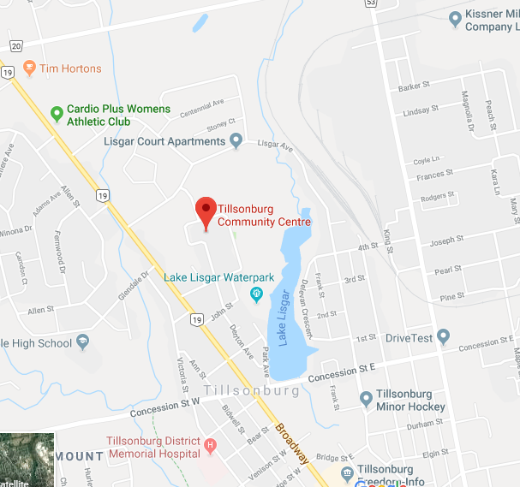

OFFICIALS VOLUNTEER LIST:

CLUB:
Please list people who will be at the meet and would be willing to offer their services in officiating. Please submit with meet entries if possible, or EMAIL to Competition Coordinator: monsterdark@sympatico.ca

NAME | LEVEL | SESSION | POSITIONS QUALIFIED | PREFERENCE(S)

- CLUB SPONSORS

