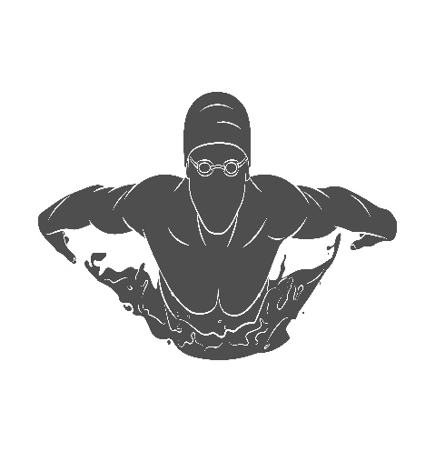
Off the Blocks

Greetings to our swimmers and their families. I hope everyone is well and staying engaged with our club through our various on-line offerings. This season has been like no other but despite all the challenges I’m confident we can come out of the other side of this with a stronger sense of team and connection.
We are now past the halfway mark of the season and are now looking at the final 1/3rd of our season and we have some big plans in store. I remain confident that we will be able to offer a sanctioned event to put up some official times when we know when the current lockdown will lift. Historically I have always had a final social event at the end of the season and I remain confident we can be creative and offer a great event for all our members to reflect on this season and celebrate our successes
Happy reading,
Coach John

Important Dates
April 12 – school/swimming break
May 24 – Canadian Olympic Trials (Toronto)

FAQ
Q: How will coaches keep our swimmers motivated this season?
A: Our coaches have a weekly meeting to discuss ideas and handle situations as a team. We have had challenges in our dryland program that has touched on different groups. We offer a social activity on Friday’s that have proved popular and we still have a few ideas up our sleeve.
Q: How do we communicate with the club?
A: Coaching – Head Coach John (coach.john@hotmail.com)
Administration – Liisa admin@thunderbolts.ca
Board – President Megan Harri boltspres@gmail.com

National & Provincial news

Congratulations to our swimmers that have trained with effort and grace as we enter the final 1/3rd of our season. We have had many challenges and still more to face but I am proud of the swimmers and want to reinforce the message that what we do now will have a gratifying pay-off in the upcoming season. A swim career is not just composed of many swim seasons it is a package deal even with an off-season. What you do as young swimmer sets you up for the higher groups. What you do this season will set you up for a post-secondary swimming career.
I feel it is important to talk about consistency and how it applies to a swimmer’s development and success. While this season has proven challenging unlike no other consistency is something you can control and maintain. I believe success is something a club needs to plan for and expect and not something that happens by accident. A few examples of consistency I would like to see our provincial/national group strive for:
- Consistent sleep patterns - we may not have to wake up early in the morning but don’t let this be a reason to now sleep in excessively. When we return to the pool we will be at full schedule and athletes need to be ready
- Consistent workout schedule – during lockdown it’s important to maintain as similar a schedule as possible. We do provide hour long workouts 4X week but I encourage swimmers to maintain another 2-4 cardio sessions a week of running, biking, skipping etc. If athletes need ideas or help I encourage them to reach out to me
- Consistent connection with their swim team – We do a weekly group check-in during lockdowns and this is my NUMBER ONE tool for evaluating the athletes and developing our program. I strongly encourage athletes to attend these check-in’s even if they can’t attend our other virtual offerings.
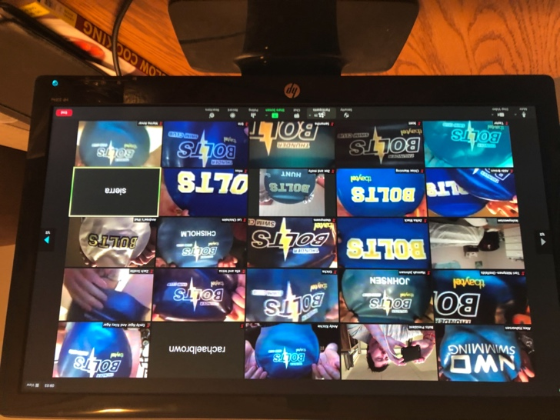
A nice reminder of teamwork from our bolts!
Several of our swimmers are in Grade 10 or above and these are the athletes that need to start considering their swim career post-Thunderbolts. We had a great webinar a month ago about how to get recruited and I’ve been talking to several coaches in Canadian Universities and American universities and they all say the same thing when I ask them “how are you going to recruit Canadian swimmers that can’t put up official times?”. The response is surprisingly similar, Times in competition have now taken a backseat to the following:
- Swimmers knowing their times in test sets (ie: 20X50m best avg @ 1:30) are a great example for a potential university swimmer
- Filming some of your in-training races and sending them to coaches is a great way for a coach to know what your underwater work and stroke counts look like.
- Knowing what your weekly volume and # of training sessions are and asking me about our training such as:
  - What’s the focus for the workout
  - What’s the plan for the week
  - How much of a certain color are we doing
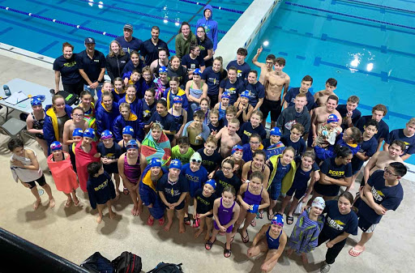
A nice reminder of what we are working towards and striving for everyday!
Stay Safe and stay active and most of all stay connected to each other, Hopefully we are back in the water come January!

Coach john!

Junior and Senior Development group news

One Fish Two Fish Red Fish Blue Fish
One fish, Reid fish, Rudy fish, Ben fish,
Emily fish, Hayden fish, Sophie fish, Paige fish.
This one has some nice pink fins.
This one under waters spins.
Say! What a lot of fish there are!
Some are gold, and some are blue.
Some are old and some are new.
Some are mad, and some are glad,
And some are very, very sad.
Why ARE they mad and glad and sad?
I do not know, ask Addi Prad.
One is Russell, one is Sawyer,
Maddie B’s mom is a lawyer.
From there to here, from here to there,
Fun loving Bolts are everywhere!
Some come early like Addie Lutz,
Some walk on the deck with boots,
Madison, she ski’s like crazy,
Our skiing Bolts are far from lazy,
Scott and Mairin and Taylor and Soren,
When they get yakking there’s nothin' borin'
Abby and Ella they love to kick,
Pull sets make Samantha sick, 🤢
Prisha and Maggie they kick like frogs,
Coach Alex makes them work like dogs,
Coach Rachael says…”Alrighty then!”
She says it to Danny and Seija and Fenn,
Oh me! Oh my! EL BLASTO! How COOL!
We have such FUN down at the pool!
Where do they come from? I cannot say.
But some they come from far away,
We see them come, we see them go.
Sometimes they're fast. Sometimes they're slow.
Not one of them is like another.
Don't ask me why, go ask your mother.
Sometimes they’re quiet. Sometimes they’re loud,
But Coach is ALWAYS….. VERY PROUD!!!
GO BOLTS!!!
Coach Andy

Prospects group news
Our week back in the pool is one I’m sure we will all cherish! We had so much fun, there were so many smiling faces, and the kids worked harder than I’ve ever seen! One thing that really stuck out to me when we returned back to the pool was how much the kids have grown, not only physically but mentally as well. It is definitely not easy adjusting to the changing world around us, but the kids have honestly surprised me with how they have all adapted to the changes with positive mindsets. Going into lockdown again was a bit of bummer, but also kind of expected. So, the prospects and intro swimmers started off the zoom sessions on a more personal level. We dug down deep into some topics they may have never truly thought of before; “what are things you are grateful for that you sometimes take for granted and how can you change these things in the future?” Throughout this pandemic it’s really important to reflect back on yourself and possibilities for change within yourself. I was more than impressed with their responses. I didn’t think such mature responses could come from such tiny humans. These kids continue to amaze me and inspire me to be a better person and coach. Please remember to stay safe and stay connected with each other during these difficult times! Coach Brooke
~Coach Brooke
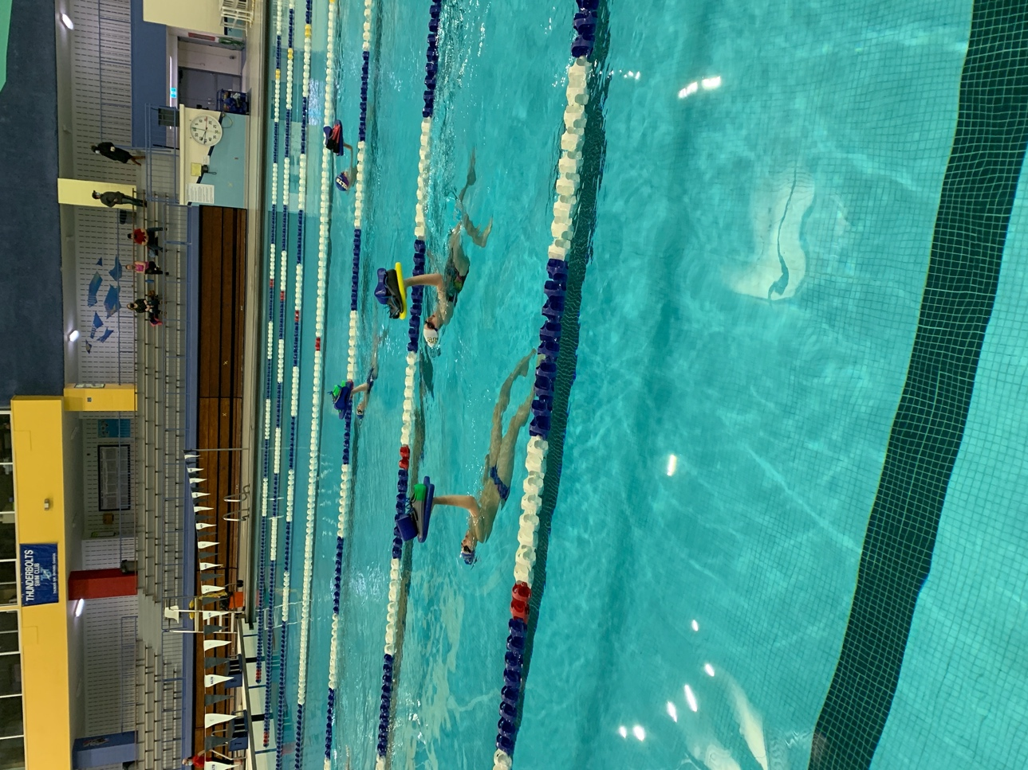

Intro group news

Hello Intro families!

It’s certainly been a strange few months. I know it hasn’t been easy getting used to this new way of doing things, but overall, I am so, so proud of how the swimmers have been overcoming the challenges that come with it.

As you all know, even before our current lockdown, the Intro and Prospects groups had been doing their Zoom calls together, which made the Zoom dryland sessions very, very lively! It was an awesome opportunity for the Intro swimmers to better understand the expectations that would come from a move-up later on in the future, and also gave them the chance to get to know the other swimmers better. Every week, Coach Brooke and I tried to maintain a mix of hard work and fun, including activities such as zumba, yoga, and even a TikTok challenge or two to break up the monotony.

We also spent several sessions discussing essential swimming knowledge, such as qualifying times and meets, goal-setting, and pace-times, as well as analysing Olympic swims in order to better understand what specific skills and techniques accomplished swimmers use in order to swim better and faster. It’s been so exciting to see the kids reflect on their future in swimming, and the careful thought that they have put into their goals and the steps in which they plan to achieve them is inspiring!

Although we were only back in the water a short while, it was wonderful seeing everyone’s smiling faces in person once again! We spent the week working on our flutter kick, as well as our body positioning in the water. Although I understand the disappointment we are all feeling about having to return to Zoom activities in the meantime, we have proved time and time again that we are a community who is more than capable of adapting under the most strenuous circumstances. To all the swimmers: I am so, so, so impressed with how you have been handling all the changes. I am so proud to be your coach! And to all the parents, you should all be very, very proud of these kiddos. They never fail to show up to practice, whether it be in person or over Zoom, with a smile and a strong work ethic!

We are hoping to continue to improve our Zoom programming in the coming weeks. Our goal is to keep the sessions fun and dynamic!

In the meantime, keep staying active; it’s been wonderful to hear how many of the swimmers are finding some way of getting outside, especially as the weather warms up! :)

Coach Hannah

