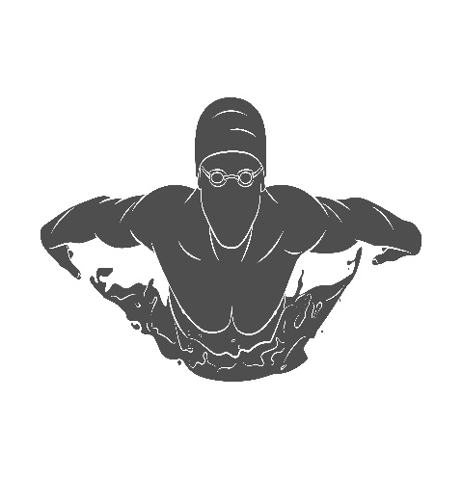
Off the Blocks

Greetings everyone and welcome to our first newsletter of the season. The goal of this newsletter is to publish monthly and to keep all our swimmers and parents connected to what is happening and what will happen within our club. You will still receive emails regarding schedule changes, fundraisers etc,
Our first 3 months of training are in the bag and swimmers are getting stronger and better every week. Our team is still training at 100% the schedule we had last year which is amazing considering other clubs in Canada. We have had no outside cases come into our club and we have started participating in several swimming related challenges within Ontario and beyond.
Communication is one of the foundations in creating meaningful and long-lasting relationships whether it is with coaches to parents, swimmers to officials and anyone in between. This newsletter will hopefully open your eyes to what is transpiring with the other groups and beyond as we have essentially “bubbled” our groups. While this is a challenge for our coaches we communicate regularly and you will see me trying to regularly work with every group.
A special mention to Swim mom extraordinaire Andrea Stach for getting this newsletter started. If anyone has a suggestion for an article, an idea or anything to spice up our newsletter please submit them to Head Coach John Mcleod at coach.john@hotmail.com
Happy reading,
Coach John

Important Dates
January 11 – potential return to swimming
April 7 – Canadian Olympic Trials (Toronto)
July 26 – Nationals (Calgary)

FAQ
Q: How will we know when we can come back and train after the lockdown?
A: You will receive an email from the head coach notifying you when your swimmer will start.

Q: How do we communicate with the club?
A: Coaching – Head Coach John (coach.john@hotmail.com)
Administration – Liisa admin@thunderbolts.ca
Board – President Megan Harri boltspres@gmail.com

Swimmers Corner
One of our National group swimmers made the decision to commit to studying at the University of Calgary and continue her swimming career with the Dino’s. Congratulations Hannah, your team and coaches are all very proud of you!!! Here is how she came to that decision in her own words.
Swimming has been a huge part of my life since a young age. 9 years ago, I began swimming competitively for this team, and have become who I am today through this sport. I’ve created and achieved many goals along the way, learned many valuable lessons, and more about myself. Swimming has taught me how to be a teammate and a leader, how to make goals, persevere through hard times, manage my time, take care of myself, and so many other things. The Thunderbolts provides us all with a place to discover your love for the sport, while creating life-long friendships with your teammates.

I have chosen to sign with the University of Calgary Dinos, and I can’t wait to start the next chapter of my swimming career. Calgary has a great swim team, and will present me with daily opportunities to better my skills and speed alongside my teammates. They have a friendly group of swimmers on their team who work together to push each other to be the best versions of themselves. The coaches Mike Blondal and Ray Bettuzzi are talented coaches who help their swimmers achieve their goals, while being supportive of academics. Equally as important as the swim team, the school also has the number one ranked Kinesiology program in North America. I am very interested in the subject, and am looking forward to learning and exploring new interests.

I’d like to thank every single Thunderbolt for being great team mates. The friendship and support from the older swimmers, as well as the opportunity to be a role model and friend for the younger swimmers. I love this team and will miss it next year. Once a Bolt, always a Bolt.

Hannah

National & Provincial news

Congratulations on the first 1/3rd of the season in the bag and a collective pat on the back to all the swimmers and their biggest supporters (family!). We have faced this quirky season with a sense of determination and teamwork that is admirable and will pay off at the end of this season. Our two groups have been putting in the miles and if our unofficial time trials are any sign of things to come, watch out.
I feel it is important to talk about motivation and how to build it, nurture it and use it. Motivation generally comes from two places when talking about a swimmer. There is the external motivation (the hug from mom, the medals from provincials, the results on Meet Mobile) and there is the internal motivation (the feeling of pride & accomplishment, the satisfaction of completing a challenging set, the feeling of seeing a plan come together). These two factors are both important and need to be worked in harmony of each other. I’m sure you’ve heard the old adage of “Medals fade but glory lives on forever” and this is most important to explain to our younger swimmers.
As we enter our second lockdown it is going to prove challenging but nothing helps you face a challenge like experience will. Using what you learned in the first lockdown will help you through the second lockdown with more ease. An example, I let my sleep get out of control and starting sleeping in too much. This time I will manage my sleep better and limit myself to an extra hour of sleep.
Here are a few tips from a coach’s perspective to manage yourself during these challenging times:
- Stay connected to your teammates, your family and your friends, it helps to talk to others about what you are collectively going through
- Don’t stop ALL physical activity, maintain your fitness during any breaks in training (this applies to summer, Christmas, etc). In place of a 2-hour swim, a 2-hour walk with the dog or an hour on a bike trainer will keep you progressing.
- Take inventory of what you need for when you return to the pool (training equipment, food, recovery, etc)
- Stay connected to the swim world, go to www.swimswam.com, check out your favorite swimmers on social media.
Stay Safe and stay active and most of all stay connected to each other, Hopefully we are back in the water come January!

Coach john!
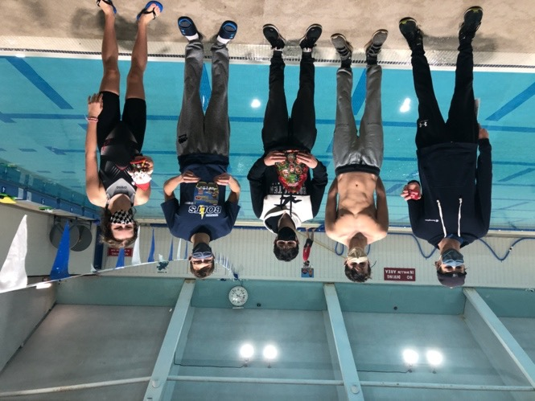
All swimmer should have the following TRAINING EQUIPMENT:
- Flutter board
- Pull buoy
- Finger paddles
- Hand paddles
- Nose clips (optional, good for BK)
- Fins
- Foam roller
Additional, for national group, we use:
- Sponges (homemade)
- Tempo Trainer (a sound investment)

Junior and Senior Development News
"Coach John asked me to send a few words for this newsletter so here we go. As often happens, I am pressed for time as I need to head to the pool soon, a place where a lot of time is spent and enjoyed. Both John and I call the pool our ‘happy place’ because it is the place where we are most happy.

For this newsletter entry I will just keep it simple and say thanks. A lot.

Thanks to Head Coach John who arrived in town on short notice and had to hit the ground at a full-on sprint to help navigate the Thunderbolts through a time of unprecedented challenge. Thanks to our team Executive and our team administrator Liisa for working closely with John and selflessly dedicating their time and energy to support our team. Thanks to my incredible assistant coaches, Alex, Rachael and Jon who without their help many more ’silver’ hairs would be upon my head.

Thanks to my wife Suzanne who has to endure a constant flow of stories and babbling about how proud I am and how much fun I have working with our Thunderbolt kids. Thanks to the astonishingly supportive staff of the Complex who have been in our corner every step of the way as we finally were able to return to our pool.

And now to The Rising Stars, my nickname for the combined JD/SD swimmers. If I had the words, I would describe to you how proud I am of those kids. They had to face challenge and met it head on. They were asked to adapt and they did. They were asked to represent our team well and they did. They were asked to listen, be respectful to their teammates, follow instructions, swim hard, swim easy, wear their masks, keep two meters apart and they did ALL those things. Great job kids!!!

And my last thanks will go out to the unsung heroes of the sport of swimming, you parents. Thanks for being brave enough to get up at a ridiculously early time and support your kids day in and day out.

Go Bolts!

Andy (aka Coach)

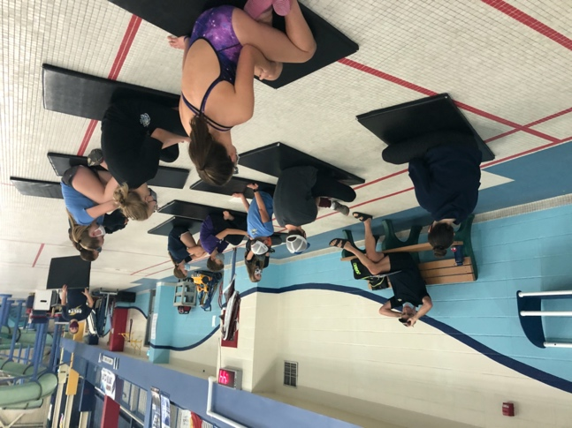

Prospects News
Throughout the session, the Prospects swimmers have been working on specific skill work in all strokes and working to improve their long-distance swimming. One big accomplishment for the Prospects swimmers this season was being able to race an 800 or 400 freestyle while following the “race plan.” This was a big mental challenge for them since most of them have not raced anything more than an 800. Although there is always room for improvement, them being able to overcome their nerves and fears of long-distance racing is something they all should be very proud of. Another big accomplishment is how well the Prospects swimmers have adapted to the new COVID protocols. We have had many race nights and test sets to allow the swimmers to recognize their improvements since there have been no official race opportunities this session. I plan to continue these race nights and test sets into next session since it is not only rewarding for the swimmers, but for the parents and coaches as well! It also gives the kids an opportunity to race.
A few things we will be working on next session include goal setting, race plans, and becoming more knowledgeable in their own swimming. For example, being more knowledgeable in their best times, and comparing to qualifying times, will assist in goal setting if a specific qualifying time is a big goal for them.
One big reminder for next session, PLEASE MAKE SURE YOUR SWIMMER HAS A WATER BOTTLE ON DECK! There has been a huge lack of water bottles on deck. Hydration is very important and is something we can all improve on!
I am looking forward to next session, and I can’t wait to see how much all the swimmers improve in the new year! On behalf of myself to all my kiddos I would like to say I am extremely proud of you all, and it is a true honour to be your coach! Keep it up kiddos! Have a safe and relaxing holiday. Looking forward to seeing you all in the new year!
~Coach Brooke
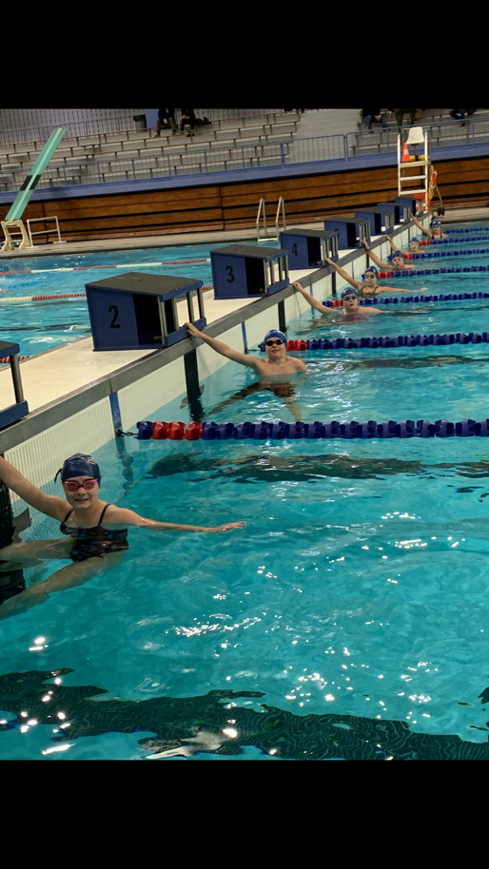

Intro News
I am very pleased to say that as a whole, Intro continues to impress. Considering the current circumstances that we find ourselves facing, the positive attitude and work ethic that each and every swimmer has shown over the past few months has been outstanding. Since October, the Intro group has been refining essential skills such as their push-offs, turns, and finishes; they have learned new drills to improve the quality of their stroke and have been working on increasing their speed and endurance in the water. As a weekly challenge, the Intros have been swimming alongside the Prospects every Saturday morning, and they have risen to the occasion time and time again.

Over the Christmas break, the Intro swimmers have a little bit of (fun!) homework; they are to reflect on the first half of their season and focus on setting goals that they will work to achieve in the new year. These goals will include 3 small actions or habits that they can work on every day at practice and 1 big goal to complete by the end of the season.

A big thank you to all of the Intro swimmers for their effort over the past few months, keep up the good work! And a HUGE thank you to all of the Intro parents; it is thanks to all of you that the Intros get to practice on time (even on those early mornings when braving the cold outside seems impossible!) and that they have the support they need to develop as dedicated athletes and as wonderful people. Wishing you all a safe and happy holiday season! :)

