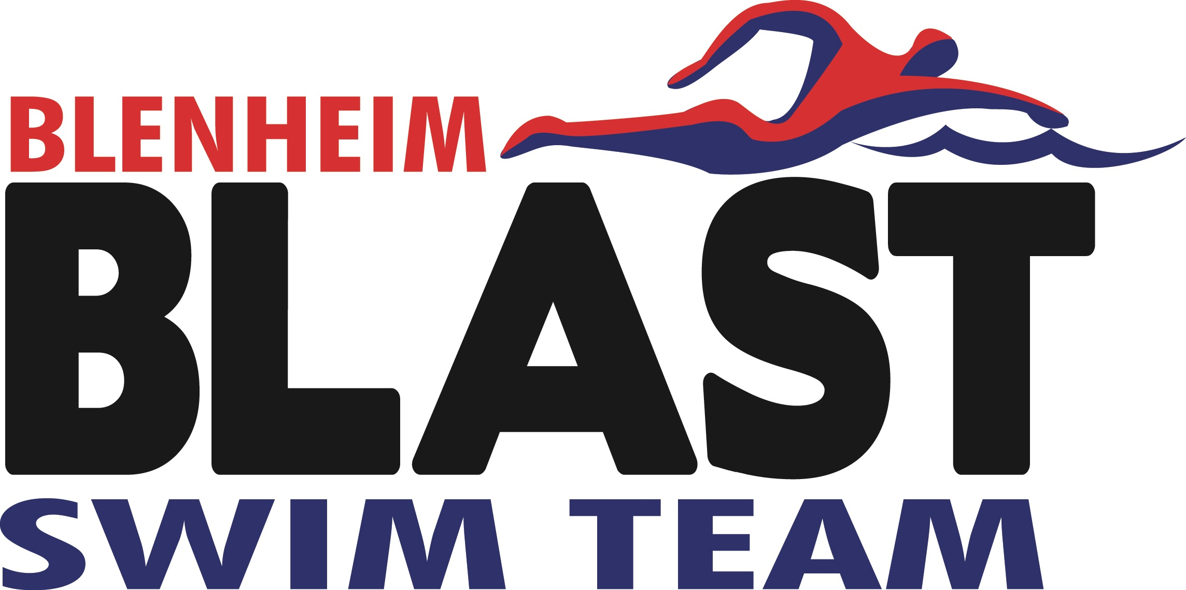

presents
Blenheim S.E.A.L Meet
sanctioned by Swim Ontario
at
GABLE REES ROTARY POOL
SUNDAY- April 8, 2018

DATE(S): April 8, 2018
REGION: Western
HOSTED BY: Blenheim Blast Swim Team
LOCATION: Gable Rees Rotary Pool, 66 Regent St, Blenheim, Ontario
FACILITY: 25 metre pool-- 4 lanes, with Spectrum Xcellerator starting platforms. Change rooms available with lockers. Viewing area on deck...
** Outdoor shoes are NOT permitted on the deck. **
PURPOSE: Seal Meet
MEET PACKAGE: The only meet package which will be considered as valid must be the most current version found on www.swimming.ca

COMPETITION Mark Armstrong, Level V Email: blenheimblastofficials@gmail.com
COORDINATOR:

MEET MANAGER: Praveen Pradhan Email: blenheimblast@gmail.com

OFFICIALS
COORDINATOR: Greg Moore Email: blenheimblastofficials@gmail.com

DESCRIPTION: Timed Finals. Meet Management will be using The Dolphin Wireless Timing System. We will use 2-3 Dolphin watches per lane plus 1 manual watch or as volunteers permit.

MARSHALLING: It is the responsibility of the swimmer and coaches to ensure that their swimmer presents themselves to the marshalling area when their event is announced.
COMPETITION RULES: Sanctioned by Swim Ontario. All current Swimming/Natation Canada (SNC) rules will be followed.
Please note that Swimming Canada Competition Warm-Up Safety Procedures will be in effect. The full document can be viewed HERE.
For club and provincial meets, a swimsuit that covers more of the body such as modesty swimwear or religious cover-ups is permitted providing that the fabric is permeable open mesh textile material and does not give the swimmer an advantage. The full interpretation can be viewed HERE. Advanced notification or for clarification of interpretation please see the Competition Coordinator.

SEAL LEAGUES RULES IN EFFECT.

AGE UP DATE: Ages submitted are to be as: April 8, 2018.

MIXED-GENDER: The Swim Ontario statement on mixed-gender swimming is set out as follows:
Notwithstanding Rule SW 10.1 adopted by the Technical Swimming Committee of Swimming/Natation Canada, Swim Ontario will consider requests for sanction for meets that provide for mixed gender swimming in the following circumstances:
The host seeks an exemption from the requirement to swim events in gender separated events, on the following basis (choose appropriate circumstances):
This is an age group meet for which swimmers who have achieved a qualifying time equal to a ‘B’ time or faster are de-qualified.
This is a meet hosted by a Region to offer developmental opportunities for swimmers with that Region.

Mixed gender swims may also be permitted when, due to a missed swim, it is necessary for a referee to seed a swimmer in a heat of the same or shorter distance, for competitors of the opposite gender, on an exception basis.

In spite of this rule, any swimmer who achieves a record time at any level (regional, provincial, national etc, whether age group or open) will not be recognized for that record unless the coach has advised the referee prior to the start of the session that there is a possibility of the record being broken, and the referee insures that the swimmer competes with competitors of the same gender for his/her heat.

In the event that mixed gender swims are permitted pursuant to this policy, the results must still be posted separately by the gender of swimmers.

ELIGIBILITY: All athletes must be registered as Competitive swimmers with SNC, or any other amateur swimming organization recognized by FINA. A valid SNC registration number is required for all Canadian swimmers, and entries without a SNC registration number will be declined entry (choose appropriate circumstances):
Preference will be given to the host club first.
This is an invitational meet. Participation of this meet is at the full discretion of the host club.

ENTRY FEE: Swimmer Fee: $ 20 per swimmer (includes 4 swims plus relay)
Please make cheques payable to: Blenheim Blast Swim Team

ENTRIES: Entries must be submitted through the SNC online entries system at www.swimming.ca . Meet Management will not accept entries via email.
Online Entry Deadline: Monday, April 2, 2018.

Swimmers may swim maximum of 4 individual event, plus relays
Relay swimmers must be entered in a non-relay event in order to compete.

CONVERSION: Entry times can be converted. Please submit converted times:
Hy-tek default conversion factor

SCHEDULE OF SESSIONS:

Session # | Date | Prelim/Finals | Warm Up | Start | Finish | Estimated Duration
1 | April 8/18 | Timed Finals | 8:00 am | 9:00 am | 12:00 pm | 3 hours
2 | April 8/18 | Timed Finals | 12:00 pm | 12:45 pm | 3:45 pm | 3 hours

SCHEDULE OF EVENTS: See event list - Appendix

COACH’S
REGISTRATION: Meet management will cross reference the list of coaches in attendance at this competition with the Swim Ontario Compliancy lists. If a coach is not on this list, meet management is obligated to enforce the SNC policy and not permit that coach to attend meet. Meet management will forward Swim Ontario a list of coaches who they have found to be in non-compliance.

COACH’S MEETING: Officials meeting on deck at 8:20 am. and 12:20 pm..
Coaches meeting on deck at 7:50am.

SEEDING: Option “A” (times converted by club and/or host)
Seeding will be in order of times entered,
as converted pursuant to the conversion process as per meet package,
followed by swimmers entered with NT (no times).

TIME SPLITS: The procedure for obtaining an 'Official Split' now requires that coaches make the request to the session referee or meet management on the “Official Split Request” form prior to the race. The split for the lead-off leg in relays will still be regarded as an official split and therefore no request by coaches is needed for relays. However, in the new 'mixed gender' relays, lead-off times/splits are not considered “official splits' as per international practice.

Meet management requires that any coach wishing to rely on a time achieved by the swimmer for an interval shorter than the total distance of the event shall so advise the Referee prior to the commencement of the session (or event) in question.

DECK ENTRIES: As per SEAL League rules, deck entries are allowed at 24.00 per swimmer.
Deck entries will be accepted for empty lanes only (no new heats will be created).
Swimmers entered on deck must have valid proof of SNC registration (number) as an active, registered, competitive swimmer.
Swimmer Fee: $20 per swimmer

CHECK IN
AND SCRATCHES: Scratches are to be made at the recorder/scorer desk 45 minutes prior to the start of each
session. There will be no penalty for during the competition.

SCORING: No Scoring

AWARDS: The following will be awarded:
Ribbon will be awarded for First through sixth for each event + heat winner ribbons.
MEET RESULTS: Official Results will be posted within 48 hours of completion of the meet to www.swimming.ca
The meet program will be run on Hy-Tek Meet Manager.
Results will be posted as quickly as possible at the meet.

RECORDING
OF EVENT: Only individuals that have made application and received authorization to record the event in any manner, in any medium or context now known or hereafter developed shall be granted access and permission to do so. Please contact Meet Management for application and authorization.

PROGRAMS: Programs will be available for purchase.
SAFETY &
LIABILITY: Only participating swimmers, officials, certified registered coaches, and authorized people are allowed on deck.

Volunteers are welcome and needed for all official positions. Please have your volunteers check in with the Meet Manager upon arrival. If evaluations/sign offs are required, please indicate so when you send in your officials to the official coordinator in advance. We will do our best to help with any evaluations/sign-offs that are needed. Please submit names of officials by Saturday, March 31, 2018.

Only swimmers, certified coaches, officials and authorized person are allowed on deck.
(or designated area if spectators are on one side).

OTHER
INFORMATION: Concessions
We will be offering canteen service. No food or beverages other than water bottles are allowed on the deck as per Municipality/Facility policy – Thank you for your co-operation.

Appendix
Event List

Session 1
11 and Under
Sunday, April 8th, 2018
Warm-up: 8:00 AM -- Start: 9:00 AM
Female Event # | Dequalifying Time | Event | Dequalifying Time | Male Event #
1 |  | 8-9 100 IM |  | 2
3 | 1:24.42 | 10-11 100 IM | 1:26.35 | 4
5 |  | 7 & Under 25 Back |  | 6
7 |  | 8-9 50 Back |  | 8
9 | 41.96 | 10-11 50 Back | 42.94 | 10
11 |  | 7 & Under 25 Fly |  | 12
13 |  | 8-9 25 Fly |  | 14
15 | 39.92 | 10-11 50 Fly | 41.91 | 16
17 |  | 7 & Under  25 Breast |  | 18
19 |  | 8-9 25 Breast |  | 20
21 | 46.41 | 10-11 50 Breast | 48.39 | 22
23 |  | 7 & Under 25 Free |  | 24
25 |  | 8-9 50 Free |  | 26
27 | 1:16.20 | 10-11 100 Free | 1:17.74 | 28
29 |  | Mixed 7 & Under 100 Free Relay
30 |  | Mixed 8-9  100 Free Relay
31 |  | Mixed 10-11  200 Free Relay

All athletes will be limited to 4 individual events and 2 relays. Relays will be mixed, exhibition and the results of relays will not be uploaded to SNC. and fun!
Session 2
12 and Over
Sunday, April 8th, 2018
Warm-up: 12pm Start Time: 12:45pm
This session will begin after a 45 minute break for officials’ lunch and warm ups.

Female Event # | Dequalifying Time | Event | Dequalifying Time | Male Event #
33 |  | Open 50 Free |  | 33
35 | 1:16.01 | 12-13 100 IM | 1:13.69 | 36
37 | 1:13.36 | 14 & Over 100 IM | 1:08.87 | 38
39 |  | Open 100 IM |  | 39
41 | 1:18.52 | 12-13 100 Back | 1:17.85 | 42
43 | 1:17.28 | 14 & Over 100 Back | 1:12.71 | 44
45 |  | Open 100 Back |  | 45
47 | 34.44 | 12–13 50 Fly | 33.70 | 48
49 | 34.01 | 14 & Over 50 Fly | 31.07 | 50
51 |  | Open 50 Fly |  | 51
52 |  | Open 100 Fly
53 | 1:30.67 | 12-13 100 Breast | 1:28.48 | 54
55 | 1:26.93 | 14 & Over  100 Breast | 1:23.06 | 56
57 |  | Open 100 Breast |  | 57
59 | 1:10.44 | 12-13 100 Free | 1:08.21 | 60
61 | 1:08.15 | 14 & Over 100 Free | 1:03.48 | 62
63 |  | Open 100 Free |  | 63
65 |  | Mixed 12-13  200 Medley Relay |  | 65
67 |  | Mixed 14+  200 Medley Relay |  | 67

All athletes will be limited to 4 individual events and 2 relays. Relays will be mixed and fun! See above

