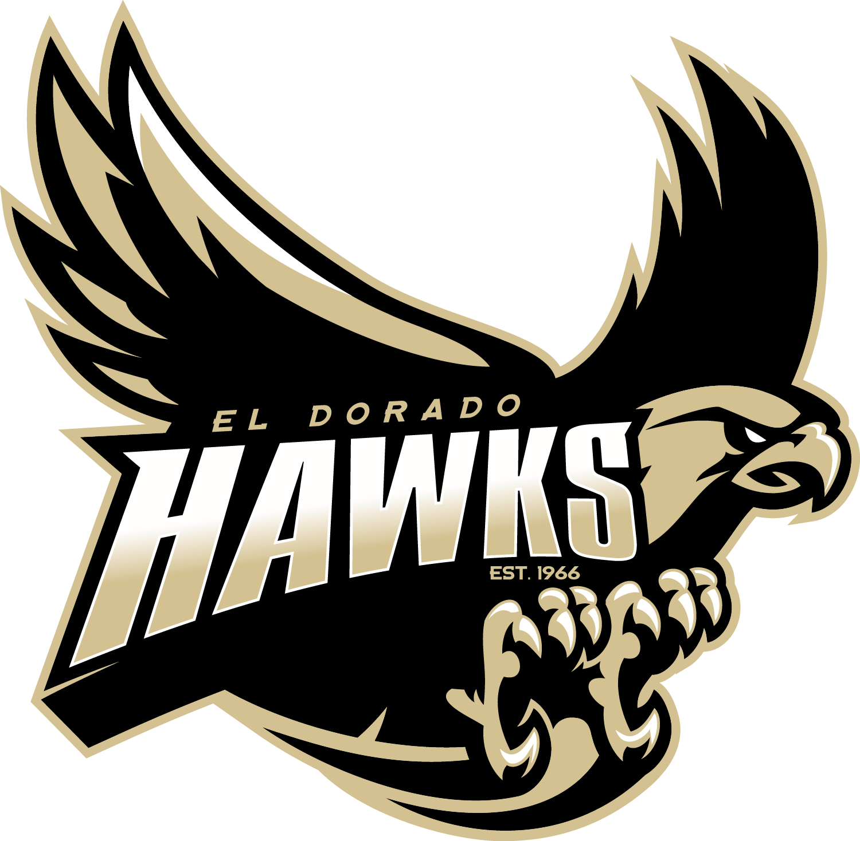

Dear Hawks Sponsors,

What an exciting time to be a part of El Dorado Aquatics!
- Our boy’s water polo team has just reached CIF for the first time in 11 years.
- Our girl’s water polo, as well as the boy’s and girl’s swim teams, have been working tirelessly in the off-season to be ready for groundbreaking seasons.

2017-2018 is a pivotal year for El Dorado Aquatics and your generosity has played a major role in the expansion of our program. We cannot thank you enough! Your continued investment in the program will position our team to reach all the goals set before them. Would you be willing to partner with us again this year?

How does my donation help the program?
- Coaching stipends – critical to our student athlete’s success!
- Deck improvements:
  - Awnings for shade - ACCOMPLISHED
  - Replacement of pool façade panels - ACCOMPLISHED
  - EDHS Aquatics Champions Display Board - ACCOMPLISHED
  - New Scoreboard (wish list)
- Improved coaching tools
  - We want to provide our coaches with the very best resources to train our student athletes. We CANNOT do this without your support!
- All new website with easy access to the most up-to-date information

How can I help again this year?
Sponsorship Levels
- Partners $500 First year; $350 Renewal for following years
  - 5’ x 3’ Vinyl Banner with Company Logo or Custom Message displayed on the EDHS pool deck for a year
  - Sponsorship ad on team website
    - Artwork needs to be submitted in pdf, eps, or high resolution jpeg to lisajackman@yahoo.com
- Friends of the Hawks $300 First year; $200 Renewal for following years
  - Company or Family name proudly displayed on our “Friends of the Hawks” Board on the EDHS pool deck for a year

Tax Deductible ID# 20-0040415
Make checks out to: EDHS Aquatic Parents
c/o Lisa Jackman
2401 Berkshire Way
Placentia CA 92870

I/We agree to place a sponsorship advertisement for the EDHS Aquatics Program for an indicated selection:

Display Name _________________________________________________________________
Contact Person_________________________________________________________________
Mailing Address________________________________________________________________
City _________________________________________ State _______ Zip _________________
Contact Phone Number _______________________ Email _____________________________
Please indicate your Sponsorship Selection(s):

____ New ____ Renewal
______ Partners _____ Friends of the Hawks _____ Flat Donation

