Paseo Aquatics MAAPP 2.0 Acknowledgement
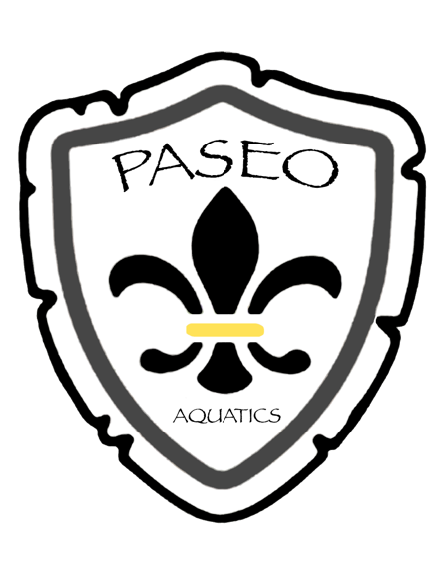

I acknowledge that I have received, read and understood the Minor Athlete Abuse Prevention Policy and/or that the Policy has been explained to me or my family. I further acknowledge and understand that agreeing to comply with the contents of this Policy is a condition of my membership with Paseo Aquatics LLC 501(c)3 and if this acknowledgement is not returned to admin@paseoaquatics.org by August 15th, that our registered swimmer(s) may not attend practices or meets until it is received and recorded, as this is a mandated USA Swimming requirement.

Printed Guardian/Parent(s) Name(s): _____________________

Signature(s): _____________________________

Swimmer(s) Names: _____________________________________________________

Date:

