Upcoming Club Meets  BAC Home Meet 6/9/18  - AB Modified AG Meet 6/15-6/17  - Firecracker 6/29-7/1  Please sign up for these swim meets as registration deadlines are approaching!  Upcoming Rec meets  - Wasco “B” 6/5  - Shafter “A” 6/9  - Taft Tigersharks “A” 6/16  - Taft Tigersharks “B” 6/19  - Lakeside 6/23  - RBG 6/30  Swimmer of the month  Senior Elite – Qualley Vega  Age Group Elite – Alexandra Ostrom  Age Group Black – Corbon Lawrence  Age Group Red – Lauren Martinez  Jr. Age Group Development – Arya Crow  Jr. Orcas – Levi Salazar | More News Here  Frugattis Fundraiser, BAC Home MEET, AND Staying Hydrated  - Please bring money from the Frugattis fundraiser to coaches, or VP Jon Malamma on deck 6/4  - Please sign up for a job for our upcoming home meet. If you have any questions, please talk to a board member.  - Please make sure you children are coming to practice with plenty of water! BAC does not have access to cold filtered water yet.  Does your child have a championship cut time? Click on this link and find out!  Summer Junior Olympics - https://www.teamunify.com/ccbac/UserFiles/File/2018%20lc%20jo%20standard%20list(1).pdf | 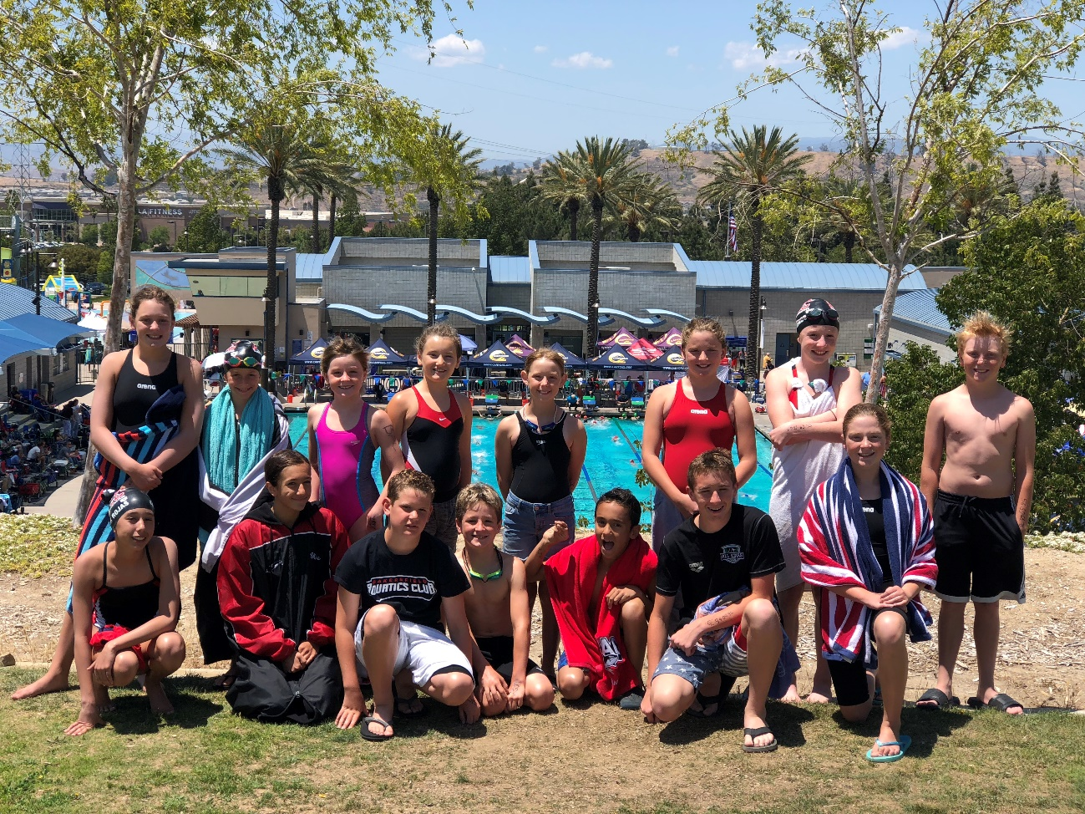
Western Zone Age Group Championships information! If cut times, or are coming close to one, please talk to Coach Cristian!  https://www.teamunify.com/ccbac/UserFiles/File/2018%20Age%20Group%20Western%20Zone%20Times.pdf | Nutrition and Performance Tips for Swimmers? Click on this link for more info!  https://www.usaswimming.org/docs/default-source/camps/national-select-camp/home-coach-presentations--boy's-camp-2017/nutrition--christina-deehl.pdf

“Empowering young people to pursue excellence and develop character through competitive swimming.”

