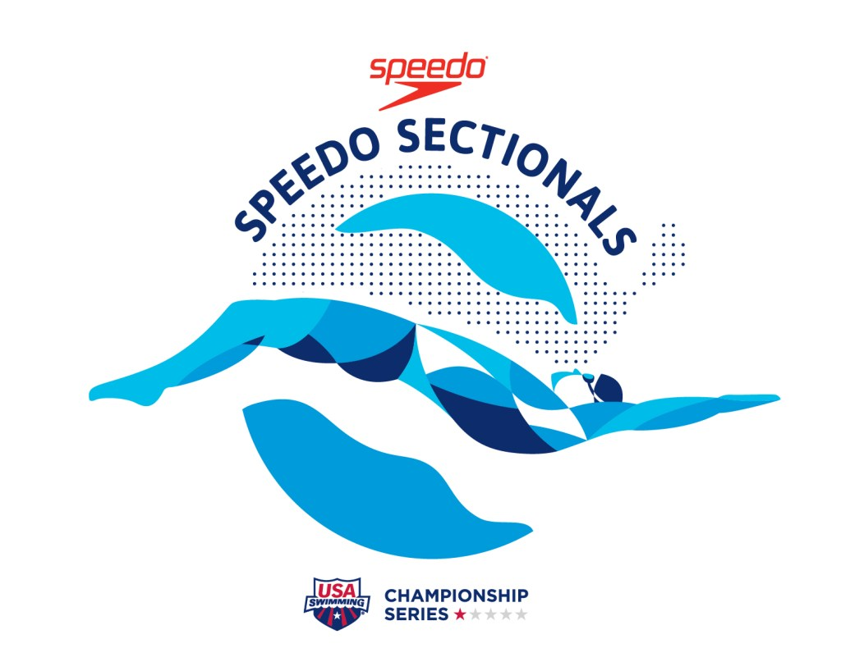
2021 Central Zone Speedo Sectionals Series
Section 1, Site 2 Spring Championships
Hosted by West Fargo Flyers
Hulbert Aquatic Center
March 26 - 28

Meet Information
Dates,  Locations,  & Hosts | Site 1:  Des Moines, IA  March 11-14, 2021 | Site 2:  West Fargo, ND  March 26-28, 2021  West Fargo Flyers  Sanction: ND-SC-21-15  ND-SC-21-15TT
Facility Address | Hulbert Aquatic Center  620 7th Ave E  West Fargo, ND 58078  Main entrance for Athletes and Spectators is on the South side of the building. Additional parking for Coaches and Officials during the is on the North side of the building with a separate entrance available for them during designated times. Parking is free in all lots.
Facility Details, Availability, & Contact Information | Hulbert Aquatics Center houses a 54 meter x 25 yard pool. A 10-lane 25 yard pool will be in use with anti-wave lane lines, electronic timing and start, Colorado Gen 7 Timing System with Hy-Tek interface. Pool 1: Start end pool depth is 7 feet; turn end pool depth is 7 feet. Pool 2: Start end pool depth is 7 feet; turn end pool depth is 14 feet. Pool 2 will be the warmup/cool down pool. The competition pool conforms to USA Swimming Rules and Regulations – Article 103.3. The pool is certified in accordance with USA Swimming requirements 104.2 C(3) and (4). The copy of such certificate is on file with USA Swimming.  Myrtha backstroke ledges for the blocks are available for use.  Glass doors separate another warmup/cooldown pool from the start end of the competiton pool.  Warm-up/down Pool: A six-lane 25 yard pool will be continuously available while the competition pool is in use. Depth is 3.5’ by 4.5’.  Locker Rooms: Six locker rooms are available: three enter a hallway at the competition pool deck, three enter directly to the warmup/cool down pool deck. Each has lockers where locks can be used during meet but not overnight. One family-style locker room will be available for Coaches and Officials.  Athlete Seating: Bleacher seating for 250* will be available on deck. *or current Covid capacity at the time of the meet.  Spectator seating: There are 1100* stadium chairs available on the upper-deck. Seating is top-load. There are 10 handicap areas around the upper-deck for family access. No camping is allowed in the seating area. Elevator access is available to all areas. *Current Covid capacity is 50%.  Availability of concessions. Limited grab-and-go concessions will be available on the main level of the facility.  Alyssa Kellas, Aquatics Director  akellas@west-fargo.k12.nd.us  (701) 499-9961
Meet Contacts | Meet Director  Lisa Montplaisir  Lisa.montplaisir@gmail.com  701-261-6164 |  | Meet Referee  Edie Mueller  Edie.mueller@me.com
 | Entry Chair  Lisa Montplaisir |  | Administrative Referee  TBD
Central Zone Contacts | Pam Lowenthal  CZ Non-Coach Director  Pam.lowenthal@ilswim.org |  | Michael White  CZ Coach Director  Michaelwhite184@gmail.com
Spectators, Admission, and Online Viewing | - Spectators are currently allowed to 50% capacity. We will allow spectators based upon the Covid status at the time of the meet.  - Live meet results will be available on Meet Mobile.  - Final meet results will be posted on the host team’s website.  Westfargoflyers.com and click on the Sectionals tab  - Swimming can be watched live Lane 4 Athletic youtube page (link can be inserted)  - Spectator admission is $5/day.
Timeline | Thursday, March 25 | Warmups lanes will be available on request throughout the day. Must be scheduled with facility director, Alyssa Kellas  Registration 2:00p – 6:00p in the Hospitality Room, # 112, just inside the main doors.  General Meeting: 6p.
 | Friday, March 26 | Registration: 7:00 – 9:00 outside Hospitality  Prelims Warmup: 7:00 – 8:45  Prelims Session: 9:00  Time Trials: after conclusion of prelims  Finals Warmup: 4:30 – 5:45p  Finals Session: 6:00p
 | Saturday, March 27 | Registration: 7:00 – 9:00 outside Hospitality  Prelims Warmup: 7:00 – 8:45  Prelims Session: 9:00  Time Trials: after conclusion of prelims  Finals Warmup: 4:30 – 5:45p  Finals Session: 6:00p
 | Sunday, March 28 | Registration: 7:00 – 9:00 outside Hospitality  Prelims Warmup: 7:00 – 8:45  Prelims Session: 9:00  Time Trials: after conclusion of prelims  Distance Event: after conclusion of time trials.  Finals Warmup: 3:30 – 4:45p  Finals Session: 5:00p

Eligibility & Entry Information
Eligibility | The meet is open to all full time (not seasonal) 2021 USA registered athletes. Athletes must be registered members (either attached or unattached) of a Central Zone Section 1 LSC (IL, MN, ND, SD) to attend.
Entry Deadline | Entries for current qualifiers may be accepted five weeks before the start of competition for each site and will close ten days before the start of competition.  Des Moines: February 5th, 2021-March 1st, 2021  West Fargo: February 19th, 2021-March 15th, 2021  New Qualifiers will be accepted through midnight, March 21st.
Entry Procedure | All entries must be submitted using the USA Swimming OME (online meet entry) system at http://www.usaswimming.org/ome. Payment method through OME must be Visa, MasterCard, American Express or Discover. Entries are not considered accepted until payment method is validated. A confirmation email will be sent upon completion of your entries.
Entry Times | Entry times may be submitted in either short course yards (Y) or long course meters (L). Please do not convert meter times to yard times.
Qualifying Times | Swimmers must be qualified to swim the events entered. Events may be qualified for by meeting yards or meters qualifying times. All submitted entry times must have been achieved after January 1, 2019.
Number of Events | Swimmers may enter as many events as they qualify for and may compete in a maximum of 3 individual events per day. Time Trial Events count towards the daily entry limit of 3 events.
Bonus Events | Swimmers entered in at least one individual event, may swim up to two bonus events during the championships, provided they have achieved the published “Bonus Event Time Standards”.  - Swimmers entering 1 individual event are permitted to swim 2 Bonus Events;  - Swimmers entering 2 individual events are permitted to swim 1 Bonus Event;  - Swimmers entering 3 or more individual events are not permitted to swim a Bonus Event.  The 1000 and 1650 freestyle are not offered as Bonus Events.
1000/1650 Free Events | - Any swimmer who qualifies for the 1000/1650 freestyle events may enter at their fastest time or at the qualifying time standard, if entered in two or more events on the day of the distance freestyle.  - Swimmers may qualify for the 1000 Freestyle Event with the 800m/1000 yard time standards and for the 1650 Freestyle event using the 1500m/1650 yard time standards.
Proof of Time | All "Custom or Override Times" must either be  - verified prior to the scratch deadline for that event; or,  - "down‐seeded" (written request required) prior to seeding the event.  If the entry time is "down‐seeded" the athlete may still compete; however, if Proof of Time is not provided as specified AND the swimmer fails to achieve the minimum qualifying time standard, a fine of $100 will be assessed. Computer access will NOT be provided; coaches/swimmers must bring appropriate proof of time to the meet. All fines must be paid to the meet host(s) prior to the start of the following session. Fines not paid prior to the start of the final session of the meet shall be automatically doubled.
Times Achieved after Deadline: | New times after the deadline, through midnight March 21st, will be accepted.
Late Entries | Will not be accepted.
Entry Fees | A flat fee of $100 per swimmer will cover all entry fees, the Central Zone Surcharge, LSC, and Facility surcharges.

Meet Format, Scratching, Positive Check-In, Scoring, Awards
Meet Format | For 2021, all Section 1 Spring Sectional Meets will be held in prelims/finals formats in short course yards. A total of 16 swimmers will advance to finals.
Seeding | Seeding priority for the meet is 1) SCY 2) LCM  Events of 500 yards or less will be pre-seeded with heats organized according to USA Swimming Rules 102.5
Finals | For individual events 500 yards or less, 16 swimmers will advance to the finals. Finals will be swam in the order of slowest to fastest.  Events greater than 500 yards will be swam as timed finals events.
Positive Check In | Positive check-in is required for the 1000 and 1650 freestyle events prior to the scratch deadline in order to compete in the event. Each swimmer must provide a timer and lap counter.  The single fastest heat of the 1650 freestyle will be swum in the finals.
Scratch Procedure | Scratches shall be made prior to the seeding of heats and confirmed by properly filling out a scratch card and depositing it in the scratch box. After the heats have been seeded, any  swimmer who fails to compete in a preliminary individual event heat in which they have been entered and have not been scratched or have not declared a false start prior to the start of the race, will be barred from further individual and relay events that day. Additionally, that swimmer shall not be seeded in any individual events on succeeding days unless that swimmer declares an intent to swim prior to the close of the scratch box for the succeeding day’s events. The scratch box shall be located at the Clerk of Course.  Deadlines:  Deadline for Friday's events: Thursday 6:30 pm  Deadline for Saturday's events: Friday 6:30 pm  Deadline for Sunday's events: Saturday 6:30 pm
Finals & Scratching from Finals | Any finalist who fails to compete at finals, consolation finals or any other bonus final heat, for which he/she has qualified and failed to scratch with the Clerk of Course prior to the scratch deadline, shall be banned from further competition in the meet in accordance with the USA Swimming Rules and Regulations.  In a Prelim/Final meet, the finalists and alternates for finals shall be announced and shall have thirty (30) minutes after the announcement to scratch from finals. All swimmers who will not be present at finals are strongly encouraged to scratch even if they did not initially qualify for finals as they may be moved into finals due to scratches in order to allow swimmers who will be present a chance to compete. Thirty (30) minutes after the announcement, no further scratches shall be accepted, the existing scratches will be tabulated and the finalists and two  (2) alternates for the event will be set.
Scoring | All events will be scored to 16 places.  Scoring will be finalized after results are combined from the multiple sites.
Awards | Individual awards will not be offered.
Time Trials | Time Trials will be conducted at the discretion of the Meet Referee, based on session timelines. More information will be given by meet hosts in the week leading up to the meet. Time trial events may be SCY or LCM based on facility availability.
Meet Results

Swimmers with a Disability
Procedure | Entry Procedure for swimmers with a disability  Coaches/club entry contact should:  • Enter the swimmers with a disability electronically, or, on the paper entry form.  • Provide advance notice of any “necessary accommodations.”  • List in the email with the electronic entry (or, on paper) the swimmer’s name, entry times, strokes/distances and days/sessions.  Eligibility for swimmers with a disability  For entry into this Sectional Championship swimmers with a disability approved time(s) must meet or exceed the Nationally Approved ‘Sectional Motivational Time Standards for ParaSwimmers’ for one event and Bonus Time Standards for up to 3 bonus swims in the selfreported Grouping (P1, P2, and P3).  Official sport class recognition of a swimmer with a disability is NOT required; however, they MUST be identified as such on the team’s meet entry form.  Swimmers with a disability will be given the designation of D‐2. The Grouping (P1, P2, and P3) standards are provided as a means to group swimmers with similar (dis)abilities into general classes and provide the appropriate nationally recognized time‐standards as qualification for entry. Inclusion in any one of these groupings will be athlete/coach‐reported and any questions should be referred to the Disability Chair for clarification.  Grouping Descriptions:  P1 ‐ non‐ambulatory (wheelchair bound): limited use of all four extremities  P2 ‐ dwarfism, multiple limb deficiencies, ambulatory with assistance, can be wheelchair bound with high functioning upper body.  P3 ‐ single limb deficiencies, visual impairments, and intellectual impairments, ambulatory without significant assistance  Conduct of the meet for swimmers with a disability (D‐2)  D‐2 Swimmers will swim preliminaries during their respective event, or paired event and seeded by time. Preferred seeding is in the swimmer’s entered event at the same distance, or in a longer distance race (i.e., 100 free during the 200 free). Exceptions to this should be listed in “necessary accommodations.”  D‐2 Swimmers will swim a separate final for each of the championship events to include up a combination of male and female athletes not to exceed one full heat finalists per event.  D‐2 Swimmers will score points and be awarded and recognized in the same fashion as the D‐1 swimmers.  D‐2 Swimmer final events may be combined if the total number of finalists do not exceed one full heat of competitors.  The D‐2 finals heat will precede the respective D‐1 heat.  Accommodations:  Coaches entering swimmers with disabilities that require any accommodations, including the needs for personal assistants and/or registered service animals must provide advance notice in writing, accompanying their meet entry file, to the meet director by the entry deadline. Failure to provide advance notice may limit the host’s ability to accommodate all requests.

Rules & Regulations
Rules | Current USA Swimming Rules and Regulations will govern the conduct of this meet, except as otherwise specified in this meet information or the Section 1 Competition Manual. It shall be the swimmers’ and coaches’ responsibility to acquaint themselves with all the information contained in this meet announcement.  Pursuant to NDLSC Swimming, Inc. mandate, all applicable adults participating or associated with respective meet to which this information applies, acknowledge that they are an applicable adult, subject to the provisions of the USA Swimming Minor Athlete Abuse Prevention Policy (“MAAPP”), and that they understand the compliance with the MAAPP Policy is a condition of participation in the conduct of this competition.  Any swimmer entered in the meet must be certified by a USA Swimming coach member as being proficient in performing a racing start or must start each race from within the water. Further, those participants not proficient with a backstroke ledge must start each race from within the water, and without use of the backstroke ledge. When unaccompanied by a member‐coach, it is the responsibility of the swimmer or the swimmer's legal guardian to ensure compliance with this requirement.
Swimmer Conduct | Each team is responsible for the conduct of its swimmers. Meet Marshals shall have the authority to remove any swimmer/s from the meet for any violation such as improper behavior, damage to property, etc. Such teams are responsible financially for damage of property. Please make sure your team’s area on deck and rest area is picked up at the end of each session.
Meet Committee | A Meet Committee consisting of at least one official, one coach, and one athlete will be appointed by the Meet Referee to review conflicts arising from administrative matters.
Deck Changing | Changing in or out of swimsuits other than in locker rooms and other designated areas is prohibited.
Audio/ Video Recording | In compliance with the Video Voyeurism Prevention Act the use of audio or visual recording devices, including a cell phone, is not permitted in the area behind the starting blocks, in changing areas, restrooms, showers or locker rooms. Violators may be reported to law enforcement or other governmental authorities and/or may be barred from the facility during the sanctioned event.
Drones | Operation of a drone, or any other flying apparatus, is prohibited over the venue (pools, athlete/coach areas, spectator areas and open ceiling locker rooms) any time athletes, coaches, officials, and/or spectators are present. Exceptions may be granted with prior written approval by the USA Swimming Program Operations Vice Chair.
Liability | In granting this sanction it is understood and agreed that USA Swimming and North Dakota Swimming, Inc shall be free from any liabilities or claims for damages arising by reason of injuries to anyone during the conduct of the the meet.

Officials
Officials’ Information | All officials must attend a mandatory meeting one hour before the start of each session.  The uniform for all preliminary sessions will be white polo shirt over khaki shorts/pants/skirt, as appropriate. Finals uniform will be white polo shirt over khaki pants/skirt (NO shorts) as appropriate.  This meet will be submitted for designation as an "Officials Qualifying Meet," for certification and re‐certification evaluations for N2‐ and N3‐level positions. A combined “Request for Evaluation/Application to Officiate” is available on the Central Zone website. Completed forms should be sent to the Assistant Central Zone Officials Chair, as indicated on the form.  Opportunities for evaluations may be limited by time and personnel resources. Availability of final evaluations for N‐3 may be provided at the discretion of USAS Officials Committee designation of the meet.

Order of Events
Women’s Event # | Thursday, March 25 | Men’s Event #
 | Warmups and general meeting
 | Friday, March 26
1 | 200 Backstroke | 2
3 | 100 Freestyle | 4
5 | 200 Butterfly | 6
7 | 500 Freestyle | 8
 | Saturday, March 27
9 | 200 Freestyle | 10
11 | 200 Breaststroke | 12
13 | 100 Butterfly | 14
15 | 400 IM | 16
 | Sunday, March 28
17 | 100 Backstroke | 18
19 | 100 Breaststroke | 20
21 | 50 Freestyle | 22
23 | 200 IM | 24
25 | 1650 Freestyle*  1000 splits available | 26

Time Standards
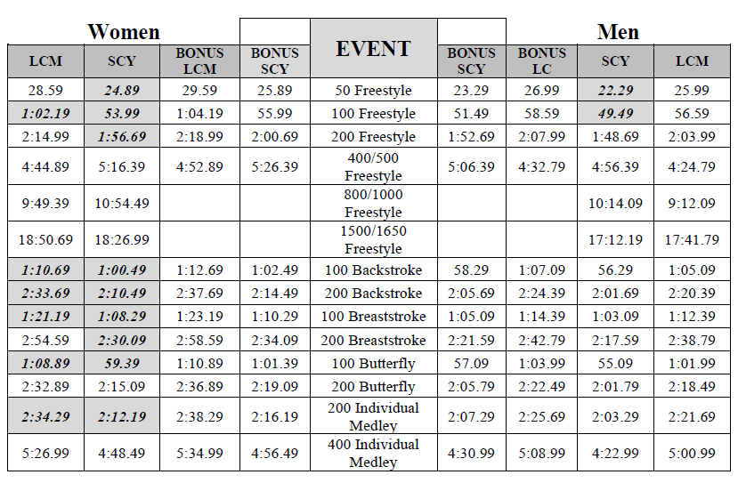

Para 1 Sectional Motivational Time Standards
 | Women |  |  |  |  | Men
P1 - non-ambulatory  (wheelchair bound):  limited use of all four  extremities | Sectional |  | Bonus |  | P1 | Sectional |  | Bonus
 | SCY | LCM | SCY | LCM |  | SCY | LCM | SCY | LCM
 | 1:18.39 | 1:18.39 | 121.59 | 121.59 | 50 FR | 1:12.29 | 1:12.29 | 1:15.29 | 1:15.29
 | 2:44.39 | 2:44.39 | 1:51.19 | 1:51.19 | 100 FR | 2:43.09 | 2:43.09 | 2:49.89 | 2:49.89
 | 6:33.69 | 6:33.69 | 6:50.09 | 6:50.09 | 200 FR | 4:28.49 | 4:28.49 | 4:39.69 | 4:39.69
 | 1:32.69 | 1:32.69 | 1:36.59 | 1:36.59 | 50 BK | 1:00.29 | 1:00.29 | 1:02.79 | 1:02.79
 | 2:50.39 | 2:50.39 | 2:57.49 | 2:57.49 | 100 BK | 2:11.79 | 2:11.79 | 2:17.29 | 2:17.29
 | 1:25.79 | 1:25.79 | 1:29.39 | 1:29.39 | 50 BR | 1:05.19 | 1:05.19 | 1:07.89 | 1:07.89
 | 4:04.79 | 4:04.79 | 4:14.99 | 4:14.99 | 100 BR | 3:09.09 | 3:09.09 | 3:16.99 | 3:16.99
 | 2:17.99 | 2:17.99 | 2:23.69 | 2:23.69 | 50 FL | 2:02.29 | 2:02.29 | 2:07.29 | 2:07.29
 | 5:41.99 | 5:41.99 | 5:56.19 | 5:56.19 | 150 IM | 5:27.29 | 5:27.29 | 5:40.99 | 5:40.99
Para 2 Sectional Motivational Time Standards
 | Women |  |  |  |  | Men
P2 - dwarfism, multiple limb  deficiencies, ambulatory with  assistance, can be wheelchair bound  with high functioning upper body. | Sectional |  | Bonus |  | P2 | Sectional |  | Bonus
 | SCY | LCM | SCY | LCM |  | SCY | LCM | SCY | LCM
 | 42.69 | 44.89 | 44.49 | 46.79 | 50 FR | 39.29 | 41.39 | 40.89 | 43.09
 | 1:34.89 | 1:39.89 | 1:38.89 | 1:44.09 | 100 FR | 1:26.59 | 1:31.19 | 1:30.19 | 1:34.99
 | 3:15.39 | 3:25.69 | 3:23.59 | 3:34.29 | 200 FR | 3:03.19 | 3:12.79 | 3:10.79 | 3:20.89
 | 7:57.69 | 6:29.89 | 8:17.49 | 6:46.09 | 400/ 500  FR | 7:42.39 | 6:17.39 | 8:01.59 | 6:33.09
 | 51.79 | 54.49 | 53.99 | 56.79 | 50 BK | 44.39 | 46.79 | 46.29 | 48.69
 | 1:59.89 | 2:06.19 | 2:04.89 | 2:11.39 | 100 BK | 1:51.19 | 1:56.99 | 1:55.79 | 2:01.89
 | 4:07.29 | 4:20.29 | 4:17.69 | 4:31.19 | 200 BK | 3:28.79 | 3:39.69 | 3:37.39 | 3:48.79
 | 54.09 | 56.89 | 56.39 | 59.29 | 50 BR | 50.29 | 52.99 | 52.39 | 55.19
 | 1:59.99 | 2:06.29 | 2:05.09 | 2:11.59 | 100 BR | 1:51.59 | 1:57.49 | 1:56.19 | 2:02.39
 | 4:22.79 | 4:36.59 | 4:33.79 | 4:48.19 | 200 BR | 4:00.79 | 4:13.49 | 4:10.79 | 4:23.99
 | 52.19 | 54.89 | 54.39 | 57.19 | 50 FL | 40.69 | 42.79 | 42.39 | 44.59
 | 2:14.19 | 2:21.19 | 2:19.79 | 2:27.09 | 100 FL | 2:07.49 | 2:14.19 | 2:12.79 | 2:19.79
 | 4:08.79 | 4:21.89 | 4:19.19 | 4:32.79 | 200 IM | 3:49.19 | 3:59.19 | 3:56.69 | 4:09.19
Para 3 Sectional Motivational Time Standards
 | Women |  |  |  |  | Men
P3 - single limb deficiencies, visual impairments,  intellectual impairments, ambulatory without  significant assistance. | Sectional |  | Bonus |  | P3 | Sectional |  | Bonus
 | SCY | LCM | SCY | LCM |  | SCY | LCM | SCY | LCM
 | 33.09 | 36.69 | 34.39 | 38.19 | 50 FR | 28.89 | 32.19 | 30.09 | 33.49
 | 1:10.39 | 1:18.19 | 1:13.39 | 1:21.49 | 100 FR | 1:02.89 | 1:09.89 | 1:05.49 | 1:12.79
 | 2:53.69 | 3:12.89 | 3:00.89 | 3:20.99 | 200 FR | 2:23.79 | 2:39.79 | 2:29.79 | 2:46.39
 | 6:35.19 | 5:47.39 | 6:51.69 | 6:01.89 | 400/ 500  FR | 6:12.49 | 5:27.39 | 6:27.89 | 5:40.99
 | 15:10.39 | 12:54.79 | 15:44.49 | 13:23.79 | 800/  1000 FR | 14:41.29 | 12:29.99 | 15:17.89 | 13:01.19
 | 27:41.99 | 25:57.69 | 28:40.09 | 26:52.09 | 1500/  1650 FR | 27:15.29 | 25:32.59 | 28:23.49 | 26:36.49
 | 40.09 | 44.49 | 42.19 | 46.79 | 50 BK | 33.19 | 36.89 | 34.59 | 38.39
 | 1:24.49 | 1:33.79 | 1:27.99 | 1:37.69 | 100 BK | 1:09.89 | 1:17.69 | 1:12.79 | 1:20.89
 | 3:22.59 | 3:45.09 | 3:32.79 | 3:56.39 | 200 BK | 2:47.59 | 3:06.19 | 2:54.59 | 3:13.99
 | 40.49 | 44.99 | 42.59 | 47.29 | 50 BR | 36.19 | 40.29 | 37.79 | 41.89
 | 1:29.79 | 1:39.69 | 1:33.49 | 1:43.89 | 100 BR | 1:20.49 | 1:29.39 | 1:23.79 | 1:33.09
 | 3:16.29 | 3:38.39 | 3:26.39 | 3:49.29 | 200 BR | 2:56.09 | 3:15.59 | 3:03.39 | 3:23.79
 | 36.39 | 40.39 | 38.29 | 42.49 | 50 FL | 31.49 | 34.99 | 32.79 | 36.39
 | 1:16.29 | 1:24.69 | 1:19.39 | 1:28.19 | 100 FL | 1:06.09 | 1:13.49 | 1:08.89 | 1:16.49
 | 3:12.89 | 3:34.29 | 3:22.49 | 344.99 | 200 FL | 2:47.39 | 3:05.89 | 2:44.29 | 3:13.69
 | 2:58.49 | 3:18.29 | 3:05.99 | 3:26.59 | 200 IM | 2:32.49 | 2:49.49 | 2:38.89 | 2:56.49
 | 7:01.19 | 7:47.99 | 7:22.29 | 8:11.39 | 400 IM | 6:06.79 | 6:40.09 | 6:56.79 | 6:56.79

COVID PROTOCOLS WILL BE IN PLACE AS APPOPRIATE AT TIME OF MEET
ALL DECK PERSONNEL MUST WEAR FACE MASKS COVERING MOUTH AND NOSE. WFPS does not allow the faceshield only as adequate covering.
Only 1 timer will be in use per lane
A clerk of course format will be used for three heats prior to swim to continue to maintain social distancing.

Coaches and Officials Hospitality: may be available. Pack your own and have labelled our separated from others. We will provide beverages. IF WFPS begins to allow limited gathering we will have some grab and go snacks. This is not guaranteed at this point.

SUPPLEMENTARY INFORMATION REQUIREMENTS FROM USA SWIMMING:
- WFPS Covid-19 Screening questionnaire for guests is a supplementary document to the meet info.
- Total capacity is currently 250 athletes and 500 Spectators. At the conclusion of competition, they will be asked to wait in their cars for their athlete(s) rather than facility lobby. The event will be livestreamed on Lane 4 athletic youtube page.
- Deck capacity will not exceed 350 to include coaches, officials, volunteers.
- In applying for this sanctioned event, the Host, ______WFF____________________ agrees to comply and to enforce all health and safety mandates and guidelines of USA Swimming, __NDLSC_____ , the State of ______ND________ and ____City of West Fargo_______ and WFPS guidelines.
- “We have taken enhanced health and safety measures for you and our other guests. You must follow all posted instructions while visiting Hulbert Aquatic Center. An inherent risk of exposure exists in any public place where people are present. CPVID-19 is an extremely contagious disease that can lead to severe illness and death. According to the Centers for Disease Control and Prevention, senior citizens, and guests with underlying medical conditions are especially vulnerable. By visiting Hulbert Aquatic Center, you voluntarily assume all risks related to exposure to CPVID-19.
- An inherent risk of exposure to COVID-19 exists in any public place where people are present. COVID-19 is an extremely contagious disease that can lead to severe illness and death. According to the Centers for Disease Control and Prevention, senior citizens and individuals with underlying medical conditions are especially vulnerable.

USA Swimming, Inc., cannot prevent you (or your child(ren)) from becoming exposed to, contracting, or spreading COVID-19 while participating in USA Swimming sanctioned events. It is not possible to prevent against the presence of the disease. Therefore, if you choose to participate in a USA Swimming sanctioned event, you may be exposing yourself to and/or increasing your risk of contracting or spreading COVID-19.

BY ATTENDING OR PARTICIPATING IN THIS COMPETITION, YOU VOLUNTARILY ASSUME ALL RISKS ASSOCIATED WITH EXPOSURE TO COVID-19 AND FOREVER RELEASE AND HOLD HARMLESS USA SWIMMING, NDLSC, WFF, AND WFPS AND EACH OF THEIR OFFICERS, DIRECTORS, AGENTS, EMPLOYEES OR OTHER REPRESENTATIVES FROM ANY LIABILITY OR CLAIMS INCLUDING FOR PERSONAL INJURIES, DEATH, DISEASE OR PROPERTY LOSSES, OR ANY OTHER LOSS, INCLUDING BUT NOT LIMITED TO CLAIMS OF NEGLIGENCE AND GIVE UP ANY CLAIMS YOU MAY HAVE TO SEEK DAMAGES, WHETHER KNOWN OR UNKNOWN, FORESEEN OR UNFORESEEN, IN CONNECTION THEREWITH.

