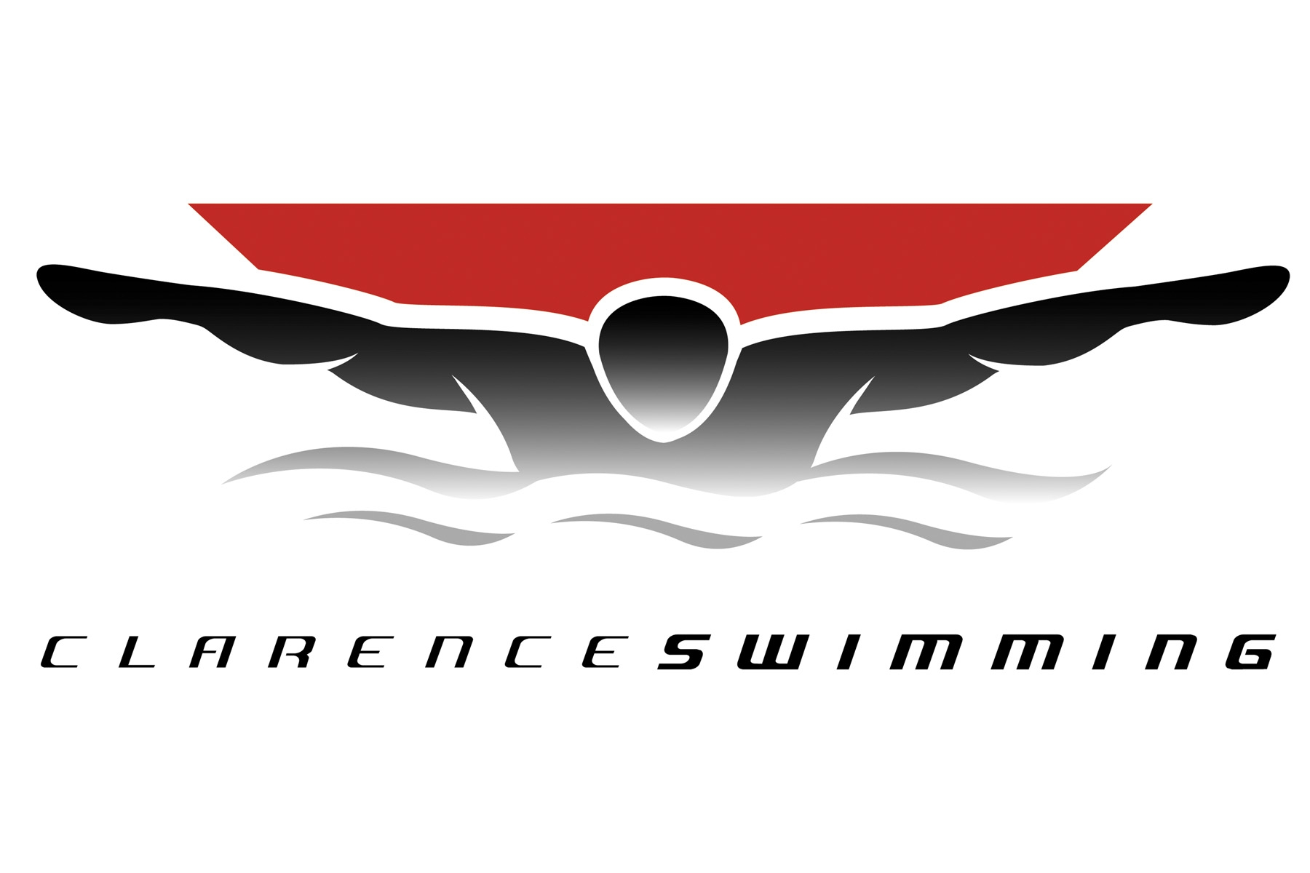

**American Red Cross Lifeguarding Course**

Clarence Swimming will be hosting an American Red Cross Lifeguarding Course **at Clarence Middle School** starting January 3rd and concluding on January 10th (please see below for specific times and dates). The cost to participate is **$100**, with checks made payable to Clarence Swim Club.

Participants **MUST be at least 15 years old by January 10, 2019** and meet the following swimming requirements:

* swim 300 yds of the pool continuously
* tread water for 2 minutes without the use of your arms
* retrieve a 10lb brick from at least 10 feet deep

At the conclusion of the course participants must pass both written exams and skills tests to receive their American Red Cross Certifications in Lifeguarding, CPR, First Aid and AED Training. Please note that payment for the course will not be returned regardless of participants ability to pass the written exams and/or skills tests, nor does it guarantee approval of certifications.

Please contact Program Director Steven Monkelbaan at [CLTSDirector@gmail.com](mailto:CLTSDirector@gmail.com) or (716)982-3326 to register. The class size is limited so please be sure to register soon.

**Lifeguarding Dates & Times**:

* Thursday January 3rd, 5:30pm – 9:00pm
* Friday January 4th, 5:30pm – 9:00pm
* Saturday January 5th, 8:00am – 1:00pm
* Monday January 7th, 5:30pm – 9:00pm
* Tuesday January 8th, 5:30pm – 9:00pm
* Wednesday January 9th, 5:30pm – 9:00pm
* Thursday January 10th, 5:30 pm – 9:00pm

Are you already a Lifeguard, and looking for employment? Clarence Learn to Swim is NOW HIRING responsible individuals to lifeguard and instruct our Learn to Swim Program. Please contact Program Director Steven Monkelbaan at [CLTSDirector@gmail.com](mailto:CLTSDirector@gmail.com) or (716) 982-3326 to apply. Applications can also be found on our website at ClarenceLearntoSwim.com.