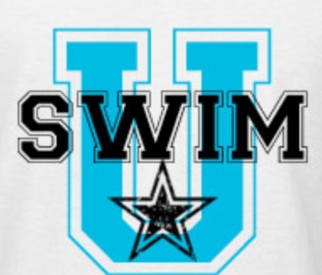

WHO? Swim U at the LONGVIEW Rec Center is a non-competitive group that is geared towards swimmers who want to get or stay in competitive shape by learning the most up to date competitive techniques.

Intermediate (7-14yrs) Every T/TH 7:00-7:55 PM
Advanced (9- 14yrs) Every Saturday 1:30-2:30 PM

THESE ARE NOT SWIM LESSONS!
GROUP REQUIREMENTS:
INTERMEDIATE: COMPLETE 25 YARDS FREE(face in water)BACK, BREAST AND FLY
ADVANCED: COMPLETE 50 YARDS FREE(face in water) BACK, AND 25 YARDS BREAST,FLY

WHERE? Longview Rec Center
2909 Commonwealth Drive
Spring Hill, TN 37174

SESSION Session I Sept 4, 2018 – NOV 3, 2018
Session II Nov 6, 2018 – Dec 21, 2018
Session III Jan 8, 2019 – March 9, 2019
Session IV March 26, 2019- May 17, 2019

PRICE? $25 Registration Fee (1 time per year) *NEW - includes swim cap and t-shirt
Session I T or TH or Saturday class $70
Session II T or TH or Saturday class $60
Session III ` T or TH or Saturday class $80
Session IV T or TH or Saturday class $60

The Swim U program is a non-competitive training group designed as a transition from summer league to competitive team or middle school team. Swimmers will learn competitive techniques for all four competitive strokes turns and dives. For Swim U Junior group, you can register for one day a week or two days a week. Swim U Middle School is Saturday only.

Online registration at EXCELAQUATICS2.ORG opens July 15, 2018 and spots are LIMITED!
Please contact Dawn Van Ryckeghem at coachdawn@excelaquatics.org with questions.

