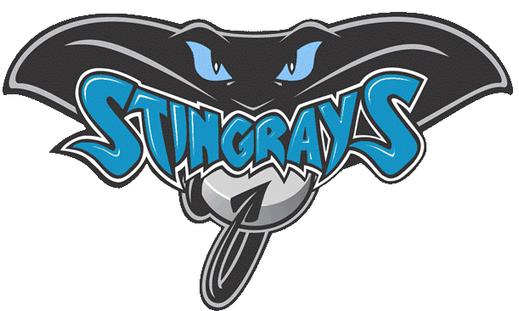
Pueblo West

Swim Club

CODE OF CONDUCT
As our team grows, and we continue to add to our program, we seek to establish and clarify our policies. Our policies help to guide us and ensure continued success. The Code was designed as a standard to emphasize the commitment of our team to create a positive and safe experience for everyone involved.
As a swimmer and member of the Pueblo West Swim Club, I will abide by the following Code of Conduct.

- The possession or use of alcohol, tobacco products or controlled substances is prohibited.
- No Horseplay is allowed during practices, meets or team functions, especial around or in the pool, this is to help prevent an injury to yourself or others. Also to help in your ability get as much out of your swimming experience as possible. This includes, No running on deck, No hitting of any kind, No touching others inappropriately, No purposely throwing water or swim equipment, No spitting, No talking while coach is giving instruction.
- Team members will refrain from any illegal or inappropriate behavior as that of criticizing, name calling, use of abusive language or gestures toward coaches, officials, and/or any participating swimmer that would distract from a positive image of Pueblo West Swim Club.
- Swimmers are expected to meet with their coach before and after each of their events.
- Team members will display proper respect and sportsmanship at all times.

Failure to fulfill with any of our teams Code of Conduct in this document may result in disciplinary action. Such discipline may include, but not limited to:
- Verbal warning, and or time outs.
- Suspension for a period of time from the team
- Dismissal from the team

_______________________________ ________________________
PWSC Swimmer Date

_______________________________ ________________________
Parent or Guardian Date

