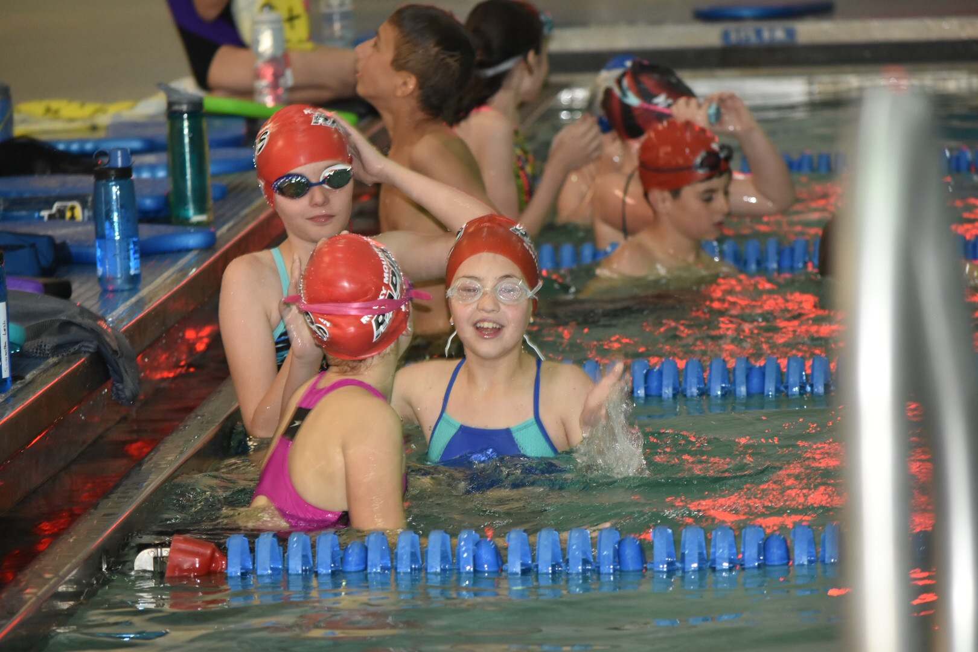

Congratulations to all the Championship Meet Qualifiers:

Silver State |  |  |  | Age Group State |  | Senior State
Madison Alexander |  |  |  | Seth Shyrock |  | Nathan Aumiller
Taylor Alexander |  |  |  |  |  | Savana Baker
Anna Clayton |  |  |  |  |  | Kate Carlson
Josh Clayton |  |  |  |  |  | Noel Clayton
Tristian Dosh |  |  |  |  |  | Maya Jabbour
Caleb Obenchain |  |  |  |  |  | Grace McCrary
Anna Shyrock |  |  |  |  |  | Julie Papaj
 |  |  |  |  |  | Ryan Schuster
 |  | Congratulations also to Coach Erik! He was awarded Coach of the Year for Colorado Springs Metro League for his work as Head Coach of Liberty High School!

UPCOMING MEETS
CSST Spring Invite
April 26-28, 2019
https://www.teamunify.com/EventShow.jsp?id=1015064&team=cormrst

CUDA Steve Drozda Shotgun Open LC
May 3—5, 2019
https://www.teamunify.com/EventShow.jsp?id=1029092&team=cormrst

CMA ImX Challenge
May 18-19, 2019
https://www.teamunify.com/EventShow.jsp?id=1031481&team=cormrst

AFA Spring Open (Co-hosted with Altitude)
May 31-June 1, 2019
https://www.teamunify.com/EventShow.jsp?id=1022760&team=cormrst

Summer Travel Meet for Senior Team and older Class swimmers:
The Senior Team Summer Travel meet with be to the VAST Open in Albuquerque, NM. June 28-30, 2019. More info coming soon!

TEAM INFORMATION
ONGOING FUNDRAISERS
SwimOutlet.com Support Rocky Mountain Rapids Swim Team by shopping at our https://www.swimoutlet.com/rockymtrapidsswim
store. You can also shop the full Swim Outlet site as always FREE SHIPPING on orders over $49.00.
AmazonSmile is a simple and automatic way for you to support the Rocky Mountain Rapids Swim Team every time you shop on https://smile.amazon.com/. You use your existing Amazon account. Then shop as normal and the Rocky Mt Rapids Swim Team will get 0.5% of the purchase price of all qualified purchases! It's that easy!
King Soopers Reloadable Gift Card 5% will be donated to the Rocky Mountain Rapids Swim Team.
-Contact fundraising@rockymountainrapids.org to receive a King
Soopers Reloadable Gift Card linked to the Rapids. Each card costs $2.50, however, $2.50 is preloaded on the card. Each family can have multiple cards; so pick up one for spouses, family, and neighbors!
-Take your Rapids/King Soopers Gift Card to Customer Service, any
Cashier, or the Gas Station to load your desired amount on the card. You can pay by cash, check, or credit card (you still get your points) Remember to load the gift card before they ring up your purchases. It can take up to 15 minutes for the gift card to show your new balance.
-Use your Rapids/King Soopers Gift Card to purchase groceries and
gasoline. They may not be used to purchase other gift cards. Continue to use your King Soopers Frequent Shopper Card during your regular checkout to accumulate points.
new balance.
-The Rocky Mountain Rapids Swim Team gives an additional incentive - the family that raises the most money through their Rapids/King Soopers card each month will receive a 10% discount on their monthly fees that month!

Shop With Scrip For gift cards that can be used for gifts or everyday purchases, check out! https://shop.shopwithscrip.com
-Earn money toward your swim fees, while helping fundraise for the team at no additional cost to you? From this website, you can order physical or instant gift cards for the face value of the card. Every gift card returns a rebate to the team. Twice a year, in March and September, 30% of the money you have earned for the team will be credited towards your account.
-After establishing a Presto Pay account, you are able to place an order for Scrip Now or Reloads anytime! Your Scrip Now and Reload orders are available instantly. This is handy while standing in line at the checkout or if you need a last minute gift. It's also great for added security when ordering at stores online. This is a great way to have Scrip benefits and earnings year-round!
Rapids enrollment code: 96BL4B42395L5
COACHES CORNER
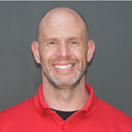
Coach Brady Shyrock
Class 3 Coach
TIME
Time, it is how we as swimmers and coaches ultimately evaluate ourselves and one another. The crazy thing about time is that we ALL have one thing in common, we are given the exact same amount of time to work with each day. What are you choosing to do with the time that has been given to you? Are you taking advantage of the opportunities in front of you?
If taking a closer look, forgive me for getting a bit philosophical about it, our sport is made up of by hundredths of seconds. A hundredth here, one one-hundredth there. How many races have been won or lost by this margin? Could we have done just a little better? What if I had held my streamline better off of that last turn? What if I hadn’t taken that extra breath inside the flags at the finish? These choices are magnified especially when they are held up to our goals. Was that one one-hundredth the difference between a state, zone, sectional, or national qualifying time?
I would like to present an equation to everyone. Success=time multiplied by the number of opportunities taken advantage of minus time wasted. If the time wasted outweighs the time taken advantage of in the form of opportunities (more on this in a moment), this will ultimately lead to failure or lack of success.
OPPORTUNITY. I have been thinking a lot about this word lately. When we don’t take advantage of an opportunity to hone a skill, to better discipline ourselves, to give our most even when it doesn’t feel good, to wake up for morning practice when we want to sleep in, etc. You get the idea. Every single day we are presented with opportunities to better ourselves. As someone who has more time behind them than I care to admit, I lookback and see several occasions where I didn’t take advantage of my opportunities. The most successful swimmers we see nowadays are the ones who take advantage of their opportunities. The elite level coaches won’t waste their time coaching an athlete who doesn’t care. Those coaches are wise enough to recognize what their opportunities are as well. Something special happens when a very strong combination of self-discipline, effort, focus, skill, and opportunity meet. There are some raw athletes who need guidance in order to succeed. In those cases, both coach and athlete recognize what it will take to become successful. Together, they create a plan and commit to it. At the basic level, our opportunities are not at the meet level, they are at the practice level. The “little” things that we tend to take for granted add up to create much bigger results than we can possibly know. For example, when we train to hold a breathing pattern in the 50 and 100 freestyles, each breath added also adds on average approximately 0.05 to 0.1 seconds to our race. So, if an athlete takes an additional 5 breaths, that athlete had an opportunity to drop 0.5 seconds off of their best time. Streamline is the most efficient and hydrodynamic position in the water. If we don’t use this amazing tool during practice so that is becomes second nature, we are wasting an opportunity and likely won’t obtain our goal times. Did you give it your very best effort on that test set the other night? Yikes, now you have to wait until the next time you perform that test set to see what you are capable of. The point is that all of these kinds of things add up, or more like multiply exponentially (are magnified) when it comes to our goal situation(s).
Here is another equation for you all. Time now > time later. Procrastination does not breed success. How many times have you attempted to “cram” before a test? How well did you perform on that exam? Statistics say those instances are not very successful. Should it be any different with our athletic endeavors? Can you wait until the week before your big meet to prepare and make changes? How much training can you “cram” into the week before your big meet? As a coach, I implore you all to take advantage of the time and opportunities in front of you NOW, not later. The choices we make today shape our future. Of course there is balance in all of this. Should you go to swim practice the night before a final exam that you need to review for? That is entirely up to you and how much preparation you have given to your exam before that particular evening. No one can make you choose the correct way to utilize your opportunities. Coaches and parents can help give guidance, but ultimately it is up to each of us to take advantage of our own opportunities.
So, what are you choosing to do with the time that has been given to you? Are you taking advantage of the opportunities in front of you?

NOTES FROM THE PRESIDENT
I’m writing this on one of those “false peak days”, you know the ones. It’s 70 degrees, beautiful, sunny, flowers are starting to poke through the melted snow. Stores are starting to stock flowers and plants, and everything for outdoor life. I’ve lived in Colorado most of my life, and know that this is all a lie. We’ve still got more snow coming. You can’t rush it here.
As parents, it’s easy to look at our eight year old swimmer and think “they are so fast, they’ll swim in college”. I heard a fairly interesting statistic that has held true over the last few years. 70% of State Champions at age 10 are not swimming at all by the time they are 13-14. I get to write this only from my perspective, and not everyone may agree with me, and that’s okay. My family has been in this sport long enough to see people, champion swimmers at young ages, stop swimming either through burn-out, injury, and wanting to pursue other interests. The “fast kids” in town have changed dramatically throughout the last 11 years we’ve been around this sport in town. People move in and out.
Cheryl
Note from the Treasurer:
Remember to notify the team Treasurer of any account changes by the 24th of the month prior to the change at Treasurer@rockymountainrapids.org.
Team Check In!
ROCKY MOUNTAIN RAPIDS SWIM TEAM
Rocky Mountain Rapids PO Box 62485 Colorado Springs, Colorado 80962

