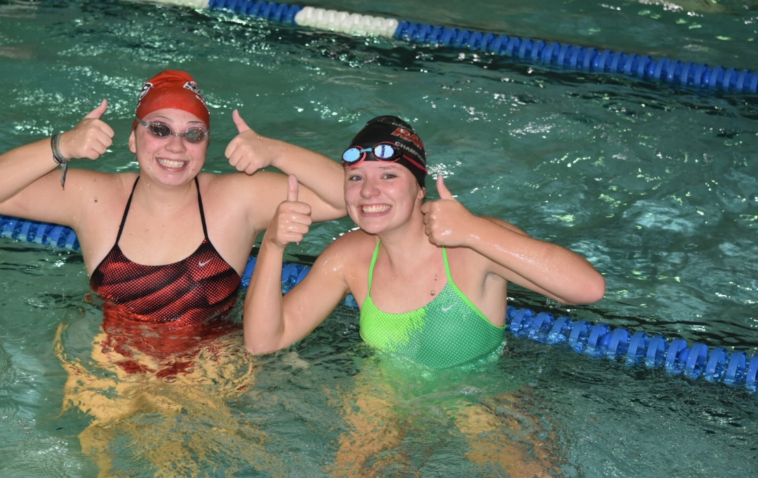
TEAM NEWS
November 2018

TEAM NEWS

Why are swim meets important?
Swimming in and of itself can be a crazy sport. There are four different strokes and a multitude of different ways to swim each stroke. The sport is very individual, yet very much a team sport. Whether it be training in practice to competing at a meet or racing on a relay, it is a fun to be swimming with your friends and hear them cheering you on.
Swim meets are set up each day in practice. The coaches are preparing daily in what they do to best prepare the kids and help them learn. Sets are designed to simulate races, challenge the athletes both mentally and physically and help the kids discover for themselves what they are capable of. Practice, in most aspects, can and should be more difficult than a race at the swim meet. The only thing a practice can’t replicate is 300 swimmers, packed stands, and the noise.
The swim meets can be overwhelming when brand new to the sport. The Rapids will do two “in-house” meets during the year, held in September and December. These are to help the kids learn and see what a swim meet will look like. We want our kids to be comfortable before jumping into a large meet. If there are ever questions, don’t be afraid to check in with a coach or a board member. After a few meets, meets become second nature.
There are several levels of swim meets as a swimmer progress through their respective swim careers.
- Local Level – These are open to all swimmers and held over 1-3 days. Swimmers may choose to only swim 1 day or swim all days. These would include meets in Denver, Fort Collins, etc.
- Silver State – This is the first step to what may be considered a swimming postseason participation. It does require certain times being met, “qualifying time standards.”
- Age Group State – This is the next step and requires time standards and is for 14 and Under.
- Senior State – This would be the first step or next step once a swimmer as turned 15 and requires time standards.
- Sectionals – At this point, travel may become necessary depending on meet location and will have teams from multiple states. Time standards are required.
- National Level – This would include Junior and Senior Nationals and includes travel to the meet location. Time standards are required.
The time standards do become more difficult as a swimmer ages up and the level of swim meet becomes larger.
One may read all of this and wonder why I would want to go through all of this. As challenging as swimming and meets may be, it can be equally rewarding. The swimmers can get to know other swimmers and develop friendships through competition, get to travel and share experiences with their teammates and have the enjoyment and accomplishing a goal.
Intrinsic rewards are important in any athlete’s growth and development. They can learn a lot about themselves when they complete an event for the first team or see a hard set and complete it. It can also include achieving that first state cut when they thought it would never happen. The sport of swimming can offer so much in terms of personal growth and determination. The swim meets can only add to this when they put in the work day in and day out and then get the opportunity to go out and race.
Extrinsic rewards are also important, but should not be the only reason to be involved in something. These are the extra rewards that go along with the intrinsic rewards. The Rapids will offer several throughout the season. These include Class Swimmer of the Meet Bag Tags, plaques for silver state and state qualifiers, and t-shirts for championship meet qualifiers. Through our sponsorship, swimmers who make junior nationals or higher will receive a full warm up, backpack and suit!
Swim meets may not be for every single swimmer out there, but they are a critical piece of overall development. The Rapids don’t require everyone participate, but we do strongly encourage it. There are five important reasons for why a young swimmer should participate.
- To experience competition
- Fast times are produced in practice and born at meets
- Swim meets can serve as a testing ground for athletes
- Swim competitions provide young athletes with an environment where they can learn to compete with grace and sportsmanship
- Swim meets are fun!
Let’s get out there and have some fun!
Go Rapids!
Erik Richardson
Head Coach

Sources:
“The Purpose of Participating in Swim Meets”, Head Coach Dorsi Raynolds, edited by Suzan Ballmer M.Ed.
“Swim Meets are Fun!” Alameda Gators Swim Team

NOVEMBER REMINDERS & EVENTS

. Schedule Change Begins November 5!
Email Reminder:
We have discovered a “glitch” in our software, and we apologize that we have not received some of your messages. When responding to your coach’s or volunteers weekly updates or broadcast messages, please do not just hit “reply”. Instead, address it to the person (ie: headcoach@rockymountainrapids.org) This will ensure your messages is received and we can respond quickly. Thank You!
Rapids will “shift” practice times due to the high school teams practices and meets. This schedule will be in place until summer, with the exception of Thanksgiving and Christmas break. Practices times are as follows:
Class 1: 7:00-7:45 (Dryland 6:30-6:55)
Class 2: 7:00-8:00 (Dryland 6:30-6:55)
Class 3 - 7:00-8:15 (Dryland 6:30-6:55)
Seniors - 7:45-9:15 (Dryland 7:00-7:40)
Thanksgiving break practices will be held at Colorado College. More details coming soon!

Safe Sport Training
USA Swimming is requesting that all parents take the Safe Sport training. If you have not already done so, please go to the attached link and take the training. It will take you about an hour. Parents may also choose include their athletes by accessing the athlete training resources available.

FUNDRAISER
Why cook Thanksgiving week when you can have someone else do it? The Senior Team will be hosting a fundraiser to support their travel meet in Phoenix, AZ. Go to Blaze Pizza on Tuesday November 20 between 5-9pm and they will donate 20%

https://www.usaswimming.org/Home/safe-sport

CMA Fall Open
Friday November 1, 2018 – Sunday November 3, 2018
Cheyenne Mountain Aquatic Center (Cheyenne Mountain HS)
1200 Cresta Rd., Colorado Springs, 80906
Registration Deadline: October 19, 2018
For more information for this meet please follow the link below.
http://www.teamunify.com/EvSignup.jsp?event_id=956013&team=cormrst

Thanksgiving Open
Saturday November 17
USAFA Natatorium
We are co-hosting this meet so our goal is 100% participation.
Registration Deadline: November 8, 2018
For more information for this meet please follow the link below.
https://www.teamunify.com/EventShow.jsp?id=965827&team=cormrst

Loveland Holiday Open
December 7-9
More info coming soon! We will have a block of hotel rooms so the team can stay together.

TEAM INFORMATION
FUNDRAISERS
SwimOutlet.com Support Rocky Mountain Rapids Swim Team by shopping at our https://www.swimoutlet.com/rockymtrapidsswim
store. You can also shop the full Swim Outlet site as always FREE SHIPPING on orders over $49.00.
AmazonSmile is a simple and automatic way for you to support the Rocky Mountain Rapids Swim Team every time you shop on https://smile.amazon.com/. You use your existing Amazon account. Then shop as normal and the Rocky Mt Rapids Swim Team will get 0.5% of the purchase price of all qualified purchases! It's that easy!
King Soopers Reloadable Gift Card 5% will be donated to the Rocky Mountain Rapids Swim Team.
-Contact fundraising@rockymountainrapids.org to receive a King
Soopers Reloadable Gift Card linked to the Rapids. Each card costs $2.50, however, $2.50 is preloaded on the card. Each family can have multiple cards; so pick up one for spouses, family, and neighbors!
-Take your Rapids/King Soopers Gift Card to Customer Service, any
Cashier, or the Gas Station to load your desired amount on the card. You can pay by cash, check, or credit card (you still get your points) Remember to load the gift card before they ring up your purchases. It can take up to 15 minutes for the gift card to show your new balance.
-Use your Rapids/King Soopers Gift Card to purchase groceries and
gasoline. They may not be used to purchase other gift cards. Continue to use your King Soopers Frequent Shopper Card during your regular checkout to accumulate points.
new balance.
-The Rocky Mountain Rapids Swim Team gives an additional incentive - the family that raises the most money through their Rapids/King Soopers card each month will receive a 10% discount on their monthly fees that month!

Shop With Scrip For gift cards that can be used for gifts or everyday purchases, check out! https://shop.shopwithscrip.com
-Earn money toward your swim fees, while helping fundraise for the team at no additional cost to you? From this website, you can order physical or instant gift cards for the face value of the card. Every gift card returns a rebate to the team. Twice a year, in March and September, 30% of the money you have earned for the team will be credited towards your account.
-After establishing a Presto Pay account, you are able to place an order for Scrip Now or Reloads anytime! Your Scrip Now and Reload orders are available instantly. This is handy while standing in line at the checkout or if you need a last minute gift. It's also great for added security when ordering at stores online. This is a great way to have Scrip benefits and earnings year-round!
Rapids enrollment code: 96BL4B42395L5
PRESIDENTS NOTES
It’s hard to believe, but I just sent my oldest kid off to college. It was (and is) the most amazing mix of emotions I have ever experienced. I am so proud of him, and miss him so much all at the same time. He swam his entire life, and began competitive swimming at age 7 (Erik was his first coach on a different team). This is personal, especially in this world of competitive youth sports, but I believe this is important to say. The crazy thing, when I look back on his career, is that he never won a single event that I can remember in 11 years of competing (I could be wrong, if he did, it was not many). So why do I believe he had a very successful career? Because his focus was on improving each time he raced, he focused on the “intangibles”, he learned to focus on what he could control and to let the rest go. He was born prematurely, and his muscle composition made competition challenging. Club swimming has no “bench”, and no age limit. Everyone competes and everyone has their own individual path to improvement. This is not advocating “participation ribbons” or the like. In fact, it’s the opposite. Kids who aren’t natural athletes or are “late or early bloomers” still need a place to learn teamwork, to challenge themselves, to see improvement, and get the physical and emotional exercise for health. He had a sport that he could participate in, be part of the team, and work and learn the life lessons just like kids who did not have the same challenges as him. I will add that his younger brother was always faster than him, and experienced much more traditional “success” in the pool, so that was an added challenge. My oldest had the choice of developmental physical therapy, or a very structured exercise plan, and he chose competitive swimming. In a culture where 70% of kids are quitting organized sports by age 14, swimming can be a place where kids don’t have to quit. In fact, for swimming, the current world records reach to the 105-109 age group. It really is a life-long sport.

Now that he is at college, I look at the skills and character traits he gained along the way that I directly attribute to swimming. He learned to never give up. The kid that doctors told to his face at 12 years old to do either ballet or Tai-chi and to not expect much has been on a 100 -mile backpacking trip. He learned teamwork, and now that he’s at college, he knows the importance of friends having each other’s backs. He knows how to ask for help, manage his time, break big tasks into smaller manageable pieces, and to find his way in an uncomfortable sea of people (thank you huge swim meets!), All those years of competition taught him competitive mindset, and believe it or not, he’s now a semi-professional archer, and has begun competing in international tournaments.

It’s easy as parents to get caught up in “winning”, and believe me, I love to come in first place. Sometimes, though, “winning” is about mastering a turn, or dealing with disappointment, or struggling through a plateau, and your own kids improvement.

Cheryl Sistare
President

The next board meeting will be held on:
Wednesday November 7th
6:00 pm – 8:00 pm
Email president@rockymountainrapids.org for location.

These meetings are open to everyone, and we’d love your input. Attending a meeting does not mean you’re volunteering for anything.

For administrative questions (dues, safety, team policies), please contact the appropriate Board Member.

https://www.teamunify.com/Contact.jsp?team=cormrst

