Hold each of the stretches for 10-20 seconds. And never, ever bounce!

1. Runner’s lunge with side stretch
Directions:
- Assume a lunge position with your forward knee bent over your foot and your back leg extended behind you.
- Bring your opposite arm over your head and lean into the stretch.
- Drop your knee to the ground for a deeper stretch.
- Repeat on the opposite side.
Muscles stretched: Hip flexors, obliques (side abs)

2. Sitting hamstring stretch
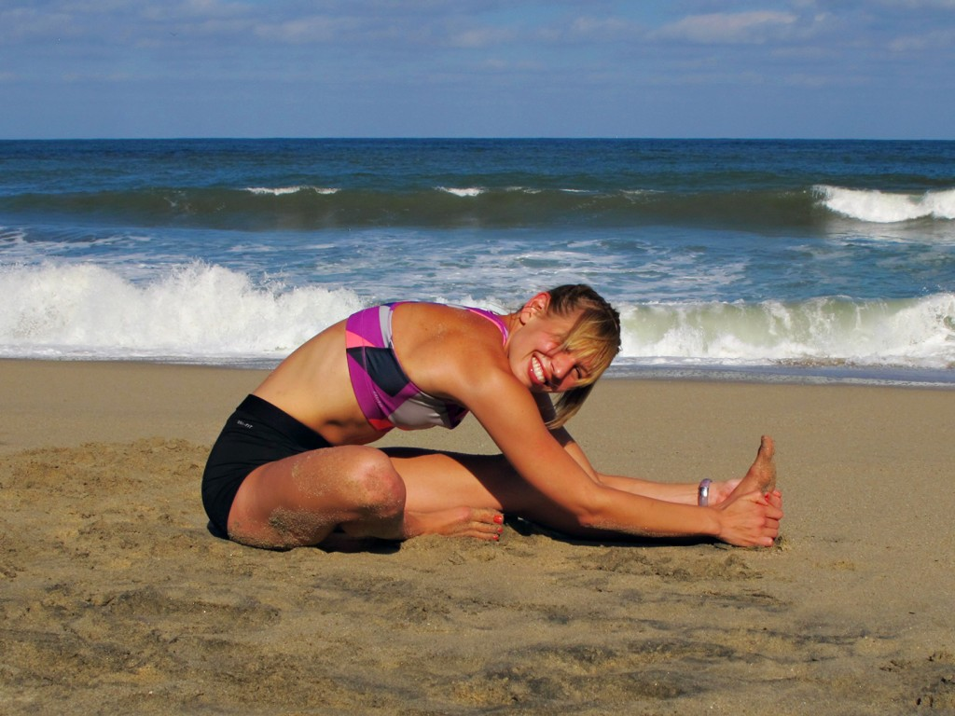
Directions:
- Sit on the floor with your legs stretched out in front of you.
- Bend one leg in at the knee.
- Slowly bend forward from hips toward foot of straight leg until you feel slight stretch.
- Hold for 10 to 20 seconds, then repeat on the other side.
Muscles stretched: Hamstrings (back of leg), lower back

3. Triceps stretch
Directions:
- Put one arm overhead, positioning your forearm as close as possible to your upper arm.
- Grasp your elbow overhead with your other hand.
- Pull your elbow back and toward your head.
- Hold stretch for 10-20 seconds, then repeat with opposite arm.
Muscles stretched: Triceps, lats

4. Pigeon pose
Directions:
- Cross one knee in front of you while keeping the opposite leg straight behind you.
- Place both hands on the ground in front of you and slowly lower your upper body down as low as possible.
- Hold for 10-20 seconds then switch sides.
Muscles stretched: Hips, glutes, lower back

5. Chest opener stretch
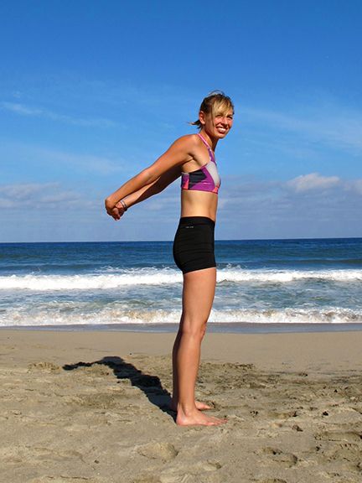
Directions:
- Stand or sit with your back straight and shoulders pulled back.
- Reach behind you and clasp both hands together.
- Bring hands up toward your head as far as possible.
- Hold for 10-20 seconds.
Muscles stretched: Chest, shoulders

6. Runner’s lunge with quad stretch
Directions:
- Assume a lunge position with your forward knee bent over your foot and your back leg extended behind you.
- Drop your knee to the ground.
- Reach your arm back and grab your foot or ankle and pull forward to stretch.
- Repeat on the opposite side.
Muscles stretched: Hip flexors, quads (front of legs)

7. Twisted arm stretch
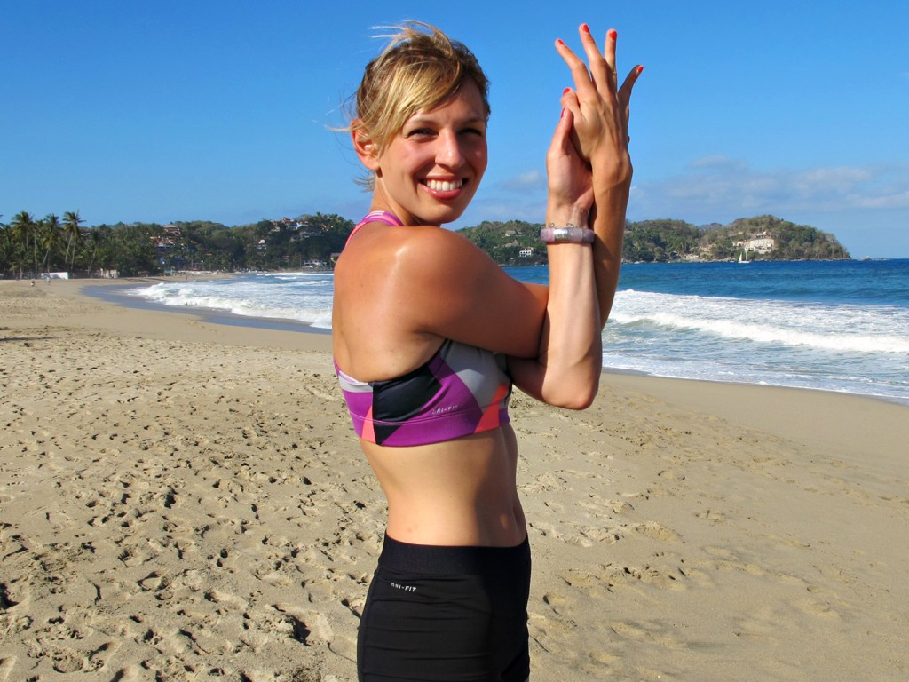
Directions:
- Bring your hands out in front and cross your arms, one over the other.
- Twist your hands such that the palms face into each other, trying to create contact with your fingers.
- Hold for 4 counts, unwind your arms, and then repeat on the other side.
Muscles stretched: Lats, shoulders, triceps

8. Downward dog
Directions:
- Start by kneeling on the ground with your hands shoulder-width apart on front of you.
- Take a deep breath and raise your buttocks into the air, straightening your legs as much as possible.
- Lower your head toward the ground and straighten your spine.
- Lower your heels toward the ground as far as you can go to give your calves a good stretch.
Muscles stretched: Calves; releases tension in back, shoulders

9. Upward dog
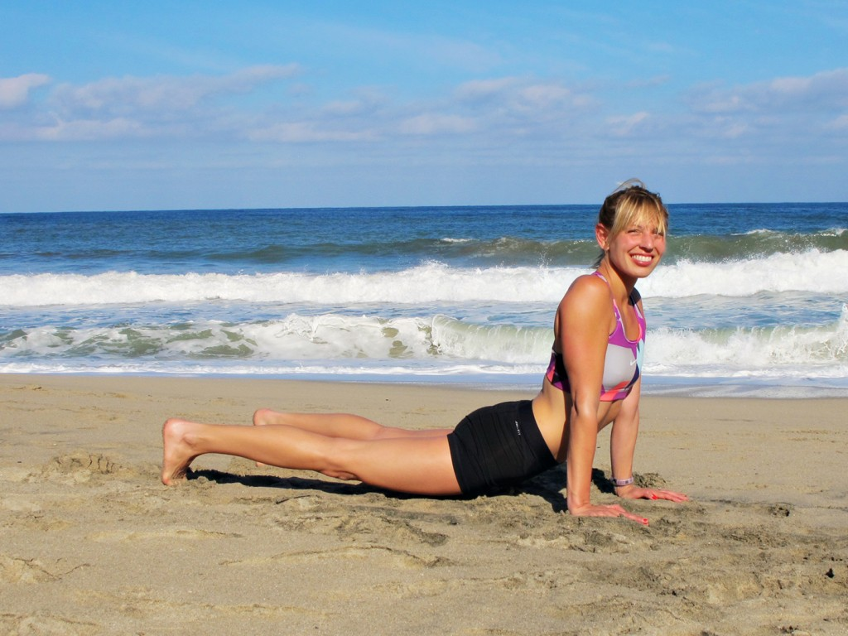
Directions:
- Lie face down on the ground with your feet hip-width apart and your hands resting next to your lower ribs.
- Keeping your toes and hands on the floor, press your chest up so that your back is straight.
- Squeeze your buttocks (to keep your back from hurting) and pull your shoulders back.
- You may raise slightly above the ground for a deeper yoga stretch.
Muscles stretched: Chest, abs; opens up shoulders, upper back

10. Leg over or “Iron Cross” stretch
Directions:
- Lie on your back with your legs straight in front of you.
- Bring one leg straight into the air then bring across your body so it rests on the ground.
- Hold for 10-20 seconds, then repeat on the other side.
Muscles stretched: Side of hips, lower back, middle back

