Junior National Long Course Camp
Nov 15-17, 2019
Sponsored by: Colorado Swimming and the Univ. of Denver Hilltoppers
Athletes Invited: Open to USA Swimming member athletes registered to a CSI club, that have achieved a qualification time since Sept 1, 2018. Colorado Swimming reserves the right to limit the camp roster to the first 70 swimmers who apply.

Location: University of Denver, El Pomar Natatorium, 2201 E. Asbury, Denver, CO 80208

Parking: Maps and permits will be mailed to athletes who submit the enclosed forms.

Cost: $10 per athlete. Cash or checks made payable to “DU Hilltoppers” accepted.

Camp consists of:
- 4 long course sessions.
- Each athlete will receive a T-shirt and Cap for participation.

Coach Participation: Any coaches of qualified swimmers are welcome to attend and observe any session. The camp will be run by a staff of coaches, chosen in advance, who will attend all sessions. If you are interested in coaching please contact Shawn Smith at 303-871-3135, or shawn.smith@du.edu

What to Expect: This is a training camp. It is designed to provide the best athletes in Colorado a weekend of long course training. Workouts will be challenging. Bring a great attitude, a desire to improve, and be prepared to challenge yourself. Please bring training equipment.

Workout schedule:
Friday Nov 15: 4:30-7 PM workout
Saturday Nov 16: 7-9:30 AM workout, 2-3pm athlete education session, 3:00-5:15 PM workout
Sunday Nov 17: 10am-11am workout. Camp Dual Meet approx 11am-2pm

COLORADO JUNIOR NATIONAL CAMP QUALIFYING TIME STANDARDS

Women 2019 Winter Junior National Bonus Standards Men
SCY | LC | EVENT DESCRIPTION | SCY | LC
23.99 | 27.29 | 50 FREE | 21.19 | 24.69
51.59 | 58.99 | 100 FREE | 46.69 | 53.79
1:51.39 | 2:06.79 | 200 FREE | 1:40.99 | 1:57.29
5:03.49 | 4:28.79 | 400/500 FREE | 4:34.29 | 4:08.19
10:20.49 | 9:13.89 | 800/1000 FREE | 9:34.29 | 8:40.69
17:14.39 | 17:40.19 | 1500/1650 FREE | 16:05.49 | 16:38.69
57.29 | 1:06.39 | 100 BACK | 51.69 | 1:00.29
2:03.59 | 2:22.79 | 200 BACK | 1:52.09 | 2:10.79
1:04.99 | 1:15.29 | 100 BREAST | 58.19 | 1:07.99
2:21.49 | 2:41.99 | 200 BREAST | 2:07.19 | 2:27.99
56.89 | 1:04.29 | 100 FLY | 50.79 | 57.89
2:04.49 | 2:20.79 | 200 FLY | 1:52.89 | 2:09.19
2:05.29 | 2:24.49 | 200 INDIV. MEDLEY | 1:53.29 | 2:11.69
4:26.09 | 5:04.59 | 400 INDIV. MEDLEY | 4:03.89 | 4:40.39

Team Name:

Coach’s Name: Phone #
Coach E-mail
E-Mail Address is for Parking Permits:
PLEASE TYPE ATHLETE EMAIL

Athlete Name/Phone#: T-Shirt Size

1) Choose an item. Events Qualified:

USAS # Athlete E-mail:

2) Choose an item. Events Qualified:

USAS # Athlete E-mail:

3) ) Choose an item. Events Qualified:

USAS # Athlete E-mail:

4) ) Choose an item. Events Qualified:

USAS # Athlete E-mail:

5) ) Choose an item. Events Qualified:

USAS # Athlete E-mail:

6) ) Choose an item. Events Qualified:

USAS # Athlete E-mail:

7) Choose an item. Events Qualified:

USAS # Athlete E-mail:

Registration must be received by Nov 1, 2019- Late registrations may be accepted, but will not receive T-Shirts.

Please mail all registration materials, consent/liability release forms and $10 camp fee to:
DU Dept. of Recreation: Aquatics
Hilltopper Swimming
c/o Shawn Smith
2201 E. Asbury, Denver, CO 80208

Parental Permission Form/ Acknowledgment of Risk and Release

Name of Activity: Colorado Swimming Inc. Jr. National Camp Effective Date: Nov 15-17, 2019

THIS DOCUMENT MUST BE SIGNED BY THE PARENT OR LEGAL GUARDIAN OF PERSONS UNDER THE AGE OF 18 PARTICIPATING IN AN EVENT HELD UNDER THE AUSPICES OF COLORADO SEMINARY WHICH OWNS AND OPERATES THE UNIVERSITY OF DENVER. IF THE PERSON PARTICIPATING IN THE EVENT IS 18 YEARS OF AGE OR OLDER, THEN THE PARTICIPANT MUST SIGN THIS DOCUMENT.
* * *
The individual named below as “Participant,” if over the age of 18, or his parent or legal guardian if the Participant is under the age of 18, hereby acknowledges that he or she authorizes Participant to participate in Colorado Swimming Inc. Jr. National Camp (the “Event”), and further acknowledges his or her full understanding and appreciation that there are risks of damage or injury associated with participation in the Event including those risks involved. The person signing further acknowledges his understanding that Events held other than on the campus of the University of Denver are not subject to the same degree of supervision and control by the University as events occurring on its campus and that, absent the signing of this document by Event Participants or their parent or legal guardian, Colorado Seminary likely would not sponsor or offer Events taking place off campus.

The person signing this document hereby represents that he or she has advised the University of any facts known to him or her which would make the Participant more susceptible to injury or risk of injury as a result of participating in the Event than would be the average person of the same age. Any parent or legal guardian signing further represents that he or she has thoroughly explained to the minor Participant the risks associated with participating in the Event using language appropriate to the age and intellectual capacity of the Participant.

By signing this form, the Participant, or his parent or legal guardian, on behalf of himself, his heirs, assigns, legal and personal representative(s), agrees to assume all risks and responsibilities surrounding Participant’s participation in the Event and further to release Colorado Seminary, the University of Denver, and all departments and divisions thereof from any claims, demands, actions, causes of action, lawsuits, expenses, or losses (including court costs and all reasonable attorney fees) he or she may have on account of property damage or personal injury (including death) arising out of or attributable to Participant’s travel to or participation in the Event, whether such property damage or personal injury or death is caused by the negligence of Colorado Seminary, its trustees, employees or agents, or otherwise.

Executed this day of ,2019.

________________________________________
PRINTED NAME OF PARTICIPANT SIGNATURE OF PARTICIPANT (if 18 or older)

________________________________________________________________________________
SIGNATURE OF PARTICIPANT’S PARENT OR LEGAL GUARDIAN IF PARTICIPANT IS UNDER 18 YEARS OF AGE

Address

City State Zip Code

2019 Jr. National Camp Meet
Sunday Nov 17, 2019--10am-11am workout, Tentative Meet Start 11 am

SANCTION: This is a Colorado Swimming event, hosted by Univ of Denver Hilltoppers. Held under the sanction of USA Swimming Sanction # 2019-148. The competition course has been certified in accordance with 104.2.2C(4). The copy of such certification is on file with USA Swimming.

ELIGIBILITY: Open to USA Swimming member athletes registered to a CSI club and registered to participate in the Colorado Swimming Jr. National camp. To attend camp, athletes must have achieved a CSI Jr National Camp qualification time since Sept 1, 2018, and submitted registration paperwork by established deadlines. Athletes must attend camp to swim in the meet.

LOCATION: University of Denver, El Pomar Natatorium 2201 E. Asbury, Denver, CO 80210

FACILITY: The competition course has been certified in accordance with 104.2.2C(4). The copy of such certification is on file with USA Swimming. Competition water depth measured in accordance with Article 103.2.3 ranges below.
• 50 meter course with start depth of 4 ft on the South end, and ranging from 7-13 ft on North end.
• Meet will be conducted in 7 lanes competition, with 1 lane continuous warm-up/down. No buffer lane.
• Continuous warm-up/down lanes will be available in all circumstances.

RULES: The meet referee will be the final authority for the conduct of the meet. Current USA Swimming and CSI rules shall govern the conduct of the meet. Age of swimmer is determined as of November 17, 2019. Swimmers are limited to 4 events + Relays. Swimmers entered in the meet must be certified by a USA Swimming member-coach as being proficient in performing a racing start or must start each race from within the water. When unaccompanied by a member-coach, it is the responsibility of the swimmer or the swimmer's legal guardian to ensure compliance with this requirement. Deck changing is prohibited. Use of audio or visual recording devices, including a cell phone, is not permitted in changing areas, rest rooms or locker rooms. The standard CSI warm-up procedures are in effect for this meet. This includes swimmers entering the warm-up lanes using a 3-point feet-first entry where both feet and one hand must be in contact with the deck or end wall immediately prior to entering the water. On-deck photography is not allowed from behind the starting blocks and relays.

SCORING: Dual Meet Scoring, Individual 9-7-5-3-2-1. Relay 18-14-10-6-4-2

MEET ENTRY PROCEDURE/MEET CONDUCT:
- Home coach will submit individual entries via Hy-Tek (only enter individual events)
- Athletes team affiliation will be changed fit dual meet format (just like Zones/All-Stars)
- Relays will be determined during camp and may be combined to mixed gender relays at the determination of coaching staff.

ENTRY DEADLINE: Entries must be received by Monday Nov 11. Submit entries via e-mail to shawn.smith@du.edu
MEET REFEREE: Derigan Silver or Designee, 720-544-1768 derigansilver@gmail.com
MEET DIRECTOR: shawn.smith@du.edu

Women Men
1 200 Medley Relay 2
3 200 Free 4
5 100 Back 6
7 200 Breast 8
9 200 Fly 10
11 50 Free 12
13 200 Back 14
15 100 Breast 16
17 400 Free 18
19 100 Fly 20
21 100 Free 22
23 200 IM 24
25 200 Free Relay 26

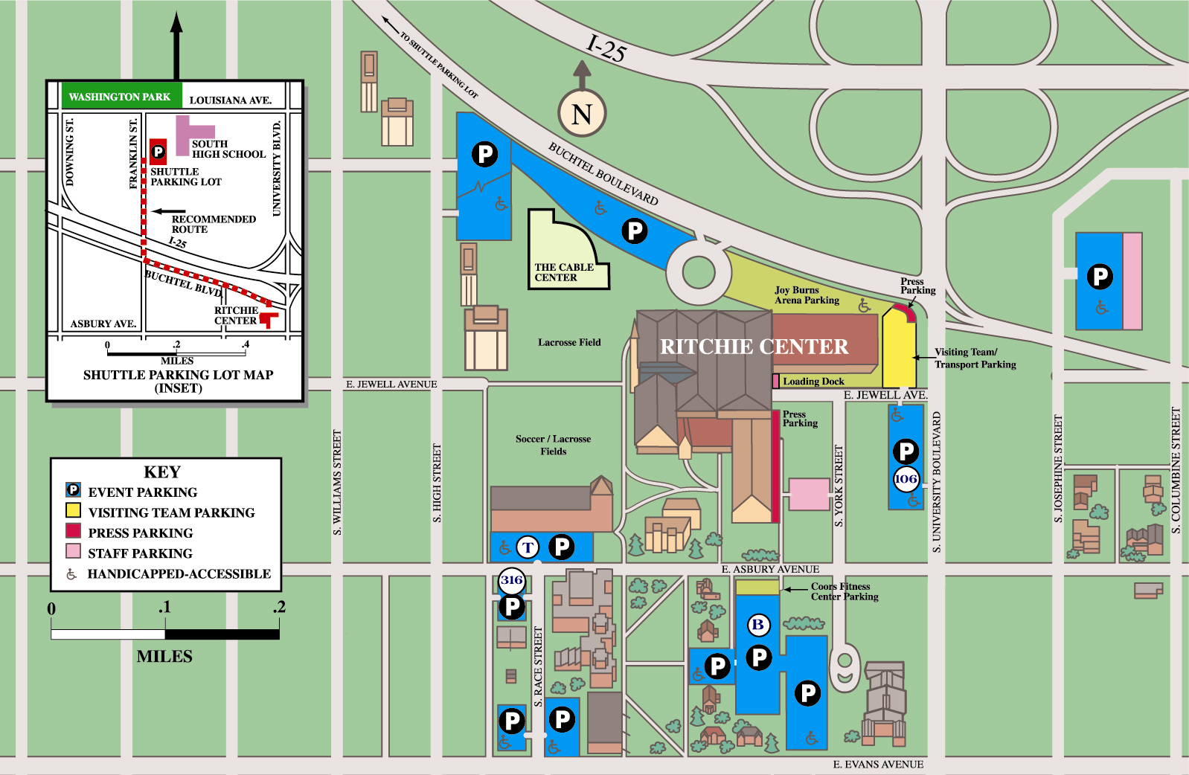

Hilltoppers Swim Meet
Participant Parking Lot 108
Please use surface Lot 108.

Parking on residential streets surrounding the University is limited to one hour for non-residents, and violators risk fines and possible towing.

The City & County of Denver-Traffic Department will be issuing tickets.

2019 Jr National Camp

Parking Instructions

Lot 108 has been designated for Jr Camp parking. Please keep your permit visible on your dashboard at all times.

