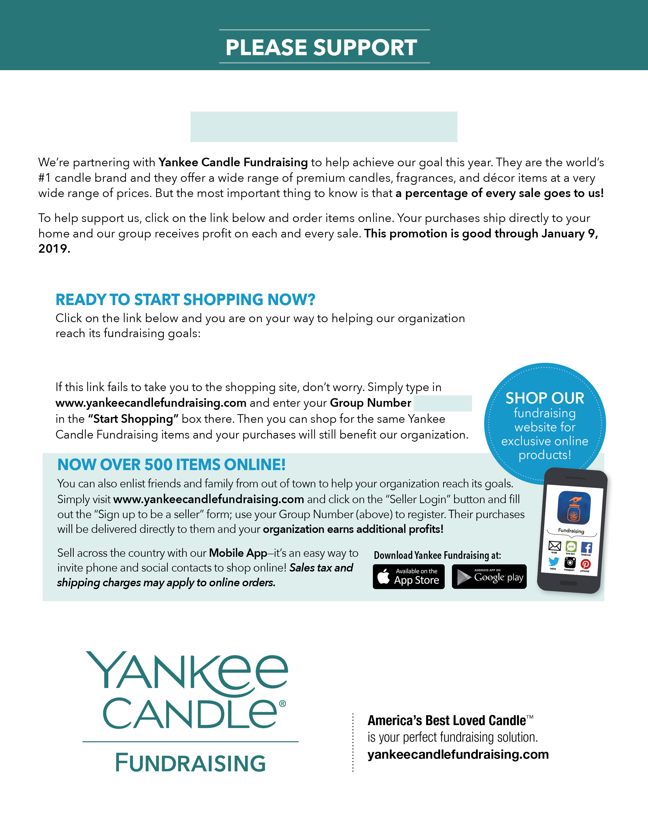

WESTON SWIMMING [Yankee](https://www.yankeecandlefundraising.com/scripts/ycfwcgi.exe?_V4=Process&_Func=enterWebsiteGroupEmail&frComp=ycf&cusId=990101608) Candle Shopping Site

990101608

WESTON SWIMMING

Group #990101608