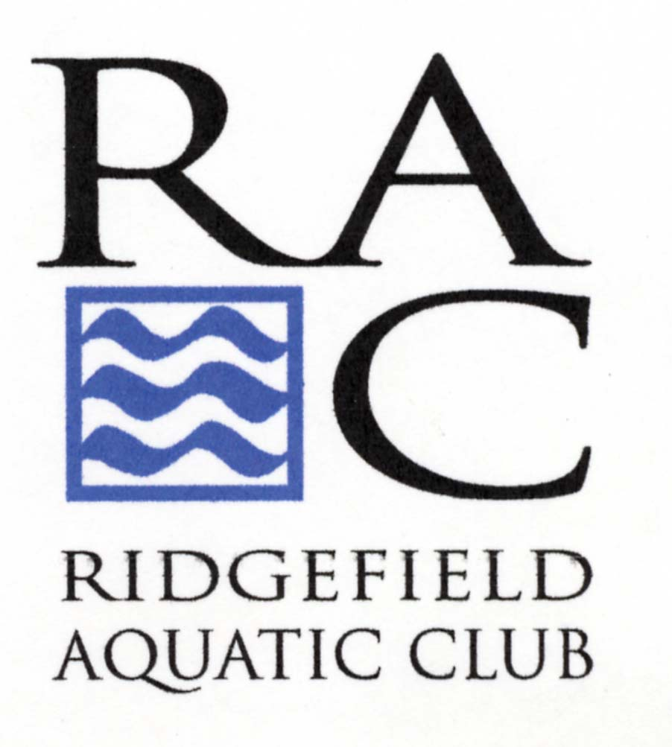

I, the parent or Guardian of _________________________, hereby acknowledge and agree to the following:

Waiver of Liability: Participation in swim practice and competition carries with it potential hazard and risk of bodily and other injuries. I, therefore, release the Ridgefield Aquatic Club, the town of Ridgefield, the Ridgefield Parks & Recreation Department, and any other potential practice or competition facilities, coaches, officials and any agents, employees, directors or others involved in any swim activities for which my child or ward (identified above) is registered from any claim for any injury or harm incurred as a result of such activity.

Medical Release & Treatment Authorization: I give my permission to the Ridgefield Aquatic Club personnel to authorize any and all medical attention required by my child or ward (identified above) in the event of an accident, sickness, illness or injury of whatever nature while engage in or associated with competitive swimming or other Club activities until I can be contacted. I also hereby assume the responsibility for payment for any such treatment given pursuant to this authorization. In addition, there are no medical conditions that I am aware of that would preclude my child from engaging in competitive swimming and related activities:

Insurance Company: _______________________________

Insurance Group #: __________________________

Other Insurance ID#: _______________________________

Physician: _________________________________

Physician Phone #: _________________________________

Allergies/Medication/Medical Conditions: ___________________________________

Emergency Contact Name: __________________________________________

Relationship: _____________________________

Phone #: __________________________________________

