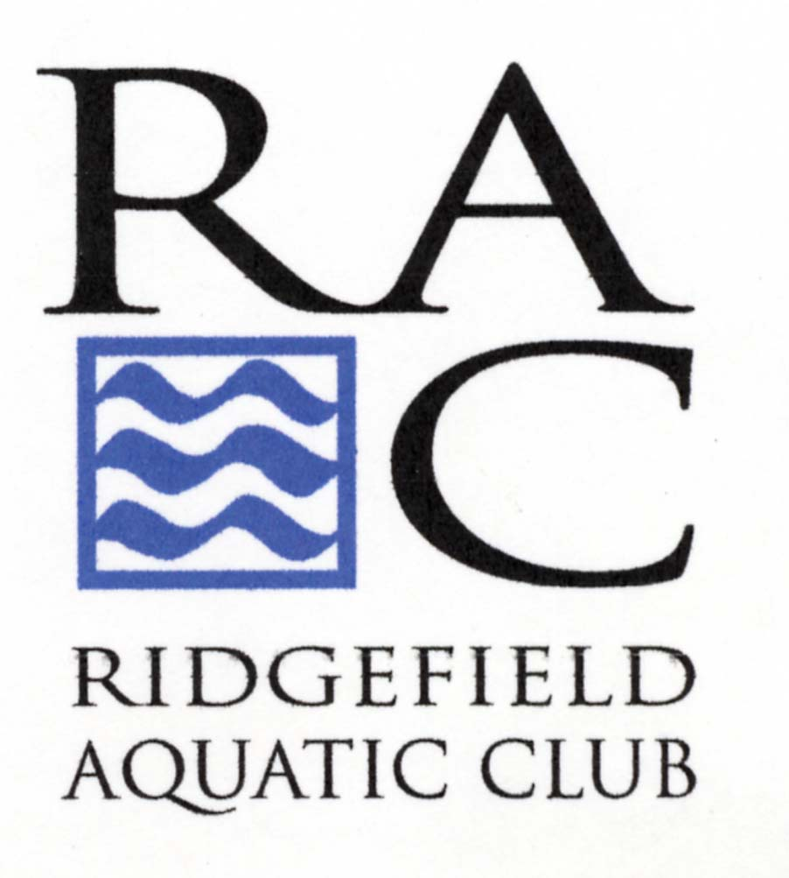

RIDGEFIELD AQUATIC CLUB

SWIM-A-THON
January 22, 2016

From____________________

Dear___________________________,

Personal Message:_________________________________________________________
_______________________________________________________________________________________________________________________________________________________________________________________________________________________

On January 22, 2016 the Ridgefield Aquatic Club will hold its 12th annual Swim-a-Thon to raise funds for our swim team. I hope you will sponsor me. I will be swimming as many laps as I can in a two-hour period; but will stop swimming if and when I have completed 200 laps (that’s 5000 meters).

As a sponsor, you may give a flat donation, or if you would like, you may sponsor me “per lap” by checking one of the spaces below. Following the Swim-a-Thon, I will let you know the number of laps I swam and your pledge amount. Please indicate your choice below.

ALL DONATIONS ARE TAX DEDUCTIBLE AS ALLOWED BY LAW!
------------------------------------------------------------------------------------------------------------------------------------------------------------------------------------------------------------------------------------------------------------------

Swimmer’s Name______________________________

I am enclosing a flat donation of:

______$10.00 ______$25.00 _______$50.00 ___________$100.00 _________Other

I plan to sponsor you for:

____________$.10 per lap _______________$.25 per lap ___________________$.50 per lap Other__________

Please make your check payable to Ridgefield Aquatic Club and mail to RAC at

PO Box 256 Ridgefield, CT 06877

Name____________________________
Street Address________________________________________________________________________
City_____________________________________State___________Zip Code___________

Want to use a credit card? Visit our website at www.racswimming.org

